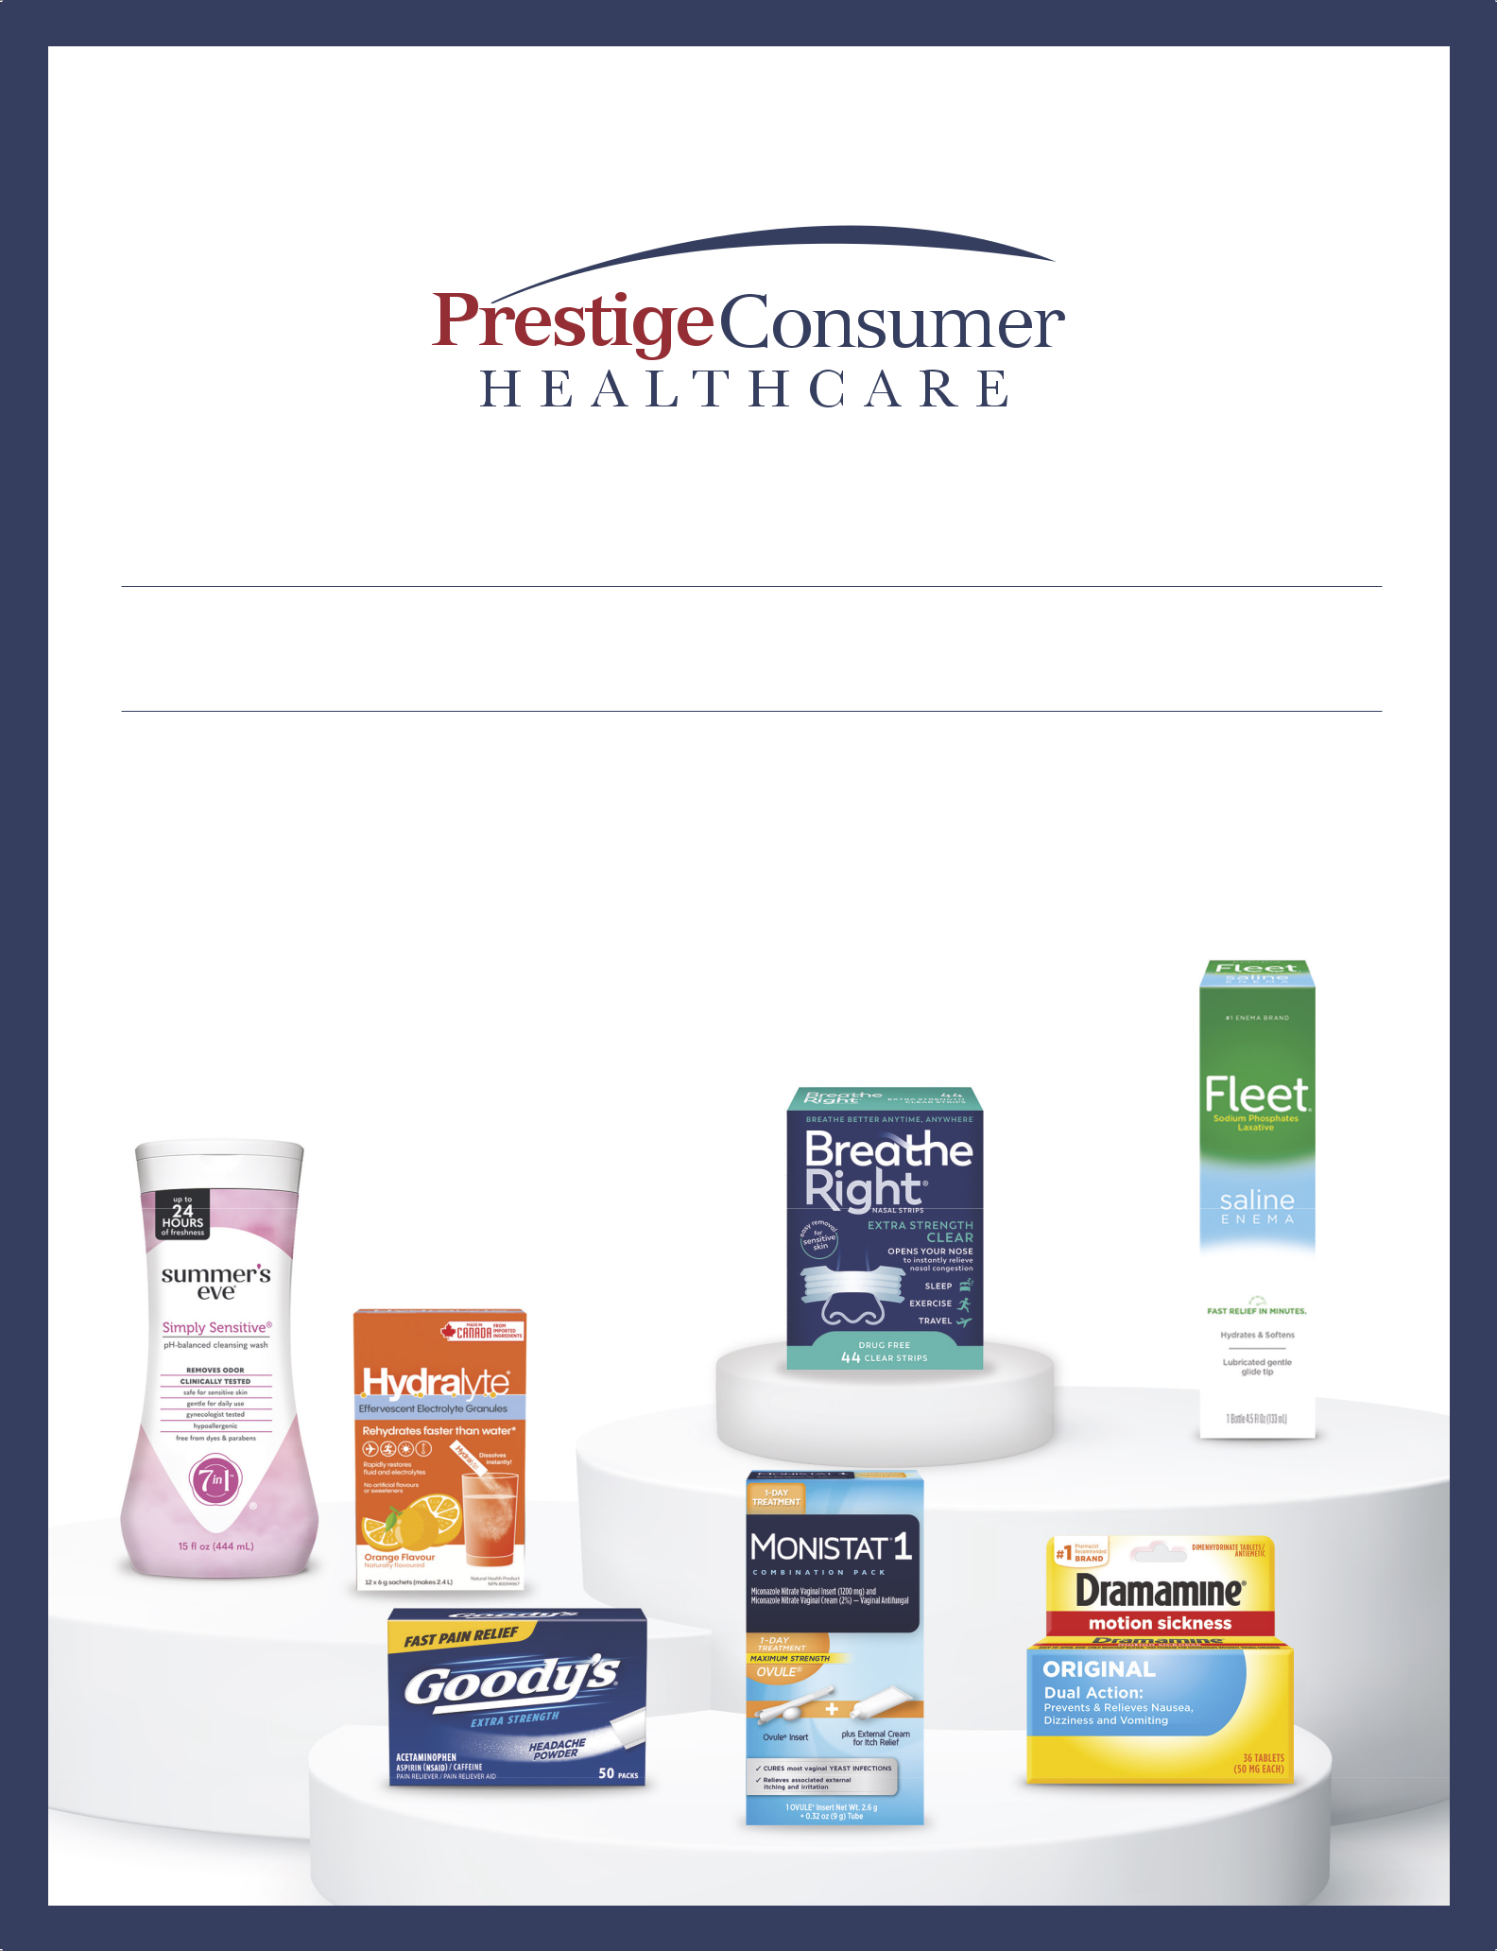

PROVEN STRATEGY DRIVING LONG-TERM SUCCESS

2026 Annual Report

Prestige Consumer Healthcare Inc. markets, sells, manufactures and distributes consumer healthcare products to retail outlets in the U.S., Canada, Australia and certain other international markets. We are a company of brand builders. We have grown organically and by acquiring well-recognized leading brands in niche categories. Our management provides our brands with the marketing expertise and investment necessary to grow the brands’ market position, expand its distribution and successfully launch line extensions and new products, with the goal of continually enhancing consumer satisfaction.
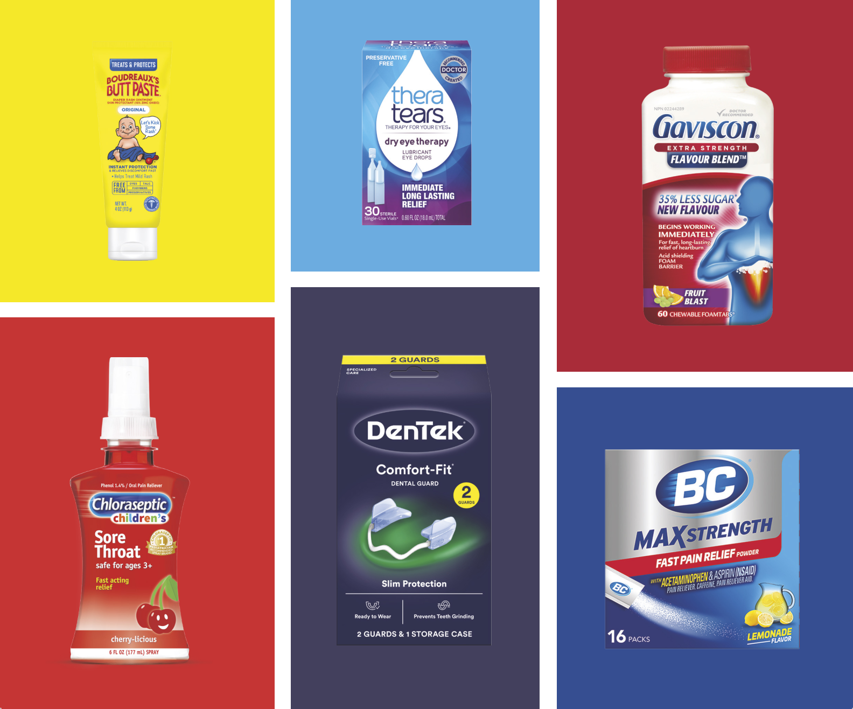



2026
FACTS+FIGURES

At Prestige Consumer Healthcare, we focus on brand-building and product innovation in niche consumer healthcare categories to better improve the lives of our consumers. For generations, our trusted brands have helped consumers care for themselves and their loved ones.

It is our mission to preserve this trust by continuing to provide products with their needs in mind.

Consistent Long-Term Revenue Performance

Revenues of

$1,089 M

a 2.9% CAGR over the last five years

Strong Cash Generation

Free Cash Flow of

$246 M

Continued growth in

Category-defining Brands

Dramamine®

Fleet®

drove the fifth year in a row of

Gastrointestinal category growth

Efficient Capital Allocation

Leverage of

2.6x

enabling the June 2026 acquisition at year-end, enabling capital

of Breathe Right® deployment flexibility


A DIVERSIFIED PORTFOLIO OF BRANDS

Category percentage of FY26 revenues

9%

ORAL CARE

9%

COUGH & COLD

11%

ANALGESICS

12%

DERMATOLOGICALS

13%

EYE & EAR CARE

24%

GASTROINTESTINAL

21%

WOMEN’S HEALTH

Note: Numbers are approximate,

Other OTC (1% of sales) not shown

FINANCIAL HIGHLIGHTS

(in thousands, |  |  |  | Fiscal Year Ended March 31,
except per share amounts) |  | 2026 |  | 2025 |  | 2024 |  | 2023 |  | 2022
Total Revenues | $ | 1,088,705 | $ | 1,137,762 | $ | 1,125,357 | $ | 1,127,725 | $ | 1,086,812
Adjusted EBITDA* | $ | 353,770 | $ | 374,460 | $ | 373,860 | $ | 378,091 | $ | 367,653
Net Income (Loss) | $ | 190,301 | $ | 214,605 | $ | 209,339 | $ | (82,306) | $ | 205,381
Adjusted Net Income* | $ | 213,344 | $ | 226,346 | $ | 211,322 | $ | 211,974 | $ | 206,310
Earnings (Loss) Per Share-Diluted | $ | 3.91 | $ | 4.29 | $ | 4.17 | $ | (1.63) | $ | 4.04
Adjusted Earnings Per Share-Diluted* | $ | 4.38 | $ | 4.52 | $ | 4.21 | $ | 4.21 | $ | 4.06
Weighted Average Shares |  | 48,720 |  | 50,080 |  | 50,178 |  | 49,889 |  | 50,842
Outstanding-Diluted
Net Cash Provided by | $ | 257,627 | $ | 251,515 | $ | 248,926 | $ | 229,716 | $ | 259,922
Operating Activities
Capital Expenditures | $ | (11,178) | $ | (8,224) | $ | (9,550) | $ | (7,784) | $ | (9,642)
Free Cash Flow** | $ | 246,449 | $ | 243,291 | $ | 239,376 | $ | 221,932 | $ | 250,280
Adjusted Free Cash Flow** | $ | 246,449 | $ | 243,291 | $ | 239,376 | $ | 221,932 | $ | 253,745
Adjusted Free Cash Flow as a |  | 22.6% |  | 21.4% |  | 21.3% |  | 19.7% |  | 23.3%
Percentage of Net Revenues


TOTAL REVENUES |  |  |  |  |  |  |  |  |  |  |  |  |  |  |  |  | ADJUSTED EARNINGS |  |  |  |  |  |  |  |  |  |  |  |  | ADJUSTED FREE CASH FLOW**
(in millions) |  |  |  |  |  |  |  |  |  |  |  |  |  |  |  |  | PER SHARE–DILUTED* |  |  |  |  |  |  |  |  |  |  |  |  | (in millions)
 |  |  |  |  | $1,127.7 |  |  | $1,125.4 |  |  | $1,137.8 |  |  | $1,088.7 |  |  |  |  |  |  |  |  |  |  |  | $4.52 | $4.38
$1,086.8 |  |  |  |  |  |  |  |  |  |  |  |  |  |  |  |  | $4.06 |  |  |  | $4.21 |  | $4.21 |  |  | $4.52 |  |  | $253.7 |  |  |  |  |  |  |  |  |  |  |  | $243.3 $246.4
 |  |  |  |  |  |  |  |  |  |  |  |  |  |  |  |  |  |  |  |  |  |  |  |  |  |  |  |  |  |  |  |  |  |  |  |  |  | $239.4
 |  |  |  |  |  |  |  |  |  |  |  |  |  |  |  |  |  |  |  |  |  |  |  |  |  |  |  |  |  |  |  |  |  |  | $221.9

2022 2023 2024 2025 2026 2022 2023 2024 2025 2026 2022 2023 2024 2025 2026

- Organic revenue growth, adjusted net income, adjusted diluted earnings per share, and adjusted EBITDA are non-GAAP financial measures and are reconciled to the reported GAAP figures in Exhibit 99.1 and 99.2 accompanying our earnings release filed with the Securities and Exchange Commission on May 13, 2026.

- Free cash flow and adjusted free cash flow are non-GAAP financial measures. Management believes free cash flow is a commonly

used measure of liquidity, indicative of cash available for capital allocation. Free cash flow and adjusted free cash flow are reconciled to GAAP Net Cash provided by operating activities in Exhibit 99.1 and 99.2 accompanying our earnings release filed with the Securities and Exchange Commission on May 13, 2026.

Management believes that these measures provide additional ways to view our operations and a more complete understanding of our business than could be obtained absent this disclosure, when considered with both our GAAP results and our reconciliation therewith.

Prestige Consumer Healthcare Inc. 2026 Annual Report 1



FELLOW
SHAREHOLDERS

Ron Lombardi

Chair, President, and Chief Executive Officer

- 2026 Annual Report

Fiscal 2026 was a defining year for Prestige Consumer Healthcare—one that showcased both the resilience of our three-pillar strategy and our commitment to building long-term shareholder value. Against a backdrop
of macroeconomic volatility, geopolitical uncertainty, and supply chain disruptions in our eye care business, we remained steadfast in our strategic priorities. We invested behind our brands, grew free cash flow, and executed the most significant capital deployment in our company’s history with the acquisition of Breathe Right® and forthcoming acquisition of LaCorium Health—transactions that will meaningfully expand our platform and enhance our long-term growth trajectory.

These accomplishments reflect the discipline and consistency of our operating model, which is anchored by three core strategic priorities:

- Brand building and innovation

- Maintaining a strong financial profile

- Disciplined capital allocation

This three-pillar strategy has proven its effectiveness over the past 15 years, driving organic growth and creating a powerful compounding effect through disciplined capital allocation.

Over this period, the combination of our organic growth engine and strategic M&A has delivered over 8% revenue and 12% adjusted diluted earnings per share CAGR*—a track record that demonstrates how our consistent operating model translates strategic discipline into measurable shareholder value.

As we look ahead, we remain committed to these proven principles. With the same operational rigor and strategic focus that has driven our success, we expect to deliver strong growth of 10% revenue CAGR and over 8% adjusted earnings per share CAGR through 2029. This forecast reflects the same disciplined approach that has consistently created value for our shareholders.

- Revenue and Adjusted Diluted EPS compare periods Fiscal 2011 and Fiscal 2026 and are reconciled in Exhibit 99.1 and 99.2 accompanying our earnings release filed with the Securities and Exchange Commission on May 12, 2011 and May 13, 2026.

Prestige Consumer Healthcare Inc.

Letter to Our Shareholders

Investing for Growth with Our Proven Brand-Building Playbook

Our brand-building strategy is built on a simple but powerful foundation: consumer insights that drive effective marketing, relevant innovation that solves unmet needs, and broad distribution that ensures our products are available wherever consumers shop. In fiscal 2026, this playbook continued to generate results across much of the portfolio.

Our gastrointestinal franchise was a clear standout this year. Dramamine®, Fleet®, and Hydralyte® each delivered growth, reflecting the ongoing strength of our category-building investments. In Fleet®, we expanded our already sizable market share position, driven by proven marketing and targeted innovation, including the launch of Fleet® Mini Enemas—a travel-friendly, fast-acting format designed to reach both new and existing laxative users.

Dramamine® extended its reach by accelerating penetration into the nausea category, including pediatric nausea, and by engaging GLP-1 users seeking relief from side effects through marketing efforts. These tactics exemplify how we grow categories, not just brands.


Our Dramamine® and Fleet® brands continue to deliver strong growth, most recently by

showcasing engaging content that helps GLP-1 users seeking relief from side-effects.

In Women’s Health, Summer’s Eve® achieved a year of stabilization and remains positioned for future growth. Monistat® largely held share in the vaginal antifungal category—a notable result in an area that has experienced meaningful category-level headwinds over the past several years. In Dermatologicals, we launched Compound W® Skin Tag Remover, leveraging our nitro freeze technology leadership into an adjacent niche and further demonstrating the expansive potential of our brand-building toolkit.

Underlying these results is a structural advantage we have observed consistently over more than two decades in OTC healthcare: consumers treat trusted health brands as a necessity, not a discretionary purchase. Even as household budgets tightened and economic uncertainty persisted, our categories were among the last consumers looked to change—a hallmark attribute of our portfolio.

Our e-commerce sales continued to outpace the Company average, delivering double-digit consumption growth and reaching approximately 18% of total revenue this year. This reflects years of deliberate investment in content, channel development, and digital marketing. We are also evolving how we reach consumers, adapting to behavioral shifts driven by artificial intelligence, social media, and other emerging influences, enhancing seasonal relevance and brand page effectiveness to sustain our competitive position across e-commerce partners.

Prestige Consumer Healthcare Inc. 2026 Annual Report 3

Letter to Our Shareholders

In eye care, we acquired Pillar5 Pharma, our primary Clear Eyes® manufacturer, in December to gain direct control over our supply chain. Early progress includes a new high-speed production line, facility upgrades, and capacity expansion initiatives. Our “quality product on time” standards guide operations, with nearly all eye care supply undergoing recent regulatory review. Industry-wide quality disruptions among private label manufacturers have strengthened retailer preference for trusted, quality-focused brands, creating significant long-term share opportunities for Clear Eyes as our supply normalizes. We are positioning ourselves to capitalize on these opportunities and return Clear Eyes to growth.


Superior Business Attributes Drive Strong Free Cash Flow

Our superior and sustainable free cash flow profile is the engine that drives everything we do. In fiscal 2026, we generated approximately $246 million in free cash flow, up slightly versus the prior year and in line with the outlook we provided at the start of the year. This result reflects the durability of our model: a high proportion of externally manufactured product, low capital expenditure requirements, and the consistent demand characteristics of the OTC healthcare categories we serve.

Consumers rely on our products for their health, and the loyalty of our consumer base has proven remarkably consistent through tariff uncertainty, government disruption, inflation volatility, and geopolitical conflict alike. Together, these attributes consistently produce EBITDA margins in the low 30s and best-in-class free cash flow conversion.

This free cash flow profile gives us the financial flexibility to invest behind our brands, pursue strategic acquisitions, and return capital to shareholders, all in the same year. During fiscal 2026, we deployed capital across these priorities, including over $150 million in share repurchases and approximately $110 million invested in acquiring Pillar5 to enhance our long-term eye care manufacturing capabilities. Looking ahead, we anticipate strong free cash flow once again in fiscal 2027, which will support our debt reduction prioritization following the acquisitions of Breathe Right® and LaCorium Health.

4 2026 Annual Report Prestige Consumer Healthcare Inc.

Letter to Our Shareholders

Disciplined Capital Deployment Drives Future Growth

Looking ahead, we are executing two acquisitions representing the largest capital deployment in the Company’s history. The Breathe Right® portfolio is expected to generate approximately $200 million in revenue annually, anchored by the category-defining Breathe Right® brand. Breathe Right® is an iconic #1 brand synonymous with the nasal strip category and represents our entry into a new category. Its drug-free nasal strips serve multiple consumer “better breathing” needs.

The brand is widely distributed throughout the United States, where it holds the leading position in the category, and is sold internationally, primarily in Europe, with further growth opportunity. It will become the largest brand in our portfolio, and on an annualized basis, the transaction is expected to be accretive.


The acquisition of Breathe Right® will expand our portfolio into a new category of better

breathing, expand our presence in Europe, and become the company’s largest brand.

LaCorium Health, an Australian therapeutic skincare business built around the fast-growing Dermal Therapy® brand, brings approximately $40 million in expected annual revenue, proven double-digit revenue growth, and a strong fit with our Care Pharma infrastructure. Under Prestige, we will leverage our existing Australia distribution network to accelerate growth while integrating the business into our platform for cost synergies.

These acquisitions accelerate our international footprint toward 20% of total revenues, add complementary growth brands, and, combined with our organic growth initiatives, position Prestige for sustained value creation. We are confident that our proven approach to capital deployment—balancing strategic growth investments with prudent debt management—will drive enhanced shareholder returns while strengthening our competitive position.

Prestige Consumer Healthcare Inc. 2026 Annual Report 5

Letter to Our Shareholders

A Track Record That Endures, A Future That Is Compelling

It is worth stepping back from the near-term noise of fiscal 2026 to recognize what this business has built over time. Over the past two decades as a public company, disciplined portfolio management, focused consumer health M&A, and consistent reinvestment in marketing and innovation have created a diversified platform generating over $1 billion in annual revenue, with trusted brands holding leading positions in categories that matter to consumers every day.

The most recent five years provide a useful lens: approximately 3% revenue CAGR and 6% adjusted diluted EPS* CAGR, even including the challenges of fiscal 2026. This is the nature of what we have built—consistent, compounding value creation over time, through cycles and disruptions alike.

Looking ahead, we see multiple catalysts supporting a compelling multi-year outlook. The Breathe Right® and LaCorium acquisitions provide accretive growth and expanded international scale. Our eye care category represents meaningful upside, with capacity expanding as Pillar5 matures. And our broad, needs-based portfolio continues to demonstrate resilience.

Collectively, based on our current assumptions, we see a path to approximately 10% revenue CAGR and 8%+ EPS CAGR through fiscal 2029, while maintaining industry-leading low-to-mid-30s EBITDA margins. We anticipate cumulative free cash flow* approaching $900 million over the next three years, enabling rapid debt reduction and restoring capacity for future capital deployment.

The foundation of our confidence remains unchanged: trusted brands, a resilient consumer base, a durable financial model, and a management team with deep experience navigating volatility. Our guiding principles of Leadership, Trust, Change, and Execution continue to define how we operate.

On behalf of our management team and Board of Directors, I want to express my sincere appreciation for your continued confidence in Prestige. This has not been a simple year, and we do not take lightly the trust you place in our strategy and our team. We have built this business one deliberate decision at a time, always with a long-term perspective, and fiscal 2026 reflects that same approach.

We look forward to integration of our acquisitions, building momentum in our organic business, and providing updates to all of our stakeholders throughout the year. The opportunity ahead is clear, and I am confident in our ability to deliver.


Ron Lombardi

Chair, President and Chief Executive Officer

- Adjusted Diluted EPS and Free Cash Flow are Non-GAAP financial measures and are reconciled to their most closely related GAAP financial measures in our earnings release dated May 13, 2026 in the “About Non-GAAP Financial Measures” section.

6 2026 Annual Report Prestige Consumer Healthcare Inc.

Letter to Our Shareholders

Corporate Responsibility

Prestige Consumer Healthcare’s Board of Directors, management and employees all recognize the responsibility that comes with selling trusted consumer healthcare brands, and the importance of integrating corporate responsibility into our operations and culture for the benefit of future generations. We are committed to building environmental sustainability, social responsibility, and effective corporate governance into all aspects of our business. We view this as sound business strategy that drives resiliency and long-term value creation for the benefit of all stakeholders, including our consumers, customers, employees, investors, suppliers, regulators and the communities in which we live and operate.

Our 2025 sustainability report is available on our website, https://www.prestigebrands.com/about-us/corporate-responsibility. Our approach to Corporate Responsibility is based on credible frameworks and standards that create a foundation for identifying material topics, understanding our risks and opportunities, and informing our strategy.


Our People

Our people are critical to our Company’s success. We trust them every day to maintain safety and performance excellence, uphold integrity in manufacturing and marketing, and adhere to our Company’s four guiding principles.

Our Community & Consumers

Prestige’s commitment to responsible corporate citizenship extends beyond our employees and into the lives of our communities and consumers.

Our Planet & Partners

In line with our goal to continuously innovate and provide quality products to our consumers, we aim to assess, reduce, and report on our environmental impacts.

Prestige Consumer Healthcare Inc. 2026 Annual Report 7

CORPORATE
INFORMATION

DIRECTORS

Ronald M. Lombardi | Sheila A. Hopkins
Chair, President and Chief Executive Officer | President, Global Vision Care and Executive
Prestige Consumer Healthcare Inc. | Vice President of Bausch + Lomb (Retired)
John E. Byom | John F. Kelly
Chief Executive Officer | Vice President, Quality Operations and
Classic Provisions, Inc. (Retired) | Environment, Health & Safety
Celeste A. Clark, Ph.D. | Pfizer Inc. (Retired)
Senior Vice President | Dawn M. Zier
Kellogg Company (Retired) | Board Chair of The Hain Celestial Group, Inc.
James C. D’Arecca | President and Chief Operating Officer
James C. D’Arecca | Tivity Health, Inc. (Retired)
Executive Vice President, CFO | Tivity Health, Inc. (Retired)
Haemonetics Corporation

EXECUTIVES

Ronald M. Lombardi | Adel Mekhail
Chair, President and Chief Executive Officer | Executive Vice President—Sales and Marketing
Prestige Consumer Healthcare Inc. | Jeff Zerillo
Christine Sacco | Senior Vice President—Operations
Chief Financial Officer and Chief Operating Officer | Jose Rosado
William P’Pool | Senior Vice President—Quality & Regulatory
Senior Vice President, General Counsel | Jeff Thompson
and Corporate Secretary | Jeff Thompson
and Corporate Secretary | Vice President—Manufacturing and Operations
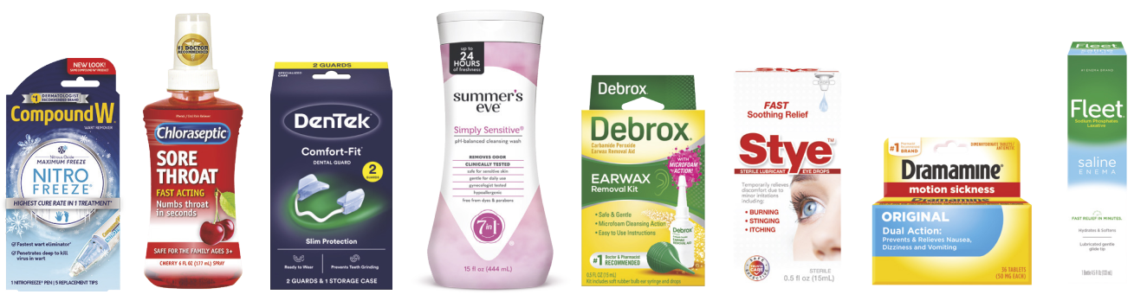

8 2026 Annual Report Prestige Consumer Healthcare Inc.

STOCKHOLDER
INFORMATION

TRANSFER AGENT AND REGISTRAR

Registered stockholders with questions regarding stock holdings, certificate replacement/transfer and address change should contact our Transfer Agent:

Equiniti Trust Company, LLC

28 Liberty Street, Floor 53

New York, NY 10005

INDEPENDENT AUDITOR

PricewaterhouseCoopers LLP

300 Atlantic Street

Stamford, CT 06901

COMMON STOCK LISTING


New York Stock Exchange (Symbol—PBH)

INVESTOR INQUIRIES

Attn: Investor Relations

Prestige Consumer Healthcare Inc.

660 White Plains Road

Tarrytown, NY 10591

Telephone: (914) 524-6800

IRInquiries@PrestigeBrands.com

www.PrestigeConsumerHealthcare.com

CAUTIONARY STATEMENT REGARDING FORWARD-LOOKING STATEMENTS

This annual report contains “forward-looking statements” within the meaning of the federal securities laws that are intended to qualify for the safe harbor from liability established by the Private Securities Litigation Reform Act of 1995. “Forward-looking statements” generally can be identified by the use of forward-looking terminology such as “guidance,” “outlook,” “look forward,” “projection,” “plan,” “positioned,” “may,” “will,” “would,” “expect,” “anticipate,” “believe,” “consistent,” “confidence,” “opportunity,” or “continue” (or the negative or other deriva-tives of each of these terms) or similar terminology. The “forward-looking statements” include, without limitation, statements regarding the Company’s future operating results, including revenues, free cash flow, organic growth and diluted earnings per share; the success of new product introductions; consumer demand; the successful completion and integration of acquisitions and the realization of expected benefits from such acquisitions; the Company’s intended uses of cash flow, including debt repayment and deleveraging, share repurchases, acqui-sitions and capital expenditures; the creation of shareholder value; and the Company’s ability to navigate a challenging environment. These statements are based on management’s estimates and assumptions with respect to future events and financial performance and are believed to be reasonable, though they are inherently uncertain and difficult to predict.

Actual results could differ materially from those expected as a result of a variety of factors, including the impact of the Company’s efforts to address supply chain constraints; the ability of the Company’s manufacturing operations and third-party manufacturers, logistics providers and suppliers to meet demand for its products and to avoid inflationary cost increases and disruption, including as a result of labor shortages; business and economic conditions, including evolving U.S. and international tariffs and trade actions, inflation and geopolitical instability; consumer trends; the impact of the Company’s advertising and marketing and new product development initiatives; customer inventory management initiatives; fluctuating foreign exchange rates; competitive pressures; the Company’s ability to successfully complete and integrate acquisitions and realize expected benefits from such acquisitions; and other risks and uncertainties. A discussion of other factors that could cause results to vary is included in the Company’s Annual Report on Form 10-K for the year ended March 31, 2026 and other periodic reports filed with the Securities and Exchange Commission.



www.prestigebrands.com

