UNITED STATES
SECURITIES AND EXCHANGE COMMISSION
Washington, D.C. 20549

FORM 8-K

CURRENT REPORT

Pursuant to Section 13 or 15(d) of the Securities Exchange Act of 1934

Date of report (Date of earliest event reported): March 19, 2026

PRESTIGE CONSUMER HEALTHCARE INC.
(Exact Name of Registrant as Specified in Charter)

Delaware | 001-32433 | 20-1297589
(State or Other Jurisdiction of  Incorporation) | (Commission File Number) | (IRS Employer Identification No.)

660 White Plains Road, Tarrytown, New York 10591
(Address of Principal Executive Offices) (Zip Code)

(914) 524-6800
(Registrant's telephone number, including area code)

(Former Name or Former Address, if Changed Since Last Report.)

Check the appropriate box below if the Form 8-K filing is intended to simultaneously satisfy the filing obligation of the registrant under any of the following provisions (see General Instruction A.2. below):

☐ Written communications pursuant to Rule 425 under the Securities Act (17 CFR 230.425)

☐ Soliciting material pursuant to Rule 14a-12 under the Exchange Act (17 CFR 240.14a-12)

☐ Pre-commencement communications pursuant to Rule 14d-2(b) under the Exchange Act (17 CFR 240.14d-2(b))

☐ Pre-commencement communications pursuant to Rule 13e-4(c) under the Exchange Act (17 CFR 240.13e-4(c))

Securities registered or to be registered pursuant to Section 12(b) of the Act:

Title of each class | Trading Symbol(s) | Name of each exchange on which registered
Common stock, par value $0.01 per share | PBH | New York Stock Exchange

Indicate by check mark whether the registrant is an emerging growth company as defined in Rule 405 of the Securities Act of 1933 (§ 230.405 of this chapter) or Rule 12b-2 of the Securities Exchange Act of 1934 (§ 240.12b-2 of this chapter).

Emerging Growth Company ☐

If an emerging growth company, indicate by check mark if the registrant has elected not to use the extended transition period for complying with any new or revised financial accounting standards provided pursuant to Section 13(a) of the Exchange Act. ☐

Item 1.01 Entry into a Material Definitive Agreement.

On March 19, 2026, Prestige Brands, Inc. (“Purchaser”), a Delaware corporation and a wholly-owned subsidiary of Prestige Consumer Healthcare Inc. (the “Company”), entered into a definitive agreement (the “Asset Purchase Agreement”) with Foundation Consumer Brands, LLC (“Foundation”), a Delaware limited liability company. The Asset Purchase Agreement provides that, upon the terms and subject to the conditions set forth therein, Purchaser will acquire certain assets and assume certain liabilities primarily related to a portfolio of over-the-counter consumer health products, including Breathe Right® and certain other brands, for $1.045 billion in cash (the “Transaction”).

The Company expects the Transaction to close in the first half of Fiscal 2027, subject to the satisfaction or waiver of customary conditions to closing and clearance under the Hart-Scott Rodino Antitrust Improvements Act of 1976.

The Asset Purchase Agreement contains customary representations, warranties, and covenants of both Purchaser and Foundation, as well as indemnification provisions that are subject to specified limitations. Purchaser has obtained representation and warranty insurance, which serves as Purchaser’s sole recourse for losses related to breaches of Foundation’s representations and warranties, other than in the case of fraud. Subject to certain exceptions and limitations, Purchaser and Foundation have agreed to indemnify each other for breaches of post-closing covenants and other specified matters contained in the Asset Purchase Agreement.

The Asset Purchase Agreement also contains certain customary termination rights for each of Purchaser and Foundation. The Asset Purchase Agreement may be terminated by either Purchaser or Foundation if the closing of the Transaction has not occurred prior to July 20, 2026, subject to certain exceptions specified in the Asset Purchase Agreement. The Asset Purchase Agreement may also be terminated by either Purchaser or Foundation if the other party is in breach of the Asset Purchase Agreement, such that it has not met its closing conditions and has not or is not able to cure such breach.

The foregoing description of the terms of the Asset Purchase Agreement does not purport to be complete and is qualified in its entirety by reference to the full text of the Asset Purchase Agreement. The Company expects to file a copy of the Asset Purchase Agreement as an exhibit to its Annual Report on Form 10-K for the year ending on March 31, 2026.

The Asset Purchase Agreement contains various representations and warranties made by the parties solely for purposes of the Asset Purchase Agreement and as of specific dates set forth therein, which were the product of negotiations, and may be subject to important qualifications and limitations included in confidential disclosure schedules of the Asset Purchase Agreement. Certain representations and warranties in the Asset Purchase Agreement were used for the purpose of allocating risk between the parties, rather than establishing matters of fact. Furthermore, the representations and warranties may be subject to standards of materiality applicable to the parties that may be different from those applicable to the Company’s stockholders. Additionally, information concerning the subject matter of such representations and warranties may change after the date of the Asset Purchase Agreement, which subsequent information may or may not be fully reflected in the Company’s public disclosures. Accordingly, such representations and warranties in the Asset Purchase Agreement may not constitute the actual state of facts about Foundation, the Company, or Purchaser. Stockholders of the Company are not third-party beneficiaries under the Asset Purchase Agreement and should not rely on the representations, warranties, and covenants or any descriptions thereof as characterizations of the actual state of facts or condition of Foundation (or any of its subsidiaries), the Company, or Purchaser or any of their respective subsidiaries or affiliates.

Item 7.01 Regulation FD Disclosure.

On March 19, 2026, representatives of the Company began making presentations to investors regarding the Transaction using slides attached to this Current Report on Form 8-K as Exhibit 99.1 (the “Investor Presentation”) and incorporated herein by reference. The Company expects to use the Investor Presentation, in whole or in part, and possibly with modifications, in connection with presentations to investors, analysts and others during the fourth fiscal quarter ending March 31, 2026 and during the fiscal year ending March 31, 2027.

By furnishing the information contained in this Item 7.01, the Company makes no admission as to the materiality of any information that is required to be disclosed solely by reason of Regulation FD.

The information contained in the Investor Presentation is summary information that is intended to be considered in the context of the Company's Securities and Exchange Commission (“SEC”) filings and other public announcements that the Company may make, by press release or otherwise, from time to time. The Company undertakes no duty or obligation to publicly update or revise the information contained in this report, although it may do so from time to time as its management believes is warranted. Any such updating may be made through the filing of other reports or documents with the SEC, through press releases or through other public disclosure.

The information presented in Item 7.01 of this Current Report on Form 8-K and Exhibit 99.1 shall not be deemed to be “filed” for purposes of Section 18 of the Securities Exchange Act of 1934, as amended (the “Exchange Act”), or otherwise subject to the liabilities of that section, unless the Company specifically states that the information is to be considered “filed” under the Exchange Act or specifically incorporates it by reference into a filing under the Securities Act of 1933, as amended, or the Exchange Act.

Item 8.01 Other Events.

On March 20, 2026, the Company issued a press release announcing the entry into the Asset Purchase Agreement. A copy of the press release is attached hereto as Exhibit 99.2 and incorporated herein by reference.

Item 9.01 Financial Statements and Exhibits.

(d) Exhibits.

See Exhibit Index immediately following the signature page.

SIGNATURES

Pursuant to the requirements of the Securities Exchange Act of 1934, the registrant has duly caused this report to be signed on its behalf by the undersigned hereunto duly authorized.

Dated: March 20, 2026 | PRESTIGE CONSUMER HEALTHCARE INC.
 | By: | /s/ Christine Sacco
 |  | Christine Sacco
 |  | Chief Financial Officer & Chief Operating Officer

EXHIBIT INDEX

Exhibit |  | Description
99.1 |  | Investor Presentation in use beginning March 20, 2026 (furnished only).
99.2 |  | Press Release dated March 20, 2026 announcing the Company's entry into the Asset Purchase Agreement.
104 |  | Cover Page Interactive Data File (the cover page XBRL tags are embedded within the Inline XBRL document).

Exhibit 99.1

 | 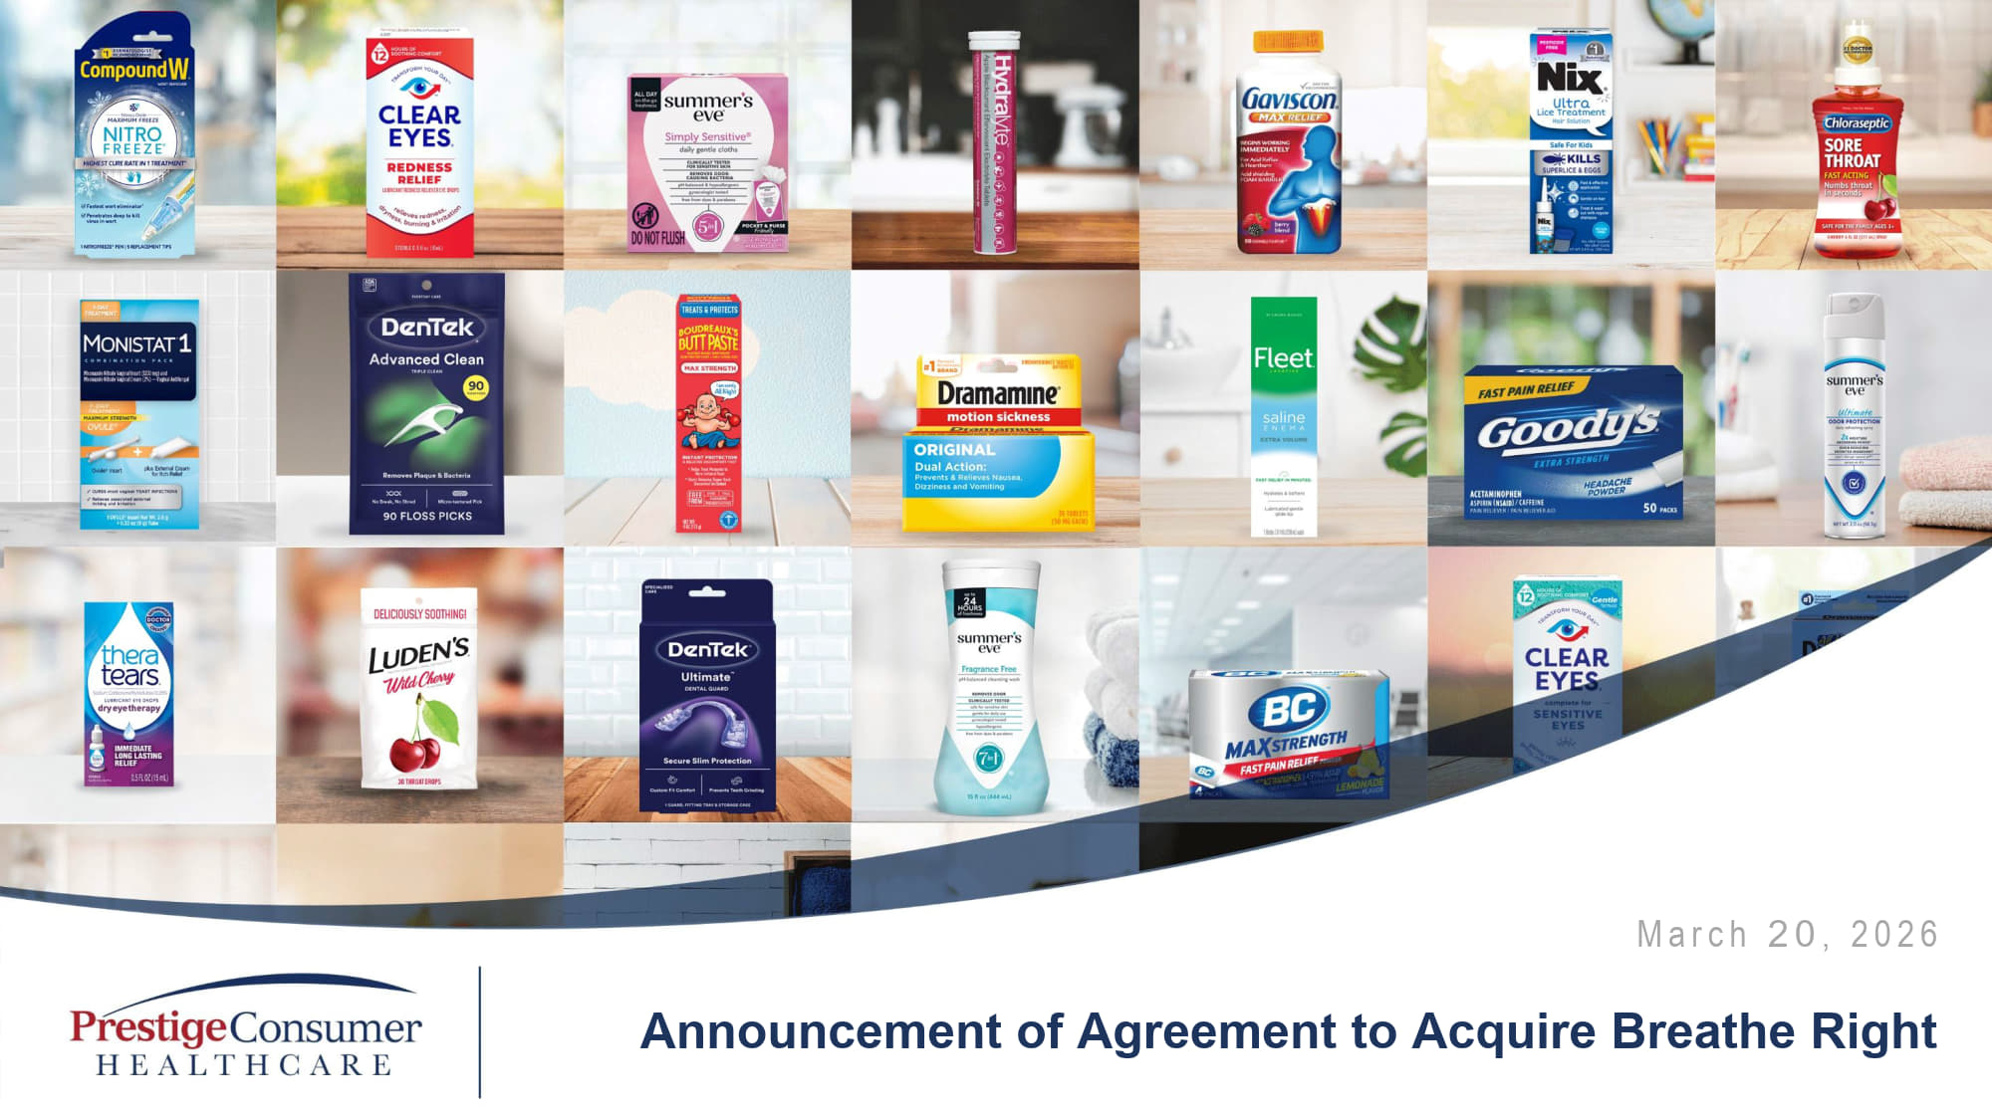 | M a r c h 2 0 , 2 0 2 6 Announcement of Agreement to Acquire Breathe Right Exhibit 99.1
 | 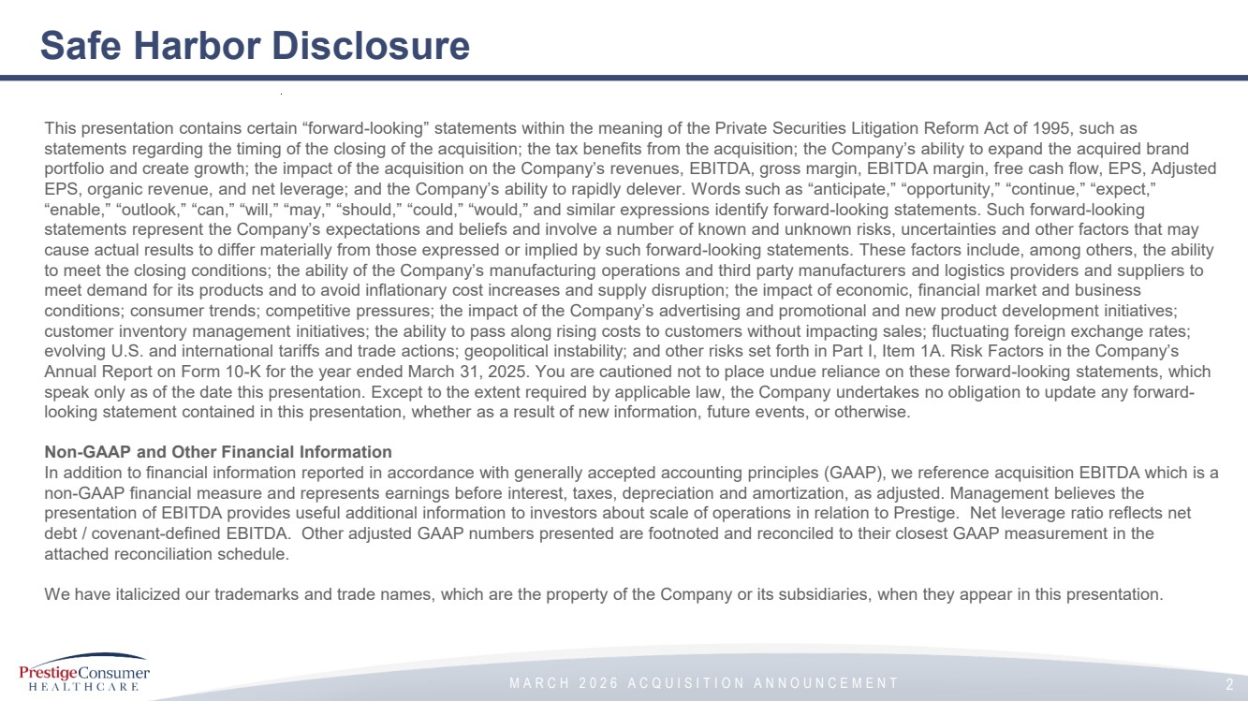 | M A R C H 2 0 2 6 A C Q U I S I T I O N A N N O U N C E M E N T Safe Harbor Disclosure 2 This presentation contains certain “forward-looking” statements within the meaning of the Private Securities Litigation Reform Act of 1995, such as statements regarding the timing of the closing of the acquisition; the tax benefits from the acquisition; the Company’s ability to expand the acquired brand portfolio and create growth; the impact of the acquisition on the Company’s revenues, EBITDA, gross margin, EBITDA margin, free cash flow, EPS, Adjusted EPS, organic revenue, and net leverage; and the Company’s ability to rapidly delever. Words such as “anticipate,” “opportunity,” “continue,” “expect,” “enable,” “outlook,” “can,” “will,” “may,” “should,” “could,” “would,” and similar expressions identify forward-looking statements. Such forward-looking statements represent the Company’s expectations and beliefs and involve a number of known and unknown risks, uncertainties and other factors that may cause actual results to differ materially from those expressed or implied by such forward-looking statements. These factors include, among others, the ability to meet the closing conditions; the ability of the Company’s manufacturing operations and third party manufacturers and logistics providers and suppliers to meet demand for its products and to avoid inflationary cost increases and supply disruption; the impact of economic, financial market and business conditions; consumer trends; competitive pressures; the impact of the Company’s advertising and promotional and new product development initiatives; customer inventory management initiatives; the ability to pass along rising costs to customers without impacting sales; fluctuating foreign exchange rates; evolving U.S. and international tariffs and trade actions; geopolitical instability; and other risks set forth in Part I, Item 1A. Risk Factors in the Company’s Annual Report on Form 10-K for the year ended March 31, 2025. You are cautioned not to place undue reliance on these forward-looking statements, which speak only as of the date this presentation. Except to the extent required by applicable law, the Company undertakes no obligation to update any forward-looking statement contained in this presentation, whether as a result of new information, future events, or otherwise. Non-GAAP and Other Financial Information In addition to financial information reported in accordance with generally accepted accounting principles (GAAP), we reference acquisition EBITDA which is a non-GAAP financial measure and represents earnings before interest, taxes, depreciation and amortization, as adjusted. Management believes the presentation of EBITDA provides useful additional information to investors about scale of operations in relation to Prestige. Net leverage ratio reflects net debt / covenant-defined EBITDA. Other adjusted GAAP numbers presented are footnoted and reconciled to their closest GAAP measurement in the attached reconciliation schedule. We have italicized our trademarks and trade names, which are the property of the Company or its subsidiaries, when they appear in this presentation.
 | 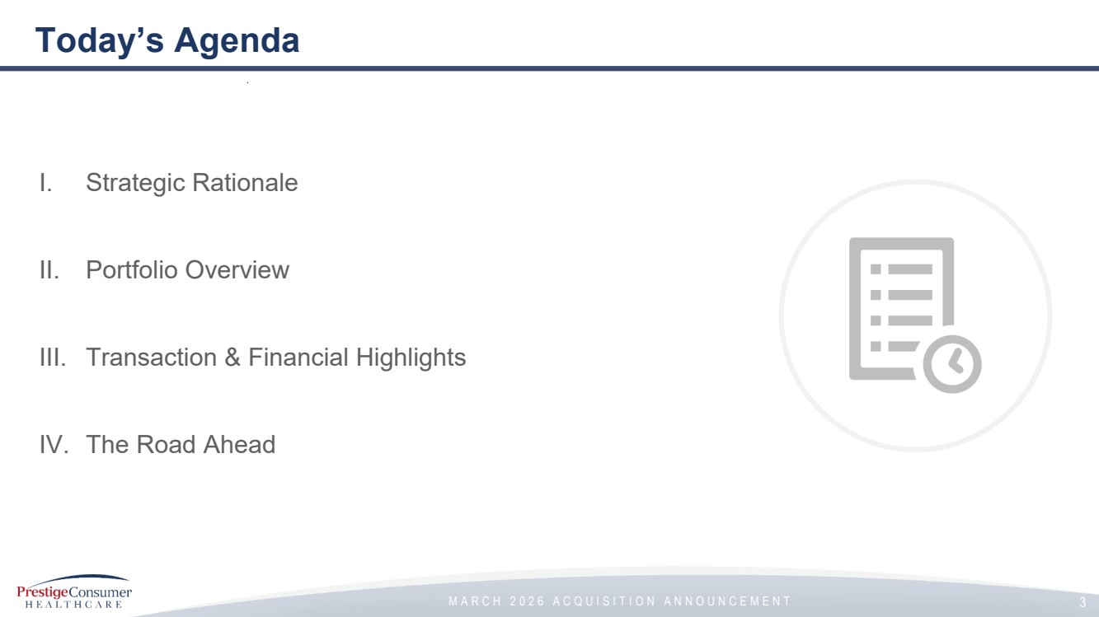 | M A R C H 2 0 2 6 A C Q U I S I T I O N A N N O U N C E M E N T Today’s Agenda 3 I. Strategic Rationale II. Portfolio Overview III. Transaction & Financial Highlights IV. The Road Ahead
 | 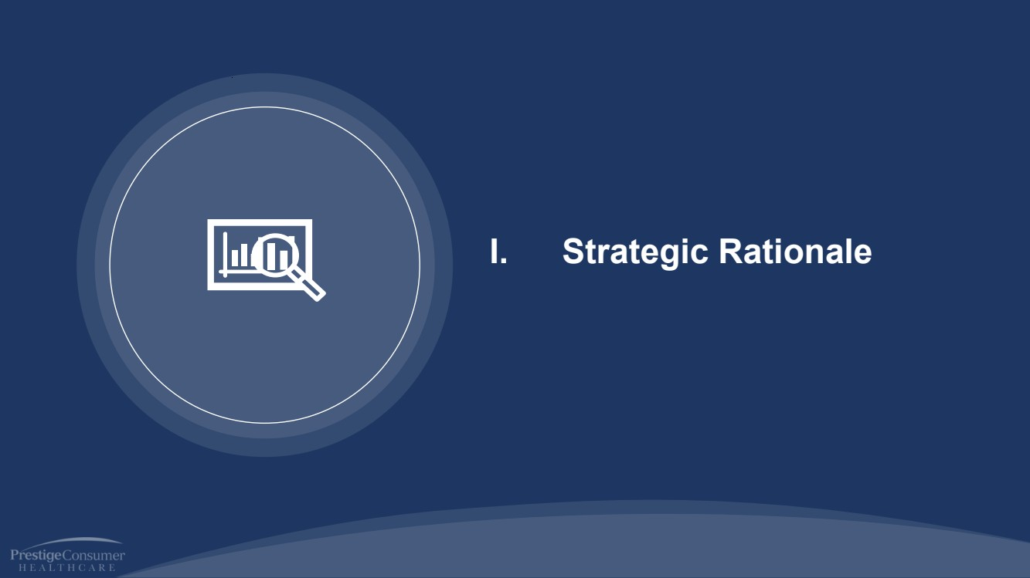 | M A R C H 2 0 2 6 A C Q U I S I T I O N A N N O U N C E M E N T I. Strategic Rationale
 | 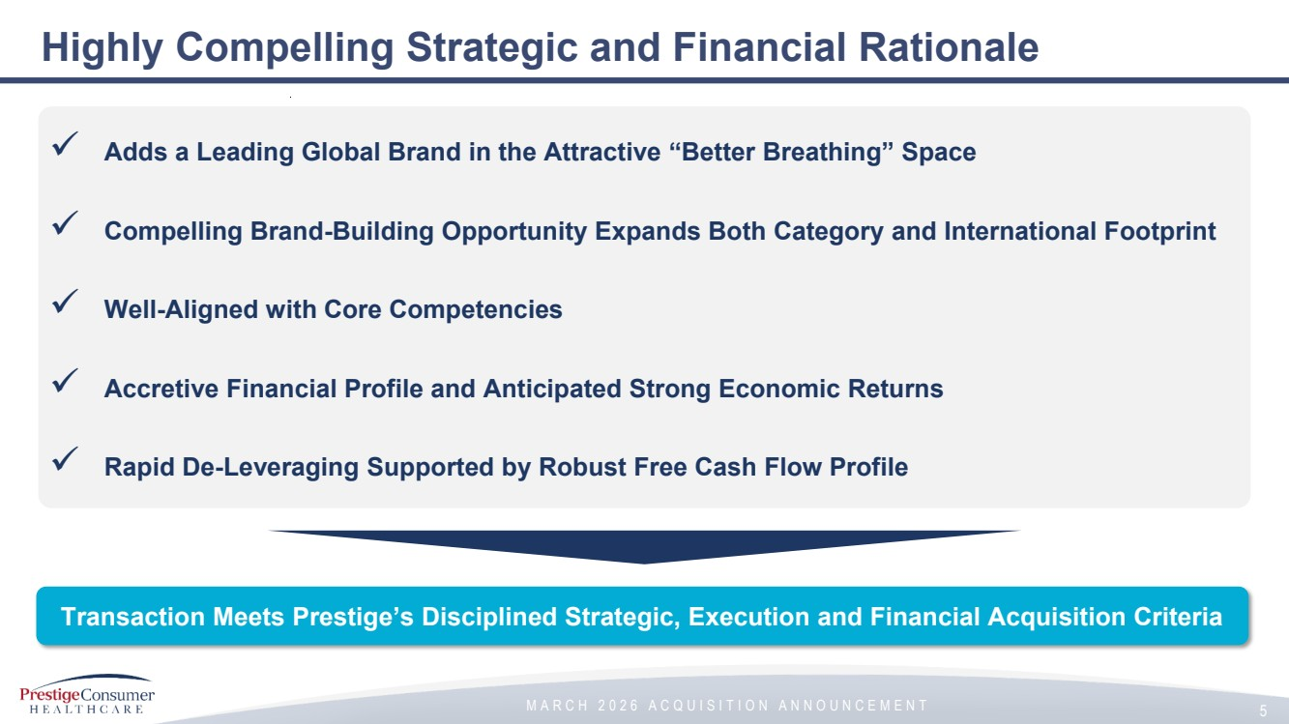 | M A R C H 2 0 2 6 A C Q U I S I T I O N A N N O U N C E M E N T Highly Compelling Strategic and Financial Rationale 5 Transaction Meets Prestige’s Disciplined Strategic, Execution and Financial Acquisition Criteria ✓ Adds a Leading Global Brand in the Attractive “Better Breathing” Space ✓ Compelling Brand-Building Opportunity Expands Both Category and International Footprint ✓ Well-Aligned with Core Competencies ✓ Accretive Financial Profile and Anticipated Strong Economic Returns ✓ Rapid De-Leveraging Supported by Robust Free Cash Flow Profile
 |  | M A R C H 2 0 2 6 A C Q U I S I T I O N A N N O U N C E M E N T II. Portfolio Overview
 | 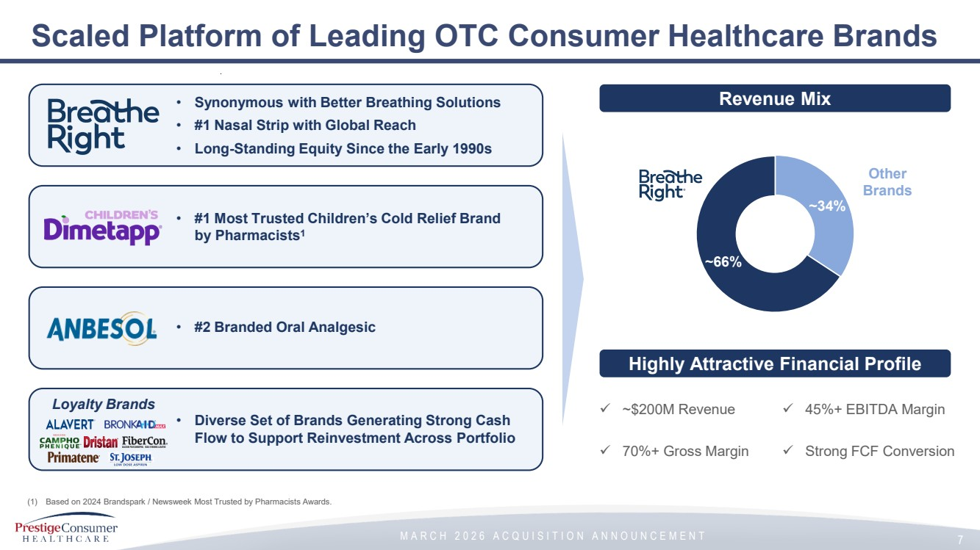 | M A R C H 2 0 2 6 A C Q U I S I T I O N A N N O U N C E M E N T Scaled Platform of Leading OTC Consumer Healthcare Brands 7 • Synonymous with Better Breathing Solutions • #1 Nasal Strip with Global Reach • Long-Standing Equity Since the Early 1990s • #1 Most Trusted Children’s Cold Relief Brand by Pharmacists1 (1) Based on 2024 Brandspark / Newsweek Most Trusted by Pharmacists Awards. • #2 Branded Oral Analgesic Loyalty Brands • Diverse Set of Brands Generating Strong Cash Flow to Support Reinvestment Across Portfolio Highly Attractive Financial Profile Revenue Mix ✓ ~$200M Revenue ✓ 70%+ Gross Margin ✓ 45%+ EBITDA Margin ✓ Strong FCF Conversion ~34% ~66% Other Brands
 | 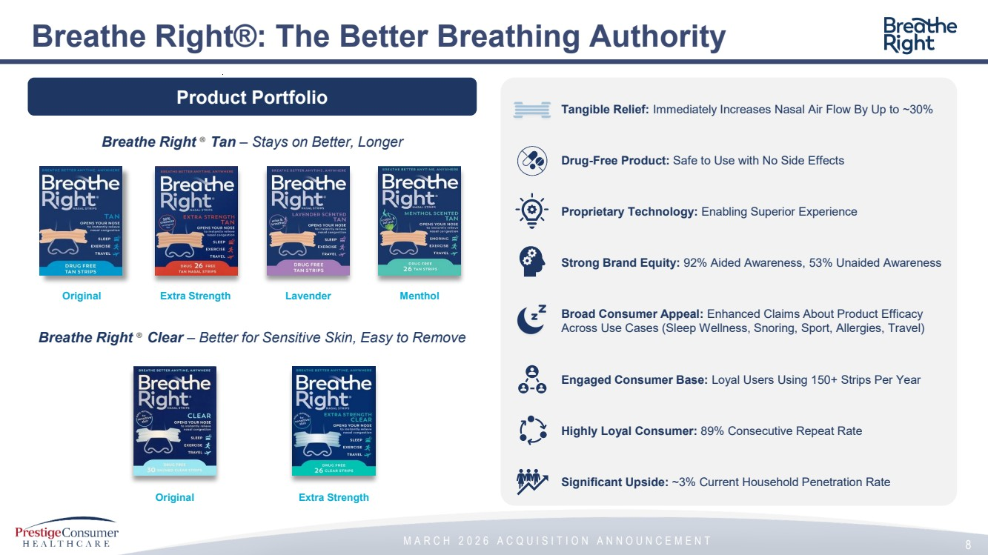 | M A R C H 2 0 2 6 A C Q U I S I T I O N A N N O U N C E M E N T Tangible Relief: Immediately Increases Nasal Air Flow By Up to ~30% Drug-Free Product: Safe to Use with No Side Effects Proprietary Technology: Enabling Superior Experience Strong Brand Equity: 92% Aided Awareness, 53% Unaided Awareness Broad Consumer Appeal: Enhanced Claims About Product Efficacy Across Use Cases (Sleep Wellness, Snoring, Sport, Allergies, Travel) Engaged Consumer Base: Loyal Users Using 150+ Strips Per Year Highly Loyal Consumer: 89% Consecutive Repeat Rate Significant Upside: ~3% Current Household Penetration Rate Breathe Right®: The Better Breathing Authority 8 Original Extra Strength Lavender Menthol Breathe Right ® Tan – Stays on Better, Longer Original Extra Strength Product Portfolio Breathe Right ® Clear – Better for Sensitive Skin, Easy to Remove
 | 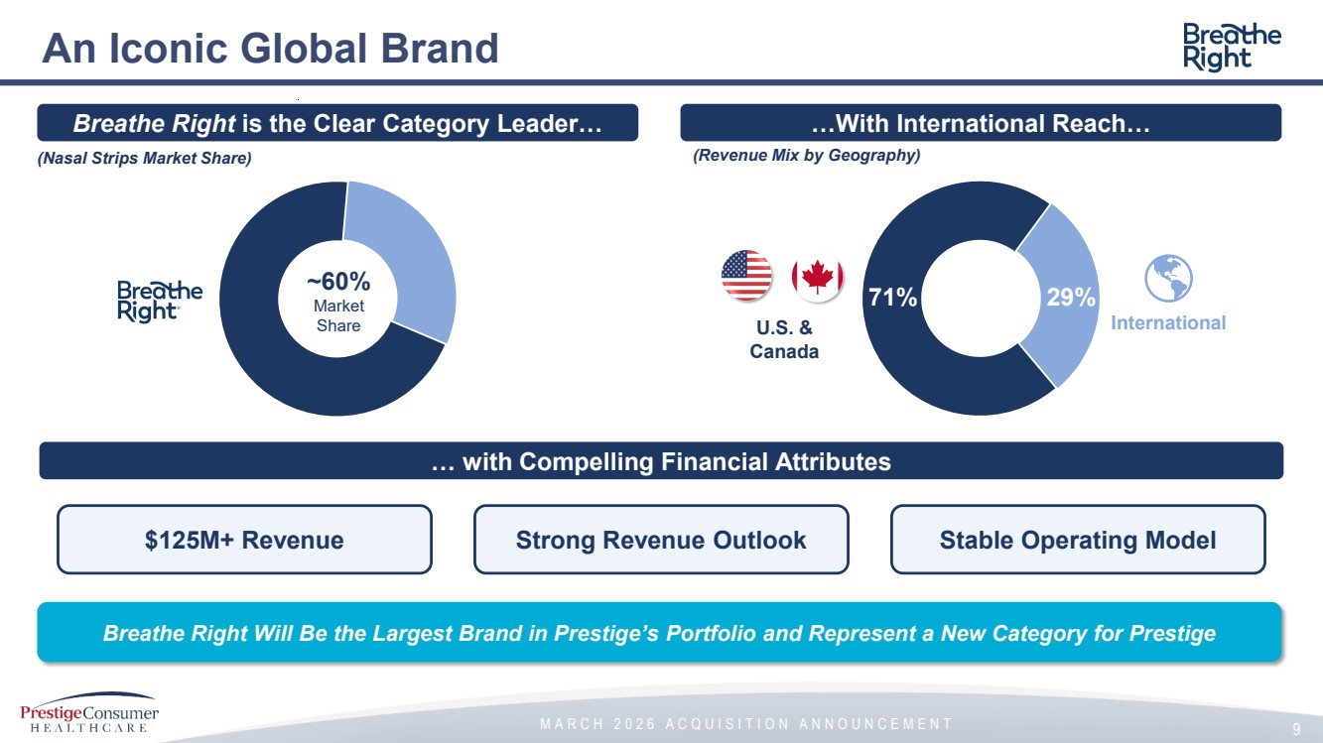 | M A R C H 2 0 2 6 A C Q U I S I T I O N A N N O U N C E M E N T An Iconic Global Brand 9 Breathe Right is the Clear Category Leader… (Nasal Strips Market Share) $125M+ Revenue …With International Reach… (Revenue Mix by Geography) … with Compelling Financial Attributes Strong Revenue Outlook Stable Operating Model Breathe Right Will Be the Largest Brand in Prestige’s Portfolio and Represent a New Category for Prestige ~60% Market Share U.S. & Canada International 71% 29%
 |  | M A R C H 2 0 2 6 A C Q U I S I T I O N A N N O U N C E M E N T III. Transaction & Financial Highlights
 | 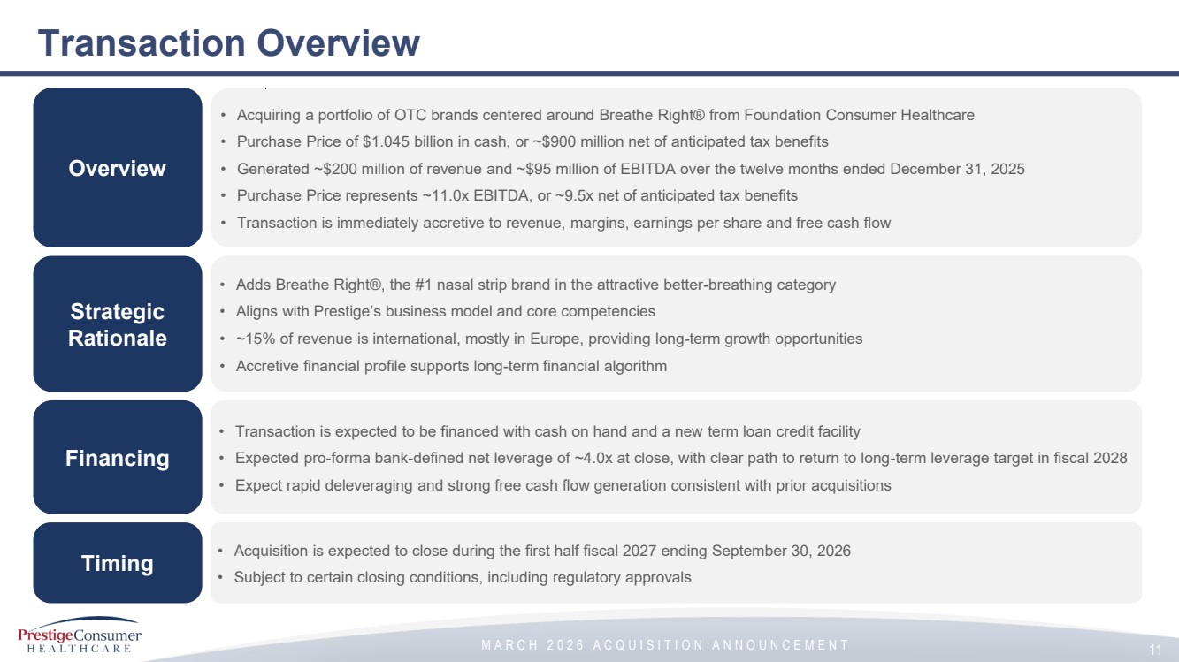 | M A R C H 2 0 2 6 A C Q U I S I T I O N A N N O U N C E M E N T • Adds Breathe Right®, the #1 nasal strip brand in the attractive better-breathing category • Aligns with Prestige’s business model and core competencies • ~15% of revenue is international, mostly in Europe, providing long-term growth opportunities • Accretive financial profile supports long-term financial algorithm • Transaction is expected to be financed with cash on hand and a new term loan credit facility • Expected pro-forma bank-defined net leverage of ~4.0x at close, with clear path to return to long-term leverage target in fiscal 2028 • Expect rapid deleveraging and strong free cash flow generation consistent with prior acquisitions • Acquisition is expected to close during the first half fiscal 2027 ending September 30, 2026 • Subject to certain closing conditions, including regulatory approvals • Acquiring a portfolio of OTC brands centered around Breathe Right® from Foundation Consumer Healthcare • Purchase Price of $1.045 billion in cash, or ~$900 million net of anticipated tax benefits • Generated ~$200 million of revenue and ~$95 million of EBITDA over the twelve months ended December 31, 2025 • Purchase Price represents ~11.0x EBITDA, or ~9.5x net of anticipated tax benefits • Transaction is immediately accretive to revenue, margins, earnings per share and free cash flow Transaction Overview Overview Strategic Rationale Financing Timing 11
 | 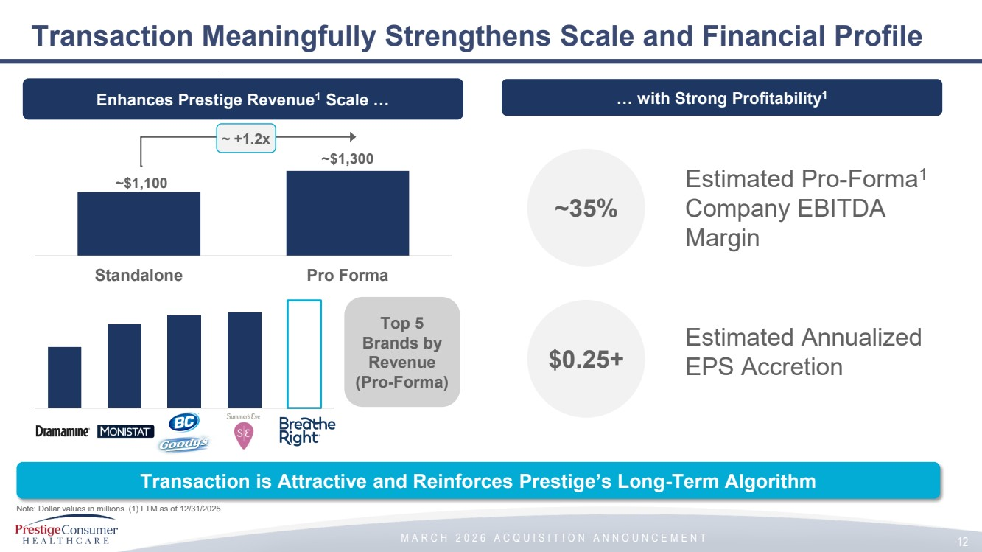 | M A R C H 2 0 2 6 A C Q U I S I T I O N A N N O U N C E M E N T Transaction Meaningfully Strengthens Scale and Financial Profile 12 Note: Dollar values in millions. (1) LTM as of 12/31/2025. Enhances Prestige Revenue1 Scale … ~$1,100 ~$1,300 Standalone Pro Forma Transaction is Attractive and Reinforces Prestige’s Long-Term Algorithm ~ +1.2x … with Strong Profitability1 Top 5 Brands by Revenue (Pro-Forma) ~35% $0.25+ Estimated Pro-Forma1 Company EBITDA Margin Estimated Annualized EPS Accretion
 | 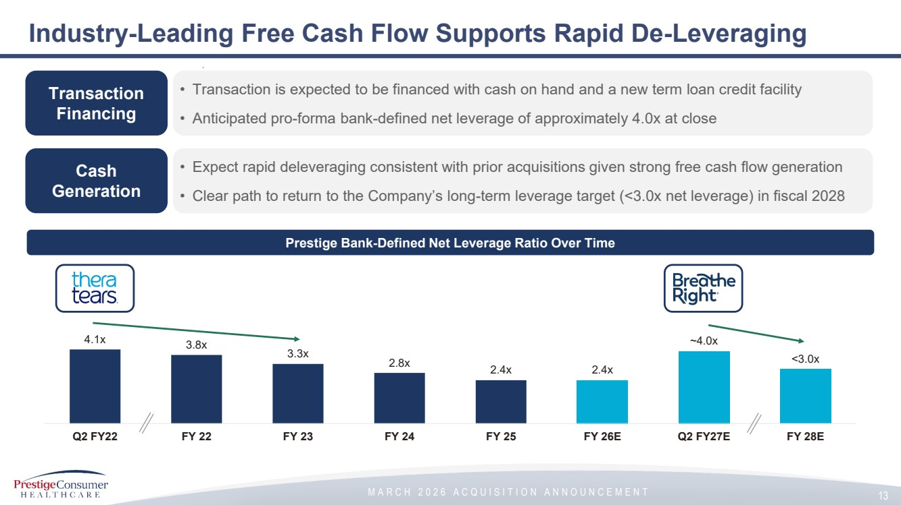 | M A R C H 2 0 2 6 A C Q U I S I T I O N A N N O U N C E M E N T 4.1x 3.8x 3.3x 2.8x 2.4x 2.4x ~4.0x <3.0x Q2 FY22 FY 22 FY 23 FY 24 FY 25 FY 26E Q2 FY27E FY 28E Industry-Leading Free Cash Flow Supports Rapid De-Leveraging Transaction Financing Cash Generation • Transaction is expected to be financed with cash on hand and a new term loan credit facility • Anticipated pro-forma bank-defined net leverage of approximately 4.0x at close • Expect rapid deleveraging consistent with prior acquisitions given strong free cash flow generation • Clear path to return to the Company’s long-term leverage target (<3.0x net leverage) in fiscal 2028 Prestige Bank-Defined Net Leverage Ratio Over Time 13
 |  | M A R C H 2 0 2 6 A C Q U I S I T I O N A N N O U N C E M E N T IV. The Road Ahead
 | 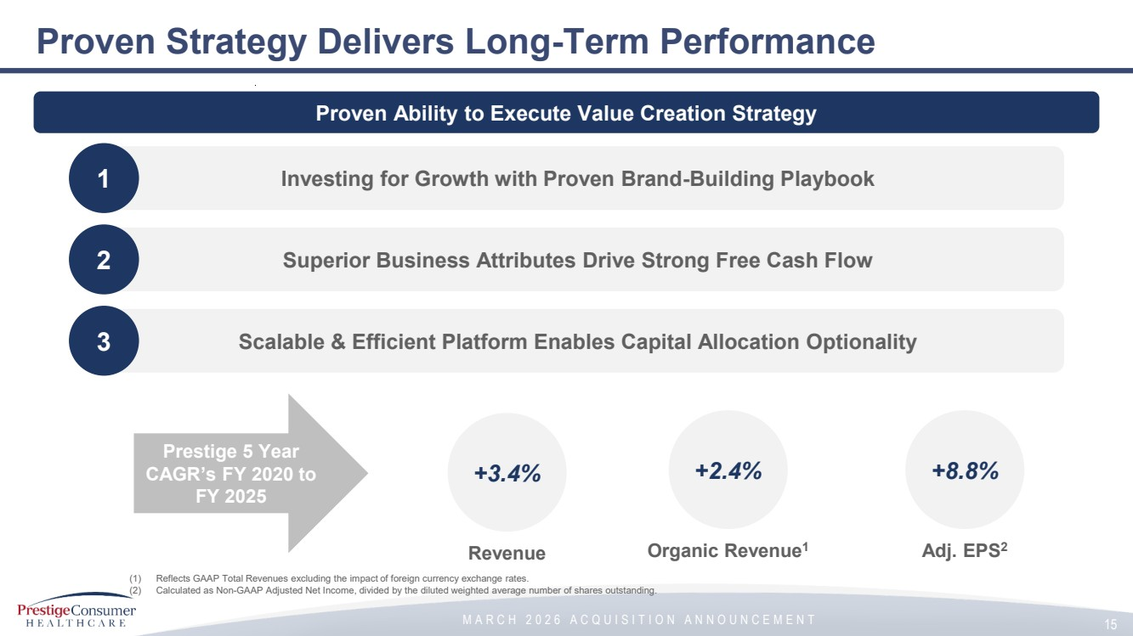 | M A R C H 2 0 2 6 A C Q U I S I T I O N A N N O U N C E M E N T Proven Strategy Delivers Long-Term Performance Proven Ability to Execute Value Creation Strategy 1 Investing for Growth with Proven Brand-Building Playbook 2 Superior Business Attributes Drive Strong Free Cash Flow 3 Scalable & Efficient Platform Enables Capital Allocation Optionality +3.4% +2.4% +8.8% Revenue Organic Revenue1 Adj. EPS2 (1) Reflects GAAP Total Revenues excluding the impact of foreign currency exchange rates. (2) Calculated as Non-GAAP Adjusted Net Income, divided by the diluted weighted average number of shares outstanding. 15 Prestige 5 Year CAGR’s FY 2020 to FY 2025
 | 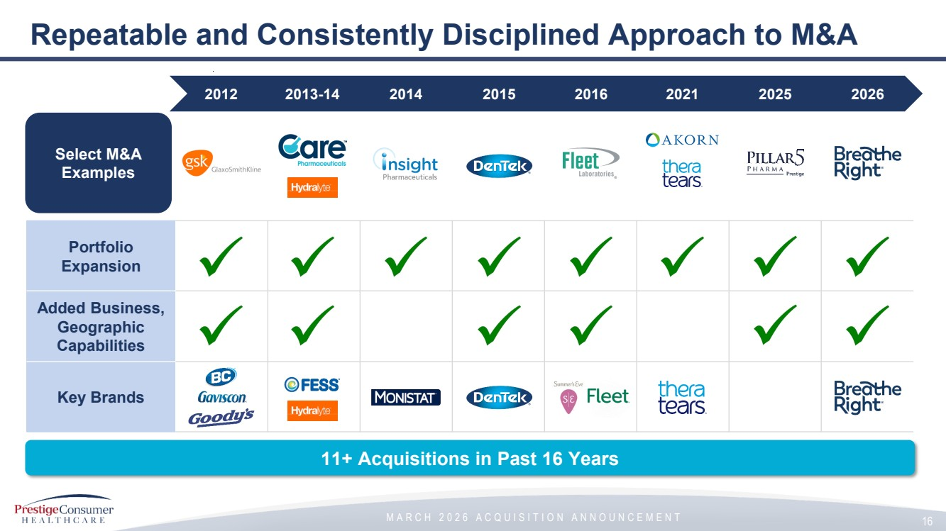 | M A R C H 2 0 2 6 A C Q U I S I T I O N A N N O U N C E M E N T Repeatable and Consistently Disciplined Approach to M&A Portfolio Expansion Added Business, Geographic Capabilities Key Brands Select M&A Examples 2012 2013-14 2014 2015 2016 2021 2025 2026 11+ Acquisitions in Past 16 Years 16
 | 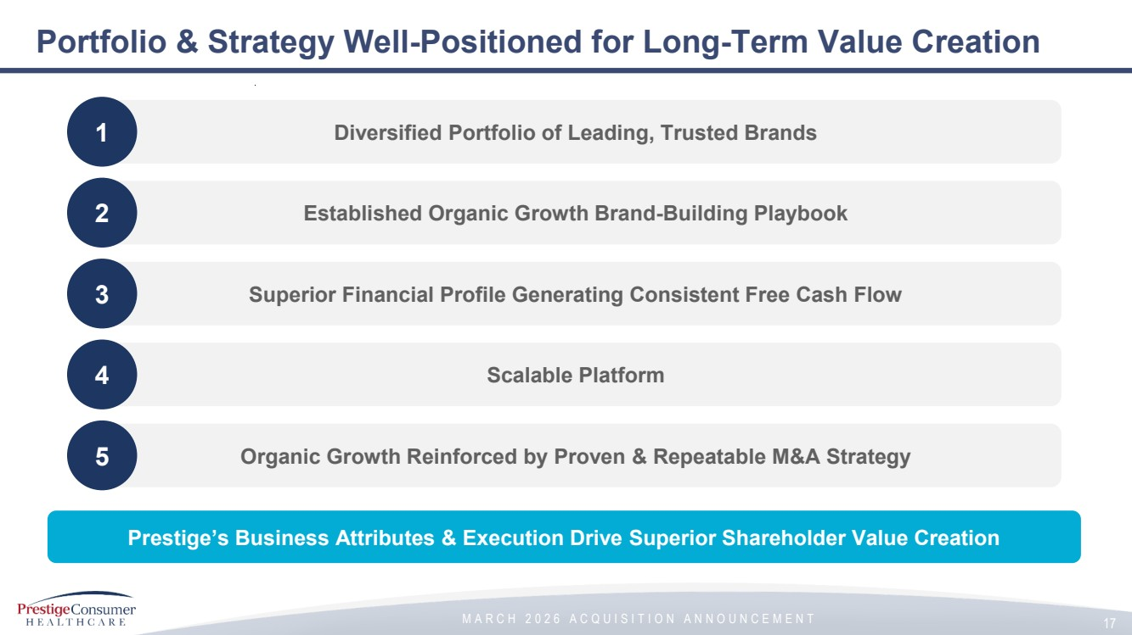 | M A R C H 2 0 2 6 A C Q U I S I T I O N A N N O U N C E M E N T Portfolio & Strategy Well-Positioned for Long-Term Value Creation 1 Diversified Portfolio of Leading, Trusted Brands 2 Established Organic Growth Brand-Building Playbook 3 Superior Financial Profile Generating Consistent Free Cash Flow 4 Scalable Platform 5 Organic Growth Reinforced by Proven & Repeatable M&A Strategy Prestige’s Business Attributes & Execution Drive Superior Shareholder Value Creation 17
 |  | M A R C H 2 0 2 6 A C Q U I S I T I O N A N N O U N C E M E N T Q&A
 | 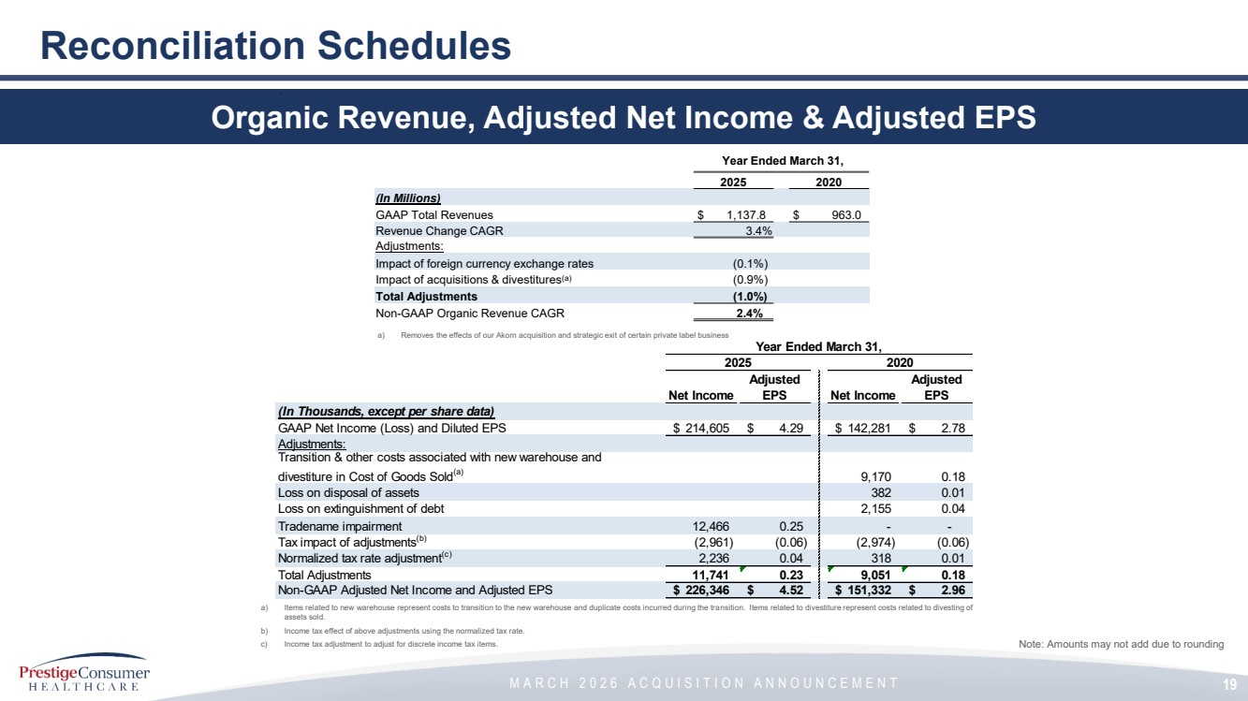 | M A R C H 2 0 2 6 A C Q U I S I T I O N A N N O U N C E M E N T 19 Reconciliation Schedules Organic Revenue, Adjusted Net Income & Adjusted EPS a) Items related to new warehouse represent costs to transition to the new warehouse and duplicate costs incurred during the transition. Items related to divestiture represent costs related to divesting of assets sold. b) Income tax effect of above adjustments using the normalized tax rate. c) Income tax adjustment to adjust for discrete income tax items. Note: Amounts may not add due to rounding Year Ended March 31, 2025 2020 Net Income Adjusted EPS Net Income Adjusted EPS (In Thousands, except per share data) GAAP Net Income (Loss) and Diluted EPS $ 214,605 $ 4.29 $ 142,281 $ 2.78 Adjustments: Transition & other costs associated with new warehouse and divestiture in Cost of Goods Sold(a) 9,170 0.18 Loss on disposal of assets 382 0.01 Loss on extinguishment of debt 2,155 0.04 Tradename impairment 12,466 0.25 - - Tax impact of adjustments(b) (2,961) (0.06) (2,974) (0.06) Normalized tax rate adjustment(c) 2,236 0.04 318 0.01 Total Adjustments 11,741 0.23 9,051 0.18 Non-GAAP Adjusted Net Income and Adjusted EPS $ 226,346 $ 4.52 $ 151,332 $ 2.96 Year Ended March 31, 2025 2020 (In Millions) GAAP Total Revenues $ 1,137.8 $ 963.0 Revenue Change CAGR 3.4% Adjustments: Impact of foreign currency exchange rates (0.1%) Impact of acquisitions & divestitures(a) (0.9%) Total Adjustments (1.0%) Non-GAAP Organic Revenue CAGR 2.4% a) Removes the effects of our Akorn acquisition and strategic exit of certain private label business
 |  | M A R C H 2 0 2 6 A C Q U I S I T I O N A N N O U N C E M E N T

Exhibit 99.2

Prestige Consumer Healthcare Announces Agreement to Acquire Breathe Right®, the Leader in Nasal Strips

 | - | Entered agreement to acquire a portfolio of brands with revenue of $200 million and EBITDA of $95 million

 | - | Breathe Right is an iconic and category-leading brand with strong margins and cash flow generation

 | - | Acquisition reinforces Prestige’s long-term organic growth algorithm

 | - | Transaction expected to close in Prestige’s first half fiscal 2027

TARRYTOWN, N.Y., March 20, 2026 (GLOBE NEWSWIRE) – Prestige Consumer Healthcare Inc. (the “Company” or “Prestige”) (NYSE: PBH) today announced that it has entered into a definitive agreement to acquire the Breathe Right® brand and certain other brands from Foundation Consumer Healthcare for $1.045 billion, or approximately $900 million net of anticipated tax benefits valued at $150 million.

Breathe Right®, created in the 1990s, is an iconic #1 brand synonymous with the nasal strip category and represents expansion into a new category for Prestige. Its drug-free nasal strips serve multiple consumer “better breathing” needs, such as sleep wellness, snoring, athletic performance, allergy relief, congestion relief and more. The brand is widely distributed throughout the United States, where it holds the leading position in the category, and is sold internationally, mainly concentrated in Europe, with further growth opportunity. The acquired portfolio also includes other established brands with loyal consumer followings, such as Dimetapp®, the #1 most trusted children’s cough and cold relief brand by pharmacists.

“Today’s acquisition fits squarely within our disciplined M&A framework and the Breathe Right brand enhances our portfolio over the long-term. With its strong consumer awareness, Breathe Right is a trusted, multi-use consumer health solution in the attractive and growing sleep and better-breathing categories, with solid opportunity for long-term brand building. Similar to our approach with brands like Dramamine® in motion sickness, we’re acquiring a brand that is synonymous with its category, providing a strong foundation for sustained growth,” said Ron Lombardi, Chairman, President, and CEO of Prestige Consumer Healthcare.

“Operationally, the business uses a proven, asset-light model whose distribution channels and supplier relationships align well to our current business. Financially, the acquisition is highly attractive with strong margins, and we anticipate it to be accretive to gross and EBITDA margins as well as to EPS. These attributes are expected to drive incremental free cash flow that will enable rapid deleveraging towards the Company’s long-term leverage target,” he concluded.

Financial Highlights

 | • | Attractive financial profile, with approximately $200 million of revenue and approximately $95 million of EBITDA over the twelve months ended December 31, 2025

 | • | Breathe Right represents approximately two-thirds of the acquired portfolio’s revenue and profitability and will be the largest brand in Prestige’s portfolio

 | • | Remaining portfolio is highlighted by Dimetapp® and Anbesol®, two long-standing brands in the children’s cold relief and oral pain relief categories, respectively

 | • | Reinforces Prestige’s long-term organic sales growth target of 2-3%

 | • | Immediately accretive to Prestige’s gross and EBITDA margins

 | • | Attractive valuation of 11.0x EBITDA, or approximately 9.5x EBITDA net of anticipated tax benefits, reflecting the benefit of the $150 million estimated present value of future tax savings

 | • | Expected pro-forma bank-defined net leverage of approximately 4.0x at closing, and a clear path to return to below 3.0x net leverage (the Company’s long-term leverage target) in fiscal 2028 driven by strong free cash flow generation

Transaction Details

The Company plans to finance the acquisition with cash on hand and a new Term Loan credit facility. The transaction is expected to close during the first half fiscal 2027, subject to certain closing conditions, including clearance under the Hart-Scott Rodino Antitrust Improvements Act of 1976.

Conference Call

Management will hold a webcast to discuss the acquisition today March 20 at 8:30 a.m. ET. To participate in the conference call via phone, participants may register for the call https://register-conf.media-server.com/register/BI71764f2c050644d683803751ec7960c4 to receive dial-in details and a unique pin. The webcast can be accessed at www.prestigeconsumerhealthcare.com. A slide presentation will accompany the call and can be accessed from the Investors section of the Company’s website, www.prestigeconsumerhealthcare.com.

Non-GAAP and Other Financial Information

In addition to financial information reported in accordance with generally accepted accounting principles (GAAP), this press release presents acquisition EBITDA which is a non-GAAP financial measure and represents earnings before interest, taxes, depreciation and amortization, as adjusted. Management believes the presentation of EBITDA provides useful additional information to investors about scale of operations in relation to Prestige. Net leverage ratio reflects net debt / covenant-defined EBITDA.

Note Regarding Forward-Looking Statements

This news release contains "forward-looking statements" within the meaning of the federal securities laws that are intended to qualify for the Safe Harbor from liability established by the Private Securities Litigation Reform Act of 1995. "Forward-looking statements" generally can be identified by the use of forward-looking terminology such as "outlook," “anticipate,” "may," "will," "would," “believe,” "expect," “opportunity,” "enable,” or "continue" (or the negative or other derivatives of each of these terms) or similar terminology. The "forward-looking statements" include, without limitation, statements regarding the timing of the closing of the acquisition; the tax benefits from the acquisition; the Company’s ability to expand the acquired brand portfolio and create growth; the impact of the acquisition on the Company’s gross margin, EBITDA margin, free cash flow, organic sales growth, and net leverage; and the Company’s ability to rapidly delever. These statements are based on management's estimates and assumptions with respect to future events and financial performance and are believed to be reasonable, though are inherently uncertain and difficult to predict. Actual results could differ materially from those expected as a result of a variety of factors, including the impact of business, financial market and economic conditions, including as a result of interest rates, market volatility, evolving U.S. and international tariffs and trade actions, inflation and geopolitical instability, consumer trends, the impact of the Company’s advertising and marketing and new product development initiatives, customer inventory management initiatives, fluctuating foreign exchange rates, competitive pressures, the ability to meet the acquisition’s closing conditions, and the ability of the Company’s manufacturing operations and third party manufacturers and logistics providers and suppliers to meet demand for its products and to avoid inflationary cost increases and disruption. A discussion of other factors that could cause results to vary is included in the Company's Annual Report on Form 10-K for the year ended March 31, 2025 and other periodic reports filed with the Securities and Exchange Commission.

Advisors

Citi is acting as exclusive advisor to Prestige on the transaction and Alston & Bird is acting as legal advisor. Canaccord Genuity LLC is acting as exclusive financial advisor to Foundation Consumer Healthcare on the transaction and Skadden, Arps, Slate, Meagher & Flom is acting as legal advisor.

About Prestige Consumer Healthcare Inc.

Prestige Consumer Healthcare is a leading consumer healthcare products company with sales throughout the U.S. and Canada, Australia, and in certain other international markets. The Company’s diverse portfolio of brands include Monistat® and Summer’s Eve® women's health products, BC® and Goody's® pain relievers, Clear Eyes® and TheraTears® eye care products, DenTek® specialty oral care products, Dramamine® motion sickness treatments, Fleet® enemas and glycerin suppositories, Chloraseptic® and Luden's® sore throat treatments and drops, Compound W® wart treatments, Little Remedies® pediatric over-the-counter products, Boudreaux’s Butt Paste® diaper rash ointments, Nix® lice treatment, Debrox® earwax remover, Gaviscon® antacid in Canada, and Hydralyte® rehydration products and the Fess® line of nasal and sinus care products in Australia. Visit the Company's website at www.prestigeconsumerhealthcare.com.

Investor Relations Contact

Phil Terpolilli, CFA, 914-524-6819
irinquiries@prestigebrands.com

Source: Prestige Consumer Healthcare Inc.

