UNITED STATES
SECURITIES AND EXCHANGE COMMISSION
Washington, D.C. 20549
SCHEDULE 14A
(Rule 14a-101)
INFORMATION REQUIRED IN PROXY STATEMENT
SCHEDULE 14A INFORMATION
Proxy Statement Pursuant to Section 14(a) of the
Securities Exchange Act of 1934 (Amendment No.)
Filed by the Registrant ☒
Filed by a Party other than the Registrant ☐
Check the appropriate box:
☐ | Preliminary Proxy Statement
☐ | Confidential, For Use of the Commission Only (as permitted by Rule 14a-6(e)(2))
☒ | Definitive Proxy Statement
☐ | Definitive Additional Materials
☐ | Soliciting Material Under §240.14a-12
Prestige Consumer Healthcare Inc.
(Name of Registrant as Specified in Its Charter)
(Name of Person(s) Filing Proxy Statement, if Other Than the Registrant)
Payment of Filing Fee (Check all boxes that apply):
☒ | No fee required.
☐ | Fee paid previously with preliminary materials.
☐ | Fee computed on table in exhibit required by Item 25(b) per Exchange Act Rules 14a-6(i)(1) and 0-11.




Prestige Consumer Healthcare Inc. | 2026 Proxy Statement |  | 1

MESSAGE FROM OUR CHAIR
AND CEO


Fiscal 2026 showcased both the resilience of our three-pillar strategy and our
commitment to building long-term shareholder value even against a challenging
backdrop. Executing our strategy is an entire organization that continues to
operate at the highest level of excellence thanks to our guiding principles of
Leadership, Trust, Change, and Execution.
Ronald M. Lombardi
President, Chief Executive Officer and Chair of the Board
Dear Stockholder:
Fiscal 2026 was a defining year for Prestige Consumer Healthcare - one that showcased both the resilience of our three-pillar
strategy and our commitment to building long-term shareholder value. Against a backdrop of macroeconomic volatility,
geopolitical uncertainty, and supply chain disruptions in our eye care business, we remained steadfast in our strategic
priorities. We invested behind our brands, grew free cash flow, and executed the most significant capital deployment in our
company’s history with the acquisition of Breathe Right® - a transaction that will meaningfully expand our platform and
accelerate our growth trajectory.
These accomplishments reflect the discipline and consistency of our operating model, which is anchored by three core
strategic priorities: leading brand-building, maintaining a strong financial profile, and disciplined capital allocation.
We are excited about the ongoing evolution of our business and the ability to continue creating value for you, our
shareholders. On behalf of our management team and board of directors, I thank you for your confidence in Prestige and
appreciate your continued support and commitment to the Company.
We look forward to seeing you at the 2026 Annual Meeting of Stockholders.
Sincerely,

Ronald M. Lombardi
President, Chief Executive Officer
and Chair of the Board
2 |  | 2026 Proxy Statement | Prestige Consumer Healthcare Inc.

NOTICE OF ANNUAL MEETING
OF STOCKHOLDERS
To Our Stockholders:
The 2026 Annual Meeting of Stockholders of Prestige Consumer Healthcare Inc. will be held:
 | When  Tuesday, August 4, 2026  10:00 a.m. (Eastern  Daylight Time) |  | Where  At the Company’s offices  660 White Plains Road  Tarrytown, New York 10591 |  | Who  Only stockholders of record at the close of  business on June 10, 2026 will be entitled to  vote at the Annual Meeting.
Items of Business
Proposal |  | Board’s Recommendation | See Page
1 | Elect the six directors nominated by the Board of Directors and named in the accompanying Proxy Statement to  serve until the 2027 Annual Meeting of Stockholders or until their earlier death, removal or resignation | FOR each    director nominee | 14
2 | Conduct an advisory vote to approve the compensation of our named executive officers | FOR   | 40
3 | Ratify the appointment of PricewaterhouseCoopers LLP as the independent registered public accounting firm of  Prestige Consumer Healthcare Inc. for the fiscal year ending March 31, 2027 | FOR | 68
We will also conduct other business as may properly be brought before the 2026 Annual Meeting of Stockholders or any adjournment or postponement
thereof, including proposals to adjourn or postpone the meeting.
Accompanying this Notice of Annual Meeting of Stockholders is a Proxy Statement, related proxy card with a postage paid return envelope, and our
Annual Report for our fiscal year ended March 31, 2026. The Annual Report contains financial and other information that is not incorporated into the
Proxy Statement and is not deemed to be a part of the proxy soliciting material.
How to Vote
Stockholders of Record
Have your proxy card with your 11-digit control number available and follow
the instructions.
 | By Internet  Visit, 24/7, www.proxyvote.com/ and follow the  on-screen instructions or scan the QR code with your smartphone | 
 | By Mail  Complete, date and sign your proxy card and send by mail in the enclosed  postage-paid envelope
 | By Telephone  Call 1-800-690-6903
 | In Person  Attend the Annual Meeting and cast your ballot
The deadline to vote electronically or by telephone is 11:59 p.m. Eastern Daylight Time
on August 3, 2026. If you vote electronically, you do not need to return a proxy card. If
you return your proxy card, it must be received by Vote Processing, c/o Broadridge, 51
Mercedes Way, Edgewood, NY 11717, by 5:00 p.m., Eastern Daylight Time, on
August 3, 2026.
Beneficial Owners
If your shares are held in “street name,” your bank
or brokerage firm forwarded these proxy materials, as
well as a voting instruction card, to you. Please follow
the instructions on the voting instruction card to vote
your shares.
Beneficial owners who hold shares in “street name”
and who wish to vote in person at the Annual Meeting
must bring a power of attorney or legal proxy from their
bank, broker or other nominee.
This Proxy Statement and the proxy card are
first being mailed or given to stockholders
on or about June 29, 2026.
Prestige Consumer Healthcare Inc. | 2026 Proxy Statement |  | 3

Whether or not you expect to attend the Annual Meeting in person, please promptly complete, sign, date and mail the enclosed proxy
card, or vote by the internet or telephone according to the instructions on your proxy card. A self-addressed postage paid return
envelope is enclosed for your convenience. No postage is required if mailed in the United States. If you do attend the Annual Meeting,
you may withdraw your proxy should you wish to vote in person. You may revoke your proxy by following the instructions on page 77
of the proxy statement.
If you own shares in a brokerage account, your bank or brokerage firm forwarded these proxy materials, as well as a voting instruction card, to
you. Please follow the instructions on the voting instruction card to vote your shares. Your broker cannot vote your shares for proposals
regarding the election of our directors and approval of the compensation of our named executive officers unless you provide voting instructions
to your broker. Therefore, it is very important that you exercise your right as a stockholder and vote on all proposals.
4 |  | 2026 Proxy Statement | Prestige Consumer Healthcare Inc.

TABLE OF CONTENTS
 |  | Company Highlights |  | 6
 |  | About Us |  | 6
 |  | Strategy |  | 6
 |  | Performance Highlights |  | 7
 |  | Corporate Responsibility |  | 8
 |  | Proxy Summary |  | 10
 |  | Voting Matters |  | 10
 |  | Election of Directors |  | 10
 |  | 2026 Executive Compensation Overview |  | 12
 |  | Board and Governance Matters |  | 14
 |  |  | Proposal 1: Election of Directors | 14
 |  | Board Skills and Qualifications |  | 15
 |  | Director Biographies |  | 17
 |  | Director Independence |  | 21
 |  | Conditional Resignation Policy |  | 21
 |  | Director Nomination Process |  | 22
 |  | Our Governance |  | 24
 |  | Corporate Governance Highlights |  | 24
 |  | Board Leadership Structure and Composition |  | 25
 |  | The Board’s Role and Responsibilities |  | 30
 |  | Risk Oversight and Risk Management |  | 31
 |  | Director Engagement |  | 33
 |  | Other Governance Policies and Practices |  | 35
 |  | Director Compensation |  | 36
 |  | Overview |  | 36
 |  | Director Compensation in 2026 |  | 37
 |  | Our Executive Officers |  | 38
 |  | Executive Compensation |  | 40
 |  |  | Proposal 2: Advisory Vote to Approve Named  Executive Officer Compensation | 40
 |  | Compensation Discussion and Analysis |  | 41
 |  | Compensation and Talent Committee Report |  | 57
 |  | Executive Compensation Tables |  | 58
 |  | CEO Pay Ratio |  | 64
 |  | Pay Versus Performance |  | 65
 |  | Audit Matters |  | 68
 |  |  | Proposal 3: Ratification of Appointment of the  Independent Registered Public Accounting Firm | 68
 |  | Selection and Engagement of Auditors |  | 69
 |  | Audit and Non-Audit Fees |  | 69
 |  | Pre-Approval of Audit and Non-Audit Services |  | 69
 |  | Report of the Audit and Finance Committee |  | 70
 |  | Security Ownership Information |  | 72
 |  | Securities Ownership of Certain Beneficial Owners  and Management |  | 72
 |  | Equity Compensation Plan Information |  | 74
 |  | Information About the Annual Meeting |  | 75
 |  | General Information |  | 75
 |  | Voting Matters |  | 76
 |  | Other Matters |  | 79
 |  | Certain Relationships and Related Transactions |  | 79
 |  | Submission of Stockholder Proposals and  Director Nominations |  | 80
 |  | Form 10-K |  | 80
 |  | Appendix A |  | 82
 |  | About Non-GAAP Financial Measures |  | 82
Prestige Consumer Healthcare Inc. | 2026 Proxy Statement |  | 5
IMPORTANT NOTICE REGARDING THE AVAILABILITY OF PROXY MATERIALS FOR THE
STOCKHOLDERS MEETING TO BE HELD ON AUGUST 4, 2026:
This Proxy Statement, the Proxy Card and the 2026 Annual Report to Stockholders are available at the “Investors” tab
of www.prestigeconsumerhealthcare.com, our internet website.
You can submit a request for a copy of the proxy statement, annual report and form of proxy for any future stockholder
meetings (including the meeting of stockholders to be held on August 4, 2026) to 1-800-831-7105, (Attention: Investor
Relations), proxy@prestigebrands.com or the “contact us” tab at www.prestigeconsumerhealthcare.com.
You can also contact us at the phone number, e-mail address and website set forth above to request directions to the
location of the Annual Meeting of Stockholders so that you may attend the meeting and vote in person.
Forward-Looking Statements:
This Proxy Statement contains “forward-looking statements” within the meaning of the federal securities laws.
"Forward-looking statements" generally can be identified by the use of forward-looking terminology such as “focus,”
“committed,” “growing,” “goal,” "may," "will," "would," “plan,” or "continue" (or the negative or other derivatives of each
of these terms) or similar terminology. The "forward-looking statements" include, without limitation, statements
regarding the impact of the Breathe Right® acquisition; the Company's future operating results including revenues,
organic growth, adjusted diluted earnings per share, and free cash flow; the strength of the Company’s financial profile,
improvements in eye care supply from the acquisition of our key supplier; the timing of the closing of acquisitions; the
Company’s focus on environmental sustainability, social responsibility, corporate governance and innovation; the
impact of volatile markets on consumer spending; the timing of the Company’s return to historical leverage; and the
Company’s ability to manage and mitigate energy costs; and the Company’s ability to create shareholder value. These
statements are based on management's estimates and assumptions with respect to future events and financial
performance and are believed to be reasonable, though are inherently uncertain and difficult to predict. Actual results
could differ materially from those expected as a result of a variety of factors, including the impact of business and
economic conditions, including as a result of evolving U.S. and international tariffs and trade actions, labor shortages,
inflation and geopolitical instability, consumer trends, the impact of the Company’s advertising and marketing and new
product development initiatives, customer inventory management initiatives, fluctuating foreign exchange rates,
competitive pressures, and the ability of the Company’s manufacturing operations and third party manufacturers and
logistics providers and suppliers to meet demand for its products and to avoid inflationary cost increases and
disruption. A discussion of factors that could cause results to vary is included in the Company’s Annual Report on Form
10-K for the fiscal year ended March 31, 2026 and other periodic reports filed with the SEC.
6 |  | 2026 Proxy Statement | Prestige Consumer Healthcare Inc.

COMPANY HIGHLIGHTS

About Us
Who We Are: Helping Consumers Care for Themselves
Prestige Consumer Healthcare Inc. is a New York Stock Exchange (“NYSE”) company that develops, manufactures, markets,
sells, and distributes consumer health and personal care products in the United States, Canada, Australia, and certain other
international markets. Headquartered in Tarrytown, New York, and operating with approximately 890 employees out of sites
across the United States, Canada, Australia, Asia, and the United Kingdom, our portfolio consists of numerous well-
recognized, brand-name, consumer healthcare products including:
 |  |  |  | 
 |  |  |  | 
 |  |  |  | 
 |  |  |  | 

Strategy
Proven Strategy Delivers Long-Term Performance
 | Proven Ability to Execute Value Creation Strategy
1  Investing for  Growth with Proven  Brand-Building  Playbook |  | 2  Superior Business  Attributes Drive  Strong Free  Cash Flow | 3  Scalable & Efficient  Platform Enables  Capital Allocation  Optionality |  |  | Revenue  +2.9%  5-Yr CAGR
Prestige Consumer Healthcare Inc. | 2026 Proxy Statement |  | 7
Company Highlights

Performance Highlights
Fiscal 2026 demonstrated the resilience of our business model in a challenging consumer backdrop. We achieved strong free
cash flow growth thanks to our business strategy and the unique attributes of our portfolio. Below are just a few of the financial
highlights of fiscal 2026 that tie both directly and indirectly into incentive program compensation.
 | Top Line Trends  •Revenue of $1,089M  •Organic revenue declines due  primarily to supply challenges in  the Eye & Ear Care Category  •Continued growth in the  Gastrointestinal Category | EPS  •Adjusted Diluted EPS of  $4.38, down approximately  3% vs. Adjusted prior year  •Strong financial profile helped  to offset revenue challenges | Free Cash Flow & Allocation  •Free Cash Flow of  approximately $246M  •Enabled fiscal 2027 acquisition  of Breathe Right
Please refer to Appendix A for a reconciliation of non-GAAP organic revenue growth, Adjusted Diluted EPS and Free Cash
Flow to our most directly comparable financial measures presented in accordance with GAAP.
TOTAL REVENUES
(In Millions)
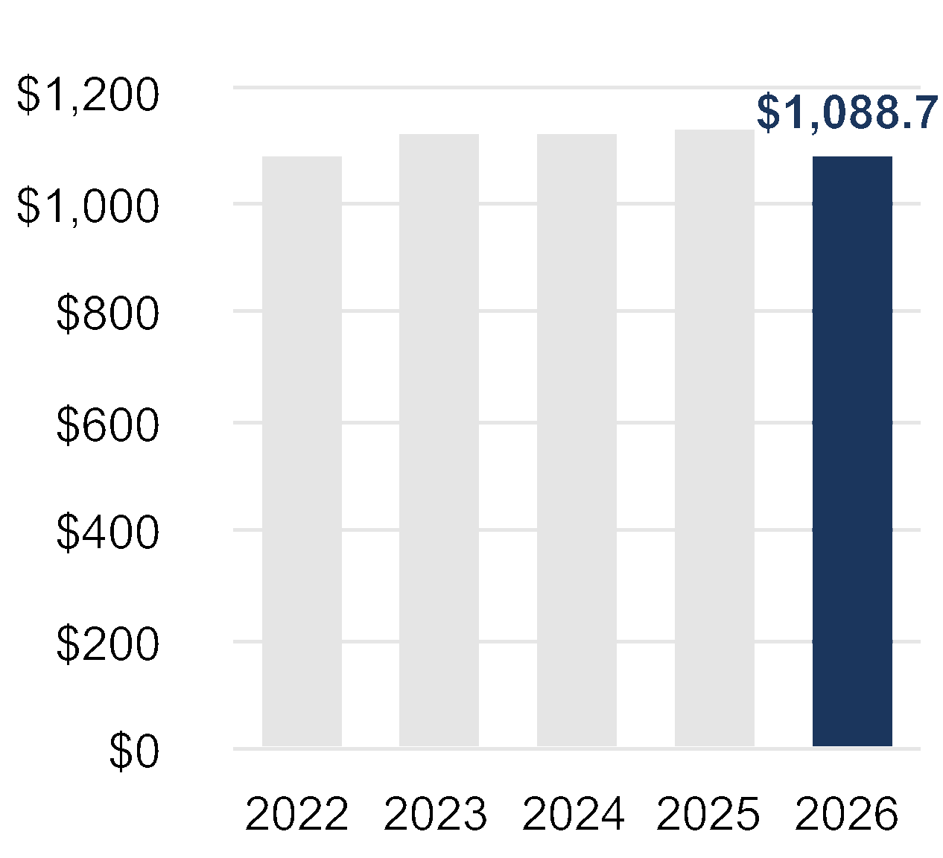
ADJUSTED NET INCOME PER
SHARE-DILUTED*
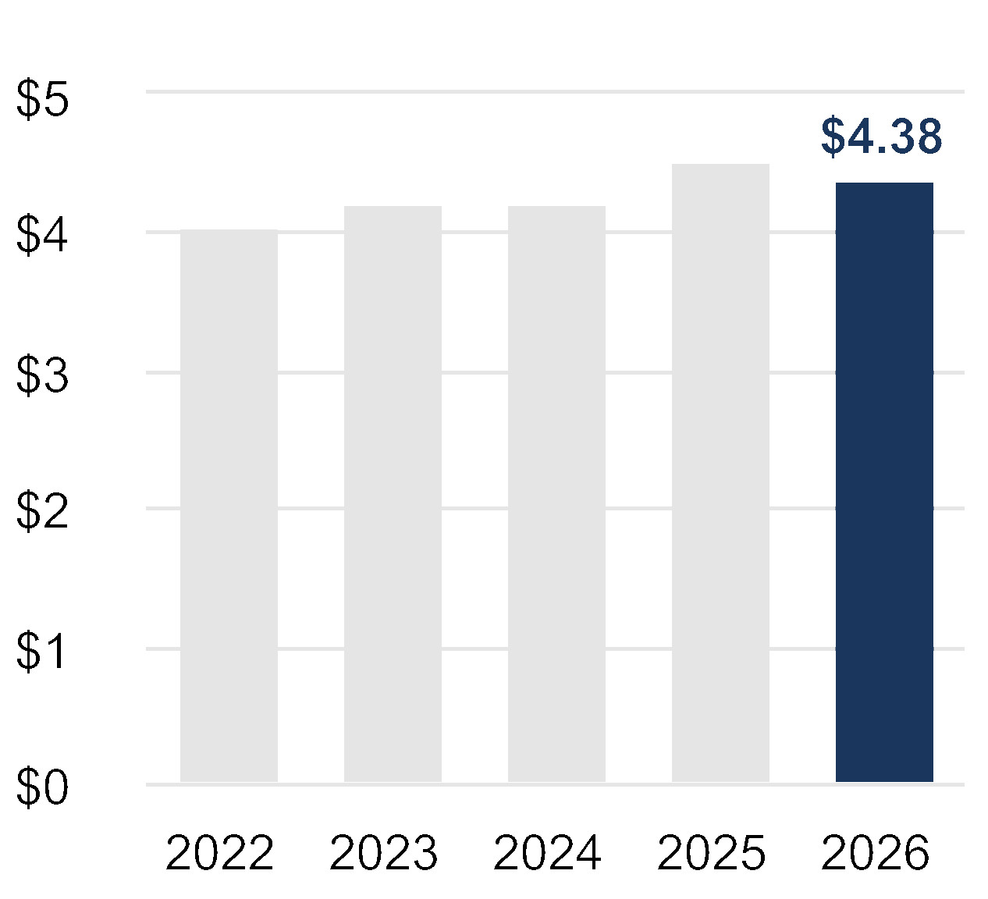
ADJUSTED FREE CASH FLOW**
(In Millions)
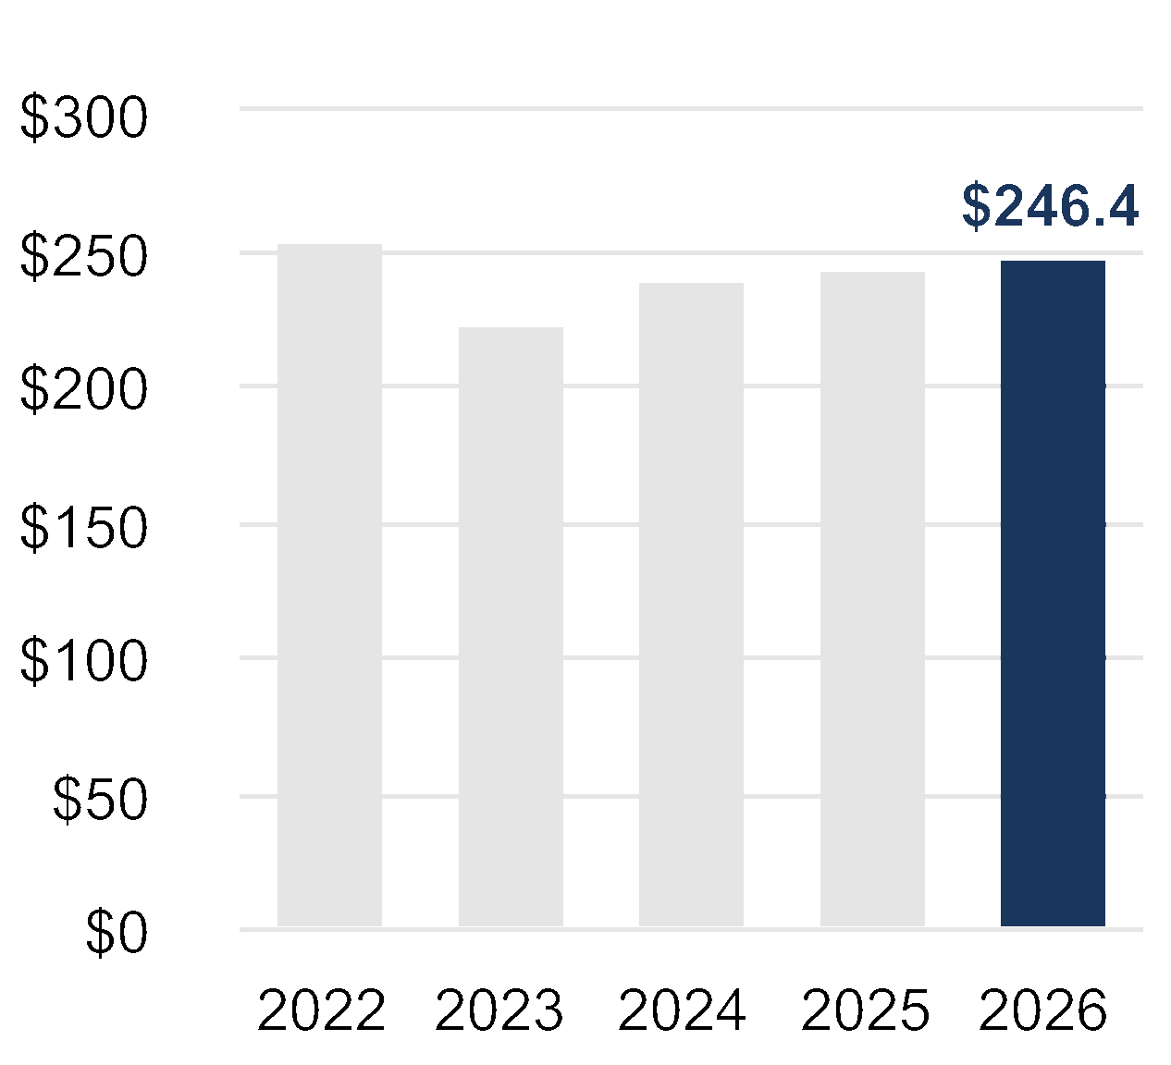
*Adjusted net income per share-diluted is a non-GAAP financial measure and is reconciled to the reported GAAP figure in Appendix A.
**Adjusted free cash flow is a non -GAAP financial measure. Management believes free cash flow is a commonly used measure of liquidity,
indicative of cash available for debt repayment and acquisitions. Adjusted free cash flow is reconciled to GAAP Net Cash provided by
operating activities in Appendix A.
Management believes that these measures provide additional ways to view our operations and a more complete understanding of our
business than could be obtained absent this disclosure, when considered with both our GAAP results and our reconciliation thereto.
8 |  | 2026 Proxy Statement | Prestige Consumer Healthcare Inc.
Company Highlights

Corporate Responsibility
Prestige Consumer Healthcare’s Board of Directors, management and employees all recognize the responsibility that comes
with selling trusted consumer healthcare brands, and the importance of integrating corporate responsibility into our operations
and culture for the benefit of future generations. We are committed to building environmental sustainability, social
responsibility, and effective corporate governance into all aspects of our business. We view this as sound business strategy
that drives resiliency and long-term value creation for the benefit of all stakeholders, including our consumers, customers,
employees, investors, suppliers, regulators and the communities in which we live and operate.
Our 2025 sustainability report is available on our website, https://www.prestigebrands.com/about-us/corporate-responsibility.
Our approach to Corporate Responsibility is based on credible frameworks and standards that create a foundation for
identifying material topics, understanding our risks and opportunities, and informing our strategy.
 |  | Our People  Our people are critical to our Company’s success. We  trust them every day to maintain safety and performance  excellence, uphold integrity in manufacturing and  marketing, and adhere to our Company’s four  guiding principles.
Our Community & Consumers
Prestige’s commitment to responsible corporate
citizenship extends beyond our employees and into
the lives of our communities and consumers.
Our Planet & Partners
In line with our goal to continuously innovate and provide
quality products to our consumers, we aim to assess,
reduce, and report on our environmental impacts.
Prestige Consumer Healthcare Inc. | 2026 Proxy Statement |  | 9
Company Highlights
Our Operations and Supply Chain
We are committed to managing our manufacturing facilities in Virginia, Ontario, Canada and Victoria, Australia, as well as
our over 100 global suppliers, in a responsible manner so that they are aligned with our mission and values. We require
each supplier to embrace and adhere to our Supplier Code of Conduct, which outlines environmental, ethical and social
responsibilities that are aligned with our mission. This code is a standard communication across all suppliers, which allows us
to convey to each our formal expectations around business practices. This serves to actively aid our partners in their ability to
observe our values and standards.
Code of Conduct
We have a strict Code of Conduct and Ethics that fosters a work environment that is free from intimidation, harassment and
violence. Our team employs a process to investigate and resolve any potential conduct or ethics concern that may violate
our Code of Conduct and Ethics. We use a third-party service for employees to report any concern with anonymity and
confidentiality. Raising a concern honestly or participating in an investigation cannot be the basis for any adverse employment
action, including termination, suspension, loss of benefits, threats, harassment or discrimination.
Human Capital Management
Our Company culture is founded on the principles of Leadership, Trust, Change and Execution. Of those principles, Trust is
among the most important — Trust in the safety and performance of our products, the integrity of our manufacturing and
marketing processes, the character of our people, and the benefit to our consumers and society. We also reward employees
who take ownership and embody our principle of Leadership with projects that positively impact our business, community
and stakeholders.
Safety & Health
We are committed to providing a safe work environment for our employees and require employees to share this commitment
by abiding by rigorous safety measures. To enable this and assure that the message of health, safety and well-being are part
of our work culture, we conduct regular training programs at our production facilities. We seek to comply with all U.S. federal,
state and/or local occupational safety and health standards and report our safety records in accordance with the Occupational
Safety and Health Administration (“OSHA”). We also seek to comply with the applicable safety and health standards in all other
countries in which we have employees, including Australia, the United Kingdom and Singapore.
10 |  | 2026 Proxy Statement | Prestige Consumer Healthcare Inc.

PROXY SUMMARY

Voting Matters
 | 1 |  | 2 | 3
 | To elect the six directors nominated by the Board of  Directors and named in this Proxy Statement to serve  until the 2027 Annual Meeting of Stockholders or until  their earlier death, removal or resignation |  | To vote on a non-binding  resolution to approve the  compensation of our  named executive officers  as disclosed in our  Proxy Statement | To ratify the appointment of  PricewaterhouseCoopers LLP as  the independent registered public  accounting firm of Prestige  Consumer Healthcare Inc. for the  fiscal year ending March 31, 2027
 | •Ronald M. Lombardi  •John E. Byom  •Celeste A. Clark | •James C. D’Arecca  •John F. Kelly  •Dawn M. Zier

Election of Directors
2026 Board Nominees
Name Age Director Since |  | Primary (or Former) Occupation | Independence | Committee Assignments
 | Ronald M. Lombardi, 62  June 2015 | Chair of the Board, President and Chief  Executive Officer of Prestige Consumer  Healthcare Inc.
 | John E. Byom, 72  January 2006 | (Former) Chief Executive Officer of Classic  Provisions Inc; (former) Chief Financial Officer  of International Multifoods Corporation |  | Audit & Finance,  Compensation & Talent  Management
 | Celeste A. Clark, Ph.D. 73  February 2021 | (Former) Senior Vice President, Global Policy  and External Affairs and Chief Sustainability  Officer of Kellogg Company |  | Compensation & Talent  Management, Nominating &  Corporate Governance (Chair)
 | James C. D’Arecca, 55  August 2023 | Executive Vice President, Chief Financial Officer  of Haemonetics Corporation. |  | Audit & Finance (Chair),  Nominating & Corporate  Governance
 | John F. Kelly, 65  May 2024 | (Former) Vice President, Quality Operations and  Environment, Health & Safety of Pfizer Inc. |  | Compensation & Talent  Management, Nominating &  Corporate Governance
 | Dawn M. Zier, 61  May 2020 | Chair of The Hain Celestial Group, Inc; (former)  President and CEO of Nutrisystem |  | Audit & Finance,  Compensation & Talent  Management (Chair)
Prestige Consumer Healthcare Inc. | 2026 Proxy Statement |  | 11
Proxy Summary
2026 Board Snapshot
Experienced Independent Board with a Range of Skills and Tenure
INDEPENDENCE
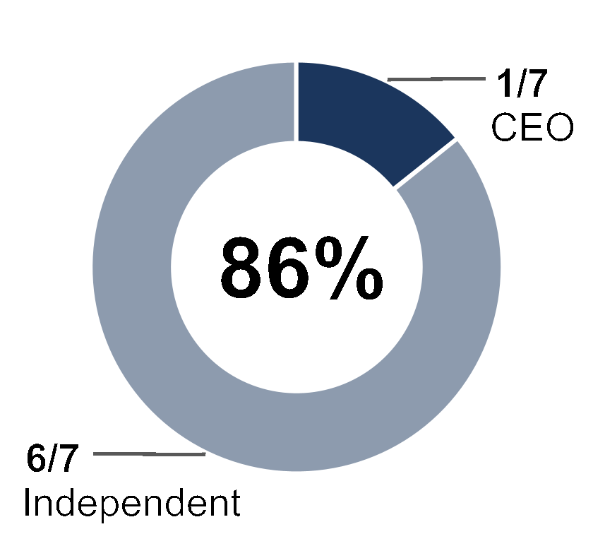
TENURE
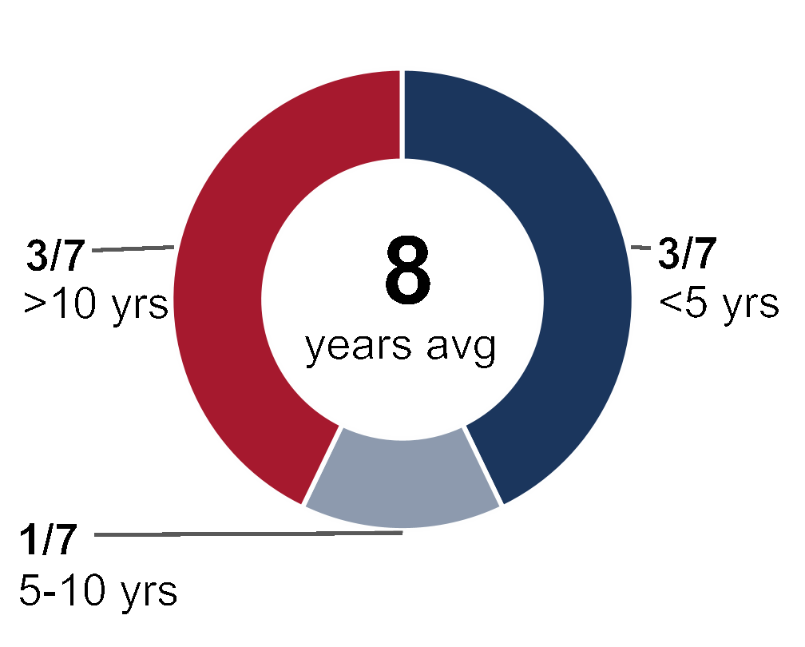
AGE
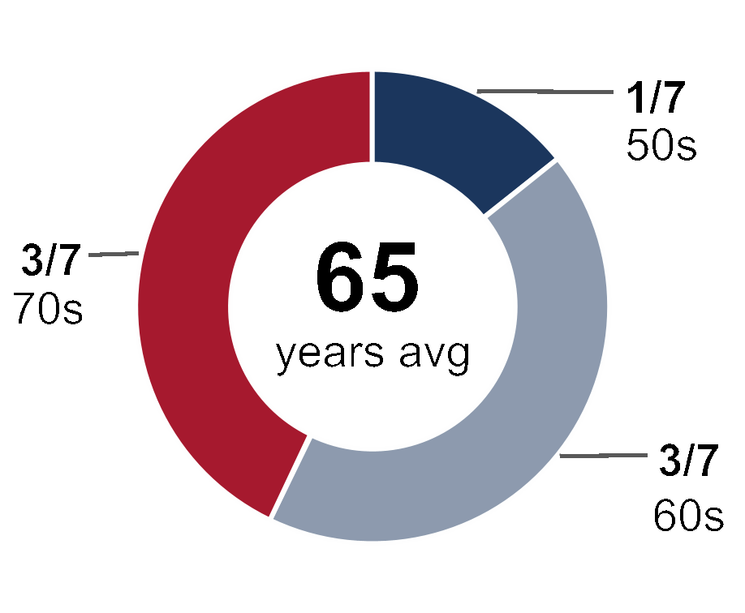
DIVERSITY
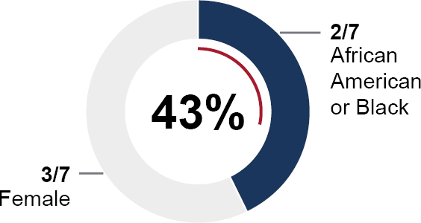
Director Skills
 |  | Some Knowledge | Deep Knowledge
 | Leadership Experience |  | 
 | Finance Experience |  | 
 | Consumer Products Experience |  | 
 | Marketing Experience |  | 
 | Sustainability & Corporate Governance
 | Supply Chain Experience
Corporate Governance Highlights
 | Board Accountability
 | Director Independence
 | Board Leadership
 | Director Engagement
 | Board Diversity
 | Continuous Board Education
Regular Executive Sessions
Board and Committee
Self-Evaluations
No Overboarding
Director Access
and Resources
Stockholder Rights
Regular Review of Key
Governance Documents
Compensation
Best Practices
Robust Code of Conduct
and Ethics
Robust Risk Management
Oversight
12 |  | 2026 Proxy Statement | Prestige Consumer Healthcare Inc.
Proxy Summary

2026 Executive Compensation Overview
We Pay for Performance
We closely link pay and performance through the rigorous goals we set in our incentive programs and the fact that our entire
long-term incentive is delivered in equity, which aligns our management team with our stockholders.
CEO
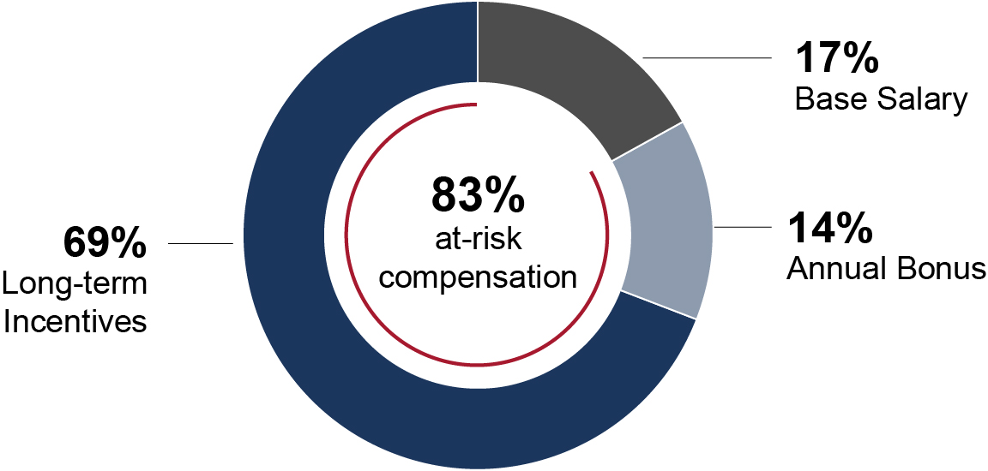
AVERAGE OTHER NEOs
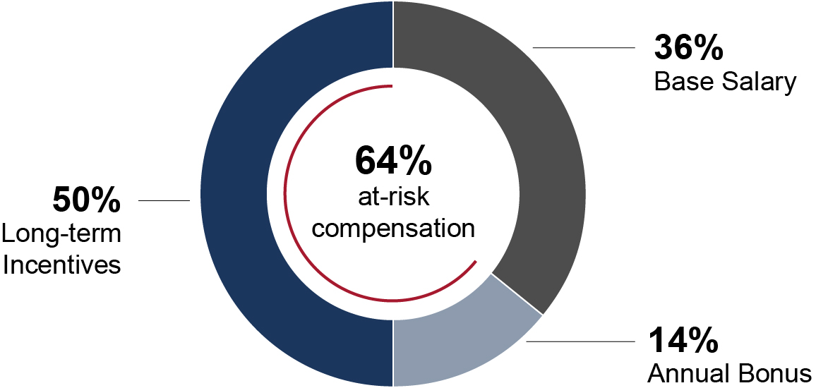
Elements of Compensation
The following table provides additional information regarding the various elements of our 2026 executive
compensation program.
 |  |  | Pay Element | Objective | Purpose of the Pay Element
 |  |  | Base Salary | •Skills, experience, competence,  performance, responsibility, leadership and  contribution to the Company. | •Recognize the level of job scope and  complexity, and the skills, experience,  leadership and sustained performance  required by the executive.
 |  |  | Annual Cash  Incentive (“AIP”) | •Achieving annual target revenue  and profitability. | •Reward the achievement of annual  performance targets.  •Ensures compensation is properly  aligned to financial performance,  including being completely at risk for  failure to meet annual financial  threshold targets.
 |  |  | Long-Term  Incentive Awards  (Performance  Stock Units,  Restricted  Stock Units) | •Achieving long-term revenue growth  and profitability over the three year period.  •Ability to increase and maintain stock price.  •Achievement of adjusted cumulative EBITDA  and cumulative revenue goals.  •Continued employment with the Company  during the three-year vesting period. | •Reward achievement of long-term  financial performance and strategic  corporate initiatives.  •Provide a competitive mix of  incentives to attract and retain top  talent and to further reinforce  alignment between the interests of  management and stockholders.
Prestige Consumer Healthcare Inc. | 2026 Proxy Statement |  | 13
Proxy Summary
Say-on-Pay Vote
At the 2025 Annual Meeting of Stockholders, approximately
97% of the shares represented voted to in favor of the
compensation of the Company’s named executive officers
as discussed and disclosed in our 2025 Proxy Statement.
In considering the results of this advisory vote on executive
compensation, the Compensation and Talent Management
Committee concluded that the compensation paid to our
named executive officers and the Company’s overall
compensation program enjoy strong stockholder support.
We also regularly meet with our largest stockholders and
solicit feedback on a wide range of topics, including
executive compensation.
2025 SAY ON PAY APPROVAL
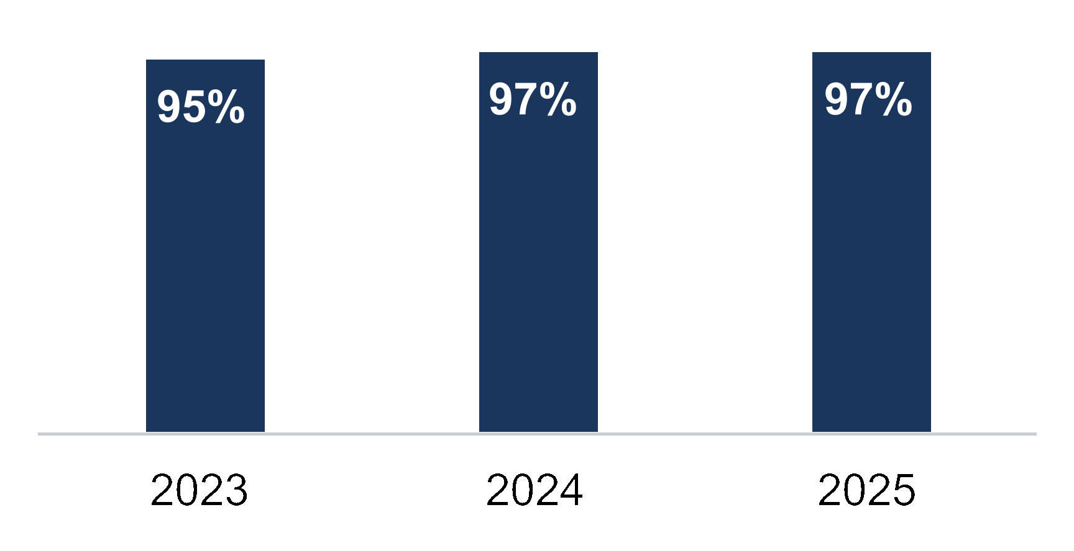
Executive Compensation Best Practices
 |  |  | What We Do |  |  |  |  |  | What We Don’t Do
 |  | Clawback Policy.    Minimum vesting requirements.  Limitation on non-employee  director compensation.  Robust Stock  Ownership Guidelines. |  |  |  |  |  | No evergreen provision in our    equity plan.  No repricing of stock options.  No dividends on  unearned awards.  No excessive perks. |  | No liberal share  recycling provisions.  No single-trigger change of  control vesting.  No gross-ups.  No hedging.
14 |  | 2026 Proxy Statement | Prestige Consumer Healthcare Inc.

BOARD AND GOVERNANCE
MATTERS

PROPOSAL 1:
Election of Directors
How many directors are stockholders being asked to elect and for what term?
The number of directors on the Board of Directors is fixed from time to time by resolution adopted by the affirmative vote
of a majority of the total number of directors then in office. Currently, the Board of Directors is fixed at seven directors. In
connection with the 2026 Annual Meeting of Stockholders, Sheila A. Hopkins has elected to retire from the Board of
Directors and will not stand for reelection. The Board wishes to express its deep appreciation for her nearly eleven years
of service and her significant contributions to the Company. Following the Annual Meeting, the Board will be reduced
from seven to six directors. If elected, each of the six nominees would hold office until the 2027 Annual Meeting of
Stockholders and until his or her respective successor is elected and qualified or until his or her earlier death, removal
or resignation.
What if a nominee is unable to stand for election?
If a nominee is unable to stand for election, the Board may either reduce the number of directors to be elected or select
a substitute nominee. If a substitute nominee is selected, the proxy holders will vote your shares for the substitute
nominee, unless you have voted “Withhold” with respect to the original nominee.
How many votes are needed to elect directors?
A plurality of the votes of shares present, in person or represented by proxy, at the Annual Meeting and entitled to vote in
the election of directors is necessary for the election of directors. This means that the six director nominees with the
most votes will be elected. You may vote in favor of all nominees, withhold your vote as to all nominees, or withhold your
vote as to specific nominees.
What Does the Board of Directors Recommend?
 | The Board Recommends You Vote FOR the Election of the Nominees for Director Named Above.
Prestige Consumer Healthcare Inc. | 2026 Proxy Statement |  | 15
Board and Governance Matters

Board Skills and Qualifications
We believe that our directors should possess the highest personal and professional ethics, integrity and values and be
committed to representing the interests of the stockholders. They must also have an inquisitive and objective perspective,
practical wisdom, mature judgment and demonstrated leadership skills. We also endeavor to have a Board of Directors
representing a range of experiences in areas that are relevant to the Company’s business activities. Below we identify and
describe the key experience, qualifications and skills our directors bring to the Board that are important considering the
Company’s business and structure. The directors’ experiences, qualifications and skills that the Nominating and Corporate
Governance Committee considered in their nominations are included in their individual biographies.
 |  | Leadership Experience  We believe that directors with experience in significant leadership positions over an extended period, especially  chief executive officer positions, chief financial officers and other senior executives, provide the Company with  valuable insights and strategic thinking. These individuals generally possess extraordinary leadership qualities  and the ability to identify and develop those qualities in others. They demonstrate a practical understanding of  organizations, processes, strategy, risk management and the methods to drive change and growth.
 |  | Finance Experience  We believe that an understanding of finance and the financial reporting process is important for our directors.  We measure our operating and strategic performance by reference to financial targets. In addition, accurate  financial reporting and robust auditing are critical to our success and developing stockholders’ confidence in our  reporting processes under the Sarbanes-Oxley Act of 2002. We expect all of our directors to be  financially literate.
 |  | Consumer Products Experience  The Company is a marketer and distributor of brand name personal healthcare products throughout the  U.S. and Canada, Australia, and in certain other international markets. We seek directors who possess  demonstrated executive experience in the management, marketing, and commercial development of  consumer products businesses, including familiarity with omnichannel retail environments and international  market distribution.
 |  | Marketing Experience  The Company pursues a strategy of organic growth by identifying and executing on opportunities to expand the  distribution and commercial reach of its product portfolio through omnichannel marketing strategies —  encompassing digital, social media, and ecommerce platforms — while also identifying and commercializing  new product opportunities. We seek directors who possess demonstrated expertise in brand-led marketing  strategy, digital marketing performance, and ecommerce growth and scalability.
 |  | Sustainability & Corporate Governance  As a global corporate citizen, we believe that sustainable operations are both financially and operationally  beneficial to our business, and critical to the health of our employees and the communities in which we operate.  We seek directors with experience in building strong environmental, labor, health & safety, corporate  governance and ethical practices.
 |  | Supply Chain Experience  The Company relies on both third party manufacturers and its own manufacturing facilities to fulfill its  manufacturing needs. As a result, we seek directors with experience in supply chain management, quality and  compliance with the various regulations that govern the manufacturing, packaging, labeling, distribution, and  importation of our products.
16 |  | 2026 Proxy Statement | Prestige Consumer Healthcare Inc.
Board and Governance Matters
Director Skills Matrix
We endeavor to have a Board of Directors representing a range of experiences in areas that are relevant to the Company’s
business activities. Below we identify and describe the key experience, qualifications and skills our directors bring to the Board
that are important considering the Company’s business and structure.
 |  |  |  |  |  |  |  |  | Total Experience
 |  |  |  |  |  |  |  |  | Some  Knowledge | Deep  Knowledge
 | Leadership Experience |  |  |  |  |  |  |  |  | 
 | Finance Experience |  |  |  |  |  |  |  |  | 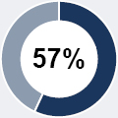
 | Consumer Products Experience |  |  |  |  |  |  |  |  | 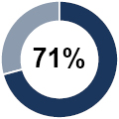
 | Marketing Experience |  |  |  |  |  |  |  |  | 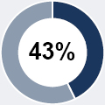
 | Sustainability & Corporate Governance |  |  |  |  |  |  |  |  | 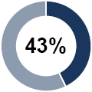
 | Supply Chain Experience
 | Deep Knowledge or Experience |  | Some Knowledge or Experience
Experienced Board Attributes
Below is a snapshot of our current Board.
INDEPENDENCE
TENURE
AGE
DIVERSITY
Creating an Experienced Board with Diversity of Tenure
We believe that having directors with differing tenures is important to provide both fresh perspectives and deep experience and
knowledge of the Company. Our longer-tenured directors have significant institutional knowledge and deep understanding of
the Company’s business, which enhances the Board’s oversight of strategy and risk. The Board believes that a mix of these
longer-tenured directors and shorter-tenured directors with fresh perspectives ensures an appropriate balance of views and
insights and allows the Board as a whole to benefit.
Family Relationships
There are no family relationships between or among any of our directors and executive officers.
Prestige Consumer Healthcare Inc. | 2026 Proxy Statement |  | 17
Board and Governance Matters

Director Biographies
 |  |  |  |  | John E. Byom  Independent Lead Director |  |  |  |   
 |  |  |  |  | Current Public Company Directorships |  |  | Previous Public Company Directorships
 |  |  |  |  | •None |  |  | •MGP Ingredients Inc.
 | Career Highlights:  •Has served as a director since January 2006  •Was Chief Executive Officer of Classic Provisions Inc., a specialty  foods distribution company, from October 2007 until the business  was sold and he retired in June 2019  •Was previously the Chief Financial Officer of International Multifoods  Corporation. He left International Multifoods Corporation in March  2005 after 26 years, including four years as Vice President Finance  and Chief Financial Officer from March 2000 to June 2004  •Was President of Multifoods Foodservice and Bakery Products from  June 2004 until March 2005 after the sale of International Multifoods  Corporation to The J.M. Smucker Company in June 2004 |  |  |  |  |  | •Was President of U.S. Manufacturing from July 1999 to March  2000, and Vice President Finance and IT for the North American  Foods Division from 1993 to 1999, prior to his time as Chief  Financial Officer and as President of Multifoods Foodservice and  Bakery Products  •Prior to 1993, held various positions in finance and was an  internal auditor for International Multifoods Corporation from  1979 to 1981  Education:  Mr. Byom earned his B.A. in Accounting from Luther College.
 |  |  |  |  | Celeste A. Clark, Ph.D.  Director |  |  |  |  | 
 |  |  |  |  | Current Public Company Directorships |  |  |  |  | Previous Public Company Directorships
 |  |  |  |  | •The Hain Celestial Group, Inc. (Better  For You CPG Products) (Nominating &  Governance Committee Chair)  •Darling Ingredients Inc. (Sustainability  Committee Chair) |  |  |  |  | •Wells Fargo & Company  •Mead Johnson Nutrition Company, Inc.  •Diamond Foods, Inc.  •AdvancePierre Foods Holdings, Inc.  •Omega Protein Corporation, Inc.
 | Career Highlights:  •Has served as a director since February 2021  •Has been the principal of Abraham Clark Consulting, LLC, a  consulting firm, since November 2011 and consults on nutrition and  health policy, regulatory affairs and leadership development  •Has been an adjunct professor in the Department of Food Science  and Human Nutrition at Michigan State University since  January 2012  •Serves as a trustee of the W.K. Kellogg Foundation  •Served as Senior Vice President, Global Policy and External Affairs  of Kellogg Company, a food manufacturing company, and was the  Chief Sustainability Officer until she retired in 2011  •Was a member of the Global Executive Management Team and had  an accomplished career spanning nearly 35 years at Kellogg  Company, in which time she was responsible for the development  and implementation of global health, nutrition and regulatory science  initiatives. In addition, she led global corporate communications,  public affairs, philanthropy and several administrative functions |  |  |  |  |  |  | Recognition & Certifications:  •Recognized as a Director 100 by the National Association of  Corporate Directors in 2023  •Recognized by Savoy Magazine as one of the most influential  black directors in 2023, and by Women’s Inc as one of the most  influential female directors in 2025  •She brings significant industry experience in various nutrition,  consumer products, public policy, risk management, governance  and sustainability matters to the Board.  Education:  Dr. Clark earned her Ph.D. from Michigan State University in Food  Science and in 2021, she was bestowed an honorary Ph.D. in  Humanities.
 |  | Leadership  Experience |  | Finance  Experience |  | Consumer Products  Experience |  | Marketing  Experience |  | Sustainability &  Corporate Governance |  | Supply Chain  Experience
18 |  | 2026 Proxy Statement | Prestige Consumer Healthcare Inc.
Board and Governance Matters

 |  |  |  |  | James C. D’Arecca  Director
 |  |  |  |  | Current Public Company Directorships |  |  | Previous Public Company Directorships
 |  |  |  |  | •None |  |  | •None
 | Career Highlights:  •Has served as a director since August 2023  •Has been Executive Vice President, Chief Financial Officer of  Haemonetics Corporation, a medical technology company, since  April 2022  •Previously served as Chief Financial Officer of TherapeuticsMD, Inc.,  a women’s healthcare company, from June 2020 to April 2022  •Served as the Senior Vice President and Chief Accounting Officer of  Allergen plc (formerly known as Actavis plc), a global pharmaceutical  company, from August 2013 until its merger with AbbVie Inc. in  May 2020, prior to joining TherapeuticsMD, Inc.  •Served as Chief Accounting Officer at Bausch & Lomb prior to  joining Actavis plc |  |  |  |  |  | •Held finance and business development positions of increasing  responsibility at Merck & Co., Inc. and Schering-Plough  Corporation earlier in his career  •Began his career at PricewaterhouseCoopers LLP from 1992 to  2005, where he had an industry focus on pharmaceuticals,  medical devices, and consumer products  Education:  Mr. D’Arecca earned a Bachelor of Science in Accounting from  Rutgers University and a Master of Business Administration from  Columbia University. He is a Certified Public Accountant.
 |  |  |  |  | Sheila A. Hopkins  Director
 |  |  |  |  | Current Public Company Directorships |  |  | Previous Public Company Directorships
 |  |  |  |  | •None |  |  | •Cutera, Inc.  •Warnaco, Inc.
 | Career Highlights:  •Has served as a director since August 2015, retiring as of the 2026  Annual Meeting of Stockholders and will not stand for reelection  •Formerly served as the Interim Chief Executive Officer of Cutera,  Inc., an energy based and aesthetic devices company, from April  2023 to August 2023; Cutera, Inc. filed Chapter 11 Bankruptcy in  March 2025  •Previously served as President, Global Vision Care and Executive  Vice President of Bausch + Lomb, a healthcare company, from  September 2011 until her retirement in August 2013  •Worked at Colgate-Palmolive, a leading consumer products  company, where she held several senior executive positions  including Vice President and General Manager, Personal Care, Vice  President, Global Business Development and Vice President and  General Manager, Professional Oral Care, from September 1997 to  August 2011  •Held significant marketing and sales positions at Procter &  Gamble, American Cyanamid, and Tambrands, prior to joining  Colgate-Palmolive |  |  |  |  |  | •Served on the boards of the Consumer Healthcare Products  Association and the American Dental Association Foundation  Recognition & Certifications:  •Certified in Cyber-Risk Oversight by the NACD - National  Association of Corporate Directors  Education:  Ms. Hopkins earned a B.A. in History from Wellesley College.
 |  | Leadership  Experience |  | Finance  Experience |  | Consumer Products  Experience |  | Marketing  Experience |  | Sustainability &  Corporate Governance |  | Supply Chain  Experience
Prestige Consumer Healthcare Inc. | 2026 Proxy Statement |  | 19
Board and Governance Matters
 |  |  |  |  | John F. Kelly  Director
 |  |  |  |  | Current Public Company Directorships |  |  | Previous Public Company Directorships
 |  |  |  |  | •None |  |  | •None
 | Career Highlights:  •Has served as a director since May 2024  •Is Chair of the Board of Trustees of Wakeman Boys & Girls Club,  and a member of the Worcester Polytechnic Institute Engineering  Dean’s Advisory Board  •Retired in June 2022 after a 40-year career at Pfizer Inc., a  biopharmaceutical company, where he was a member of the Pfizer  Global Supply Leadership Team and a member of the Pfizer PAC  Board of Directors  •Held multiple positions in his career with Pfizer starting in August  1982 and finishing as the Vice President, Quality Operations and  Environment, Health & Safety; At Pfizer, Mr. Kelly’s responsibilities  included pharmaceutical and consumer product operations,  manufacturing strategy, business development, quality and EHS |  |  |  |  |  | •Served as Chair of the Board of Directors of Zydus Cadila  Oncology Private Limited, a 50/50 joint venture between Pfizer  and Zydus Cadila, between March 2019 and June 2022, and prior  to that he was a director of same between December 2015 and  March 2019  •Was a member of the Board of Directors of The Patterson Club,  Fairfield, CT and co-President of the Fairfield College Preparatory  School Father’s Club  Education:  Mr. Kelly earned a degree in Chemical Engineering from Worcester  Polytechnic Institute and an M.B.A. in Operations Management from  Pace University.
 |  |  |  |  | Ronald M. Lombardi  Chair of the Board, CEO and President
 |  |  |  |  | Current Public Company Directorships |  |  | Previous Public Company Directorships
 |  |  |  |  | •ACCO Brands Corporation (Audit  Committee Chair) |  |  | •None
 | Career Highlights:  •Elected Chair of the Board in May 2017 and has served as a director  and as President and Chief Executive Officer of the Company since  June 2015  •Served as Chief Financial Officer of the Company from December  2010 until November 2015  •Employed by Medtech Group Holdings, a components and contract  medical device manufacturer, as Chief Financial Officer, prior to  joining the Company, from October 2010 to December 2010  •Served as the Chief Financial Officer of Waterbury International  Holdings, a specialty chemical and pest control business, from  October 2009 to October 2010  •Employed by Cannondale Sports Group, a sporting goods and  apparel manufacturing company, as Chief Operating Officer from  August 2008 to October 2009 and as Senior Vice President and  Chief Financial Officer from March 2004 to August 2008 |  |  |  |  |  | •Served in various roles at Gerber Scientific Inc., including Vice  President and Chief Financial Officer of Gerber Scientific Inc.’s  Gerber Coburn Optical Division and Director of Financial Planning  and Analysis from 2000 to 2004  •Previously employed by Emerson Electric, Scovill Fasteners, Inc.  and Go/Dan Industries  Education:  Mr. Lombardi earned a B.S. from Springfield College and an M.B.A.  from American International College and has been a licensed CPA.
 |  | Leadership  Experience |  | Finance  Experience |  | Consumer Products  Experience |  | Marketing  Experience |  | Sustainability &  Corporate Governance |  | Supply Chain  Experience
20 |  | 2026 Proxy Statement | Prestige Consumer Healthcare Inc.
Board and Governance Matters
 |  |  |  |  | Dawn M. Zier  Director
 |  |  |  |  | Current Public Company Directorships |  |  | Previous Public Company Directorships
 |  |  |  |  | •The Hain Celestial Group, Inc. (Better  For You CPG Products) (Board Chair) |  |  | •Spirit Airlines, Inc. (Nominating and Governance  Committee Chair)  •Purple Innovation, Inc.  •Tivity Health, Inc.
 | Career Highlights:  •Has served as a director since May 2020  •Has served as a director of privately held Acorns Advisers, LLC  (Acorns) since May 2023  •Has been an Operating Partner with the ExCo Group since 2026  with whom she has served as an executive mentor/advisor to  Fortune 500 leaders since 2020.  •Was formerly the President and CEO and a director of Nutrisystem,  an innovative provider of weight loss programs and digital tools, from  November 2012 until its March 2019 acquisition by Tivity Health,  Inc., a leading provider of fitness and social engagement solutions)  •Joined Tivity Health, serving as President and Chief Operating  Officer and a member of its Board of Directors, to help with the  integration efforts through December 2019 |  |  |  |  |  | •Served in a variety of executive positions at Reader’s Digest  Association (now Trusted Media Brands), a global media and data  marketing company, including President of International from  2011-2012, President of Europe from 2009-2011, President of  Global Consumer Marketing from 2008-2009 and President of  North America Consumer Marketing from 2005-2008, prior to  November 2012  Recognition & Certifications:  •Earned a certificate from MIT, Artificial Intelligence: Implications  for Business Strategy in March 2025  •Recognized as a Director 100 by the National Association of  Corporate Directors in 2022  •Received a Corporate Director Certification from Harvard  Business School in 2020  Education:  Ms. Zier earned an M.B.A. and Master of Science in Engineering  from the Massachusetts Institute of Technology.
 |  | Leadership  Experience |  | Finance  Experience |  | Consumer Products  Experience |  | Marketing  Experience |  | Sustainability &  Corporate Governance |  | Supply Chain  Experience
Prestige Consumer Healthcare Inc. | 2026 Proxy Statement |  | 21
Board and Governance Matters

Director Independence
In accordance with the NYSE’s listing requirements, the Board of Directors has evaluated, for each of the directors, his or
her independence from the Company and its management. In its evaluation, the Board of Directors reviewed whether any
transactions or relationships exist currently, or existed during the past three years, between each director and the Company or
its subsidiaries, affiliates or independent auditors. The Board of Directors also examined whether there were any transactions
or relationships between each director and members of the senior management of the Company or their affiliates. Based on
this review and the NYSE’s definition of “independence,” the Board of Directors has determined that a majority of the Board of
Directors is “independent.” The independent directors currently are Mses. Clark, Hopkins and Zier and Messrs. Byom,
D’Arecca, and Kelly. Based on the NYSE’s listing requirements, the Board of Directors has also determined that each of the
members of our Compensation and Talent Management Committee is “independent”. The Board of Directors has also
determined that each of the members of our Audit and Finance Committee is “independent” for purposes of Rule 10A-3 under
the Securities Exchange Act of 1934, as amended (the “Exchange Act”), and the NYSE’s listing requirements. The Board of
Directors also determined that Ms. Zier, Mr. Byom and Mr. D’Arecca are financially literate as that qualification is interpreted by
the Board and the NYSE and each is an “audit committee financial expert” as that term is defined by Securities and Exchange
Commission (the “SEC”) regulations.

Conditional Resignation Policy
If a director does not receive more votes “for” than “withhold” for his or her election in an uncontested election, then the
director will promptly tender his or her resignation. The Nominating and Corporate Governance Committee, without the
participation of the director who tendered his or her resignation, will then take action to accept or reject the director’s
resignation and submit its recommendation to the full Board of Directors. The full Board of Directors, without the participation
of the director who tendered his or her resignation, will accept or reject the resignation and, if it chooses not to accept the
resignation, will disclose its decision in a Form 8-K or similar filing with the SEC.
22 |  | 2026 Proxy Statement | Prestige Consumer Healthcare Inc.
Board and Governance Matters

Director Nomination Process
Board Refreshment and Director Recruitment Process
The Board is committed to an ongoing refreshment process and continually evaluates the composition of the Board to ensure
that it has a strong balance of skills, experience, perspective and rigorous oversight through independent judgment.
The Nominating and Corporate Governance Committee identifies potential candidates for nomination as directors based on
recommendations by our executive officers or directors, as well as through professional search firms engaged on a retainer
basis. The Nominating and Corporate Governance Committee also considers properly submitted stockholder
recommendations for candidates for the Board of Directors. In evaluating candidates for nomination, the Nominating and
Corporate Governance Committee will consider the factors it believes to be appropriate, which would generally include the
candidate’s personal and professional integrity, business judgment, relevant experience and skills, and potential to be an
effective director in conjunction with the rest of the Board of Directors in collectively serving the interests of our stockholders.
Generally, candidates must have the key experience, qualifications and skills as discussed on page 15 of this
Proxy Statement.
 |  |  |  |  |  |  |  |  |  |  |  |  |  |  | 
 |  | 01 |  |  |  |  | 02 |  |  |  |  | 03
 |  | Board and Nominating and  Corporate Governance  Committee determine desired  criteria, including skills  and experience of  director candidates |  |  |  |  | Director candidates identified  by search firm, Board  members, executive officers  and stockholders |  |  |  |  | Nominating and Corporate  Governance Committee  evaluates candidates of interest  against selection criteria,  individual characteristics  and qualifications
 |  |  |  |  |  |  |  |  |  |  |  |  |  |  | 
 |  | 06 |  |  |  |  | 05 |  |  |  |  | 04
 |  | The Board votes to appoint  director candidate based on  an assessment of his or her  qualifications and potential  contributions to the Board |  |  |  |  | Nominating and Corporate  Governance Committee  discusses each director  candidate, evaluates potential  contributions to the Board as a  whole and recommends the  potential candidate to the Board |  |  |  |  | Nominating and Corporate  Governance Committee Chair,  the Independent Lead Director  and the Chair conduct interviews  and gather information; other  Board members may also meet  with candidates
Diverse and Experienced Board
In evaluating potential candidates for Board membership, the Nominating and Corporate Governance Committee considers
diversity of age, gender, race, and professional experience. The Board seeks the best qualified candidates which bring the mix
of experience that facilitates the strong strategic oversight necessary to support our business and management. As a result,
our Board consists of former public company CEOs, current and former CFOs, marketing experts, supply chain experts, and
governance/communications experts. The Board believes that diversity of experience is important because the various points
of view are reflective of our stakeholders and contribute to a more effective, engaged Board and better decision-making
processes.
Prestige Consumer Healthcare Inc. | 2026 Proxy Statement |  | 23
Board and Governance Matters
Stockholder Recommendations for Nominees
The Nominating and Corporate Governance Committee will consider as potential director nominees any individuals properly
recommended by stockholders. Recommendations concerning individuals proposed for consideration by the Nominating and
Corporate Governance Committee should be addressed to Prestige Consumer Healthcare Inc., 660 White Plains Road,
Tarrytown, New York 10591, Attention: Corporate Secretary. Each recommendation should include a personal biography of the
suggested nominee, an indication of the background or experience that qualifies the person for consideration, and a statement
that the person has agreed to serve if nominated and elected.
Stockholders who themselves want to nominate a person for election to the Board of Directors, as contrasted with
recommending a potential nominee to the Nominating and Corporate Governance Committee for its consideration, are
required to comply with the advance notice and other requirements set forth in the Company’s Amended and Restated Bylaws,
as amended (the “Amended and Restated Bylaws”), and any applicable requirements of the Exchange Act, including the
information required by Rule 14a-19(b) such as a statement that the nominating stockholder intends to solicit the holders of
shares representing at least 67% of the voting power of shares entitled to vote in the election of directors in support of the
nominee. The Nominating and Corporate Governance Committee does not evaluate potential nominees for director differently
based on whether they are recommended to the Nominating and Corporate Governance Committee by officers or directors of
the Company or by a stockholder.
24 |  | 2026 Proxy Statement | Prestige Consumer Healthcare Inc.

OUR GOVERNANCE
WHAT IS CORPORATE GOVERNANCE AND HOW DOES THE COMPANY IMPLEMENT IT?
Corporate governance is a set of guidelines and policies established by the Company to ensure that our directors and
all employees conduct the Company’s business in a legal, impartial and ethical manner. Your Board has a strong
commitment to sound and effective corporate governance practices. The Company’s management and the Board have
reviewed and continue to monitor our corporate governance practices considering Delaware law, U.S. federal
securities laws, the listing requirements of the NYSE and best practices.

Corporate Governance Highlights
Board Accountability.
All directors stand for election each year subject to a resignation
policy if they do not receive more votes “for” than “withhold.”.
Director Independence.
6 of 7 directors are independent and all members of each
committee are independent.
Board Leadership.
Annual assessment of Board leadership structure and strong
Lead Independent Director role appointed each year.
Director Engagement.
Robust attendance for Board and committee meetings in 2026;
all directors attended more than 75% of the meetings of the
Board and the committees on which they served.
Board Diversity of Experience.
Diverse and experienced Board comprised of individuals with
different backgrounds, relevant experiences, ages, gender and
ethnic diversity.
Regular Executive Sessions.
All regularly scheduled Board and committee meetings
provide an opportunity for the directors to meet without
management present.
Board and Committee Self-Evaluations.
The Board and each of its committees conducts a self-
evaluation of its performance on an annual basis, with individual
assignment and follow-up for any items identified as a part of
continuous improvement efforts.
No Overboarding.
Non-employee directors are limited to no more than four public
company boards in addition to the Company, and the CEO is
limited to one board in addition to the Company.
Director Access and Resources.
Board members have significant interaction with and direct
access to senior business leaders and outside experts.
Stockholder Rights.
Stockholders may act by written consent.
Regular Review of Key Governance Documents.
Annual review of Committee Charters, Corporate Governance
Guidelines and Code of Conduct and Ethics.
Robust Code of Conduct and Ethics.
Code of Conduct and Ethics promotes honest and ethical
conduct throughout the Company and all employees receive
regular online training.
Robust Risk Management Oversight.
The Board and designated committees exercise oversight of
management’s risk assessment and management processes
and findings and oversee the Corporate Responsibility strategy
and initiatives.
Prestige Consumer Healthcare Inc. | 2026 Proxy Statement |  | 25
Our Governance

Board Leadership Structure and Composition
Ronald M. Lombardi serves as Chair of the Board, and John E. Byom currently serves as the Lead Independent Director.
The Board of Directors currently has three standing committees: Audit and Finance Committee, Compensation and Talent
Management Committee and Nominating and Corporate Governance Committee. Each year at the meeting of the Board of
Directors immediately following the Annual Meeting of Stockholders, the Lead Independent Director designation is reviewed
and reaffirmed by the independent directors, and the roles of Committee Chairs and the size and composition of each
committee are reviewed by the Nominating and Corporate Governance Committee and set by the full Board with consideration
of the Committee's recommendation.
Board of Director Practice Highlights
 | Annual Election of Directors.  All directors stand for election on an annual basis.
Majority Voting in Uncontested Director Elections.
Any director nominee must resign if they do not
receive more votes “for” than “withhold” of those cast
in an uncontested election. The Board will then
determine whether to accept the resignation and
disclose any decision not to accept the resignation.
Director Independence.
6 out of 7 directors are independent (all directors are
independent other than the CEO; fully independent
Audit and Finance Committee, Compensation and
Talent Management Committee and Nominating and
Corporate Governance Committee).
Independent Board Leadership.
Our Board of Directors maintains a Lead Independent
Director who meets regularly with our independent
members in executive session. The Lead Independent
Director designation is reviewed by the Nominating
and Corporate Governance Committee and set
annually by the independent directors at the meeting
of the Board following the Annual Meeting of
Stockholders.
Board Refreshment.
4 of our 5 independent Board nominees have joined in
the last 6 years and have expanded the Board’s scope
of experience.
Financial Literacy for Audit Committee.
Three current Audit and Finance Committee members
are “audit committee financial experts” under
SEC rules.
26 |  | 2026 Proxy Statement | Prestige Consumer Healthcare Inc.
Our Governance
The Role of the Chair of the Board and the Independent
Lead Director
The Board of Directors appointed Mr. Lombardi as the Chair of the Board in May of 2017.
John E. Byom currently serves as Lead Independent Director. The Board of Directors considered the structure of its leadership
and determined that, based on experience and efficiency, it would strengthen the Company’s ability to meet its strategic vision
and create shareholder value by appointing Mr. Lombardi to the combined role of CEO and Chair. The Board appointed Mr.
Byom as its independent and non-executive Lead Independent Director to help ensure the independent directors continue to
provide effective oversight of Company management and key issues related to strategy, risk and integrity.
 |  |  |  |  | Ronald M. Lombardi  Chair of the Board, President and Chief Executive Officer
The Board of Directors believes the most effective leadership structure for the Company at this time is one with a combined
Chair and CEO, coupled with an independent Lead Director. Key responsibilities of the Chair include:
•set meeting agendas and Board schedules in coordination with the Lead Director;
•prepare meeting materials and ensure that key issues and recommendations are brought to the attention of the Board and
management;
•identify and lead Board discussions on important matters related to our business operations and related risk;
•promote a cohesive vision and strategy for the Company, enhancing effective execution;
•provide in-depth knowledge of strategic priorities and operations; and
•facilitate effective communication between management and the Board.
John E. Byom
Lead Independent Director
The Lead Independent Director acts in a leadership capacity with respect to the Board of Directors and consults with the
Chair of the Board between meetings of the Board of Directors. The Board created the Lead Independent Director role as an
integral part of a leadership structure that promotes strong, independent oversight of the Company’s management and
affairs. Key responsibilities of the Lead Independent Director include:
•assist the Board, the Chief Executive Officer and other members of management in promoting compliance with and
implementation of the Corporate Governance Guidelines;
•preside at the executive sessions of the independent directors and have the authority to call additional executive sessions
or meetings of the independent directors;
•preside at Board meetings in the Chair’s absence;
•review and approve information sent to the Board;
•review and approve meeting agendas for the Board and approve meeting schedules to ensure sufficient time for
discussion of all agenda items;
•facilitate communications between employees, stockholders and others with the independent directors;
•be available for consultation and direct communication with major stockholders if requested; and
•monitor and evaluate, along with the members of the Compensation and Talent Management Committee and the other
independent directors, the performance of the Chief Executive Officer.
Prestige Consumer Healthcare Inc. | 2026 Proxy Statement |  | 27
Our Governance
Committees of the Board
 | 100% |  |  | As required by the NYSE, all members of the Audit and Finance, Compensation and Talent  Management and Nominating and Corporate Governance Committees are independent directors.
Audit and Finance Committee | Meetings in 2026: 4
 |  |  | 
James C. D’Arecca  (Chair) | John E. Byom | Sheila A. Hopkins | Dawn M. Zier
Primary Responsibilities
The Audit and Finance Committee is responsible for, among other things:
•the appointment, compensation, retention and oversight of the work of the independent registered public accounting firm
engaged for the purpose of preparing and issuing an audit opinion on our annual financial statements;
•reviewing the independence of the independent registered public accounting firm and taking, or recommending that the
Board of Directors take, appropriate action to oversee their independence;
•approving, in advance, all audit and non-audit services to be performed by the independent registered public
accounting firm;
•overseeing our accounting and financial reporting processes and the audits of our financial statements;
•establishing procedures for the receipt, retention and treatment of complaints received by us regarding accounting, internal
control or auditing matters and the confidential, anonymous submission by our employees of concerns regarding
questionable accounting or auditing matters;
•engaging independent counsel and other advisers as the Audit and Finance Committee deems necessary;
•determining compensation of advisors hired by the Audit and Finance Committee and ordinary administrative expenses;
•providing advice and counsel to management on financial strategy, capital structure and capital allocation;
•reviewing and assessing the adequacy of the Audit and Finance Committee’s formal written charter on an annual basis;
•reviewing policies for risk assessment and risk management, including meeting with management at least annually to
review the Company’s strategic, enterprise risk exposures, concentrations and mitigation measures undertaken by
management to monitor and control those exposures;
•reviewing policies with respect to the Company’s information technology (IT) systems, privacy, information governance,
artificial intelligence (AI) and cybersecurity management, including meeting with management at least annually to review the
Company’s IT security program, compliance and controls with the Chief Information Security Officer, and the steps
management has taken to monitor and mitigate such cyber and privacy exposures;
•oversight of the impact of new and proposed environmental disclosure laws and regulatory requirements, filings, controls
and procedures; and
•handling such other matters as are specifically delegated to the Audit and Finance Committee by the Board of Directors
from time to time.
28 |  | 2026 Proxy Statement | Prestige Consumer Healthcare Inc.
Our Governance
The Board of Directors adopted a written charter for our Audit and Finance Committee, which is available at the “Investors” tab
on our website at www.prestigeconsumerhealthcare.com and is also available in print to any stockholder or other interested
party who makes such a request in writing to the Company’s Corporate Secretary. PricewaterhouseCoopers LLP currently
serves as our independent registered public accounting firm. The Audit and Finance Committee met four times during 2026.
Compensation and Talent Management Committee | Meetings in 2026: 6
 |  |  | 
Dawn M. Zier  (Chair) | John E. Byom | Celeste A. Clark | John F. Kelly
Primary Responsibilities
The Compensation and Talent Management Committee is responsible for, among other things:
•determining the compensation and benefits of all our executive officers;
•recommending to the Board of Directors the compensation for non-employee directors;
•reviewing our compensation and benefit plans to ensure that they meet corporate objectives, as well as evaluating the risk
associated with the compensation and benefit plans;
•administering our stock plans and other incentive compensation plans;
•approving the annual corporate goals and objectives of the CEO and executive officers and evaluating their performance
against those goals and objectives;
•reviewing succession planning for senior management and, along with the Nominating and Corporate Governance
Committee, for the CEO;
•oversight of the development, implementation, and effectiveness of the Company’s policies and strategies related to its
human capital management, including matters related to equal opportunity and talent management; and
•handling such other matters as are specifically delegated to the Compensation and Talent Management Committee by the
Board of Directors from time to time.
The Board of Directors adopted a written charter for our Compensation and Talent Management Committee, which is available
at the “Investors” tab on our website at www.prestigeconsumerhealthcare.com and is also available in print to any stockholder
or other interested party who makes such a request in writing to the Company’s Corporate Secretary. Pursuant to the charter,
the Compensation and Talent Management Committee may delegate its authority and duties to one or more subcommittees,
individual members of the Compensation and Talent Management Committee, other members of the Board or management,
as it deems appropriate, in accordance with applicable laws and regulations. In addition, the Compensation and Talent
Management Committee may, in its sole discretion and at the Company’s expense, retain and terminate such independent
consultants or experts as it deems necessary or appropriate in the performance of its duties.
The Compensation and Talent Management Committee met six times during 2026.
Prestige Consumer Healthcare Inc. | 2026 Proxy Statement |  | 29
Our Governance
Compensation and Talent Management Committee Interlocks and
Insider Participation
For 2026, John E. Byom, Celeste A. Clark, John F. Kelly and Dawn M. Zier served as members of the Compensation and
Talent Management Committee. During 2026, no member of the Compensation and Talent Management Committee served as
an officer or employee of the Company or its subsidiaries, was formerly an officer of the Company or its subsidiaries,
or entered into any transactions with the Company or its subsidiaries that would require disclosure under applicable
SEC regulations.
During 2026, none of our executive officers served as a member of the compensation committee or on the board of directors of
another entity, any of whose executive officers served on our Compensation and Talent Management Committee or on our
Board of Directors.
Nominating and Corporate Governance Committee | Meetings in 2026: 4
 | 
Celeste A. Clark  (Chair) | James C. D’Arecca | Sheila A. Hopkins | John F. Kelly
Primary Responsibilities
The Nominating and Corporate Governance Committee is responsible for, among other things:
•selecting, and recommending to the Board of Directors for selection, nominees for election to the Board of Directors;
•making recommendations to the Board of Directors regarding the size and composition of the Board of Directors and
its committees;
•considering and making recommendations to the Board of Directors on questions of independence and possible conflicts of
interest of members of our Board and executive officers in accordance with the Corporate Governance Guidelines;
•monitoring our performance under our principles of corporate governance;
•monitoring risks related to its areas of corporate responsibility and governance, including, along with the Audit and Finance
Committee, the Company’s Code of Conduct and Ethics;
•reviewing succession planning and refreshment for the Board;
•succession planning for the CEO together with the Compensation and Talent Management Committee;
•oversight of the Company’s responsibilities as a corporate citizen pertaining to corporate social responsibility and global
sustainability, including environmental, social and corporate governance policies and practices, responsible sourcing,
community impact and corporate reputation; and
•handling such other matters as are specifically delegated to the Nominating and Corporate Governance Committee by the
Board of Directors from time to time.
The Board of Directors adopted a written charter for our Nominating and Corporate Governance Committee, which is available
at the “Investors” tab on our website at www.prestigeconsumerhealthcare.com and is also available in print to any stockholder
or other interested party who makes such a request in writing to the Company’s Corporate Secretary. The Nominating and
Corporate Governance Committee met four times during 2026.
30 |  | 2026 Proxy Statement | Prestige Consumer Healthcare Inc.
Our Governance

The Board’s Role and Responsibilities
Oversight of Strategy
Our Board plays a crucial role in overseeing our long-term corporate strategy, approving strategic plans, monitoring
performance with key metrics, allocating resources effectively, and making informed investment decisions. Each year, the
Board holds a strategic planning session with members of Prestige’s senior leadership who present and solicit guidance on
both the Company’s strategic long-range plan as well as its annual operating plan. At subsequent meetings, the Board
continues to review the Company’s progress against the plans and will review specific strategic initiatives that may be
proposed during the year. The Board is continuously engaged in providing oversight and independent business judgment on
the strategic issues that are most important to the Company.
 |  |  |  |  |  | 
 |  | The Board is committed to oversight of  the Company’s business strategy and  strategic planning, including work  embedded in the Board committees,  regular Board meetings and a dedicated  meeting each year to focus on strategy. |  |  |  | This ongoing effort enables the Board to focus on  Company performance over the short, intermediate and  long term, as well as the quality of operations. In addition  to financial and operational performance, non-financial  measures, including sustainability goals, are discussed  regularly by the Board and Board committees.
 |  |  |  |  |  |  |  |  |  |  | 
 |  |  |  |  |  |  |  |  | 
 |  | Holds a two-day  strategy session,  including presentations  from, and engagement  with, the Senior  Leadership Team and  other senior executives  across the Company |  | Routinely engages with  senior management on  critical business matters  that tie to the  Company's  overall strategy |  |  | Periodically travels to  the Company’s facilities  to obtain a first-hand  look at the Company’s  operations |  | Regularly meets with  the next generation of  leadership to ensure  the pipeline remains  diverse and inclusive
Prestige Consumer Healthcare Inc. | 2026 Proxy Statement |  | 31
Our Governance

Risk Oversight and Risk Management
The Board is actively involved in oversight of the significant risks affecting our business. The Board and its committees’ risk
oversight activities are informed by our management risk assessment and risk management processes. Our Board monitors
our “tone at the top” and risk culture and oversees emerging strategic risks. Risk management is overseen by our Board
through the Board’s committees. Each committee provides regular reports to the Board regarding matters reviewed by
their committee.
 |  |  |  |  | Board Oversight
The Board implements its risk oversight function both as a whole and through its committees. Throughout the year, the Board, including
through executive session, and the committees to which it has delegated responsibility, conduct risk assessments and discuss
identified risks and how to mitigate such risks.
The Board reviews risks to the Company strategy and operations.
 |  |  |  |  |  | Committees
Audit & Finance  •Overall risk exposures  and enterprise risk  management process;  •Risks related to financial statements  and the financial reporting process;  •Accounting, legal, ethics and  compliance matters;  •Internal audit and the risk control  organization including any significant  changes to corporate risk  control policies;  •Risks related to information  technology systems, artificial  intelligence (AI), privacy and cyber  security management (including  annual review of the structure and  sufficiency of cyber security  mitigation efforts, including cyber  risk insurance);  •Financial risk related to  environmental, health and  safety matters; and  •Risks related to liquidity and  capital allocation. |  |  | Compensation &  Talent Management  •Risks associated with the  Company’s compensation  philosophy and programs;  •Engages an independent consultant  to support the Compensation  Committee in reviewing compensation  programs and policies to encourage  appropriate risk taking;  •Talent acquisition and retention  risks; and  •Human capital management  and issues related to  employment practices. |  |  |  |  |  |  |  |  |  | Nominating & Corporate  Governance  •Risks related to corporate  governance, including the  Corporate Governance Guidelines;  •Along with the Audit and Finance  Committee, the Company’s Code  of Conduct and Ethics;  •Corporate responsibility,  sustainability and environmental,  health and safety related risks and  opportunities; and  •Succession planning for the Board  and CEO.
 |  |  |  |  | Role of Management
Prestige Consumer Healthcare’s management has day-to-day responsibility for:
•Identifying risks and assessing them in relation to Company strategies and objectives;
•Implementing suitable risk mitigation plans, processes and controls; and
•Appropriately managing risks in a manner that serves the best interests of Prestige Consumer Healthcare, its stockholders and
other stakeholders.
Management regularly reports to the Board on its risk assessments and risk mitigation strategies for the major risks of our business.
Senior management and other employees also report to the Board and its committees from time to time on risk-related issues.
32 |  | 2026 Proxy Statement | Prestige Consumer Healthcare Inc.
Our Governance
Board Oversight of Certain Areas/Key Risks
Oversight of Enterprise Risk Management
Management administers an annual detailed Enterprise Risk Management assessment to identify and rank the most significant risks
that affect our Company, including consideration of a large number of risks associated with companies in the consumer products
industry. Formal alignment of the most significant risks occurs between the Board and executive management every year and as
changes in the risk environment necessitate. The assessed risks encompass, among others, economic, industry, enterprise,
operational, cybersecurity, compliance and financial risks. Our Chief Executive Officer assigns a manager to lead the management of
each of those risks identified as among the most significant. As part of the risk management process, management (with the
assistance of our third-party internal auditor) annually prepares a project plan under which it reviews activities directed to mitigate
business and financial related risks. This plan is reviewed with the Audit and Finance Committee annually and throughout the year as
updates occur. Our third-party internal auditor reports directly to the Audit and Finance Committee and advises the committee on a
quarterly basis regarding management’s risk assessment process and the progress of mitigation activities designed to facilitate the
maintenance of risk within acceptable levels.
Oversight of Cybersecurity and Privacy Risk Management
Our Board considers cybersecurity risk as part of its risk oversight function and has delegated to the Audit and Finance
Committee oversight of cybersecurity and other information technology risks. The Audit and Finance Committee oversees
management’s implementation of our cybersecurity risk management strategy, including reviewing risk assessments from
management with respect to our information technology systems and procedures, and overseeing our cybersecurity risk
management strategy. The Audit and Finance Committee, which is tasked with oversight of certain risk issues, including
cybersecurity, receives regular reports from the Chief Financial Officer and the Vice President, Information Technology and
Chief Information Security Officer (“CISO”). At least annually, the Audit and Finance Committee receives updates on the
strategy and about the results of exercises and response readiness assessments led by outside advisors who provide a third-
party independent assessment of our technical program and our internal response preparedness. The Audit and Finance
Committee also receives periodic briefings regarding our information security programs and cyber threats in order to enhance
our directors’ literacy on cyber issues. In addition, management will update the Audit and Finance Committee, as necessary,
regarding cybersecurity incidents that we may experience. Our CISO and Chief Financial Officer are responsible for assessing
and managing our material risks from cybersecurity threats. The cyber security risk management team, which includes
personnel with Certified Information Systems Security Professional ("CISSP") certification from ISC2, has primary responsibility
for our overall cybersecurity risk management program and oversees both our internal cybersecurity personnel and our retained
external cybersecurity consultants. Our cyber security risk management team is led by our CISO, who has significant
experience across digital innovation and technology-enabled growth, information security, infrastructure, operations and
compliance. Our management team supervises efforts to prevent, detect, mitigate, and remediate cybersecurity risks and
incidents through various means, which include briefings from internal personnel; threat intelligence and other information
obtained from governmental, public or private sources, including external consultants engaged by us; and alerts and reports
produced by security tools deployed in the IT environment.
Oversight of Artificial Intelligence
Our Board recognizes that artificial intelligence ("AI") presents both significant opportunities and evolving risks for the Company,
including in the areas of marketing, consumer engagement, product development, supply chain optimization, and data privacy.
Consistent with the Company's commitment to responsible governance and innovation, the Board has designated the Audit and
Finance Committee to oversee the Company's management of AI-related risks, including risks related to data integrity, regulatory
compliance, and the responsible use of AI in consumer-facing applications. The full Board also receives periodic updates on the
strategic implications of AI as part of our annual strategic planning process. To support this oversight framework, the Company has
established a management-level AI Governance Committee chaired by the Vice President, Information Technology and Chief
Information Security Officer ("CISO"). The AI Governance Committee is comprised of multifunctional representation from across the
organization, including representatives from legal, finance, marketing, operations, human resources, and supply chain, reflecting the
Company's view that the responsible development and use of AI requires coordinated oversight across all business functions. The AI
Governance Committee is responsible for developing and implementing the Company's AI governance policies and controls,
assessing AI-related risks and opportunities, monitoring the use of AI tools and technologies across the organization, and ensuring
that such use aligns with the Company's AI Policy, Code of Conduct and Ethics and applicable legal and regulatory requirements.
The Chair of the AI Governance Committee reports to the Audit and Finance Committee, which in turn provides updates to the full
Board as appropriate. The Company will continue to assess its AI governance framework as the technology and regulatory
landscape evolves.
Prestige Consumer Healthcare Inc. | 2026 Proxy Statement |  | 33
Our Governance
Oversight of Corporate Responsibility
Our Board considers corporate responsibility to be important for the long term success of the Company and has delegated
oversight of those programs to the Nominating and Corporate Governance Committee. Our Senior Vice President and General
Counsel and our Vice President, Investor Relations and Treasury lead our corporate responsibility initiatives supported by
various functional representatives and external subject matter experts. They meet regularly with functional experts to review
the health of the program, opportunities for improvement, and the status of execution against agreed program priorities. Our
Senior Vice President and General Counsel and Vice President, Investor Relations and Treasury also meet regularly with the
Nominating and Corporate Governance Committee to review our corporate responsibility priorities.
Succession Planning
Our Board of Directors recognizes that one of its most important duties is to ensure excellence and continuity in our senior
leadership by overseeing the development of executive talent and planning for the effective succession of the Chair of our
Board of Directors and our CEO and other senior members of executive management. Our CEO and other senior executive
succession planning process includes identifying external candidates, where appropriate, and identifying and developing
potential internal candidates on an ongoing basis.
Our Board of Directors is committed to being prepared for a planned or unplanned change in our leadership in order to ensure
our stability. In continuation of this process, the Nominating and Corporate Governance Committee, in collaboration with the
Compensation and Talent Management Committee, agree upon and recommend to the Board a succession plan for our CEO
in the ordinary course of business and in emergency situations. Through this process, our Board of Directors receives from our
CEO qualitative evaluations of, and recommendations concerning, potential successors to our CEO and our other senior
executives, along with a review of any development plans recommended for such individuals. At least once annually, our
Board of Directors reviews our succession plans. Succession planning is also regularly discussed in executive sessions of our
Board of Directors and in committee meetings, as applicable. Our directors become familiar with internal potential successors
for key leadership positions through various means, including a comprehensive annual talent and succession review, Board of
Directors and committee meeting presentations, and less formal interactions throughout the course of the year.

Director Engagement
Meetings and Attendance
The Board of Directors held seven meetings during fiscal
2026. Each director is expected to attend each meeting of
the Board of Directors and those committees on which he or
she serves. The Board of Directors expects that its members
will attend the 2026 Annual Meeting of Stockholders (the
“Annual Meeting”) either in person, by videoconference or by
telephone. All our directors attended the 2025 Annual
Meeting of Stockholders.
≥75% ATTENDANCE
Each of our directors attended 75% or more of the total
number of meetings of the Board of Directors and those
committees on which he or she served during the last
fiscal year.
Director Orientation and Continuing Education
Regular continuing education programs enhance the skills and knowledge directors use to perform their responsibilities. These
programs may include internally developed programs or programs presented by third parties. In addition to the regular
sustainability, cybersecurity, legal and regulatory updates the Board receives at meetings, we encourage our directors to
participate in external continuing director education programs. New directors also receive a comprehensive orientation session
that provides them with a thorough understanding of their fiduciary duties, as well as a robust overview of the Company’s
business and strategies, which allows new directors to begin making contributions to the Board at the start of their service.
34 |  | 2026 Proxy Statement | Prestige Consumer Healthcare Inc.
Our Governance
Board Evaluation Process
Every year, the Board of Directors and its committees complete a self-evaluation of their performance and engage in
discussion regarding the results. In the event the Board of Directors or its committees determine that modifications to their
practices are required, those changes may be implemented through amendments to the Company’s corporate governance
practices and the documents through which such practices are effectuated.
 |  | Review of Process  The Nominating &  Corporate Governance  Committee annually  reviews the  self-assessment process |  |  |  |  |  |  | Self-Assessment  Questionnaire  Provides director  feedback on the  Board and each of  the committees |  |  |  |  |  |  |  |  |  |  |  |  | Results Analyzed  Results of the self-  assessment analyzed  by the Chair of the  Nominating &  Corporate Governance  Committee and  discussed with  such committee |  |  |  |  |  |  |  |  |  |  |  |  | Individual  Discussions  The Chair of the  Nominating &  Corporate Governance  Committee engages  with individual directors  as appropriate
 |  | Feedback Incorporated  Policies and practices updated  as appropriate as a result of the  annual self-assessment and  ongoing feedback |  |  |  |  |  |  |  |  |  |  |  |  |  | Ongoing Feedback  Directors are encouraged  to provide ongoing feedback  in addition to the annual  self-assessment |  |  |  |  |  |  |  |  |  |  |  |  | Summary of Results  Summary of Board and  committee self-assessment  results provided to full Board
Prestige Consumer Healthcare Inc. | 2026 Proxy Statement |  | 35
Our Governance

Other Governance Policies and Practices
Code of Business Conduct
The Code of Conduct and Ethics, the Code of Ethics for Senior Financial Employees (which is applicable to the Company’s
principal executive officer, principal financial officer, principal accounting officer or controller, and persons performing similar
functions), the Corporate Governance Guidelines, the Insider Trading Policy, and the Charters of our Audit and Finance,
Compensation and Talent Management and Nominating and Corporate Governance Committees were adopted by the
Company for the purpose of transparency in our governance practices, as well as promoting honest and ethical conduct, full,
fair, accurate, timely and understandable disclosure in periodic reports required to be filed by the Company with the SEC, and
compliance with all applicable rules and regulations that apply to the Company and its officers, employees and directors. The
Insider Trading Policy governs the purchase, sale and other dispositions of the Company’s securities by the Company’s
directors, officers and employees that are reasonably designed to promote compliance with insider trading laws, rules and
regulations and NYSE listing standards.
•Code of Conduct and Ethics
•Charters of our Audit and Finance, Compensation and
Talent Management and Nominating and Corporate
Governance Committees
•Code of Ethics for Senior Financial Employees
•Corporate Governance Guidelines
•Insider Trading Policy
The documents described above may be accessed at the “Investors” tab of www.prestigeconsumerhealthcare.com, our
internet website. In addition, you may request, without charge, a copy of the foregoing documents by submitting a written
request for any of these materials to: Prestige Consumer Healthcare Inc., 660 White Plains Road, Tarrytown, New York 10591,
Attention: Corporate Secretary.
 |  |  | 
On Our Corporate Website  www.prestigeconsumerhealthcare.com |  |  | By Writing To  Prestige Consumer Healthcare Inc.  Attention: Corporate Secretary  660 White Plains Road, Tarrytown, New York 10591
Director Communications
 |  | We want to hear from you  Stockholders and other interested parties may send communications to the Board of Directors or any  committee thereof or any individual director by writing to the Board of Directors, such committee or such  individual director at Prestige Consumer Healthcare Inc., 660 White Plains Road, Tarrytown, New York  10591, Attention: Corporate Secretary. The Corporate Secretary will distribute all stockholder and other  interested party communications to the intended recipients and/or to the entire Board of Directors,  as appropriate.
Company Complaint Procedures
Complaints and concerns about accounting, internal accounting controls or auditing or related matters pertaining to the
Company may be submitted by writing to the Chair of the Audit and Finance Committee at Prestige Consumer Healthcare Inc.,
660 White Plains Road, Tarrytown, New York 10591. Complaints may be submitted on a confidential and anonymous basis by
sending them in a sealed envelope marked “Confidential.”
Alternatively, complaints and concerns about accounting, internal accounting controls or auditing or related matters pertaining
to the Company may be submitted by our employees confidentially and anonymously by contacting the Company’s Integrity
Hotline. The Integrity Hotline is an independent third party that the Company has retained to receive anonymous complaints
from the Company’s employees.
36 |  | 2026 Proxy Statement | Prestige Consumer Healthcare Inc.

DIRECTOR COMPENSATION

Overview
The Compensation and Talent Management Committee retains Compensation Advisory Partners LLC (“CAP”) to perform a full
review of director compensation against the Company’s peer group every other year. CAP most recently performed
a full review against the peer group in August 2025. In consideration of the advice and recommendations from CAP, the
Compensation and Talent Management Committee recommended, and the Board approved, the compensation program for
directors which became effective as of August 1, 2025. CAP is expected to complete a full review of director compensation
against the Company’s peer group in August 2027.
Elements of Director Compensation
Under the director compensation program, each of our directors other than Mr. Lombardi receives the following cash and
equity compensation for their services as a director:
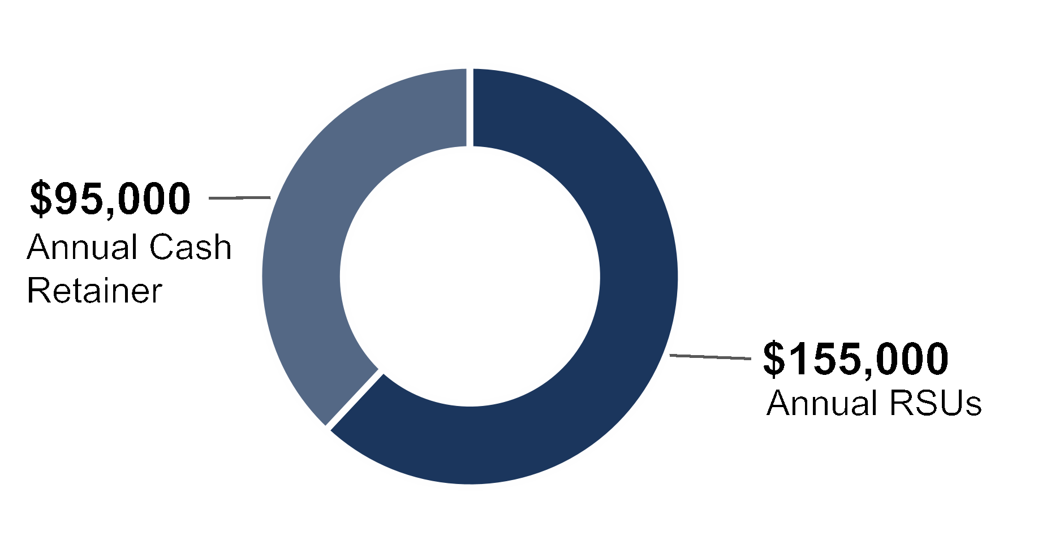
Position | 2026 Additional  Annual Fee($)
Chair of the Audit and Finance Committee | 20,000
Chair of the Compensation and Talent  Management Committee | 20,000
Chair of the Nominating and Corporate  Governance Committee | 15,000
Lead Independent Director | 30,000
•The annual grant of restricted stock units valued at $155,000, reflecting a $5,000 increase from fiscal 2025, is awarded on
the date of the election of each director at the annual meeting of stockholders, which restricted stock units vest one year
after the date of grant so long as membership on the Board of Directors continues through the vesting date. Settlement in
common stock occurs, at each recipient’s prior election, either upon vesting or on the earliest of the director’s death,
disability or the date on which the director’s board membership ceases for reasons other than death or disability.
•If a director is elected at a time other than the annual meeting, they receive a pro-rated grant of restricted stock units for
service provided between the date he or she first becomes a director and the next annual meeting of stockholders.
•The $95,000 annual cash retainer fee is paid in equal quarterly installments.
•No meeting fees are payable to directors.
•Our directors are reimbursed for out-of-pocket expenses incurred in connection with Board of Directors and/or
committee participation.
Please see the Director Compensation table for information regarding the compensation paid to our directors during 2026.
Prestige Consumer Healthcare Inc. | 2026 Proxy Statement |  | 37
Director Compensation
Director Compensation Policies and Practices
Grant Limits
Pursuant to the terms of the Company’s 2020 Long-Term Incentive Plan, which our stockholders approved in August 2020,
with respect to any one fiscal year, the aggregate compensation that may be granted or awarded to any one non-employee
director, including all stock awards and cash payments (including meeting fees and retainers), may not exceed $600,000, or
$900,000 in the case of a non-employee Chair of the Board or Lead Director.
Stock Ownership Guidelines
The Board of Directors adopted Stock Ownership Guidelines for the directors and
executive officers of the Company to align their interests with the Company’s
stockholders. Each director is expected to be fully compliant with the guidelines
by the date of the first annual meeting of stockholders following the fifth
anniversary of the date of election to the Board.
All directors are in compliance with these requirements.
Each director must maintain
ownership of shares
≥5X
the amount of their annual cash
retainer, currently $475,000 (5 X
$95,000 retainer).

Director Compensation in 2026
The following table sets forth the cash and equity compensation paid or awarded to our non-employee directors during 2026.
The columns regarding option awards and non-equity incentive, pension and deferred compensation plans have been omitted,
as the Company does not provide such elements of compensation to our directors for their services.
Name | Fees Earned or  Paid in Cash  ($) | Stock Awards  ($)(1) | Total  ($)
Mr. Byom | 165,502 | 155,040 | 320,542
Ms. Clark | 110,000 | 155,040 | 265,040
Mr. D’Arecca | 115,000 | 155,040 | 270,040
Ms. Hopkins | 95,000 | 155,040 | 250,040
Mr. Kelly | 95,000 | 155,040 | 250,040
Ms. Zier | 115,000 | 155,040 | 270,040
(1)Reflects the grant date fair value of the stock awards granted in 2026, determined in accordance with the Financial Accounting Standards
Board Accounting Standards Codification Topic 718 Stock Compensation (“FASB ASC Topic 718”). On August 5, 2025, each of Mses.
Clark, Hopkins and Zier and Messrs. Byom, D’Arecca and Kelly received 2,094 restricted stock units, representing $155,040 divided by
$74.04 (the closing price of our common stock on the NYSE on August 5, 2025). The restricted stock units, which entitle the grantee to
receive one share of common stock for each restricted stock unit, vest one year from the date of the grant and will be settled, at each
recipient’s prior election, either upon vesting or upon the earliest to occur of such director’s death, disability or the cessation of board
service for any reason other than death or disability. As of March 31, 2026, Mses. Clark, Hopkins and Zier and Messrs. Byom, D’Arecca
and Kelly held 13,530, 30,123, 16,533, 50,097, 6,591, and 4,851 restricted stock units under the Company’s equity compensation plans,
respectively. As of March 31, 2026, none of our directors held any stock options.
38 |  | 2026 Proxy Statement | Prestige Consumer Healthcare Inc.

OUR EXECUTIVE OFFICERS
Our executive officers are as follows:
Ronald M. Lombardi
Chair of the Board, President and Chief Executive Officer
Age: 62
Career Highlights:
Ronald M. Lombardi was elected Chair of the Board in May 2017 and has served as a director and as President and Chief
Executive Officer of the Company since June 2015. He served as Chief Financial Officer of the Company from December 2010
until November 2015. Prior to joining the Company, from October 2010 to December 2010, Mr. Lombardi was employed by
Medtech Group Holdings, a components and contract medical device manufacturer, as Chief Financial Officer. From October
2009 to October 2010, Mr. Lombardi served as the Chief Financial Officer of Waterbury International Holdings, a specialty
chemical and pest control business. Mr. Lombardi was employed by Cannondale Sports Group, a sporting goods and apparel
manufacturing company, as Chief Operating Officer from August 2008 to October 2009 and as Senior Vice President and
Chief Financial Officer from March 2004 to August 2008. From 2000 to 2004, Mr. Lombardi served in various roles at Gerber
Scientific Inc., including Vice President and Chief Financial Officer of Gerber Scientific Inc.’s Gerber Coburn Optical Division and
Director of Financial Planning and Analysis. Mr. Lombardi was also previously employed by Emerson Electric, Scovill Fasteners,
Inc. and Go/Dan Industries. Mr. Lombardi currently serves as Chair of the Audit Committee on the board of ACCO Brands
Corporation. Mr. Lombardi received a B.S. from Springfield College and an M.B.A. from American International College and has
been a licensed CPA.
 |  |  |  |  | Christine Sacco  Chief Financial Officer/Chief Operating Officer
 |  |  |  |  | Age: 51
Career Highlights:
Christine Sacco was appointed to the position of Chief Financial Officer and Chief Operating Officer for the Company in January
2025. She served as the Chief Financial Officer of the Company from September 2016 until January 2025. Ms. Sacco joined the
Company from Boulder Brands, Inc., a health and wellness food manufacturer, where she served as the Chief Financial Officer
and Treasurer from January 2012 to January 2016 and Vice President and Controller from January 2008 to January 2012,
including Principal Accounting Officer from January 2011 to March 2012. From October 2002 until January 2008, she held
positions of increasing financial responsibility with Alpharma, Inc., a global specialty pharma company, where she last held the
position of Vice President, Treasurer. Ms. Sacco began her career with Ernst & Young and worked for five years in the Audit and
Assurance group. She holds a B.S. in accounting from St. Thomas Aquinas College and has been a licensed CPA.
Prestige Consumer Healthcare Inc. | 2026 Proxy Statement |  | 39
Our Executive Officers
 |  |  |  |  | William C. P’Pool  Senior Vice President, General Counsel and Corporate Secretary
 |  |  |  |  | Age: 60
Career Highlights:
William C. P’Pool was appointed to the position of Senior Vice President, General Counsel and Corporate Secretary for the
Company in November 2016. From June 2004 to April 2015, Mr. P’Pool served in progressive leadership roles at Mead Johnson
Nutrition Company, a nutritional products company, the last being Senior Vice President, General Counsel and Corporate
Secretary. From May 2001 to June 2004, Mr. P’Pool served as a Senior Counsel and Director of Legal Services at Yum! Brands,
Inc. From 1991 to 2001, he served in legal roles of increasing responsibility at GrafTech International and Service Merchandise
Company, among others. He earned a B.S. in business from Murray State University and a J.D. from the University of Kentucky.
 |  |  |  |  | Adel Mekhail  Executive Vice President, Marketing & Sales
 |  |  |  |  | Age: 65
Career Highlights:
Adel Mekhail was appointed to the position of Executive Vice President of Marketing & Sales for the Company in May 2019.
From April 2017 to July 2018, Mr. Mekhail served as Vice President, Americas at Edgewell Personal Care Company, a personal
care products company, and from July 2015 to April 2017 he served as Vice President and General Manager, Private Brands
Group and Vice President, Latin America. From November 2013 to July 2015, Mr. Mekhail served as Vice President, Asia
Pacific at Energizer. He held other increasingly responsible marketing roles at Energizer from 2003 to 2013. Mr. Mekhail also
served in sales and marketing roles for Pfizer and Warner Lambert from 1996 to 2003. In 2000, he moved from Australia to the
United States for Pfizer. Mr. Mekhail earned his B.S. in Pharmaceutical Sciences from Tanta University in Egypt and his M.B.A.
from RMIT University in Melbourne, Australia.
 |  |  |  |  | Jeffrey Zerillo  Executive Vice President, Operations
 |  |  |  |  | Age: 65
Career Highlights:
Jeffrey Zerillo was appointed to the position of Senior Vice President, Operations for the Company in April 2018. Mr. Zerillo
joined the Company from Teva Pharmaceuticals, a pharmaceutical company, where he served as Vice President, Supply
Chain Management for the America’s Region from 2016 to 2018. He brings experience managing complex supply chains in
pharmaceuticals, biologics and medical devices from companies including Actavis/Allergan, a pharmaceutical company, from
2014 to 2016, Purdue Pharma from 1995 to 2013, Tura L.P. from 1994 to 1995 and Instrumentation Laboratories from 1988 to
1994. He earned a B.S. in Business Management - Production Operations from York College of Pennsylvania and an Executive
Certificate from Sloan School of Business.
40 |  | 2026 Proxy Statement | Prestige Consumer Healthcare Inc.

EXECUTIVE COMPENSATION

PROPOSAL 2:
Advisory Vote to Approve Named Executive
Officer Compensation
Why are we submitting this matter to you?
We are required by Section 14A of the Exchange Act and by the Dodd-Frank Wall Street Reform and Consumer
Protection Act of 2010 (the “Dodd-Frank Act”) to provide our stockholders with the opportunity to approve, on an advisory,
non-binding basis, the compensation of our named executive officers (“NEOs”) contained in this Proxy Statement. This
proposal, commonly known as a “Say-on-Pay” proposal, gives our stockholders the opportunity to express their views on
our executive compensation as described in this Proxy Statement. Our executive compensation program is described in
the Compensation Discussion and Analysis (“CD&A”), executive compensation tables and other narrative executive
compensation disclosures required by the disclosure rules of the SEC, all of which are found in this Proxy Statement. In
particular, the CD&A, beginning on page 41 of this Proxy Statement, describes the Company’s executive compensation
program in detail, and we encourage you to review it.
At the 2023 Annual Meeting of Stockholders, our stockholders expressed a preference that advisory votes on executive
compensation be held on an annual basis. The Board of Directors has determined, in line with the vote of the Company’s
stockholders, to have an annual advisory vote on the compensation of our named executive officers.
Accordingly, the next advisory vote on executive compensation will occur at this Annual Meeting of Stockholders.
What are you being asked to vote on?
Stockholders are being asked to vote either for or against the following non-binding resolution:
RESOLVED, that the stockholders of Prestige Consumer Healthcare Inc. approve, on an advisory basis, the
compensation of the Company’s named executive officers, as disclosed pursuant to the compensation disclosure rules of
the Securities and Exchange Commission, including the Compensation Discussion and Analysis, the compensation
tables and other narrative executive compensation disclosures included in this Proxy Statement.
Is this vote binding?
No. As provided by the Dodd-Frank Act, this vote will not be binding on the Board of Directors or the Compensation and
Talent Management Committee and may not be construed as overruling a decision by the Board of Directors or the
Compensation and Talent Management Committee or creating or implying any additional fiduciary duty for the Board.
Further, it will not affect any compensation paid or awarded to any executive officer. The Compensation and Talent
Management Committee and the Board will, however, take into account the outcome of the vote when considering future
executive compensation arrangements.
What vote is required for approval of the Say-on-Pay proposal?
The approval of this non-binding resolution requires the affirmative vote of a majority of the shares present, in person or
by proxy, at the Annual Meeting and entitled to vote on the proposal. If this proposal is not approved by the required vote,
the Board and the Compensation and Talent Management Committee will take into account the result of the vote when
determining future executive compensation arrangements, particularly if the votes cast against the resolution exceed the
number of votes cast in favor of the resolution.
What Does the Board Recommend?
For all of the reasons discussed in our CD&A beginning on Page 41 of this Proxy Statement, the Board of Directors
recommends that you vote FOR the approval of the compensation of our Named Executive Officers as described in
this Proxy Statement.
Prestige Consumer Healthcare Inc. | 2026 Proxy Statement |  | 41
Executive Compensation

Compensation Discussion and Analysis
Our Named Executive Officers
The following section is a discussion and analysis of the compensation policies and decisions made in connection with
compensation for our named executive officers listed below:
 |  |  |  | 
Ronald M. Lombardi  President and Chief  Executive Officer | Christine Sacco  Chief Financial  Officer & Chief  Operating Officer | Adel Mekhail  Executive Vice  President, Sales  and Marketing | William C. P’Pool  Senior Vice President,  General Counsel and  Corporate Secretary | Jeffrey Zerillo  Senior Vice President,  Operations
 | Table of Contents
 | Executive Summary | 42 |  | Compensation Review and Competitive Analysis | 49
 | Our Performance During 2026 | 42 |  | Peer Group | 49
 | Compensation Philosophy | 42 |  | 2026 NEO Compensation | 49
 | Approach to Compensation Program | 43 |  | Base Salary | 49
 | Our 2026 Compensation Program | 44 |  | Annual Cash Incentive Plan | 50
 | Say-on-Pay Results | 46 |  | Equity Awards | 53
 | Compensation Governance Highlights | 46 |  | Compensation Policies and Governance Practices | 56
 | Executive Compensation Best Practices | 47 |  | Stock Ownership Guidelines | 56
 | Executive Compensation  Decision-Making Process | 48 |  | Equity Grant Timing | 57
 | Executive Compensation  Decision-Making Process | 48 |  | Clawback Policy | 57
 | Roles and Responsibilities | 48 |  | Policy Against Hedging and Pledging of  Company Stock | 57
42 |  | 2026 Proxy Statement | Prestige Consumer Healthcare Inc.
Executive Compensation
Executive Summary
Our Performance During 2026
Demonstrating the resilience of our business model in a challenging consumer backdrop, the Company achieved free cash
flow growth in fiscal 2026, despite a modest decline in revenue and earnings, thanks to our business strategy and the unique
attributes of our portfolio, with key fiscal year metrics as follows:
 | Stable Revenue | Sustained Profitability | Strong Free Cash Flow | Low Year-End Leverage
 | Revenue of  $1,088.7  Million | Adjusted EPS of  $4.38 | Up from 2025 to  $246 Million | 2.6x Leverage
Please refer to Appendix A for a reconciliation of non-GAAP Adjusted EPS and Free Cash Flow to our most directly
comparable financial measure presented in accordance with GAAP.
Compensation Philosophy
It is the intent of the Company, through the efforts of the Compensation and Talent Management Committee, to:
 |  |  |  |  |  |  |  |  | 
 | Motivate our business leaders  to deliver a high degree of  business performance and  ensure that their interests are  closely aligned with those of  our stockholders; |  |  |  | Attract and retain highly  qualified senior leaders  who can drive a successful  global enterprise in today’s  competitive marketplace and  represent the diversity of our  employees and the customers  we serve; |  |  |  | Establish executive  compensation that is  competitive with the  compensation offered by  similarly situated companies;
 |  |  |  |  |  |  |  |  | 
 | Focus management on both  the Company’s short-term  and long-term strategy,  performance and success; |  |  |  | Maintain practices that support  good governance; and |  |  |  | Structure programs that  mitigate any incentives to take  excessive risks.
Our executive compensation philosophy is to have programs and pay levels that enable us to attract, retain and motivate
talented management who will drive exceptional results for our stockholders. We accomplish this by ensuring that
our executive officers are compensated in a way that considers market practice, supports good governance, and
drives both company and individual performance. To ensure fair and competitive pay, the Compensation and Talent
Management Committee references a peer group comprised of companies it selected based on various characteristics
(as described further below) and uses median as a reference point in setting target pay levels for the Company’s
executive officers.
Prestige Consumer Healthcare Inc. | 2026 Proxy Statement |  | 43
Executive Compensation
The Company uses the following types of compensation to compensate and reward our executive officers for their
performance: base salary, a cash-based annual incentive plan, and long-term equity awards comprised of performance stock
units and restricted stock units. The Compensation and Talent Management Committee believes that the elements of
compensation that it provides create a flexible, performance-based compensation package that focuses and rewards
executives for short and long-term performance, while aligning the interests of our executive officers with the interests of
the Company’s stockholders.
Each element of executive compensation described above is determined based on:
 | The executive’s level of responsibility and function  within the Company; |  |  | Executive compensation offered to similarly situated  executives at peer companies; and
 | The overall performance and profitability of  the Company; |  |  | Good governance practices.
 | The executive’s performance within the Company;
Approach to Compensation Program
Goals of Our Compensation Program
 |  |  | Base  Salary |  |  |  |  |  | Annual Cash  Incentive Awards |  |  |  |  |  | Long-term  Equity Awards
 |  |  | •Attract, Retain & Motivate  •Maintain Good Governance |  |  |  |  |  | •Attract, Retain & Motivate  •Support Company  Objectives  •Reinforce Strategy  •Maintain Good Governance |  |  |  |  |  | •Attract, Retain & Motivate  •Support Company  Objectives  •Reinforce Strategy  •Maintain Good Governance
Structure of Program
PERFORMANCE
Our executive compensation includes a significant amount of performance-based, or at-risk, compensation. We consider
compensation to be performance-based or at-risk if payment is subject to achievement of performance targets or the value
received is dependent on our stock price.
The Compensation and Talent Management Committee believes that the use of performance-based or at-risk compensation
allows the Company to tailor the compensation paid to our executive officers to the Company’s performance and maintain
a compensation system that significantly affects executive compensation in the event the Company does not meet the
pre-determined performance goals. Furthermore, utilizing threshold performance targets puts the performance units entirely at
risk, which means that in the event the Company does not meet the threshold performance goals, the performance units would
not be paid to the executive officers. Performance stock units are earned only if the Company achieves the pre-established
three- year performance goals. Performance Stock Units and Restricted Stock Units are weighted as follows:
Long-term Incentive (LTI) Vehicle | Target LTI NEOs  Other Than CEO | Target LTI  Value CEO
Performance Stock Units | 60% | 75%
Service-based Restricted Stock Units | 40% | 25%
44 |  | 2026 Proxy Statement | Prestige Consumer Healthcare Inc.
Executive Compensation
The charts below show the percentage of pay tied to financial or stock performance of 83% and 64% of the total compensation
for 2026 of our CEO and other named executive officers, respectively.
CEO
AVERAGE OTHER NEOs
ALIGNMENT
By motivating and incentivizing our executive officers with regard to the Company’s short- and long-term goals, the
Compensation and Talent Management Committee believes that the interests of the executive officers and the Company’s
stockholders are properly aligned.
Our 2026 Compensation Program
Brief Summary of Compensation Program
GOALS OF THE PROGRAM:
•To attract, retain and motivate talented management taking competitors’ compensation practices into account;
•Reinforce our strategy;
•To support achievement of our Company-wide objectives and increase stockholder value; and
•Maintain practices that support good governance.
ANNUAL CASH INCENTIVE AWARDS:
•Our named executive officers earned their annual cash incentive awards through our Annual Incentive Plan (“AIP”) primarily
based on the Company’s achievement of pre-determined performance goals related to Net Sales (weighted 50%) and
Adjusted AIP EBITDA (weighted 50%), as defined later in the Compensation Discussion and Analysis.
•The Company reached 95% of its Net Sales target and 93% of its Adjusted EBITDA goals in the very challenging
macroeconomic environment, resulting in a payout of 68% of target.
•Our plan also allows for an individual adjustment, up or down, based on individual performance as discussed later in
Compensation Discussion and Analysis.
LONG-TERM INCENTIVE AWARDS:
•The performance-based orientation of our long-term incentive program is 75% of our CEO’s targeted value of the long-term
incentive award allocated to performance stock units, which are earned based on performance over 3-years. The remaining
25% is delivered in restricted stock units, which vest ratably over 3-years.
•Our other named executive officers’ targeted value of the long-term incentive award was allocated 60% to performance
stock units and 40% to restricted stock units.
•Despite very challenging 3-year goals set for the May 2023 performance stock unit grant, the Company reached 95% of its
Net Sales target and 92% of its Adjusted EBITDA goals, resulting in a payout of 70% of target for the three-year
performance period, fiscal 2024 through 2026.
Prestige Consumer Healthcare Inc. | 2026 Proxy Statement |  | 45
Executive Compensation
CHALLENGING ENVIRONMENT:
During fiscal 2026, the Company navigated a challenging operating environment driven by significant supply chain disruptions
alongside broader macroeconomic pressures, including evolving U.S. and international trade restrictions and tariffs, a high
inflationary environment, and rising input costs. These conditions resulted in shortages, delays and backorders for certain
ingredients and products, most notably in our eye care product lines. Despite these headwinds, the Company delivered solid
financial results, maintaining strong profitability and free cash flow generation, and reduced net leverage.
This financial strength enabled meaningful capital deployment. During the fiscal year, we completed the acquisition of our key
eye care supplier, securing a critical element of our supply chain. Additionally, in March, we entered into a definitive agreement
to acquire Breathe Right® and certain other brands — the largest acquisition in Company history — which closed on June 12,
2026. These actions advance our proven capital deployment strategy and demonstrate the resilience of our diversified portfolio
of consumer healthcare brands.
Elements of Compensation
The following table provides additional information regarding the various elements of our 2026 executive
compensation program.
 |  |  | Pay Element | Objective | Purpose of the Pay Element
 |  |  | Base Salary | •Skills, experience, competence, performance,  responsibility, leadership and contribution to  the Company. | •Recognize the level of job scope and  complexity, and the skills, experience,  leadership and sustained performance  required by the executive.
 |  |  | Annual Cash  Incentive (“AIP”) | •Achieving annual target revenue  and profitability. | •Reward the achievement of annual  performance targets.  •Ensures compensation is properly  aligned to financial performance,  including being completely at risk for  failure to meet annual financial  threshold targets.
 |  |  | Long-Term  Incentive Awards  (Performance  Stock Units,  Restricted  Stock Units) | •Achieving long-term revenue growth and  profitability over the three year vesting period.  •Ability to increase and maintain stock price.  •Achievement of adjusted cumulative EBITDA  and cumulative Revenue goals.  •Continued employment with the Company  during the three-year vesting period. | •Reward achievement of long-term  financial performance and strategic  corporate initiatives.  •Provide a competitive mix of  incentives to attract and retain top  talent and to further reinforce  alignment between the interests of  management and shareholders.
46 |  | 2026 Proxy Statement | Prestige Consumer Healthcare Inc.
Executive Compensation
Say-on-Pay Results
At the 2025 Annual Meeting of Stockholders, approximately
97% of the shares represented, entitled to vote and voted
at the annual meeting were voted to approve the
compensation of the Company’s named executive officers as
discussed and disclosed in our 2025 Proxy Statement. In
considering the results of this advisory vote on executive
compensation, the Compensation and Talent Management
Committee concluded that the compensation paid to our
named executive officers and the Company’s overall
compensation program enjoy strong stockholder support. We
also regularly meet with our largest stockholders and solicit
feedback on a wide range of topics.
2025 SAY ON PAY APPROVAL
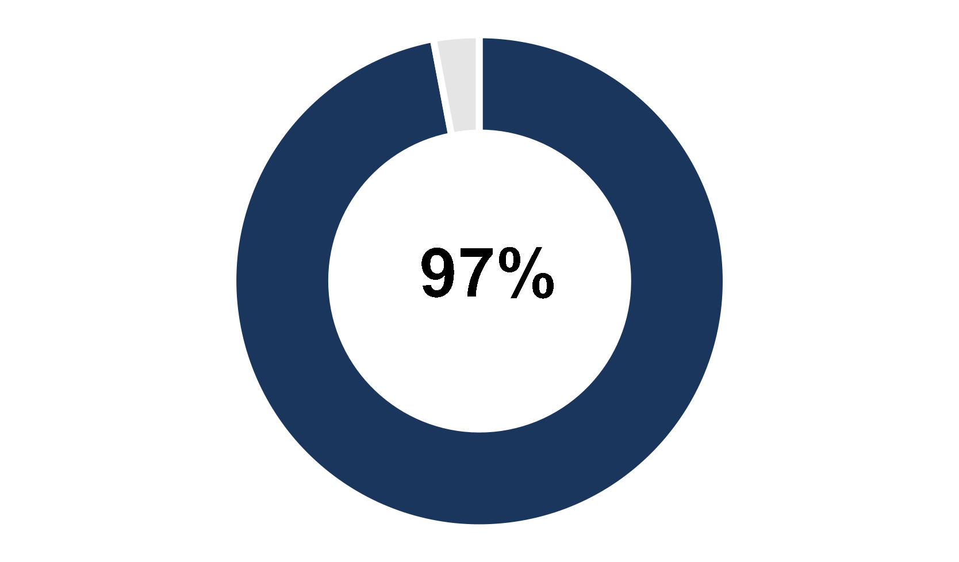
Compensation Governance Highlights
We endeavor to maintain good governance standards including with respect to the oversight of our executive compensation
policies and practices, as evidenced by the following practices of our Compensation and Talent Management Committee:
The Committee is composed solely of independent directors. | The Committee conducts an annual review of our  compensation-related risk profile to ensure that  compensation-related risks are not reasonably likely  to have a material adverse effect on the Company.
The Committee’s independent compensation consultant, CAP, is  retained directly by the Compensation and Talent Management  Committee and performs no other services for us. | The Committee regularly reviews succession and  talent management.
Prestige Consumer Healthcare Inc. | 2026 Proxy Statement |  | 47
Executive Compensation
Executive Compensation Best Practices
No Evergreen Provision.
The Company’s 2020 Long-Term Incentive Plan
(“2020 LTIP”) does not contain an “evergreen”
feature pursuant to which the shares authorized
for issuance under the 2020 LTIP can be
automatically replenished.
No Repricing of Stock Options.
Without the prior approval of the Company’s
stockholders, outstanding stock options cannot be
repriced, directly or indirectly, nor may stock options
be cancelled in exchanged for stock options with an
exercise price that is less than the exercise price of
the original stock options.
Clawback Policy.
All awards (and/or any amount received with respect
to such awards) under the Annual Incentive Plan and
the 2020 LTIP are subject to reduction, cancellation,
forfeiture or recoupment to the extent necessary to
comply with applicable law, stock exchange listing
requirements, and the recoupment policy of
the Company.
Minimum Vesting Requirements.
Awards granted under the 2020 LTIP will be subject
to a minimum vesting period of one year except for
5% of the pool that is available to grant with
shorter vesting.
No Dividends on Unearned Awards.
The 2020 LTIP prohibits the current payment of
dividends or dividend equivalent rights on
unearned awards.
No Excessive Perquisites
We do not provide excessive perquisites.
No Liberal Share Recycling Provisions.
Shares retained by or delivered to the Company to
pay the exercise price of a stock option or to satisfy
tax withholding obligations in connection with the
exercise, vesting or settlement of an award count
against the number of shares remaining available
under the 2020 LTIP.
No Single-trigger Change of Control Vesting.
If awards granted under the 2020 LTIP are assumed
by the successor entity in connection with a change
of control of the Company, such awards will not
automatically vest and pay out upon the change
of control.
Limitation on Non-employee
Director Compensation.
The 2020 LTIP provides that, with respect to any one
fiscal year, the aggregate compensation that may be
granted or awarded to any one non-employee
director, including all stock awards and cash
payments shall not exceed $600,000, or $900,000 in
the case of a nonemployee Chair of the Board or
Lead Director.
No Gross-Ups.
Our executive severance plan does not contain a
Section 280G excise tax “gross-up” provision.
Robust Stock Ownership Guidelines.
We maintain robust stock ownership guidelines for
both officers and directors, which are described later
in this CD&A.
No Hedging.
We prohibit hedging and limit pledging by
the Company’s directors, executive officers
and employees.
48 |  | 2026 Proxy Statement | Prestige Consumer Healthcare Inc.
Executive Compensation
Executive Compensation Decision-Making Process
Roles and Responsibilities
The Compensation and Talent Management Committee engaged Compensation Advisory Partners (“CAP”) to conduct
an analysis of the Company’s compensation levels and design for the Chief Executive Officer and the other executive
officers of the Company. CAP also provided market context and advice for decisions related to incentives and other
compensation practices.
In 2026, the Compensation and Talent Management Committee evaluated the independence of CAP considering SEC rules
and NYSE listing standards, which require consideration of the following factors:
•whether any other services are provided to the Company by the consultant;
•the fees paid by the Company as a percentage of the consulting firm’s total revenue;
•the policies or procedures maintained by the consulting firm that are designed to prevent a conflict of interest;
•any business or personal relationships between the individual consultants involved in the engagement and a member of the
Compensation and Talent Management Committee;
•any Company stock owned by the individual consultants involved in the engagement; and
•any business or personal relationships between our executive officers and the consulting firm or the individual consultants
involved in the engagement.
The Compensation and Talent Management Committee discussed these considerations and concluded that the engagement
of CAP and the services provided to the Compensation and Talent Management Committee by CAP did not raise any conflict
of interest and that CAP is independent.
CAP did not provide any services to the Company other than in connection with its engagement by the Compensation and
Talent Management Committee.
 | Role of Compensation and Talent Management Committee
The Compensation and Talent Management Committee and the Board of Directors are responsible for establishing the
CEO’s compensation package.
Role of Independent Consultant  •CAP assisted in reviewing the competitive landscape  for executive talent and structuring the types and  levels of executive compensation for review by the  Compensation and Talent Management Committee.  •CAP was consulted by the Compensation and Talent  Management Committee in determining the  compensation to be awarded to Mr. Lombardi in  2026, and in determining his compensation program  for 2027. |  |  |  | Role of Management  Mr. Lombardi, our Chair, President and Chief Executive  Officer, with the assistance of certain members of senior  management, participated in discussions with, and made  recommendations to, the Compensation and Talent  Management Committee regarding the setting of base  salaries and cash and equity incentive plan  compensation for the other executive officers.  Mr. Lombardi was assisted by certain members of senior  management and CAP in reviewing the competitive  landscape for executive talent and structuring the types  and levels of executive compensation for review by the  Compensation and Talent Management Committee.
Prestige Consumer Healthcare Inc. | 2026 Proxy Statement |  | 49
Executive Compensation
Compensation Review and Competitive Analysis
As part of its evaluation of the Company’s compensation packages, CAP recommended a group of peer companies that reflect
the Company’s business model, as well as being within a reasonable range of the Company’s revenue, EBITDA, EBITDA
margin, and market capitalization. Because our core products are in the over-the-counter and personal care sector, there are
relatively few companies like us. As a result, we consider companies with strong brands and similar business models as
comparable peers as well as select companies in the Pharmaceutical space. In addition, given our operating model and high
margins, we consider strong EBITDA performance to be an important metric in selecting our peers.
In determining compensation for 2026, the Compensation and Talent Management Committee reviewed and considered
market data provided to it by CAP related to individual pay components (salary and target annual bonus opportunity), total
cash compensation, long-term incentive target grant values, and total direct compensation, at the 25th percentile, median, and
75th percentile of the peer group. The Compensation and Talent Management Committee intends compensation to
approximate the median level of compensation offered to similarly situated executive officers at companies in the
Company’s peer group.
The Compensation and Talent Management Committee approved the following peer group:
2026 Peer Group
•Amphastar Pharmaceuticals  •B&G Foods Holdings Corp.  •Church & Dwight Co.  •Energizer Holdings, Inc.  •Helen of Troy Limited  •BellRing Brands, Inc.  •USANA Health Sciences, Inc.  •Utz Brands | •Pacira BioSciences, Inc.  •Calavo Growers Inc.  •Edgewell Personal Care Company  •Hain Celestial Group, Inc.  •Spectrum Brands Holdings Inc.  •Simply Good Foods Company  •Corcept Therapeutics Incorporated
For 2026 compensation benchmarking, the Compensation and Talent Management Committee removed Jazz Pharmaceuticals
(revenue no longer comparable), Primo Water (merged) and Vista Outdoor (split and acquired) and added Spectrum Brands,
BellRing Brands and Simply Good Foods based on their similar financial profile.
For 2027 compensation planning, the Compensation and Talent Management Committee removed Calavo Growers Inc. as
they had been facing operational issues and have since been acquired in May 2026. While market data is an important factor
in setting pay, it is not the only factor we consider. For example, an executive officer’s total compensation may be higher or
lower than the market median based on the level of responsibility, individual experience and performance in a particular year.
In some situations, we will also use compensation survey data as an additional point of reference for select named executive
officers.
2026 NEO Compensation
Base Salary
The Compensation and Talent Management Committee determines the base salary for our executive officers by first reviewing
peer group salaries for similarly situated positions and then adjusting such salaries as necessary based on the scope of work,
skills, experience, responsibilities, performance and seniority of the executive and the recommendation of the Chief Executive
Officer (except in the case of his own compensation, which is determined by the Compensation and Talent Management
Committee and the Board of Directors). In addition, with respect to promotions and new hires, the Compensation and Talent
Management Committee considers the predecessor’s base salary. The Company views base salary as a fixed component of
executive compensation that compensates the executive officer for the daily responsibilities assumed in keeping the Company
operating throughout the year. The Compensation and Talent Management Committee reviews executive officers’ salaries
annually at the end of the fiscal year and establishes the base salaries for the upcoming fiscal year. The base salaries paid to
our named executive officers during 2026 are set forth in the “Salary” column of the Summary Compensation table later in this
Proxy Statement.
50 |  | 2026 Proxy Statement | Prestige Consumer Healthcare Inc.
Executive Compensation
In May 2026, the Compensation and Talent Management Committee approved adjustments to base salaries for fiscal 2027 to
move each closer to the median of the peer group, as set forth below:
Name | FY2026 Salary |  | FY2027 Salary |  | % Increase Effective  April 1, 2026*
Mr. Lombardi |  | $1,000,000 |  | $1,050,000 | 5%
Ms. Sacco |  | $715,000 |  | $736,000 | 3%
Mr. Mekhail |  | $544,000 |  | $555,000 | 2%
Mr. P’Pool |  | $562,000 |  | $579,000 | 3%
Mr. Zerillo |  | $381,000 |  | $395,000 | 3.8%
*Increases approved in May were retroactive to beginning of fiscal year.
Annual Cash Incentive Plan
The Annual Incentive Plan (“AIP”) provides our executive officers with the ability to earn additional cash compensation
based on a percentage of base salary and the Company’s performance. The Company views the AIP as a performance-based
component of executive compensation that motivates and incentivizes the executive officers to achieve the short-term goals of
the Company and our stockholders.
For 2026, the Compensation and Talent Management Committee chose the following as the corporate financial goals for the AIP:
Metric |  | Definition |  | Rationale for Selection
AIP net sales (50%) |  | Total revenues. |  | Drive consistent top-line growth.
AIP Adjusted EBITDA  (50%) |  | Net income plus depreciation and amortization,  interest expense, integration, transition, purchase  accounting, legal and various other costs associated  with acquisitions and divestitures, tradename  impairment and certain tax adjustments. |  | Drive stockholder value creation in terms  of growth of earnings per share and free  cash flow.
Typically, no bonuses are payable under the AIP unless the Company achieves threshold performance for one of the goals set
for net sales or Adjusted EBITDA. If the Company achieves both of these threshold goals, then each of our named executive
officer’s bonus is subject to a maximum award of 200% of their target bonus based on achievement with respect to the
Company performance factors. The award will be subject to an additional individual performance factor that may be added to
and raise the total annual bonus for the executive above 200% of their target bonus up to the maximum of the individual award
factor of 20%. The individual performance factor may also decrease payouts by up to 20%.
Payout Formula
Base Salary |  |  | Company  Performance Factor (0%  to 200%) |  |  | Individual  Performance Factor  (+/-20%) |  |  | AIP Payout
Base Salary | × |  | Company  Performance Factor (0%  to 200%) | + |  | Individual  Performance Factor  (+/-20%) | = |  | AIP Payout
The Compensation and Talent Management Committee identified a target bonus, expressed as a percentage of their base
salary, for each named executive officer, which for 2026 were as follows:
NEO | Target Bonus (% of Base Salary)
Mr. Lombardi | 125%
Ms. Sacco | 75%
Mr. Mekhail | 60%
Mr. P’Pool | 50%
Mr. Zerillo | 40%
Prestige Consumer Healthcare Inc. | 2026 Proxy Statement |  | 51
Executive Compensation
The following table reflects the 2026 net sales, Adjusted EBITDA and payout levels approved by the Compensation and Talent
Management Committee that correspond to the threshold, target and maximum performance by the Company. The named
executive officers earn no payment if performance is below threshold or a payment on a sliding-scale between the minimum
(threshold) amount and the maximum amount, inclusive of the target amount based on the Company’s performance.
 |  |  | Performance Level/Payout (MIL)
Metric | Weighting |  | Threshold  (50%) | Target  (100%) | Maximum  (200%) | Payout
 |  |  |  |  |  | 68%
AIP Net Sales | 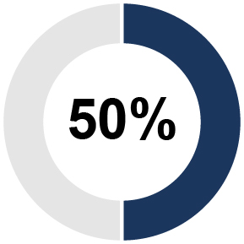 |  | 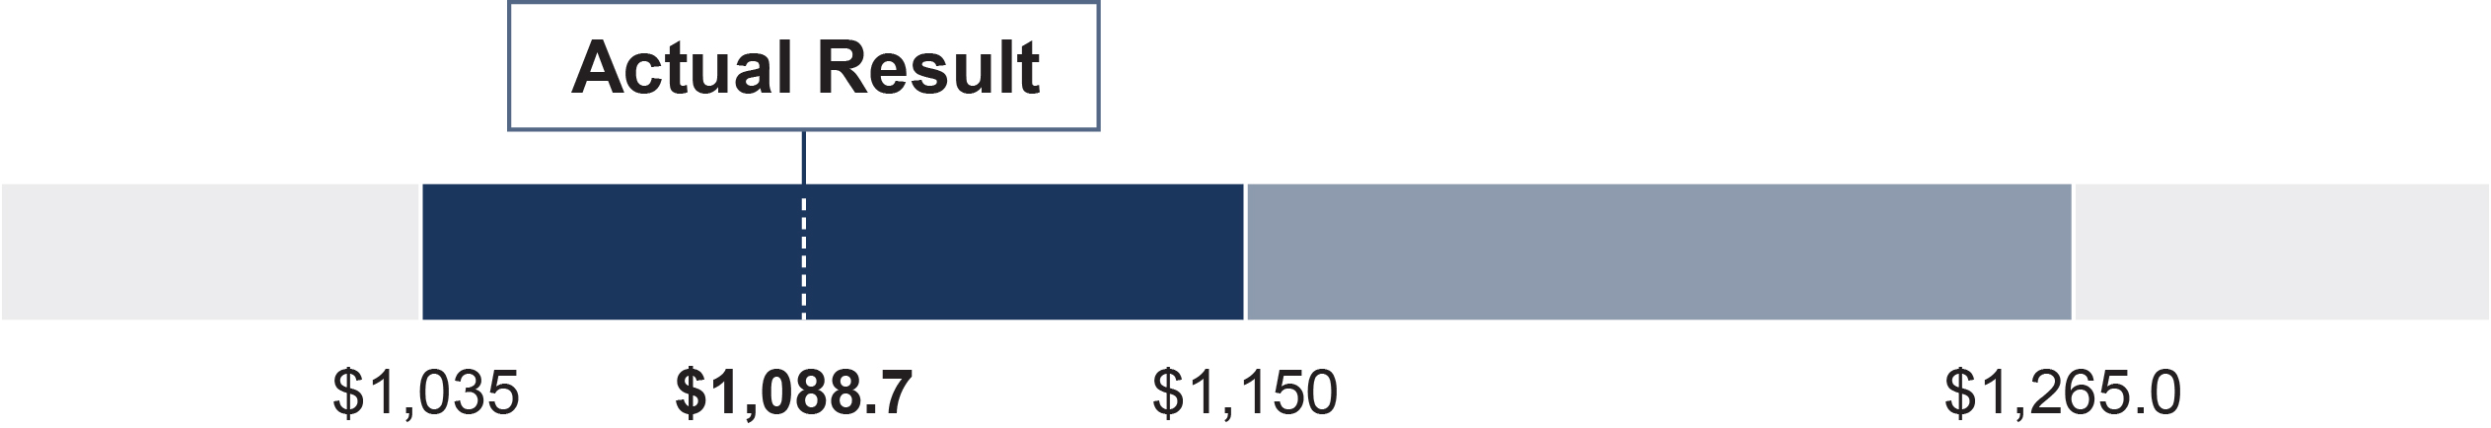 |  |  | 68%
AIP Adjusted  EBITDA |  |  | 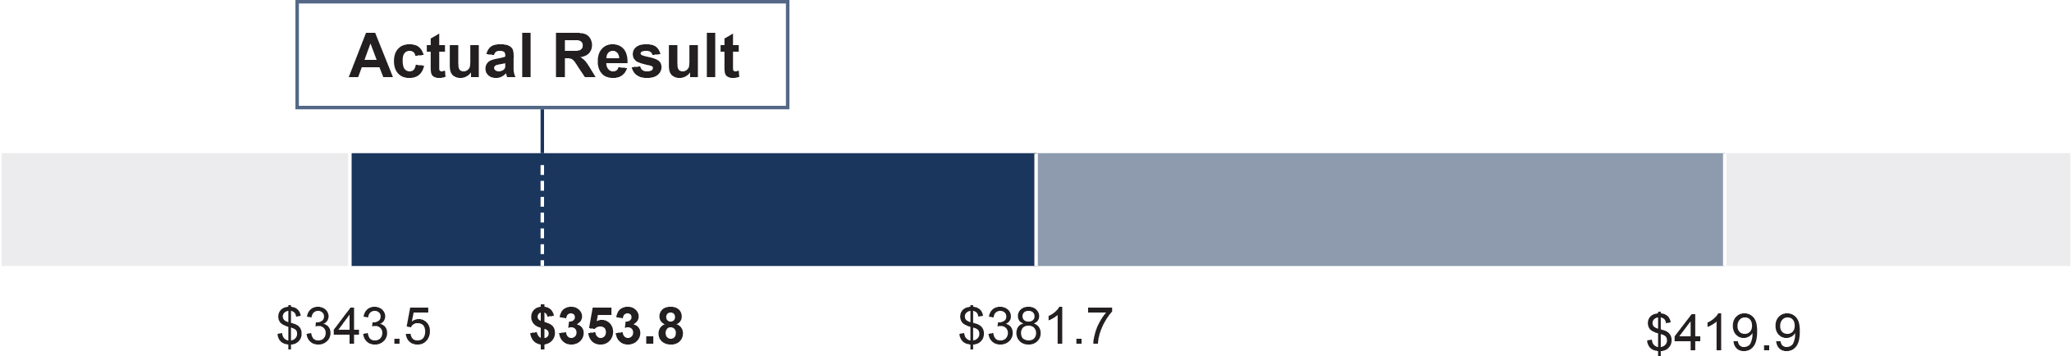 |  |  | 68%
Following the close of the fiscal year, the Compensation and Talent Management Committee assesses the Company’s
performance against the pre-determined performance targets and determines the amount, if any, of bonus earned by the
executive officers. To be eligible to receive cash incentive compensation, the executive must be employed with the Company
at the time payments are made by the Company. Even with a very challenging macroeconomic environment and supply chain
disruptions in 2026, our 2026 Net Sales and Adjusted EBITDA for the Company were $1,088.7 million and $353.8 million,
respectively. Based on the results of these financial metrics, our named executive officers earned 68% of their target bonus.
While the entire leadership team performed very well in this challenging year, the Compensation and Talent Management
Committee elected to award additional bonus to Mr. Zerillo. When determining the adjustments to individual bonus payouts,
the Compensation and Talent Management Committee considered each named executive officers’ achievement against their
respective goals. Any adjustments to the payouts are linked to the goals and objectives set for the individual by the CEO or in
the case of the CEO, by the Compensation and Talent Management Committee.
The following table reflects each named executive officer’s target bonus and actual payout.
Name | Target Bonus |  | Company  Performance  Payout (68%  of Target Bonus) |  | Individual  Performance  Adjustment |  | Total Payout
Mr. Lombardi |  | $1,250,000 |  | $850,000 |  | $0 |  | $850,000
Ms. Sacco |  | $536,250 |  | $364,650 |  | $0 |  | $364,650
Mr. Mekhail |  | $326,400 |  | $221,952 |  | $0 |  | $221,952
Mr. P’Pool |  | $281,000 |  | $191,080 |  | $0 |  | $191,080
Mr. Zerillo |  | $152,400 |  | $103,632 |  | $7,772 |  | $111,404
The 2026 AIP payouts to our named executive officers also are set forth in the “Non-Equity Incentive Plan Compensation”
column of the Summary Compensation table later in this Proxy Statement.
52 |  | 2026 Proxy Statement | Prestige Consumer Healthcare Inc.
Executive Compensation
Key achievements by our named executive officers considered by the Compensation and Talent Management Committee for
2026 included:
Name | Individual Performance Highlights | Individual  Adjustment
Ronald M. Lombardi | For Mr. Lombardi, our President and Chief Executive Officer, (a) successfully  lead the Company through the challenging macroeconomic environment  delivering solid financial performance, (b) delivered cash flow of over $245  million, (c) delivered significant debt paydown and significant stock  repurchases, (d) completed the acquisition of the Company's key eye care  supplier, securing a critical element of the supply chain, and (e) reached  agreement to acquire Breathe Right and associated brands, the largest  acquisition in Company history, advancing the Company's proven capital  deployment strategy. | —%
Christine Sacco | For Ms. Sacco, our Chief Financial Officer & Chief Operating Officer,  (a) helped successfully lead the Company through the challenging  macroeconomic environment created by significant supply chain challenges,  delivering a solid financial performance, (b) delivered cash flow of over  $245 million, (c) managed significant debt paydown with leverage below  targeted level by year end, (d) delivered against significant stock repurchase  program, (e) assisted in the acquisition and integration of the Company's key  eye care supplier, (f) reached agreement to acquire Breathe Right and  associated brands, (g) maintained and strengthened procedures and policies  in support of effective controls, and (h) continued enhancements in  information management, technology and cybersecurity. | —%
Adel Mekhail | For Mr. Mekhail, our Executive Vice President of Marketing & Sales,  (a) successfully drove North American financial performance in the  challenging macroeconomic environment which included significant  supply chain challenges, (b) actively managed marketing initiatives and  spend to continue to deliver strong sales and profit growth in e-commerce  channels, (c) successfully lead margin improvement projects to reduce  impact of inflation, and (d) successfully launched several new products  extending product lines and growing revenue and profitability. | —%
William C. P’Pool | For Mr. P’Pool, our Senior Vice President, General Counsel and Corporate  Secretary, (a) strong performance in providing legal advice to Company  particularly with regard to management of operations in context of the  significant supply chain challenges, (b) completed the acquisition of the  Company's key eye care supplier, (c) reached agreement to acquire Breathe  Right and associated brands — the largest acquisition in Company history, (d)  strengthened the organization in terms of business conduct, compliance and  control, and (e) managed the legal function to support the Company’s results  and secured, protected and defended the Company’s legal rights and interests. | —%
Jeffrey Zerillo | For Mr. Zerillo, our Senior Vice President, Operations, (a) managed the supply  chain to minimize disruption to the business despite significant supply chain  challenges, (b) made meaningful progress in customer service levels, (c)  effectively delivered productivity and savings above targeted levels, (d)  continued evolution of the Company’s manufacturing partner network capabilities  to address supply chain constraints, challenged suppliers and support business  growth, and (e) assisted with the acquisition and integration of the Company's  key eye care supplier, securing a critical element of the supply chain. | +7.5%
Prestige Consumer Healthcare Inc. | 2026 Proxy Statement |  | 53
Executive Compensation
Equity Awards
Executive officers of the Company are eligible to receive annual equity awards under our 2020 LTIP. Awards under the 2020
LTIP tie a significant portion of an executive officer’s long-term compensation directly to stock price appreciation realized by all
our stockholders and aligns an executive officer’s interests with those of our stockholders. Under the 2020 LTIP, our executive
officers may receive performance stock units and restricted stock units.
Overall Philosophy and Objectives Regarding Equity Awards
The Company views the above-mentioned equity awards as components of executive compensation that motivate and
incentivize management to achieve the long-term performance goals (including stock price appreciation) of the Company and
our stockholders.
The Compensation and Talent Management Committee believes equity-based incentive compensation aligns executive and
stockholder interests because:
 |  |  |  |  |  |  |  |  | 
 | The use of multi-year  vesting for equity awards  encourages executive  retention and emphasizes  the attainment of long-term  performance goals. |  |  |  | Paying a significant portion of  executive compensation with  long-term incentives motivates  and incentivizes the executive  officers to meet the long-term  performance goals set by the  Compensation and Talent  Management Committee. |  |  |  | The executive officers will hold  significant amounts of equity  in the Company as required  by the Company’s Stock  Ownership Guidelines and  will be motivated to increase  stockholder value over the  long-term.
In May 2025, following discussions with CAP and review of the benchmarking data for our executive officers, the Compensation
and Talent Management Committee increased target award values for each executive for FY2026 to move each closer to the
median of the peer group. Target award values increased, as provided in the table below.
Name | FY2026 Targeted  Award Value |  | % Increase  from FY2025
Mr. Lombardi |  | $4,100,000 | 2.5
Ms. Sacco |  | $1,609,000 | 2.2
Mr. Mekhail |  | $544,000 | 3.0
Mr. P’Pool |  | $562,000 | 2.9
Mr. Zerillo |  | $381,000 | 3.0
For our CEO, the Compensation and Talent Management Committee allocated seventy-five percent (75%) of his targeted
equity award value to performance stock units and the remaining twenty-five percent (25%) to restricted stock units. For our
other named executive officers, the Compensation and Talent Management Committee allocated sixty percent (60%) of the
targeted equity award value to performance stock units, and forty percent (40%) to restricted stock units. In each case, the
actual number of stock units granted was determined by dividing the allocated dollar value by the closing price of the
Company’s common stock on the grant date. The 2026 equity grants to our named executive officers are set forth in the
Grants of Plan-Based Awards table later in this Proxy Statement.
54 |  | 2026 Proxy Statement | Prestige Consumer Healthcare Inc.
Executive Compensation
Vesting Criteria for Equity Awards
Performance Stock Units
•Vest at the end of three years if company achieves pre-established goals relative to cumulative adjusted
EBITDA and cumulative Net Sales (each weighted 50%).
•The actual payout is determined based on the Company’s actual performance aggregated over the
three-year period on a sliding-scale between the minimum (threshold) amount and the maximum
amount, inclusive of the target amount.
•Participants can earn up to 200% of the target number of shares with exceptional performance.
•If performance is below target, but above threshold, participants can earn 50% of their award.
•If performance is below threshold, participants earn 0% of their award.
Restricted Stock Units
•Vest ratably over three years based on service.
For 2026, the Compensation and Talent Management Committee chose the following as the corporate financial goals for the
3-year Performance Stock Units:
Metric |  | Definition |  | Rationale for Selection
Cumulative Net Sales |  | The Company’s cumulative annual  “Net Sales,” as reported in the Company’s  audited financial statements for the 3-year  performance period, adjusted to exclude  divestitures, acquisitions, changes in  accounting policy and other adjustments  deemed appropriate by the Committee. |  | Drive consistent top-line growth over time.
Cumulative EBITDA |  | Company’s cumulative reported net  earnings (loss) excluding earnings (loss)  from discontinued operations, net of the  provision (benefit) for income taxes, net of  interest income and expense, net of  depreciation and amortization. EBITDA for  the 3-year performance period is adjusted  to exclude divestitures, acquisitions, costs  associated with integration, transition,  purchase accounting, impairment charges,  changes in accounting policy and other  adjustments deemed appropriate by  the Committee. |  | Drive stockholder value creation in terms  of growth of earnings per share and free  cash flow.
We utilize the same metrics in our annual incentive and PSU program, though they are over different timeframes. The
Committee regularly reviews what metrics align most closely with our business strategy and considers potential alternatives.
Management along with the Committee continue to believe Net Sales and EBITDA, are the metrics that drive value for our
business and provide line-of-sight to participants.
Treatment Upon Retirement. The Compensation and Talent Management Committee approved a “Rule of 62” policy for
long-term equity awards granted in 2019 and beyond. Pursuant to the “Rule of 62,” if an employee retires from the Company
with at least five years of service and a total of age and years of service at retirement equal to or greater than 62, then his or
her outstanding awards will vest, based on actual company performance at the end of the 3-year performance period in the
case of performance units, and in each case prorated based upon the employee’s length of employment during the vesting or
performance period, as applicable. In each case the employee must give at least six months’ notice prior to retirement.
Prestige Consumer Healthcare Inc. | 2026 Proxy Statement |  | 55
Executive Compensation
Severance and Change in Control Provisions. All unvested equity awards that are assumed in connection with a change of
control vest only after both the change in control event and the employee’s subsequent termination, or if the original vesting
criteria is met. In the case of awards that are not assumed in connection with the change in control, such unvested equity
awards will vest on the change in control.
For additional information regarding severance and change-in-control payments that the Company may be obligated to pay to
a named executive officer in the future due to the termination of his employment pursuant to the Company’s Executive
Severance Plan, please see the sections titled “Executive Compensation and Other Matters — Potential Payments Upon
Termination or Change in Control,” “Executive Compensation and Other Matters — Employment Agreements” and “Executive
Compensation and Other Matters — Additional Vesting Provisions” contained elsewhere in this Proxy Statement.
Deferral Option. Senior executives may elect to defer settlement of shares until a date set by the executive prior to the LTIP
award grant. Equity awards will continue to vest pursuant to the terms of the award agreements but the Company will defer
issuing shares until the date set by the executive. Vested but unissued shares will count toward the executive’s stock
ownership requirements.
May 2023 Performance Stock Unit Award Payout
The May 2023 performance stock unit grant resulted in a payout of 70% for the three-year performance period FY 2024-2026
as set out below:
 | Weighting |  | Threshold | Target | Maximum | Performance  Multiplier
 |  |  |  |  |  | 70%
3-Year  Cumulative Sales |  |  | 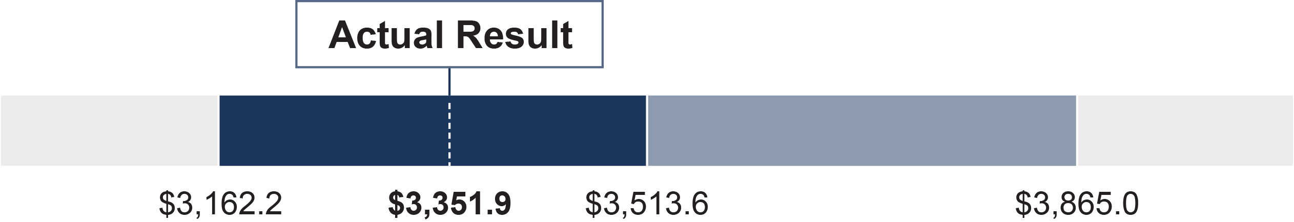 |  |  | 70%
3-Year  Cumulative  EBITDA |  |  | 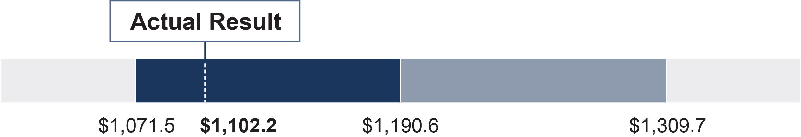 |  |  | 70%
The Performance Multiplier resulted in the distribution of 39,904 shares to Mr. Lombardi, 4,927 shares to Ms. Sacco, 2,464
shares to Mr. Mekhail, 2,562 shares to Mr. P’Pool and 1,725 shares to Mr. Zerillo from their May 2023 performance stock
unit grants.
Although the Company incurred numerous unanticipated financial impacts and other volatility resulting from the macroeconomic
environment especially significant supply chain issues, no adjustments were factored into the performance stock unit grant
payout for fiscal year 2026 results. Please refer to Appendix A for a reconciliation of Non-GAAP Adjusted EBITDA to GAAP Net
Income used to determine our May 2023 Performance Grant Payout.
56 |  | 2026 Proxy Statement | Prestige Consumer Healthcare Inc.
Executive Compensation
Compensation Policies and Governance Practices
Stock Ownership Guidelines
The Board of Directors adopted Stock Ownership Guidelines for the directors and executive officers of the Company to align
their interests with the Company’s stockholders. Each person subject to the Stock Ownership Guidelines is expected to be fully
compliant with the guidelines by the date of the first annual meeting of Stockholders following the fifth anniversary of the date
of employment as an executive officer of the Company or, for directors, the date of election to the Board.
The Stock Ownership Guidelines are summarized as follows:
Office |  |  |  |  |  | Value of Stockholdings Required to be Owned
Non-Employee Director |  |  |  |  |  | 5x Annual Retainer | 
Chief Executive Officer |  |  |  |  |  | 5x Annual Salary | 
Chief Financial Officer |  |  |  |  |  | 3x Annual Salary | 
Other NEOs |  |  |  |  |  | 2x Annual Salary | Varies
What counts toward stock ownership requirement
•shares of the Company purchased on the open market or in privately negotiated transactions;
•shares of the Company acquired by inheritance or gift or held by immediate family members or in trust for the
benefit of the employee or family member;
•after-tax shares of the Company acquired through vested restricted stock units and performance stock units;
•60% of vested options to the extent in-the-money — reflecting the approximate after-tax value of those shares;
•60% of unvested restricted stock units and performance stock units that cliff vest, prorated to the extent full years of
completed service or periods of performance, as applicable, at current projected performance multiple — reflecting
the approximate after-tax value of those shares; and
•100% of vested but deferred/unissued shares.
 | Compliance Status  All directors and executives  are in compliance with the  guidelines or are within the  five-year transition period. |  |  | What does not count toward stock ownership requirement  •unvested restricted stock and restricted stock units, except as provided above;  •unvested stock options; and  •vested but not “in-the-money” stock options.
If a director or executive is below the ownership requirement, until the specified level is met, the director or officer will be
required to retain 50 percent of the net, after-tax value of any equity received from the Company’s equity plan until the
individual meets the guideline. The CEO currently exceeds his guideline by more than three times the holding requirement.
Prestige Consumer Healthcare Inc. | 2026 Proxy Statement |  | 57
Executive Compensation
Equity Grant Timing
Other than in exceptional cases, such as promotions or new hires, long-term incentive awards are generally granted in the first
quarter of the fiscal year (April through June), at the time when salary levels and short-term incentive programs for the new
fiscal year are determined. Our CEO recommends to the Compensation and Talent Management Committee the amount to be
awarded to each NEO (other than our CEO). The Compensation and Talent Management Committee considers the equity
awards for executive officers based in part upon benchmarked data from our peer group provided by CAP, as well as other
factors, such as the officers’ individual performance and current dilution rates. In determining the awards to our CEO, the
Compensation and Talent Management Committee, without input from our CEO or other members of management, considers
the performance of our Company, returns to stockholders, effectiveness of our CEO’s leadership, as well as benchmarked data
and input from CAP. All NEO awards consist of performance stock units (PSUs) and restricted stock units and are valued at
the market closing price on the day of grant. No stock options are awarded to our NEOs. The Compensation and Talent
Management Committee does not take material nonpublic information into account when determining the timing and terms of
equity awards. The Company does not time the disclosure of material nonpublic information for the purpose of affecting the
value of executive compensation.
Clawback Policy
Pursuant to the Company’s Clawback Policy, in the event that the Company is required to restate its financial statements due
to material non-compliance with any financial reporting requirement under the U.S. federal securities laws, the Company will,
subject to the terms of the Clawback Policy, recover from executive officers any incentive-based compensation that was paid
to or received by, or is to be paid to, executive officers for the three years immediately preceding the period for which the
Company is required to restate its financial statements, insofar as such incentive compensation is a result of errors within the
financial statements that are required to be restated. The amount of the incentive-based compensation that the Company will
seek to recover is the difference between the amount of the incentive-based compensation received by executive officers
based on the erroneous financial statements and the amount of incentive-based compensation that would have been paid to
executive officers based on the financial statements as restated. Notwithstanding the foregoing, the Company is not obligated
to pursue any recovery if the Board of Directors or applicable committee determines that the expected cost of recovery will
exceed the amount to be recovered.
Policy Against Hedging and Pledging of Company Stock
The Company’s Insider Trading Policy prohibits hedging and limits any pledging by the Company’s directors, executive officers
and employees.

Compensation and Talent Committee Report
This Compensation and Talent Management Committee report shall not be deemed incorporated by reference by any general
statement incorporating by reference this Proxy Statement into any filing under the Securities Act of 1933, as amended (the
“Securities Act”), or the Exchange Act, except to the extent that we specifically incorporate this information by reference,
and shall not otherwise be deemed filed under the Securities Act and the Exchange Act.
The Compensation and Talent Management Committee has reviewed and discussed the Compensation Discussion and
Analysis with management. Based on its review and discussions of the Compensation Discussion and Analysis with
management, the Compensation and Talent Management Committee recommended to the Board of Directors that the
Compensation Discussion and Analysis be included in this Proxy Statement and incorporated by reference into our Annual
Report on Form 10-K for 2026.
MEMBERS OF THE 2026 COMPENSATION AND TALENT MANAGEMENT COMMITTEE
Dawn M. Zier (Chair)
John E. Byom
Celeste A. Clark
John F. Kelly
58 |  | 2026 Proxy Statement | Prestige Consumer Healthcare Inc.
Executive Compensation

Executive Compensation Tables
Summary Compensation Table
The following table includes information regarding the compensation paid or awarded to the named executive officers listed
below during our fiscal years ended March 31, 2026, 2025 and 2024. We have no applicable qualified pension or deferred
compensation plans and, therefore, have omitted the column regarding compensation under such plans.
 | Fiscal | Salary | Bonus | Stock  Awards(1) |  | Non-Equity  Incentive Plan  Compensation(2) | All Other  Compensation |  | Total
Ronald M. Lombardi  Chair, President, and Chief  Executive Officer | 2026 | 1,003,564 |  | 4,099,959 |  | 850,000 | 51,024 | (3) | 6,004,547
 | 2025 | 1,003,564 |  | 4,000,008 |  | 1,134,000 | 55,447 | (3) | 6,193,019
 | 2024 | 1,002,632 |  | 3,700,034 |  | 1,012,000 | 48,467 | (3) | 5,763,133
Christine Sacco  Chief Financial Officer and  Chief Operating Officer | 2026 | 716,242 |  | 1,608,733 |  | 364,650 | 24,203 | (4) | 2,713,828
 | 2025 | 658,904 |  | 2,635,065 | (6) | 595,298 | 16,334 | (5) | 3,905,601
 | 2024 | 625,809 |  | 1,029,965 |  | 330,000 | 15,075 | (5) | 2,000,849
Adel Mekhail  Executive Vice President,  Sales and Marketing | 2026 | 548,549 |  | 543,934 |  | 221,952 | 15,908 | (5) | 1,330,343
Adel Mekhail  Executive Vice President,  Sales and Marketing | 2025 | 533,499 |  | 528,047 |  | 312,365 | 15,693 | (5) | 1,389,604
Adel Mekhail  Executive Vice President,  Sales and Marketing | 2024 | 516,583 |  | 515,013 |  | 271,920 | 15,018 | (5) | 1,318,534
William C. P’Pool  Senior Vice President,  General Counsel and  Corporate Secretary | 2026 | 565,565 |  | 562,024 |  | 191,080 | 13,923 | (5) | 1,332,592
 | 2025 | 548,638 |  | 546,021 |  | 296,096 | 15,705 | (5) | 1,406,460
 | 2024 | 532,321 |  | 540,014 |  | 256,520 | 15,030 | (5) | 1,343,885
Jeffrey Zerillo  Senior Vice President,  Operations | 2026 | 384,227 |  | 381,044 |  | 111,404 | 15,908 | (5) | 892,583
Jeffrey Zerillo  Senior Vice President,  Operations | 2025 | 372,607 |  | 369,982 |  | 145,928 | 12,735 | (5) | 901,252
Jeffrey Zerillo  Senior Vice President,  Operations | 2024 | 362,448 |  | 360,009 |  | 126,720 | 13,750 | (5) | 862,927
(1)Reflects the grant date fair value of restricted stock unit awards and performance stock unit awards, determined in accordance with FASB
ASC Topic 718. The fair value of the restricted stock unit awards and performance stock unit awards is based on the market value of the
Company’s common stock on the grant date. The grant date value of the performance stock unit awards was computed by multiplying (i)
the target number of performance stock units awarded to each named executive officer, which was the assumed probable outcome as of
the grant date, by (ii) the grant date fair value used for financial reporting purposes. Assuming, instead, that the highest level of
performance would be achieved, the grant date fair values of the performance stock units would have been as follows: Mr. Lombardi
$5,550,021 (2024), $6,000,012 (2025) and $6,149,980 (2026); Ms. Sacco $1,235,958 (2024), $1,272,069 (2025) and $1,930,447 (2026);
Mr. Mekhail $618,041 (2024), $633,656 (2025) and $652,721 (2026); Mr. P’Pool $648,042 (2024), $655,198 (2025) and $674,461 (2026);
and Mr. Zerillo $431,987 (2024), $443,979 (2025) and $457,220 (2026).
(2)Reflects annual cash incentive awards, which are accrued and reflected in the Summary Compensation table for the fiscal year in which
earned but are paid promptly after the completion of the audit of the Company’s financial statements for such fiscal year.
(3)Reflects a matching contribution by the Company on Mr. Lombardi’s behalf to the Company’s 401(k) plan $15,750 (2026) and expenses
related to the use of corporate housing leased by the Company in the amount of $ 35,274 (2026). The aggregate incremental cost to the
Company of providing the corporate housing is based on the actual cost of the lease and utilities for the fiscal year.
(4)Reflects a matching contribution by the Company on the named executive officer’s behalf to the Company’s 401(k) plan and the cost of an
executive physical.
(5)Reflects a matching contribution by the Company on the named executive officer’s behalf to the Company’s 401(k) plan.
(6)For 2025, in addition to Ms. Sacco’s annual target long-term incentive award, reflects a one-time retention award of restricted stock units
which cliff vest after four years granted upon Ms. Sacco’s promotion to Chief Operating Officer, in addition to her role as Chief Financial
Officer in the amount of $1,575,055.
Prestige Consumer Healthcare Inc. | 2026 Proxy Statement |  | 59
Executive Compensation
Grants of Plan-Based Awards in 2026
The following Grants of Plan-Based Awards table provides additional information regarding non-equity and equity incentive
plan awards granted to the named executive officers during 2026. The non-equity incentive plan awards were granted
pursuant to the 2026 AIP and the equity incentive plan awards were granted pursuant to 2020 LTIP. The equity incentive plan
awards were comprised of performance stock units and restricted stock units.
 |  | Estimated Future Payouts Under  Non-Equity Incentive Plan Awards(1) |  |  |  | Estimated Future Payouts Under  Equity Incentive Plan Awards(2) |  |  | All Other  Stock  Awards:  Number of  Shares or  Stock Units  (#)(3) |  | Grant Date  Fair Value  of Stock  Awards  (#)(4)
Name |  | Threshold | Target | Maximum |  | Threshold | Target  (#) | Maximum  (#) |  |  | Grant Date  Fair Value  of Stock  Awards  (#)(4)
Mr. Lombardi |  | 625,000 | 1,250,000 | 2,500,000
 | 5/5/2025 |  |  |  |  |  |  |  | 12,352 |  | 1,024,969
 | 5/5/2025 |  |  |  |  | 18,529 | 37,057 | 74,114 |  |  | 3,074,990
Ms. Sacco |  | 268,125 | 536,250 | 1,072,500
 | 5/5/2025 |  |  |  |  |  |  |  | 7,755 |  | 643,510
 | 5/5/2025 |  |  |  |  | 5,816 | 11,632 | 23,264 |  |  | 965,223
Mr. Mekhail |  | 163,200 | 326,400 | 652,800
 | 5/5/2025 |  |  |  |  |  |  |  | 2,622 |  | 217,574
 | 5/5/2025 |  |  |  |  | 1,967 | 3,933 | 7,866 |  |  | 326,360
Mr. P’Pool |  | 140,500 | 281,000 | 562,000
 | 5/5/2025 |  |  |  |  |  |  |  | 2,709 |  | 224,793
 | 5/5/2025 |  |  |  |  | 2,032 | 4,064 | 8,128 |  |  | 337,231
Mr. Zerillo |  | 76,200 | 152,400 | 304,800
 | 5/5/2025 |  |  |  |  |  |  |  | 1,837 |  | 152,434
 | 5/5/2025 |  |  |  |  | 1,378 | 2,755 | 5,510 |  |  | 228,610
(1)Reflects threshold, target, and maximum opportunities for annual incentive plan awards, as described in further detail in the
“Compensation Discussion and Analysis.”
(2)Reflects performance stock units, which may be earned based on the achievement of 3-year cumulative adjusted sales and EBITDA
targets, as described in further detail in the “Compensation Discussion and Analysis.”
(3)Reflects restricted stock units, which vest in three equal annual installments commencing on the first anniversary of the date of grant for
the restricted stock units.
(4)Reflects the grant date fair value of the performance stock units and restricted stock units, determined in accordance with FASB ASC
Topic 718.
60 |  | 2026 Proxy Statement | Prestige Consumer Healthcare Inc.
Executive Compensation
Outstanding Equity Awards at 2026 Fiscal Year-End
The following table summarizes the equity awards granted to the named executive officers that were outstanding as of
March 31, 2026.
 | Option Awards |  |  |  |  |  |  | Stock Awards
Name | Number of  Securities  Underlying  Unexercised  Options  (#)  Exercisable |  | Number of  Securities  Underlying  Unexercised  Options  (#)  Unexercisable |  | Option  Exercise  Price  ($) | Option  Expiration  Date |  | Number of  Shares or  Units of  Stock That  Have Not  Vested  (#) |  | Market  Value of  Shares or  Units of  Stock  That Have  Not Vested(1)  ($) | Equity  Incentive  Plan Awards:  Number of  Unearned  Shares, Units  or Other  Rights That  Have Not  Vested  (#) |  | Equity  Incentive  Plan Awards:  Market or  Payout Value  of Unearned  Shares, Units  or Other  Rights That  Have Not  Vested(1)
Mr. Lombardi |  |  |  |  |  |  |  | 12,352 | (11) | 732,103 | 37,057 | (14) | 2,196,368
 |  |  |  |  |  |  |  | 9,532 | (9) | 564,962 | 42,894 | (13) | 2,542,327
 |  |  |  |  |  |  |  | 4,995 | (8) | 296,054
 |  |  |  |  |  |  |  | 31,468 | (12) | 1,865,108
Ms. Sacco |  |  |  |  |  |  |  | 7,755 | (11) | 459,639 | 11,632 | (14) | 689,429
 |  |  |  |  |  |  |  | 21,136 | (10) | 1,252,731
 |  |  |  |  |  |  |  | 4,042 | (9) | 239,569 | 9,094 | (13) | 539,001
 | 17,050 | (7) | 0 | (7) | 54.47 | 5/2/2032 |  | 2,225 | (8) | 131,876
 | 21,930 | (6) | 0 | (6) | 44.33 | 5/3/2031 |  | 7,008 | (12) | 415,364
 | 20,604 | (5) | 0 | (5) | 39.98 | 5/4/2030
Mr. Mekhail |  |  |  |  |  |  |  | 2,622 | (11) | 155,406 | 3,933 | (14) | 233,109
 |  |  |  |  |  |  |  | 2,014 | (9) | 119,370 | 4,530 | (13) | 268,493
 | 2,842 | (7) | 0 | (7) | 54.47 | 5/2/2032 |  | 1,113 | (8) | 65,968
 |  |  |  |  |  |  |  | 3,505 | (12) | 207,741
Mr. P’Pool |  |  |  |  |  |  |  | 2,709 | (11) | 160,562 | 4,064 | (14) | 240,873
 |  |  |  |  |  |  |  | 2,082 | (9) | 123,400 | 4,684 | (13) | 277,621
 | 8,195 | (7) | 0 | (7) | 54.47 | 5/2/2032 |  | 1,167 | (8) | 69,168
 | 11,496 | (6) | 0 | (6) | 44.33 | 5/3/2031 |  | 3,675 | (12) | 217,817
 | 6,333 | (2) | 0 | (2) | 56.11 | 5/8/2027
Mr. Zerillo |  |  |  |  |  |  |  | 1,837 | (11) | 108,879 | 2,755 | (14) | 163,289
 |  |  |  |  |  |  |  | 1,411 | (9) | 83,630 | 3,174 | (13) | 188,123
 | 5,516 | (7) | 0 | (7) | 54.47 | 5/2/2032 |  | 778 | (8) | 46,112
 | 7,802 | (6) | 0 | (6) | 44.33 | 5/3/2031 |  | 2,450 | (12) | 145,212
 | 8,399 | (5) | 0 | (5) | 39.98 | 5/4/2030
 | 10,063 | (4) | 0 | (4) | 30.56 | 5/6/2029
 | 10,078 | (3) | 0 | (3) | 29.46 | 5/7/2028
(1)Reflects the value of restricted stock units or performance stock units, which was calculated using $59.27 per share, the closing price of
the Company’s common stock on the NYSE on March 31, 2026.
(2)Reflects stock options granted to the named executive officer on May 8, 2017, which vested in approximately three equal installments on
May 8, 2018, 2019 and 2020.
(3)Reflects stock options granted to the named executive officer on May 7, 2018, which vested in approximately three equal installments on
May 7, 2019, 2020 and 2021.
(4)Reflects stock options granted to the named executive officer on May 6, 2019, which vested in approximately three equal installments on
May 6, 2020, 2021 and 2022.
Prestige Consumer Healthcare Inc. | 2026 Proxy Statement |  | 61
Executive Compensation
(5)Reflects stock options granted to the named executive officer on May 4, 2020, which vest in approximately three equal installments on
May 4, 2021, 2022 and 2023.
(6)Reflects stock options granted to the named executive officer on May 3, 2021, which vested in approximately three equal installments on
May 3, 2022, 2023 and 2024.
(7)Reflects stock options granted to the named executive officer on May 2, 2022, which vested in approximately three equal installments on
May 2, 2023, 2024 and 2025.
(8)Reflects restricted stock units granted to the named executive officer on May 2, 2023, which vested in approximately three equal
installments on May 2, 2024, 2025 and 2026.
(9)Reflects restricted stock units granted to the named executive officer on May 7, 2024, which vest in approximately three equal installments
on May 7, 2025, 2026 and 2027.
(10)Reflects restricted stock units granted to the named executive officer on January 6, 2025, which vest on January 6, 2029.
(11)Reflects restricted stock units granted to the named executive officer on May 5, 2025, which vest in approximately three equal installments
on May 5, 2026, 2027 and 2028.
(12)Reflects performance stock units granted to the named executive officer on May 2, 2023, which vested on May 4, 2026 based on
achievement of goals related to 3-year cumulative net sales and EBITDA, as described in further detail under “Compensation Discussion
and Analysis”.
(13)Reflects performance stock units granted to the named executive officer on May 7, 2024, which are eligible to vest on May 7, 2027 based
on achievement of goals related to adjusted 3-year cumulative net sales and EBITDA, as described in further detail under “Compensation
Discussion and Analysis”. The number of performance stock units reported reflects an assumed level of achievement of fiscal 2024-2026
performance goals based on the Company’s performance as of March 31, 2026.
(14)Reflects performance stock units granted to the named executive officer on May 5, 2025, which are eligible to vest on May 5, 2028 based
on achievement of goals related to adjusted 3-year cumulative net sales and EBITDA, as described in further detail under “Compensation
Discussion and Analysis”. The number of performance stock units reported reflects an assumed level of target achievement of fiscal
2025-2027 performance goals based on the Company’s performance as of March 31, 2026.
2026 Option Exercises and Stock Vested
 | Option Awards |  |  | Stock Awards
Name | Number of  Shares Acquired  on Exercise  (#) | Value Realized  on Exercise  ($)(1) |  | Number of  Shares Acquired  on Vesting  (#) | Value Realized  on Vesting  ($)(2)
Mr. Lombardi | — | — |  | 55,173 | 4,583,482
Ms. Sacco | — | — |  | 11,212 | 932,361
Mr. Mekhail | — | — |  | 5,602 | 465,854
Mr. P’Pool | — | — |  | 5,830 | 484,834
Mr. Zerillo | — | — |  | 3,922 | 326,146
(1)Reflects the number of shares underlying the exercised options multiplied by the difference between the fair market value of the underlying
shares on the exercise date and the exercise price of the option.
(2)Reflects the quoted market value of the underlying shares on the applicable vesting dates multiplied by the number of shares vested.
Potential Payments upon Termination or Change in Control
Employment Agreements
The Compensation and Talent Management Committee approved the Prestige Consumer Healthcare Inc. Executive
Severance Plan (“ESP”), to transition away from individual agreements with our executive officers.
Overview of the Amended and Restated Executive Severance Plan
Pursuant to the terms of the plan, the Compensation and Talent Management Committee will, in its sole discretion, select
eligible employees for participation in the and designate such employees as Tier One or Tier Two participants, subject to timely
execution of a participation letter agreement. Pursuant to the terms of the letter agreement, the participants will agree to be
62 |  | 2026 Proxy Statement | Prestige Consumer Healthcare Inc.
Executive Compensation
bound by the terms and conditions of the executive severance plan and the letter agreement. The Compensation and Talent
Management Committee designated Mr. Lombardi as a Tier One participant and certain other executive officers as Tier Two
participants, including Messrs. Mekhail, P’Pool and Zerillo and Ms. Sacco.
The executive severance plan provides for the payment of severance and other benefits to participants in the event of their
termination of employment by the Company without cause or resignation for good reason, each as defined in the executive
severance plan.
In the event of a termination of employment by the Company without cause or resignation for good reason prior to a change in
control, the executive severance plan provides the following payments and benefits to the participant:
•a prorated annual incentive payment in respect of the participant’s service during the fiscal year in which his or her date of
termination occurred based on actual performance results for such fiscal year;
•severance equal to a multiple (1.5, in the case of a Tier One participant, and 1, in the case of a Tier Two participant), of the
sum of the participant’s annual base salary plus his or her target annual incentive, payable over a period of twelve months,
in accordance with the Company’s regular payroll practices; and
•payment of COBRA premiums for a period of twelve months.
In the event of a termination of employment by the Company without cause or resignation for good reason upon or within
24 months following a change in control, the executive severance plan provides the following payments and benefits to
the participant:
•a prorated annual incentive payment in respect of the participant’s service during the fiscal year in which his or her date of
termination occurred based on actual performance results for such fiscal year;
•severance equal to a multiple (2.5, in the case of a Tier One participant, and 2, in the case of a Tier Two participant), of the
sum of the participant’s annual base salary plus his or her target annual incentive, payable in a lump sum upon
termination; and
•payment of COBRA premiums for a period of eighteen months;
•and (iv) outplacement services suitable to participant’s position.
The executive severance plan provides that in the event that the payments described above would, if paid, be subject to excise
taxes that may be imposed on excess parachute payments under Section 4999 of the Internal Revenue Code of 1986, as
amended, then the payments will be reduced to the extent necessary so that no portion of the payments is subject to the
excise tax, provided that net amount of the reduced payments, after giving effect to income tax consequences, is greater than
or equal to the net amount of the payments without such reduction, after giving effect to the excise tax and income
tax consequences.
In order to be entitled to severance payments and benefits, the participant will be required to comply with the terms and
conditions of the executive severance plan and the letter agreement, including, without limitation, a requirement to execute
a release and waiver of all claims in favor of the Company and comply with certain post-employment covenants, including a
confidentiality covenant and a covenant not to compete with the Company or solicit the Company’s employees for eighteen
months, in the case of a Tier One participant, or twelve months, in the case of a Tier Two participant, following termination
of employment.
The Compensation and Talent Management Committee may amend or terminate the executive severance plan at any time;
provided that:
•no such action may impair the rights of a participant who previously has incurred a Qualifying Termination without his or her
consent; and
•the executive severance plan may not be terminated or amended after a change in control of the Company in any manner
that would adversely affect the benefits available to any participant in the executive severance plan.
Prestige Consumer Healthcare Inc. | 2026 Proxy Statement |  | 63
Executive Compensation
Special Vesting Provisions for Equity Awards
Our 2020 LTIP provides that the Compensation and Talent Management Committee may, at its discretion, decide to vest the
unvested portion of a grantee’s restricted stock units or stock option award if a grantee’s employment is terminated due to
death, disability or retirement. In connection with a change of control event, unvested equity awards are treated as follows:
•If (i) a change in control occurs while the employee is employed by us, and (ii) the equity award is not assumed by the
surviving entity or otherwise equitably converted or substituted in connection with the change in control, then the equity
award will become fully-vested as of the date of the change in control.
•If (i) a change in control occurs while the employee is employed by us, and (ii) the equity award is assumed by the surviving
entity or otherwise equitably converted or substituted in connection with the change in control in a manner approved by our
Board, then the equity award will become fully-vested if within twenty- four (24) months following the change in control, the
participant’s employment is terminated by the Company other than for cause, disability or death or the participant resigns for
good reason (as such terms are defined in the applicable award agreement).
Also, as discussed earlier in this CD&A:
•The Compensation and Talent Management Committee approved a “Rule of 62” policy, pursuant to which an employee’s
outstanding time-based equity awards will vest, based on actual performance at the end of the 3-year performance period in
the case of performance stock units, and in each case prorated based upon the employee’s length of employment during
the vesting or performance period, as applicable, in the event he or she with at least six months’ notice retires from the
Company with at least five years of service and a total of age and years of service at retirement equal to or greater than 62.
•Senior executives may elect to defer settlement of shares until a date set by the executive prior to the LTIP award grant or
until six months after termination of employment with the Company. Equity awards will continue to vest pursuant to the
terms of the award agreements, but the Company will defer issuing shares until the date set by the executive. Vested but
unissued shares will count toward the executive’s stock ownership requirements.
Summary of Potential Payments upon Termination or Change
in Control
As described above, each of our named executive officers is entitled to certain benefits in the event his or her employment is
terminated under specified circumstances. Circumstances which would trigger payments and/or other benefits to our named
executive officers include termination of employment by the Company without cause, termination by the named executive
officer for good reason or a change in control of the Company.
The following table sets forth payments and benefits that may be received by our named executive officers in the event of
termination for specified reasons and/or a change in control of the Company.
The following information has been prepared based on the assumption that the named executive officer’s employment
terminated, or a change in control of the Company occurred, on March 31, 2026. With respect to the accelerated vesting of
equity awards, the value of such acceleration was calculated using $59.27, the closing price of our common stock on
March 31, 2026, the last trading day of fiscal 2026.
Name | Termination by  Company Without  Cause or Resignation  with Good Reason  ($)(1) |  | Death/  Disability  ($)(2) |  | Qualifying  Termination in  Connection with  Change in Control(3)
Mr. Lombardi |  | $3,400,401 |  | $8,996,238 |  | $14,655,106
Ms. Sacco |  | $1,266,718 |  | $3,905,597 |  | $6,439,032
Mr. Mekhail |  | $888,658 |  | $1,139,051 |  | $2,916,367
Mr. P’Pool |  | $867,243 |  | $1,182,733 |  | $2,917,219
Mr. Zerillo |  | $558,936 |  | $797,419 |  | $1,915,290
(1)Reflects benefits payable pursuant to the terms and conditions of the executive severance plan (as described in detail above) and
assumes that the Compensation and Talent Management Committee does not accelerate the vesting of the unvested portion of the named
executive officer’s outstanding equity awards, in which case such unvested awards will be forfeited.
64 |  | 2026 Proxy Statement | Prestige Consumer Healthcare Inc.
Executive Compensation
(2)Assumes that the Compensation and Talent Management Committee accelerates the vesting of the unvested portion of the named
executive officer’s outstanding restricted stock unit awards. Accordingly, the amount shown includes the value of the accelerated vesting of
restricted stock units . Per their terms, performance units will remain outstanding and vest on a pro-rata basis based upon actual
performance against the pre- established performance criteria (and, therefore, for purposes of this table the value included in this column
with respect to outstanding performance units assumes threshold performance).
(3)Assumes that the named executive officer had a qualifying termination in connection with a change in control of the Company. In addition
to the severance payments to be received in connection with a qualifying termination following a change in control, the amount shown
includes the value of the accelerated vesting of performance stock units (based on target performance), restricted stock units and
“in-the-money” stock option awards.

CEO Pay Ratio
As required by Section 953(b) of the Dodd-Frank Wall Street Reform and Consumer Protection Act, and Item 402(u) of
Regulation S-K, we are providing the following information about the relationship of the annual total compensation of our
employees and the annual total compensation of our CEO. The pay ratio included in this information is a reasonable estimate
calculated in a manner consistent with Item 402(u) of Regulation S-K. Given the different methodologies that various public
companies will use to determine an estimate of their pay ratio, the estimated ratio reported below should not be used as a
basis for comparison between companies.
For 2026, our last completed fiscal year, we identified as the median of the annual total compensation of all employees of the
Company (other than our CEO) of $110,232, and the annual total compensation of our CEO, as reported in the Summary
Compensation Table included in this Proxy Statement, was $6,004,547. Based on this information, for 2026, the ratio of the
annual total compensation of our CEO to the median of the annual total compensation of all employees was 54 to 1. For 2026,
we identified the median of the annual total compensation of all our employees and determined the annual total compensation
of the “median employee,” the methodology and the material assumptions, adjustment and estimates that we used were
as follows:
•For 2026, the “median employee” was selected on March 31, 2026. As of March 31, 2026, we had about 890 global
employees (full-time, part-time, temporary and seasonal) working at the Company and its consolidated subsidiaries.
•To determine our “median employee” from our 2026 employee population, we used a consistently applied compensation
definition and chose total taxable wages before deductions for pre-tax items derived from our payroll records.
•We did not exclude any employees and we did not make any cost-of-living adjustments.
•For employees located outside the United States, we applied a currency adjustment based on the average applicable
foreign currency exchange rates for the calendar year 2026.
•We determined that the “median employee” is a full-time hourly employee located in the United States, with taxable wages
before deductions for pre-tax items for the 12-month period ending March 31, 2026 in the amount of $110,232.
•With respect to the annual total compensation of the previously identified “median employee,” we calculated the elements of
such employee’s compensation for 2026 in accordance with the requirements of Item 402(c)(2)(x) of Regulation S-K,
resulting in annual total compensation of $110,232.
•With respect to the annual total compensation of our CEO, we used the amount reported in the “Total” column (column (j) of
our 2026 Summary Compensation Table included in this Proxy Statement.
Prestige Consumer Healthcare Inc. | 2026 Proxy Statement |  | 65
Executive Compensation

Pay Versus Performance
The following disclosure is required by SEC rules to provide information about the relationship between executive
compensation and the Company’s performance on select financial metrics. The amounts set forth below under the headings
“Compensation Actually Paid to CEO” and “Average Compensation Actually Paid for NEOs” have been calculated in a manner
consistent with Item 402(v) of Regulation S-K. More information on the Company’s compensation program and decisions for
the 2026 performance year can be found in the Compensation Discussion and Analysis.
PAY VERSUS PERFORMANCE TABLE
The following table sets forth information regarding the Company’s Compensation Actually Paid and certain other Company
financial information for fiscal years 2026, 2025, 2024, 2023 and 2022.
 |  |  |  |  | Average  Summary  Compensation  Table Total  for Non-CEO  NEOs(1)(3) |  | Average  Compensation  Actually  Paid to  Non-CEO  NEOs(2)(3) |  |  | Value of Initial Fixed $100  Investment Based on:
Year | Summary  Compensation  Table Total  for CEO(1) |  | Compensation  Actually  Paid to  CEO(2) |  |  |  |  |  |  | Total  Shareholder  Return(4) |  | Peer Group  Total  Shareholder  Return(4)(5) |  | Net Income  (In Millions)(6) |  | Adjusted  EBITDA  (In Millions)(7)
2026 |  | $6,004,547 |  | $825,503 |  | $1,567,337 |  | $543,905 |  |  | $134.39 |  | $69.99 |  | $190.3 |  | $353.8
2025 |  | $6,193,019 |  | $7,579,182 |  | $1,900,729 |  | $2,222,505 |  |  | $194.96 |  | $114.03 |  | $214.6 |  | $374.5
2024 |  | $5,763,133 |  | $9,714,056 |  | $1,381,549 |  | $1,689,898 |  |  | $164.57 |  | $99.82 |  | $209.3 |  | $373.9
2023 |  | $5,583,109 |  | $9,544,538 |  | $1,348,444 |  | $1,900,028 |  |  | $142.06 |  | $87.94 |  | $(82.3) |  | $378.1
2022 |  | $6,031,517 |  | $9,906,721 |  | $1,507,548 |  | $2,034,984 |  |  | $120.10 |  | $100.09 |  | $205.4 |  | $367.7
(1)Represents the total compensation for Mr. Lombardi, our CEO, and the average total compensation for our non-CEO NEOs from the
Summary Compensation Table for 2026, 2025, 2024, 2023, and 2022.
(2)Represents the total compensation from the Summary Compensation Table for our CEO and the average total compensation for our
non-CEO NEOs during 2026, 2025, 2024, 2023, and 2022 as adjusted to reflect changes in the fair value of outstanding stock and option
awards in accordance with Item 402(v) of Regulation S-K. The table shown on the following page details the adjustments.
(3)Our non-CEO NEOs include the following individuals for each of 2026, 2025, 2024, 2023, and 2022: Messrs. Mekhail, P’Pool, Zerillo and
Ms. Sacco.
(4)Total Shareholder Return for each fiscal year assumes $100 was invested at the close of March 31, 2021 in the Company and the Peer
Group and that any dividends were reinvested when and as paid.
(5)The Peer Group reflects the Company’s peer group that is used for purposes of compensation benchmarking, as defined in the
Compensation Discussion and Analysis. This peer group was changed for 2026 to exclude Jazz Pharmaceuticals, whose revenue size
was no longer comparable, Primo Water, which became too large on a revenue basis following a merger, and Vista Outdoor, which was
split and later acquired. Spectrum Brands, BellRing Brands, and Simply Good Foods were added as replacements based on their similar
financial profile. The Peer Group Total Shareholder Return with respect to the former peer group is $97.76, $84.03, $87.82, $104.52 and
$78.16, for 2022, 2023, 2024, 2025 and 2026, respectively.
(6)The dollar amounts reported represent the amount of net income reflected in the Company’s audited financial statements for the
applicable year.
(7)Represents the most important financial performance measure not otherwise reported in the above table that is used by the Company to
link actual compensation paid during the most recent fiscal year to the Company’s performance, as required pursuant to Item 402(v) of
Regulation S-K. Adjusted EBITDA is defined as net income plus depreciation and amortization, interest expense, integration, transition,
purchase accounting, legal and various other costs associated with acquisitions and divestitures, trade name impairment and certain tax
adjustments. This metric and definition is consistent with Adjusted EBITDA used in the Annual Incentive Plan, as described in the
Compensation Discussion and Analysis. Please refer to Appendix A for a reconciliation of Non-GAAP Adjusted EBITDA to GAAP Net Income.
66 |  | 2026 Proxy Statement | Prestige Consumer Healthcare Inc.
Executive Compensation
Reconciliation of  Summary Compensation  Totals and Compensation  Actually Paid |  | 2026 |  |  | 2025 |  |  | 2024 |  |  | 2023 |  |  | 2022
 |  | CEO | Average  Non-CEO  NEOs |  | CEO | Average  Non-CEO  NEOs |  | CEO | Average  Non-CEO  NEOs |  | CEO | Average  Non-CEO  NEOs |  | CEO | Average  Non-CEO  NEOs
Summary  Compensation  Table Total |  | $6,004,547 | $1,567,337 |  | $6,193,019 | $1,900,729 |  | $5,763,133 | $1,381,549 |  | $5,583,109 | $1,348,444 |  | $6,031,517 | $1,507,548
- Stock and Option  Awards(a) |  | $4,099,959 | $773,934 |  | $4,000,008 | $1,019,779 |  | $3,700,034 | $611,250 |  | $3,600,031 | $592,510 |  | $3,299,970 | $565,266
 | +Year End Fair  Value of Equity  Awards Granted in  the Applicable Year | $2,928,471 | $552,796 |  | $4,916,796 | $1,223,761 |  | $4,349,174 | $718,489 |  | $4,139,342 | $718,300 |  | $3,940,907 | $735,436
 | +Year over Year  Change in Fair  Value of Equity  Awards Granted  in Prior Years that  are Unvested at  Year End | $(3,926,725) | $(784,467) |  | $711,382 | $151,828 |  | $3,372,800 | $274,980 |  | $3,171,807 | $365,822 |  | $3,085,508 | $315,689
 | +Year over Year  Change in Fair  Value of Equity  Awards Granted in  Prior Years that  Vested in the Year | $(80,832) | $(17,828) |  | $(242,007) | $(34,034) |  | $(71,018) | $(73,869) |  | $250,311 | $59,972 |  | $148,759 | $41,577
Compensation  Actually Paid |  | $825,503 | $543,905 |  | $7,579,182 | $2,222,505 |  | $9,714,056 | $1,689,898 |  | $9,544,538 | $1,900,028 |  | $9,906,721 | $2,034,984
(a)Represents the aggregate grant date fair value of all equity awards reported in the Stock Awards and Stock Option Awards columns in the
Summary Compensation Table for the applicable year.
(b)Represents the sum of the fair value of all equity awards granted during the covered fiscal year, with financial performance measured at
the end of the year plus the change in fair value of unvested awards granted in prior fiscal years, with financial performance measured at
the end of the covered fiscal year (or, for awards that vested in the covered fiscal year, as of the vesting date). The valuation methodology
used to calculate fair values is consistent with those used at the time of grant.
Pay Versus Performance: Most Important Financial Performance Measures
As required by the SEC’s pay-versus-performance disclosure rules, the following table provides an unranked list of the
financial performance measures that, in the Company’s assessment, represent the most important measures used to link
compensation actually paid to our named executive officers to Company performance for fiscal 2026.
Most Important
Financial Performance Measures
Net Sales
Adjusted EBITDA
Free Cash Flow
We believe Adjusted EBITDA is the financial performance measure that represents the most important link between
compensation actually paid to our named executive officers and Company performance for fiscal 2026. Accordingly, Adjusted
EBITDA is the “Company-Selected Measure” required to be disclosed under the SEC’s pay-versus-performance rules. As
described in greater detail in the Compensation Discussion and Analysis under “Annual Incentive Plan,” Adjusted EBITDA is
used in our Annual Incentive Plan and is indicative of the Company’s profitability and operating performance. We also view
Free Cash Flow as an important measure because it supports our capital allocation strategy.
Prestige Consumer Healthcare Inc. | 2026 Proxy Statement |  | 67
Executive Compensation
Relationship Between Compensation and Financial Performance
The table below shows the relationship between the compensation actually paid to the CEO and average non-CEO NEOs
relative to net income and adjusted EBITDA for 2026, 2025, 2024, 2023, and 2022.
PAY VS NET INCOME AND ADJUSTED EBITDA
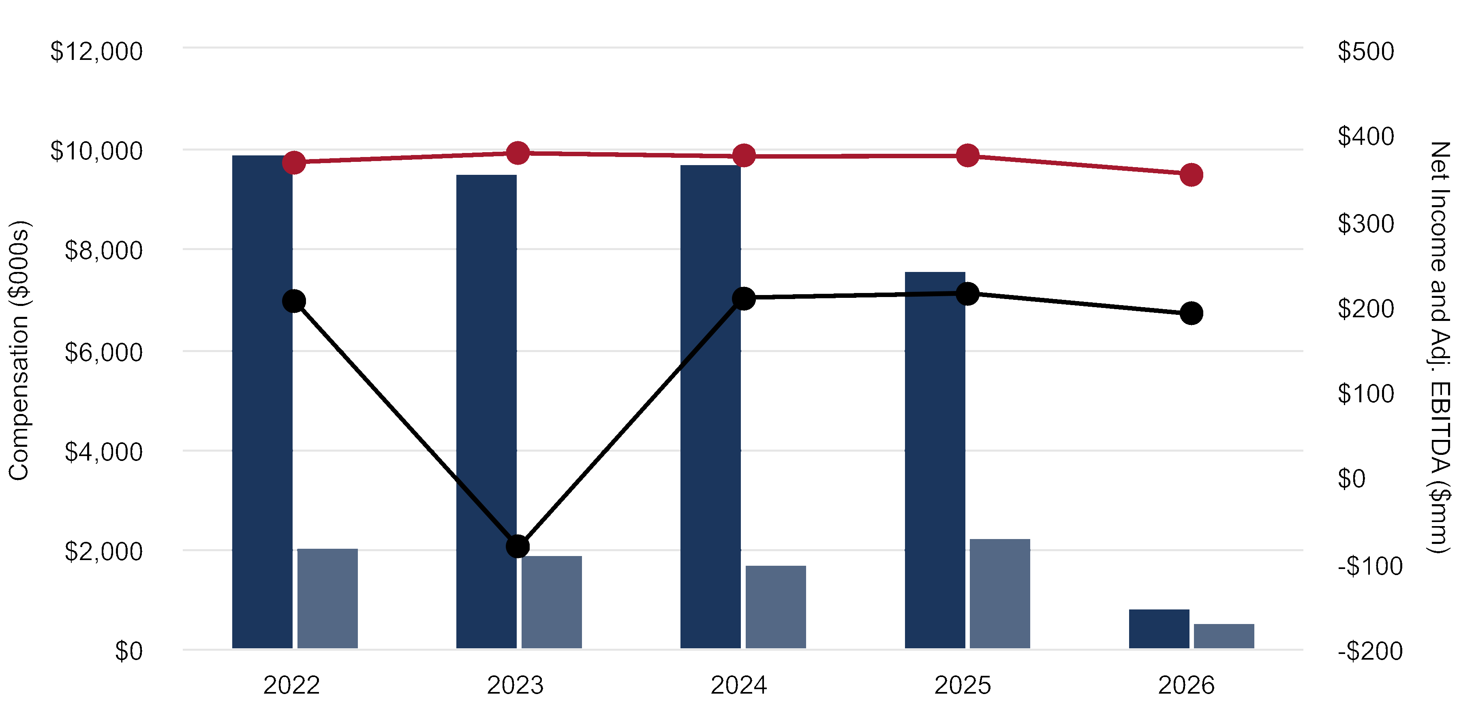
¢ | Compensation Actually Paid to CEO | ¢ | Average Compensation Actually Paid to Non-CEO NEOs
 | Prestige Net Income |  | Prestige Adjusted EBITDA
The table below shows the relationship between the compensation actually paid to the CEO and average non-CEO NEOs
relative to Total Shareholder Return for Prestige and the peer group for 2026, 2025, 2024, 2023, and 2022.
PAY VS TSR
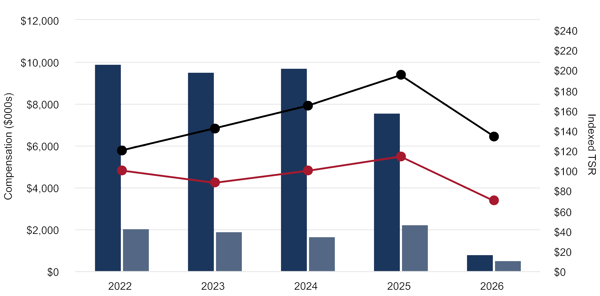
¢ | Compensation Actually Paid to CEO | ¢ | Average Compensation Actually Paid to Non-CEO NEOs
 | Prestige Total Shareholder Return |  | Peer Group Total Shareholder Return
68 |  | 2026 Proxy Statement | Prestige Consumer Healthcare Inc.

AUDIT MATTERS

PROPOSAL 3:
Ratification of Appointment of the Independent
Registered Public Accounting Firm
Who has the Audit and Finance Committee selected as the Company’s independent accounting firm for
fiscal 2027?
The Audit and Finance Committee has reappointed PricewaterhouseCoopers LLP as the independent registered public
accounting firm to audit the Company’s financial statements and evaluate its systems of internal control over financial
reporting for fiscal 2027. However, the Audit and Finance Committee may, in its discretion, decide to engage another
independent registered public accounting firm as the Company’s auditor for fiscal 2027.
Is stockholder approval required for the appointment of an independent accounting firm for 2027?
Stockholder ratification of the selection of PricewaterhouseCoopers LLP as our independent registered public accounting
firm is not required. However, the Board of Directors is submitting the selection of PricewaterhouseCoopers LLP to the
stockholders for ratification as a matter of good corporate practice. In the event the stockholders do not ratify the
appointment of PricewaterhouseCoopers LLP, the Audit and Finance Committee will reconsider the appointment; however,
the Audit and Finance Committee may, in its discretion, still direct the appointment of PricewaterhouseCoopers LLP.
Likewise, stockholder ratification of the selection of PricewaterhouseCoopers LLP would not prevent the Audit and Finance
Committee, in its discretion, from selecting and engaging another independent registered public accounting firm.
Will representatives of PricewaterhouseCoopers LLP attend the Annual Meeting?
Representatives of PricewaterhouseCoopers LLP are expected to be present at the Annual Meeting, either in person or by
videoconference or by telephone, will have the opportunity to make a statement if they desire to do so, and are expected to
be available to respond to appropriate questions.
Has the Audit and Finance Committee determined PricewaterhouseCoopers LLP’s independence from
the Company?
The Audit and Finance Committee has considered the relationships with and the non-audit services provided by
PricewaterhouseCoopers LLP and determined that the such relationships and the provision of such services had no effect
on PricewaterhouseCoopers LLP’s independence from the Company.
How many votes are needed to ratify the appointment of our independent accounting firm for 2027?
Approval of the proposal to ratify the appointment of PricewaterhouseCoopers LLP requires the affirmative vote of a
majority of the shares present and voting, in person or represented by proxy, at the Annual Meeting and entitled to vote on
the proposal.
What Does the Board of Directors Recommend?
The Board recommends that you vote FOR the ratification of PricewaterhouseCoopers LLP as the Company’s
independent registered public accounting firm for 2027.
Prestige Consumer Healthcare Inc. | 2026 Proxy Statement |  | 69
Audit Matters

Selection and Engagement of Auditors
The Audit and Finance Committee has the sole authority and responsibility to hire, evaluate and, when appropriate, replace the
Company’s independent registered public accounting firm and, in its capacity as a committee of the Board, is directly responsible
for the appointment, compensation and general oversight of the work of the independent auditors. Although the Audit and Finance
Committee has the sole authority to appoint the independent auditors, the Board submits its selection to our shareholders for
ratification as a matter of good corporate governance. In addition to the benefits of a long-term engagement, the Audit and
Finance Committee considers many factors when selecting the independent registered public accounting firm, including:
 |  |  |  |  |  | 
The quality and efficiency of  services through global capabilities  offered by the independent  registered public accounting firm |  |  | The appropriateness of the  independent registered public  accounting firm’s fees |  |  | The quality and candor of  communications between the  independent registered public  accounting firm and the Audit and  Finance Committee and management

Audit and Non-Audit Fees
For fiscal 2026 and 2025, the following fees were billed by PricewaterhouseCoopers LLP to the Company for the
indicated services:
 | 2026 |  | 2025
Audit Fees | $1,884,669 |  | $1,643,367
Audit Related Fees | 8,548 |  | 6,257
Tax Fees | 151,563 |  | 183,630
All Other Fees | 2,168 |  | —
Total Independent Accountant’s Fees | $2,046,948 |  | $1,833,254
Audit Fees. Consisted of fees billed for professional services rendered for (i) the audit of our consolidated financial statements
and internal control over financial reporting; (ii) the review of the interim consolidated financial statements included in quarterly
reports; and (iii) the services that are normally provided by PricewaterhouseCoopers LLP in connection with statutory and
regulatory filings or engagements. Audit fees for 2026 include additional audit procedures for an acquisition.
Audit-Related Fees. For 2026 and 2025, consisted of fees billed for assistance with compilation of statutory financial statements.
Tax Fees. Consisted of fees billed for professional services for tax compliance, tax advice and tax planning. These services
included assistance regarding federal, state and international tax compliance, customs and duties and tax planning.
All Other Fees. For 2026, consisted of fees for licensing software for accounting research.

Pre-Approval of Audit and Non-Audit Services
The Audit and Finance Committee’s policy is to pre-approve all audit and permissible non-audit services provided by the
independent registered public accounting firm. These services may include audit services, audit-related services, tax services
and other services. Pre-approval is generally provided for up to one year and any pre-approval is detailed as to the particular
service or category of services and is generally subject to a specific budget. The independent registered public accounting firm
and management are required to periodically report to the Audit and Finance Committee regarding the extent of services
provided by the independent registered public accounting firm in accordance with this pre-approval and the fees for the
services performed to date. The Audit and Finance Committee may also pre-approve particular services on a case-by-case
basis. During fiscal 2026, all audit and non-audit services were approved in accordance with the Audit and Finance
Committee’s pre-approval policy.
70 |  | 2026 Proxy Statement | Prestige Consumer Healthcare Inc.
Audit Matters

Report of the Audit and Finance Committee
This Audit and Finance Committee report shall not be deemed incorporated by reference by any general statement
incorporating by reference this Proxy Statement into any filing under the Securities Act or the Exchange Act, except to the
extent that we specifically incorporate this information by reference and shall not otherwise be deemed filed under the
Securities Act or the Exchange Act.
What is the Audit and Finance Committee and are its members “independent”?
The Audit and Finance Committee is composed of four directors appointed by the Board of Directors, all of whom are independent
from the Company and its management as independence for audit committee members is defined in the NYSE listing standards
and Rule 10A-3 under the Exchange Act. The Audit and Finance Committee operates under a written charter adopted by the
Board of Directors, which is available at the “Investors” tab on our website at www.prestigeconsumerhealthcare.com and is also
available in print to any stockholder or other interested party who makes a written request to the Company’s Corporate Secretary.
The primary function of the Audit and Finance Committee is to assist the Board of Directors in its oversight and monitoring of our
financial reporting and audit process, our system of internal control, our risk assessment process (including with respect to cyber
risk and privacy) and our process for monitoring compliance with laws, regulations and policies. The Audit and Finance Committee
also recommends to the Board of Directors the selection of the Company’s independent registered public accounting firm.
Are the members of the Audit and Finance Committee “financially literate”?
The members of the Audit and Finance Committee are financially literate as that qualification is interpreted by the Board of
Directors and the NYSE. In addition, the Board has determined that each of Messrs. Byom and D’Arecca and Ms. Zier is an
“audit committee financial expert” as defined by SEC regulations.
What is the relationship between management and the Audit and Finance Committee?
Management has the primary responsibility for establishing and monitoring adequate internal accounting and financial controls,
the financial reporting process for preparing financial statements, and compliance with the Company’s legal and ethics
programs. PricewaterhouseCoopers LLP is responsible for performing an independent audit of the Company’s consolidated
financial statements and internal control over financial reporting in accordance with auditing standards generally accepted in
the United States of America and for issuance of a report thereon.
The Audit and Finance Committee’s responsibility is to monitor and oversee these processes and report its findings to the full
Board of Directors.
Prestige Consumer Healthcare Inc. | 2026 Proxy Statement |  | 71
Audit Matters
What steps did the Audit and Finance Committee take in recommending that our audited financial statements be
included in our annual report?
•The Audit and Finance Committee met and held discussions separately and jointly with each of management and
PricewaterhouseCoopers LLP regarding the Company’s audited consolidated financial statements for fiscal 2026,
management’s assessment of the effectiveness of the Company’s internal control over financial reporting and
PricewaterhouseCoopers LLP’s audit of the effectiveness of the Company’s internal control over financial reporting.
•Management represented to the Audit and Finance Committee that the Company’s audited consolidated financial
statements were prepared in accordance with accounting principles generally accepted in the United States of America, on
a consistent basis, and the Audit and Finance Committee has reviewed and discussed the quarterly and annual earnings
press releases and consolidated financial statements with management and PricewaterhouseCoopers LLP. The Audit and
Finance Committee discussed with PricewaterhouseCoopers LLP matters required to be discussed by Public Company
Accounting Oversight Board (“PCAOB”) Auditing Standard No. 1301, as amended, “Communications with
Audit Committees.”
•The Audit and Finance Committee also received the written disclosures and the letter from PricewaterhouseCoopers LLP
required by PCAOB Rule 3526, “Communication with Audit Committees Concerning Independence” and discussed with
PricewaterhouseCoopers LLP their independence. The Audit and Finance Committee also considered whether
PricewaterhouseCoopers LLP’s provision of non-audit services to the Company is compatible with maintaining
PricewaterhouseCoopers LLP’s independence from the Company. The Audit and Finance Committee concluded that
PricewaterhouseCoopers LLP is independent from the Company and its management. PricewaterhouseCoopers LLP has
been the Company’s independent registered public accounting firm since at least 1999.
Based on its review of the Company’s audited financial statements and the discussions noted above, the Audit and Finance
Committee recommended to the Board of Directors that the Company’s audited consolidated financial statements for fiscal
2026 be included in the Company’s Annual Report on Form 10-K for 2026 for filing with the SEC.
MEMBERS OF THE 2026 AUDIT AND FINANCE COMMITTEE
James C. D’Arecca (Chair)
John E. Byom
Sheila A. Hopkins
Dawn M. Zier
72 |  | 2026 Proxy Statement | Prestige Consumer Healthcare Inc.

SECURITY OWNERSHIP
INFORMATION

Securities Ownership of Certain Beneficial Owners
and Management
The following table sets forth certain information with respect to the beneficial ownership of our common stock as of
June 10, 2026 by:
•each of our named executive officers;
•each of our directors and nominees for director;
•all directors and executive officers as a group; and
•each person or entity known to us to be the beneficial owner of more than five percent of our outstanding shares of
common stock.
Unless otherwise indicated, (i) each person or entity named below has sole voting and investment power with respect to the
number of shares set forth opposite his, her or its name; and (ii) the address of each person named in the table below is c/o
Prestige Consumer Healthcare Inc., 660 White Plains Road, Tarrytown, New York 10591.
 | Shares Beneficially Owned
Name of Beneficial Owner | Number | Percentage(1)
5% or more Stockholders:
BlackRock, Inc.(2) | 7,524,587 | 15.9%
Ariel Investments, LLC(3) | 4,102,497 | 8.7%
Dimensional Fund Advisors LP(4) | 2,907,066 | 6.1%
Vanguard Portfolio Management(5) | 2,826,536 | 6.0%
Vanguard Capital Management(6) | 2,454,974 | 5.2%
Directors and Named Executive Officers:
Ronald M. Lombardi | 376,501 | *
Adel Mekhail(7) | 21,776 | *
William C. P’Pool(8) | 51,003 | *
Christine Sacco(9) | 95,829 | *
Jeffrey Zerillo(10) | 61,107 | *
John E. Byom | 49,500 | *
Celeste A. Clark | 11,436 | *
James C. D’Arecca | 4,497 | *
Sheila A. Hopkins | 28,029 | *
John F. Kelly | 2,757 | *
Dawn M. Zier | 14,439 | *
All directors and executive officers as a group (11 persons)(11) | 716,874 | 1.5%
*Denotes less than one percent.
(1)Percent is based on 47,372,166 shares of our common stock outstanding as of June 10, 2026.
(2)The address for BlackRock, Inc. is 50 Hudson Yards, New York, NY 10001. BlackRock, Inc., together with its subsidiaries, affiliates, and
certain other business units, has sole voting power with respect to 7,423,766 shares and sole dispositive power with respect to 7,524,587
shares. The information disclosed herein was obtained from the Schedule 13G/A filed with the SEC by BlackRock, Inc. on April 30, 2025.
Prestige Consumer Healthcare Inc. | 2026 Proxy Statement |  | 73
Security Ownership Information
(3)The address for Ariel Investments, LLC. is 200 E. Randolph Street, Suite 2900, Chicago, IL 60601. Ariel Investments, LLC has sole voting
power with respect to 3,672,254 shares and sole dispositive power with respect to 4,102,497 shares. The information disclosed herein was
obtained from the Schedule 13G/A filed with the SEC by Ariel Investments, LLC on February 13, 2026.
(4)The address for Dimensional Fund Advisors LP is 6300 Bee Cave Road, Building One, Austin, TX 78746. Dimensional Fund Advisors LP
has sole voting power with respect to 2,827,065 shares and sole dispositive power with respect to 2,907,066 shares. Dimensional Fund
Advisors LP or its subsidiaries serve as investment manager, sub-adviser and/or adviser to certain investment companies, commingled
funds, group trusts and separate accounts that own all the reported shares. Dimensional Fund Advisors LP disclaims beneficial ownership
of such shares. The information disclosed herein was obtained from the Schedule 13G/A filed with the SEC by Dimensional Fund Advisors
LP on January 23, 2025.
(5)The address for Vanguard Portfolio Management is 100 Vanguard Blvd., Malvern, PA 19355. Vanguard Portfolio Management together
with Vanguard Fiduciary Trust Company and Vanguard Global Advisers LLC has sole voting power with respect to 22,708 shares and sole
dispositive power with respect to 2,826,536 shares. The information disclosed herein was obtained from the Schedule 13G/A filed with the
SEC by Vanguard Portfolio Management on April 29, 2026.
(6)The address for Vanguard Capital Management is 100 Vanguard Blvd., Malvern, PA 19355. Vanguard Capital Management has sole voting
power with respect to 361,981 shares and sole dispositive power with respect to 2,454,974 shares. The information disclosed herein was
obtained from the Schedule 13G/A filed with the SEC by Vanguard Capital Management on April 30, 2026.
(7)Includes shares of the Company’s common stock underlying options that vested and became exercisable as follows: 2,842 shares on
May 2, 2025.
(8)Includes shares of the Company’s common stock underlying stock options that vested and became exercisable as follows: (i) 2,111 shares
on each of May 8, 2018, 2019, and 2020; (ii) 3,832 shares on each of May 3, 2022, 2023 and 2024; (iii) 2,731 shares on May 2, 2023; and
(iv) 2,732 shares on May 2, 2024 and 2025.
(9)Includes shares of the Company’s common stock underlying stock options that vested and became exercisable as follows: (i) 6,868 on
each of May 4, 2021, 2022 and 2023; (iv) 7,310 shares on each of May 3, 2022, 2023 and 2024; (v) 5,683 shares on each of May 2, 2023
and 2024; and (vi) 5,684 shares on May 2, 2025.
(10)Includes shares of the Company’s common stock underlying stock options that vested and become exercisable as follows: (i) 3,359 shares
on each of May 7, 2019 and 2020; (ii) 3,360 shares on May 7, 2021; (iii) 3,354 shares on each of May 6, 2020 and 2021; (iv) 3,355 shares
on May 6, 2022; (v) 2,799 shares on May 4, 2021; (vi) 2,800 shares on each of May 4, 2022 and 2023; (vii) 2,600 shares on May 3, 2022;
(viii) 2,601 shares on each of May 3, 2023 and 2024; (ix) 1,838 shares on May 2, 2023; and (x) 1,839 shares on May 2, 2024 and 2025.
(11)Includes 130,308 shares of the Company’s common stock underlying stock options currently exercisable or exercisable within 60 days of
June 10, 2026.

Delinquent Section 16(a) Reports
Section 16(a) of the Exchange Act requires the Company's directors and executive officers, and persons who own more than
10% of a registered class of the Company's equity securities, to file with the SEC initial reports of ownership and reports of
changes in ownership of common stock and other equity securities of the Company. Officers, directors and greater than 10%
shareholders are required by SEC regulations to furnish the Company with copies of all Section 16(a) forms they file.
Based solely on a review of the copies of such reports furnished to the Company and written representations that no other
reports were required, the Company believes that all filing requirements applicable to its officers, directors and greater than
10% beneficial owners were complied with during fiscal 2026, except that Jose Luis Rosado did not timely file his Form 3 and
did not timely file one Form 4 reporting a grant from the Company upon joining the Company in January 2026. Both Forms
have been subsequently filed.
74 |  | 2026 Proxy Statement | Prestige Consumer Healthcare Inc.
Security Ownership Information

Equity Compensation Plan Information
The following table sets forth certain information regarding our equity compensation plans as of March 31, 2026.
Plan Category | Number of  Securities  to Be  Issued Upon  Exercise of  Outstanding  Options,  Warrants  and Rights  (A) |  | Weighted-  Average  Exercise  Price of  Outstanding  Options,  Warrants  and Rights  (B) |  | Number of  Securities  Remaining  Available For  Future Issuance  Under Equity  Compensation  Plans (Excluding  Securities  Reflected In  Column (A))  (C)
Equity compensation plans approved by security holders(1) | 1,196,959 | (2) | $56.40 | (3) | 1,423,704 | (4)(5)
Equity compensation plans not approved by security holders | — |  | — |  | —
Total | 1,196,959 |  | $56.40 |  | 1,423,704
(1)2020 LTIP replaced the 2005 LTIP upon stockholder approval of the 2020 LTIP on August 4, 2020. No further grants will be made under
the 2005 LTIP.
(2)Consists of shares issuable pursuant to the exercise of outstanding stock options and the conversion of outstanding restricted stock units
and performance stock unit awards (assuming achievement of maximum performance levels).
(3)Calculation of the weighted-average exercise price of outstanding awards includes stock options but does not include restricted stock units
and performance stock units that convert to shares of common stock for no consideration.
(4)All such shares may be issued pursuant to grants of full-value stock awards.
(5)All remaining available securities are from the 2020 LTIP.
Prestige Consumer Healthcare Inc. | 2026 Proxy Statement |  | 75

INFORMATION ABOUT THE
ANNUAL MEETING

General Information
What is this document?
This document is the Proxy Statement of Prestige Consumer Healthcare Inc. for the 2026 Annual Meeting of Stockholders to
be held at 10:00 a.m., Eastern Daylight Time, on Tuesday, August 4, 2026 at the Company’s offices, 660 White Plains Road,
Tarrytown, New York 10591. A proxy card is included.
We have tried to make this document simple and easy to understand. The SEC encourages companies to use “plain English,”
and we will always try to communicate with you clearly and effectively.
Why am I receiving this document?
You are receiving this document because you were one of our stockholders at the close of business on June 10, 2026, the
record date for our 2026 Annual Meeting. We are furnishing this Proxy Statement and the enclosed proxy card to you to solicit
your proxy (i.e., your permission) to vote your stock in connection with certain matters at the Annual Meeting.
If your shares are held by a bank or brokerage firm, you are considered the “beneficial owner” of shares held in “street name.”
If your shares are held in “street name,” your bank or brokerage firm forwarded these proxy materials, along with a voting
instruction card, to you.
What is a proxy?
A proxy is your legal designation of another person, called a “proxy,” to vote the stock you own. The document that designates
someone as your proxy is also called a proxy or a proxy card.
Giving us your proxy means that you authorize the proxy holders identified on the enclosed proxy card — Christine Sacco and
William C. P’Pool — to vote your shares at the Annual Meeting in the manner you direct.
Who is soliciting my vote?
In this Proxy Statement, the Board of Directors is soliciting your vote for matters being submitted for stockholder approval at
the 2026 Annual Meeting.
Will anyone be compensated to solicit my vote?
The cost of proxy solicitation, including the cost of preparing, assembling, printing, mailing and distributing these proxy
materials, will be paid by the Company. Our directors, officers and employees will not receive additional compensation for their
proxy solicitation efforts, but they may be reimbursed for out-of-pocket expenses in connection with any solicitation. We also
may reimburse custodians, nominees and fiduciaries for their expenses in sending proxies and proxy material to beneficial
owners of our stock.
Who may attend the Annual Meeting?
Only stockholders, their proxy holders and our invited guests may attend the Annual Meeting. For security reasons, we may
require photo identification for admission. If your shares are held in “street name” by a broker, bank or other nominee, please
bring a copy of the account statement reflecting your ownership of our common stock, so that we may verify your stockholder
status.
What if I have a disability?
If you are disabled and would like to participate in the Annual Meeting, we can provide reasonable assistance. Please send
any request for assistance to Prestige Consumer Healthcare Inc., 660 White Plains Road, Tarrytown, New York 10591,
Attention: Corporate Secretary, at least two weeks before the meeting.
76 |  | 2026 Proxy Statement | Prestige Consumer Healthcare Inc.
Information About the Annual Meeting
What is Prestige Consumer Healthcare and where is it located?
Prestige Consumer Healthcare Inc. is a holding company incorporated under the laws of the State of Delaware that, through its
wholly owned subsidiaries, markets and distributes well-recognized, brand name over-the-counter healthcare products
throughout the U.S. and Canada, and in certain international markets. Major brands include Breathe Right®, Monistat®, Nix®,
Chloraseptic®, Clear Eyes®, Compound W®, DenTek®, Luden’s®, Dramamine®, BC®, Goody’s®, TheraTears®, Debrox®, Fleet®,
Summer’s Eve®, Boudreaux’s Butt Paste®, Hydralyte®, Fess®, as well as Gaviscon® in Canada. Our principal executive offices
are located at 660 White Plains Road, Tarrytown, New York 10591. Our telephone number is (800) 831-7105.
Where is our common stock traded?
Our common stock is traded and quoted on the NYSE under the symbol “PBH.”

Voting Matters
Proposal |  |  | Board’s  Recommendation | See Page
1 | To elect the six directors nominated by the Board of Directors and named in this Proxy  Statement to serve until the 2027 Annual Meeting of Stockholders or until their earlier  death, removal or resignation |  | FOR each  director nominee | 14
 | •Ronald M. Lombardi  •John E. Byom  •Celeste A. Clark | •James C. D’Arecca  •John F. Kelly  •Dawn M. Zier |  | 14
2 | To vote on a non-binding resolution to approve the compensation of our named executive  officers as disclosed in our Proxy Statement |  | FOR | 40
3 | To ratify the appointment of PricewaterhouseCoopers LLP as the independent registered  public accounting firm of Prestige Consumer Healthcare Inc. for the fiscal year ending  March 31, 2027 |  | FOR | 68
Who is entitled to vote?
You may vote if you owned shares of our common stock at the close of business on June 10, 2026. Each share of common
stock is entitled to one vote. As of June 10, 2026, there were 47,372,166 shares of our common stock outstanding. A list of our
stockholders will be open to the examination of any stockholder, for any purpose relevant to the meeting, at our headquarters
during ordinary business hours for a period of 10 days prior to the Annual Meeting and at the Annual Meeting.
May other matters be raised at the Annual Meeting?
We currently are not aware of any business to be acted upon at the Annual Meeting other than the matters described above.
Under federal securities laws, Delaware law and our governing documents, no other business aside from procedural matters
may be raised at the Annual Meeting unless proper notice has been given to the Company by the stockholders. If other
business is properly raised and you have returned a signed proxy card with or without voting instructions or have voted by
the internet or telephone, your proxies have authority to vote your shares as they think best on such business, including to
adjourn the meeting.
How will the meeting be conducted?
The Chair of the meeting has broad authority to conduct the Annual Meeting so that the business of the meeting is carried out
in an orderly and timely manner. In doing so, he has broad discretion to establish reasonable rules for discussion, comments
and questions during the Annual Meeting. The Chair of the Annual Meeting is also entitled to rely upon applicable law regarding
disruptions or disorderly conduct to ensure that the Annual Meeting proceeds in a manner that is fair to all participants.
Prestige Consumer Healthcare Inc. | 2026 Proxy Statement |  | 77
Information About the Annual Meeting
How do I vote?
If you own shares registered directly with the Company’s transfer agent, you may vote by the internet, or by signing and
returning the enclosed proxy card. For more information about how to vote, please see the instructions on your proxy card.
If your shares are held in “street name,” your bank or brokerage firm forwarded these proxy materials, as well as a voting
instruction card, to you. Please follow the instructions on the voting instruction card to vote your shares.
In addition to voting by proxy, you may vote in person at the Annual Meeting. Beneficial owners who hold shares in “street
name” and who wish to vote in person at the Annual Meeting must bring a power of attorney or legal proxy from their bank,
broker or other nominee. However, to assist us in tabulating votes at the Annual Meeting, we encourage you to vote by proxy
even if you plan to be present at the Annual Meeting. Even if you vote prior to the Annual Meeting, stockholders are entitled to
attend the Annual Meeting. Please see “Who may attend the Annual Meeting?” above for instructions on attending the
Annual Meeting.
What materials are available on the Internet?
This Proxy Statement, our Annual Report on Form 10-K, our 2026 Annual Report to Stockholders and other financial
documents are available free of charge at the “Investors” tab on our corporate website at
www.prestigeconsumerhealthcare.com. The Proxy Statement and our Annual Report on Form 10-K also are available free
of charge on the SEC’s website at www.sec.gov.
How will my proxy be voted?
If you are a registered stockholder, the individuals named on the proxy card will vote your shares in the manner you indicate on
your proxy card. You may vote for all, some or none of the director nominees. You may also abstain from voting. If your proxy
card is signed and returned but does not contain specific voting instructions, your shares will be voted “FOR” the election of
the directors named as nominees in this Proxy Statement, “FOR” the ratification of the appointment of our independent
registered public accounting firm, and “FOR” the approval of the compensation of our named executive officers as disclosed in
this Proxy Statement. If any other matters are properly presented at the Annual Meeting for consideration, the persons named
as proxies on the enclosed proxy card will vote your shares on such matters as they think best in their own discretion.
If your shares are held in “street name,” you have the right to direct your bank or brokerage firm how to vote your shares, and
the record holder is required to vote your shares in accordance with your instructions. If you do not give instructions to your
bank or brokerage firm, it will nevertheless be entitled to vote your shares with respect to “routine” items, but it will not be
permitted to vote your shares with respect to “non-routine” items. In the case of a non- routine item, your shares will be
considered “broker non-votes” on that proposal.
Can I change my vote or revoke my proxy after I vote?
Yes. If you are a registered stockholder, to change your vote or revoke your proxy you must: cast a new vote by the internet or
telephone prior to 11:59 p.m., Eastern Daylight Time, on August 3, 2026; by signing another proxy card with a date later then
the date of the latest proxy card you submitted and returning it to Vote Processing, c/o Broadridge, 51 Mercedes Way,
Edgewood, NY 11717, by 5:00 p.m., Eastern Daylight Time, on August 3, 2026; provide a written notice of revocation dated
later than the date of the latest proxy card you submitted to Vote Processing, c/o Broadridge, 51 Mercedes Way, Edgewood,
NY 11717, by 5:00 p.m., Eastern Daylight Time, on August 3, 2026; or attend the Annual Meeting and vote in person. Note that
attendance at the Annual Meeting will not revoke a proxy if you do not actually vote at the Annual Meeting. “Street name”
stockholders should refer to the instructions above under “How do I vote?” to vote at the Annual Meeting.
If you hold your shares in “street name,” the above options for changing your vote or revoking your instructions (other than
attending the Annual Meeting and voting in person) do not apply, and you must follow the instructions received from your bank
or broker to change your vote or revoke your proxy.
What if I receive more than one copy of these proxy materials?
The receipt of multiple copies of these proxy materials means that you have more than one account with brokers or our
transfer agent. Please vote all of your shares. We also recommend that you contact your broker and/or our transfer agent to
consolidate as many accounts as possible under the same name and address. Our transfer agent is Equiniti Trust Company,
LLC, 28 Liberty Street, Floor 53, New York, NY 10005 and they can be reached at (718) 921-8300. In addition, any
stockholders who share an address and are receiving multiple copies of our proxy material can request delivery of a single
copy of our proxy materials by sending a written request addressed to Prestige Consumer Healthcare Inc., 660 White Plains
Road, Tarrytown, New York 10591, Attention: Corporate Secretary.
78 |  | 2026 Proxy Statement | Prestige Consumer Healthcare Inc.
Information About the Annual Meeting
How many shares must be present to hold the Annual Meeting?
A quorum must be present at the Annual Meeting for any business to be conducted. A quorum exists when the holders of a
majority of the 47,372,166 shares of our common stock outstanding at the close of business on June 10, 2026 and entitled to
vote at the Annual Meeting are present in person or by proxy at the Annual Meeting. The shares represented by withhold
votes, abstentions and “broker non-votes” regarding proposals in the Proxy Statement will be considered present for
quorum purposes.
How many votes are required to approve each proposal in the Proxy Statement?
•Election of Directors. A plurality of the votes of shares present, in person or represented by proxy, at the Annual Meeting
and entitled to vote in the election of directors is necessary for the election of directors. This means that the six director
nominees receiving the greatest number of “For” votes will be elected. You may vote in favor of all nominees, withhold your
vote as to all nominees or withhold your vote as to specific nominees. If you withhold your vote as to all or specific
nominees, your shares will not be voted with respect to the nominee or nominees indicated.
•Approval of Compensation of our Named Executive Officers. The approval of the non-binding resolution to approve
the compensation of our named executive officers requires the affirmative vote of a majority of the shares present and
voting, in person or represented by proxy, and entitled to vote on the proposal. Abstentions will be counted against this
matter. If the proposal is not approved by the required majority vote, the Board of Directors and the Compensation and
Talent Management Committee will take into account the result of the vote when determining future executive compensation
arrangements, particularly if the votes cast against the resolution exceed the number of votes cast in favor of the resolution.
•Ratification of Appointment of PricewaterhouseCoopers LLP as our Independent Registered Public Accounting
Firm. The ratification of the appointment of PricewaterhouseCoopers LLP as our independent registered public accounting
firm requires the affirmative vote of a majority of the shares present and voting, in person or represented by proxy and
entitled to vote on the proposal. Abstentions will be counted against this matter.
What is the effect of not voting?
If you are a stockholder of record and submit a signed proxy without specifying a choice on any given matter to be considered
at the Annual Meeting, the proxy holders will vote your shares according to the Board’s recommendation on each matter. If you
are a stockholder of record and you do not sign and return a proxy card or vote by the internet or telephone, your shares will
not count toward the quorum requirement or towards any proposal at the Annual Meeting and will not have any affect on any
proposal at the Annual Meeting (unless a quorum is not established).
If you hold shares in “street name”, then, under NYSE rules and Delaware law:
•Election of Directors. With respect to the election of directors, your broker is not entitled to vote your shares on this matter
if your broker does not receive instructions from you. A broker non-vote is not considered a vote and, therefore, it will have
no effect on the election of directors.
•Approval of Compensation of our Named Executive Officers. With respect to the advisory vote on the compensation of
our named executive officers, your broker is not entitled to vote your shares on this matter if your broker does not receive
instructions from you. Broker non-votes will have no effect on the outcome of this matter.
•Ratification of Appointment of PricewaterhouseCoopers LLP as our Independent Registered Public Accounting
Firm. With respect to ratification of the appointment of our independent registered accounting firm, your broker is entitled
to vote your shares on this matter if no instructions are received from you, so there will be no broker non-votes on
this proposal.
How many votes do I have, and can I cumulate my votes?
You have one vote for every share of our common stock that you own. Cumulative voting is not allowed.
In order to support your Board, please sign, date and mail the enclosed proxy card to vote FOR the election of the six
director nominees nominated by your Board, FOR the approval of the compensation of our named executive officers,
and FOR the ratification of PricewaterhouseCoopers LLP as the Company’s independent registered public accounting
firm. You may also vote over the internet or by telephone using the information on the proxy card. If your shares are
held in “street name”, you should follow the instructions on your voting instruction card to provide specific instructions
to your bank or broker to vote as described above.
Prestige Consumer Healthcare Inc. | 2026 Proxy Statement |  | 79

OTHER MATTERS

Certain Relationships and Related Transactions
No person or entity had significant business relationships with us since the beginning of fiscal 2026 that would require
disclosure under applicable SEC regulations, and no transactions that would need to be disclosed under SEC regulations are
currently planned for fiscal 2027.
Related Persons Transaction Policy
The Company adopted a Related Persons Transaction Policy. A summary of the Related Persons Transaction Policy is set forth
below and the full text of the Policy is available at the “Investors” tab on our website at www.prestigeconsumerhealthcare.com.
Transactions Subject to the Policy. A Related Person Transaction is a transaction in which the Company (which, for
purposes of determining whether a transaction qualifies, includes the Company’s subsidiaries) is or will be a Participant (as
defined below), involving an amount exceeding $120,000, and in which any Related Person (as defined below) had or will
have a direct or indirect material interest. The term “Participant” is broadly defined to include situations in which the Company
is not technically a party but has influenced another party to enter into a transaction or provide value to a Related Person. For
example, facilitating the use of a Related Person as a supplier to the Company’s contract manufacturer would constitute
“participation” by the Company and bring such an arrangement within the scope of the Policy.
The following transactions are exempt from the Policy:
•Payment of compensation by the Company to a Related Person for service to the Company in the capacity or capacities
that give rise to the person’s status as a Related Person, so long as the compensation is publicly disclosed, if such
disclosure is required, in the Company’s Annual Report on Form 10-K (or Proxy Statement or information statement
incorporated by reference into such Annual Report);
•Transactions available to all employees or all stockholders of the Company on the same terms and conditions; and
•Transactions that, when aggregated with the amount of all other transactions between the Related Person and the
Company, involve less than $120,000 in a fiscal year.
Definition of Related Person. For purposes of the Policy, a “Related Person” means:
•Any person who is, or at any time since the beginning of the Company’s most recently completed fiscal year was, a director
or executive officer of the Company or a nominee to become a director of the Company;
•Any person who is known to be the beneficial owner of more than 5% of any class of the Company’s voting securities;
•Any Immediate Family Member (as defined in the Policy) of any of the foregoing persons; and
•Any Affiliate (as defined in the Policy) of any of the foregoing persons or Immediate Family Members.
Notification Procedures. A transaction with a Related Person that is identified in advance is required to be disclosed to the
Company’s General Counsel for review. In the event the Company becomes aware of a transaction with a Related Person that
was not disclosed to the Company, the General Counsel will review the transaction. If the General Counsel determines that a
transaction is a Related Person Transaction subject to the Policy, he will submit such transaction to the Audit and Finance
Committee for consideration at its next meeting or, if it is not practicable or desirable to wait until the next meeting, to the Chair
of the Audit and Finance Committee for prompt consideration. The Audit and Finance Committee, or the Chair of the Audit and
Finance Committee, is authorized to approve those Related Person Transactions that are in, or are not inconsistent with, the
best interests of the Company and its stockholders, and that are consistent with the Company’s Code of Conduct and Ethics
and Code of Ethics for Senior Financial Employees, as the Audit and Finance Committee or the Chair of the Audit and Finance
Committee determines in good faith. The Audit and Finance Committee or the Chair of the Audit and Finance Committee will
consider the relevant facts and circumstances of the Related Person Transaction, including (if applicable) the non-exclusive list
of considerations set forth in the Related Persons Transaction Policy. Any ongoing or completed Related Person Transaction
that is disapproved by the Audit and Finance Committee or the Chair of the Audit and Finance Committee is subject to
corrective action.
80 |  | 2026 Proxy Statement | Prestige Consumer Healthcare Inc.
Other Matters

Submission of Stockholder Proposals and
Director Nominations
How do I submit a stockholder proposal for inclusion in the Proxy Statement for next year’s Annual Meeting?
To be included in our Proxy Statement for our 2027 Annual Meeting of Stockholders pursuant to SEC Rule 14a-8, a proposal
must be submitted by an eligible stockholder who complies with SEC Rule 14a-8 and must be received by us at our principal
executive offices at 660 White Plains Road, Tarrytown, New York 10591, Attention: Corporate Secretary, by March 1, 2027 (or,
if the 2026 Annual Meeting of Stockholders is called for a date more than 30 days before or after August 4, 2027, within a
reasonable time before we begin to print and mail our proxy materials for the 2027 Annual Meeting).
When and how must I submit a notice to introduce a director nomination or other item of business for it to be raised
at the 2027 Annual Meeting of Stockholders, but not included in the Company’s Proxy Statement?
Assuming that our 2027 Annual Meeting of Stockholders is not held more than 30 days prior to or delayed by more than
60 days after August 4, 2027, our Amended and Restated Bylaws provide that we must receive written notice of your intention
to introduce a director nomination or other item of business at the 2027 Annual Meeting not less than 90 nor more than 120
days prior to August 4, 2027 (or between April 6, 2027 and May 6, 2027). If the 2027 Annual Meeting is held more than 30
days prior to or delayed by more than 60 days after August 4, 2027, our Amended and Restated Bylaws provide that we must
receive your notice not earlier than the close of business on the 120th day prior to the date of such annual meeting and not
later than the close of business on the later of (i) the 90th day prior to such annual meeting or (ii) the 10th day following the
date on which public disclosure of such meeting was made. In the event a special stockholders meeting to elect directors is
called, our Amended and Restated Bylaws provide that we must receive your notice not later than the close of business on the
10th day following the date on which public disclosure of such meeting was made. If we do not receive notice within the
prescribed dates, or you do not meet other requirements specified in our Amended and Restated Bylaws or the SEC’s rules,
such matters will not be brought before the meeting. In addition, nominations or proposals not made in accordance with the
procedures described in our Amended and Restated Bylaws may be disregarded by the Chair of the meeting. Any stockholder
interested in making such a nomination or proposal should request a copy of our Amended and Restated Bylaws from the
Corporate Secretary.
Any written stockholder proposal or nomination for director to be presented at a meeting of our stockholders must comply with
the procedures and such other requirements as may be imposed by our Amended and Restated Bylaws, Delaware law, the
NYSE, the Exchange Act (including the information required by Rule 14a-19(b) including a statement that the nominating
stockholder intends to solicit the holders of shares representing at least 67% of the voting power of shares entitled to vote in
the election of directors in support of the nominee), and the rules and regulations of the SEC and must include the information
necessary for the Board of Directors to determine whether the candidate (with respect to a nomination for director only)
qualifies as independent under the NYSE’s and SEC’s rules and possesses the qualifications and experience we expect our
directors to have.

Form 10-K
We will furnish without charge to each person whose proxy is being solicited, upon written request of any such person, a copy
of our Annual Report on Form 10-K for the fiscal year ended March 31, 2026, as filed with the SEC, including the financial
statements and financial statement schedule thereto. Written requests for copies of our Annual Report on Form 10-K for the
fiscal year ended March 31, 2026 should be directed to Prestige Consumer Healthcare Inc., 660 White Plains Road,
Tarrytown, New York 10591, Attention: Corporate Secretary. Our Annual Report on Form 10-K for the fiscal year ended
March 31, 2026 can also be downloaded without charge from the “Investors” tab of our website at
www.prestigeconsumerhealthcare.com.
Prestige Consumer Healthcare Inc. | 2026 Proxy Statement |  | 81
Other Matters
By Order of the Board of Directors

William C. P’Pool
Senior Vice President, General Counsel & Corporate Secretary
June 29, 2026
82 |  | 2026 Proxy Statement | Prestige Consumer Healthcare Inc.

APPENDIX A

About Non-GAAP Financial Measures
We are presenting Adjusted EBITDA because it is a metric included in our Annual Cash Incentive Plan (“AIP”) against which
our performance is measured. We define Non-GAAP AIP Adjusted EBITDA as GAAP net income (loss), plus interest expense,
provision for taxes, and depreciation and amortization, with additional adjustments for integration, transition, purchase
accounting, legal and various other costs associated with acquisitions, divestitures and business transitions, goodwill and
tradename impairment loss on disposal of assets and extinguishment of debt.
We define Non-GAAP Adjusted Net Income as GAAP Net Income before amortization of inventory fair value step-up,
depreciation of idle manufacturing assets during remediation period, acquired facility remediation, period overhead and idle
capacity costs, supplier loan write-off, costs associated with acquisition in General and administrative expense, goodwill and
tradename impairment, applicable tax impact associated with these items and normalized tax rate adjustment. Reported GAAP
Diluted EPS is calculated using diluted shares outstanding, which were 48,720 for the year ended March 31, 2026 and 50,080
for the year ended March 31, 2025.
The following tables set forth the reconciliation of Organic Revenue, Adjusted EBITDA, Adjusted Net Income, Adjusted Diluted
EPS and Adjusted Free Cash Flow, which are non-GAAP financial measures, to our most directly comparable GAAP financial
measure. The tables also reconcile Non-GAAP Adjusted EBITDA to GAAP Net Income used for our May 2023 Performance
Grant Payout.
ORGANIC REVENUE AND ORGANIC REVENUE CHANGE
(Dollar Values in Thousands)
 | Year Ended March 31,
 |  | 2026 |  | 2025
(In thousands)
GAAP Total Revenues |  | $1,088,705 |  | $1,137,762
Revenue Change |  | (4.3)%
Adjustments:
Impact of foreign currency exchange rates |  | — |  | 2,718
Total adjustments |  | — |  | 2,718
Non-GAAP Organic Revenues |  | $1,088,705 |  | $1,140,480
Non-GAAP Organic Revenue Change |  | (4.5)%
Prestige Consumer Healthcare Inc. | 2026 Proxy Statement |  | 83
Appendix A
ADJUSTED EBITDA
(Dollar Values in Thousands)
 | Year Ended March 31,
 |  | 2026 |  | 2025
GAAP Net Income |  | $190,301 |  | $214,605
Interest Expense, net |  | 42,339 |  | 47,632
Provision for income taxes |  | 67,195 |  | 69,584
Depreciation and amortization |  | 31,273 |  | 30,173
Non-GAAP EBITDA |  | 331,108 |  | 361,994
Amortization of inventory fair value step-up |  | 700 |  | —
Acquired facility remediation, period overhead and idle capacity costs |  | 8,402 |  | —
Costs associated with acquisitions in G&A |  | 3,228 |  | —
Supplier loan write-off |  | 10,332 |  | —
Tradename impairment |  | — |  | 12,466
Non-GAAP Adjusted AIP EBITDA |  | $353,770 |  | $374,460
ADJUSTED NET INCOME AND ADJUSTED EPS
(Dollar Values in Thousands, Except Per Share Data)
 |  | Year Ended March 31,
 | 2026 |  |  |  |  | 2025
 | Net Income |  |  | EPS |  | Net Income |  |  | EPS
GAAP Net Income (Loss) |  | $190,301 |  | $3.91 |  |  | $214,605 |  | $4.29
Adjustments
Amortization of inventory fair value step-up |  | 700 |  | 0.01 |  |  | 0 |  | 0
Depreciation of idle manufacturing assets during remediation period |  | 610 |  | 0.01 |  |  | 0 |  | 0
Acquired facility remediation, period overhead and idle capacity costs |  | 8,402 |  | 0.17 |  |  | 0 |  | 0
Supplier loan write-off |  | 10,332 |  | 0.21 |  |  | 0 |  | 0
Costs associated with acquisition in General and administrative expense (c) |  | 3,228 |  | 0.07 |  |  | 0 |  | 0
Goodwill and Tradename Impairment |  | 0 |  | 0 |  |  | 12,466 |  | 0.25
Tax impact of adjustments |  | (5,659) |  | -0.12 |  |  | (2,961) |  | -0.06
Normalized tax rate adjustment |  | 5,430 |  | 0.11 |  |  | 2,236 |  | 0.04
Total adjustments |  | 23,043 |  | 0.46 |  |  | 11,741 |  | 0.23
Non-GAAP Adjusted Net Income and Non-GAAP Adjusted EPS |  | 213,344 |  | 4.38 |  |  | 226,346 |  | 4.52
Note: Amounts may not add due to rounding.
84 |  | 2026 Proxy Statement | Prestige Consumer Healthcare Inc.
Appendix A
NON-GAAP ADJUSTED FREE CASH FLOW
(In Thousands)
 | Year Ended March 31,
 | 2026 |  | 2025
GAAP Net Income | $190,301 |  | $214,605
Adjustments:
Adjustments to reconcile net income (loss) to net cash provided by operating activities as shown  in the Statement of Cash Flows | 84,949 |  | $78,851
Changes in operating assets and liabilities as shown in the Statement of Cash Flows | (17,623) |  | $(41,941)
Total adjustments | 67,326 |  | $36,910
GAAP Net cash provided by operating activities | $257,627 |  | $251,515
Purchase of property and equipment | (11,178) |  | $(8,224)
Non-GAAP Adjusted Free Cash Flow | $246,449 |  | $243,291
MAY 2023 PERFORMANCE SHARE GRANT TOTAL REVENUE AND ADJUSTED EBITDA
(Dollar Values in Millions)
 | FY 2024 to 2026 Total
GAAP Total Revenues |  | $3,351.8
GAAP Net Income |  | $614.2
Interest expense, net |  | 157.1
Provision for income taxes |  | 203.5
Depreciation & amortization |  | 92.1
Non-GAAP EBITDA |  | $1,067.0
Amortization of inventory fair value step up |  | 0.7
Acquired facility remediation, period overhead and idle capacity costs |  | 8.4
Costs associated with acquisition in G&A |  | 3.2
Supplier loan write-off |  | 10.3
Tradename impairment |  | 12.5
Adjustments to EBITDA |  | $35.1
Non-GAAP Adjusted EBITDA used for May 2023 Performance Share Grant Payout |  | $1,102.2






