UNITED STATES
SECURITIES AND EXCHANGE COMMISSION
Washington, D.C. 20549
_______________________

FORM 8-K/A

CURRENT REPORT

Pursuant to Section 13 or 15(d) of the Securities Exchange Act of 1934

Date of report (Date of earliest event reported): June 12, 2026

PRESTIGE CONSUMER HEALTHCARE INC.
(Exact Name of Registrant as Specified in Charter)

Delaware |  |  |  |  |  | 001-32433 |  |  |  |  |  | 20-1297589
(State or Other Jurisdiction of Incorporation) |  |  |  |  |  | (Commission File Number) |  |  |  |  |  | (IRS Employer Identification No.)

660 White Plains Road, Tarrytown, New York 10591
(Address of Principal Executive Offices) (Zip Code)

(914) 524-6800
(Registrant's telephone number, including area code)

(Former Name or Former Address, if Changed Since Last Report.)

Check the appropriate box below if the Form 8-K filing is intended to simultaneously satisfy the filing obligation of the registrant under any of the following provisions (see General Instruction A.2. below):

☐ Written communications pursuant to Rule 425 under the Securities Act (17 CFR 230.425)

☐ Soliciting material pursuant to Rule 14a-12 under the Exchange Act (17 CFR 240.14a-12)

☐ Pre-commencement communications pursuant to Rule 14d-2(b) under the Exchange Act (17 CFR 240.14d-2(b))

☐ Pre-commencement communications pursuant to Rule 13e-4(c) under the Exchange Act (17 CFR 240.13e-4(c))
Securities registered pursuant to Section 12(b) of the Act:
Title of each class |  |  | Trading Symbol(s) |  |  | Name of each exchange on which registered
Common stock, par value $0.01 per share |  |  | PBH |  |  | New York Stock Exchange
Indicate by check mark whether the registrant is an emerging growth company as defined in Rule 405 of the Securities Act of 1933 (§ 230.405 of this chapter) or Rule 12b-2 of the Securities Exchange Act of 1934 (§ 240.12b-2 of this chapter).
Emerging Growth Company |  |  | ☐
If an emerging growth company, indicate by check mark if the registrant has elected not to use the extended transition period for complying with any new or revised financial accounting standards provided pursuant to Section 13(a) of the Exchange Act.
☐

Explanatory Note.

On June 16, 2026, Prestige Consumer Healthcare Inc. (the “Company,” “we,” “us,” or “our”) filed a Current Report on Form 8-K with the Securities and Exchange Commission (the “Original 8-K”), which reported that on June 12, 2026, Prestige Brands, Inc. and Medtech Products Inc., both wholly-owned subsidiaries of the Company, completed the previously announced acquisition of Breathe Right® and certain other brands (the "OTC Wellness Business”) from Foundation Consumer Brands, LLC and certain of its affiliates, pursuant to an Asset Purchase Agreement, dated as of March 19, 2026. On June 30, 2026, the Company filed a Current Report on Form 8-K/A to the Original 8-K (the “Prior 8-K/A”) for the purpose of satisfying the Company’s undertaking to file the historical and pro forma financial statements required by Items 9.01(a) and (b) of Form 8-K. This Current Report on Form 8-K/A is being filed solely to eliminate the review report of independent auditors inadvertently filed with the Prior 8-K/A. This Current Report on Form 8-K/A should be read in conjunction with the Original 8-K and Prior 8-K/A. Except as set forth herein, no modifications have been made to information contained in the Original 8-K or Prior 8-K/A.

Item 9.01 Exhibits.

(a) Exhibits.
Exhibit |  |  |  |  |  | Description
99.2 |  |  |  |  |  | Unaudited Condensed Combined Financial Statements of the OTC Wellness Business (a portion of the operations of Foundation Consumer Brands, LLC) as of March 31, 2026 and for the three months ended March 31, 2026.

SIGNATURES

Pursuant to the requirements of the Securities Exchange Act of 1934, the registrant has duly caused this report to be signed on its behalf by the undersigned hereunto duly authorized.

Dated: July 9, 2026 |  |  | PRESTIGE CONSUMER HEALTHCARE INC.
 |  |  | By: |  |  | /s/ Christine Sacco
 |  |  |  |  |  | Christine Sacco
 |  |  |  |  |  | Chief Financial Officer & Chief Operating Officer

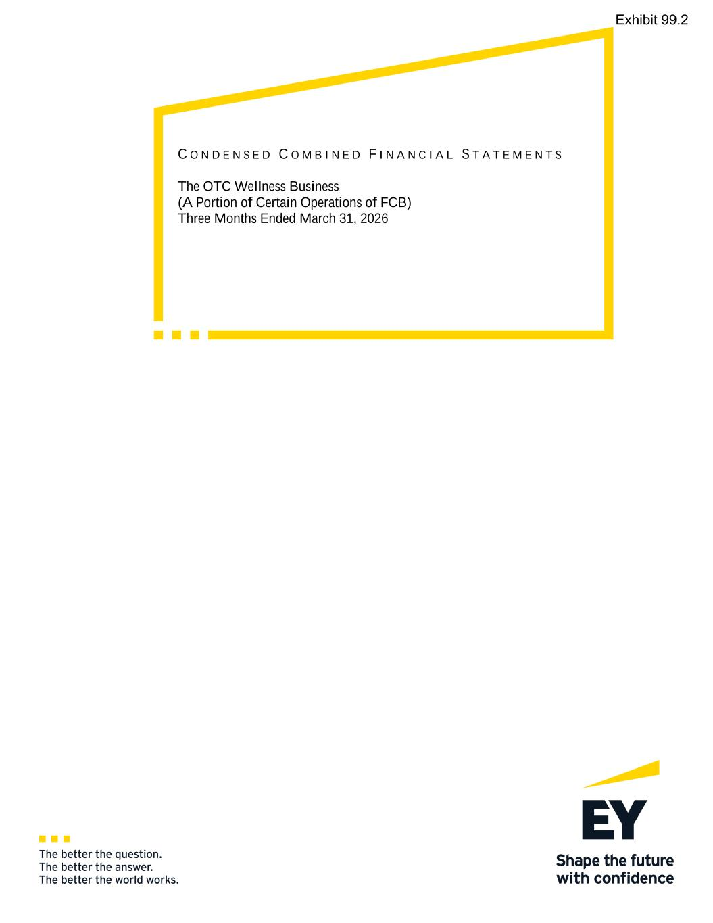

C O N D E N S E D C O M B I N E D F I N A N C I A L S T A T E M E N T S The OTC Wellness Business (A Portion of Certain Operations of FCB) Three Months Ended March 31, 2026 Exhibit 99.2

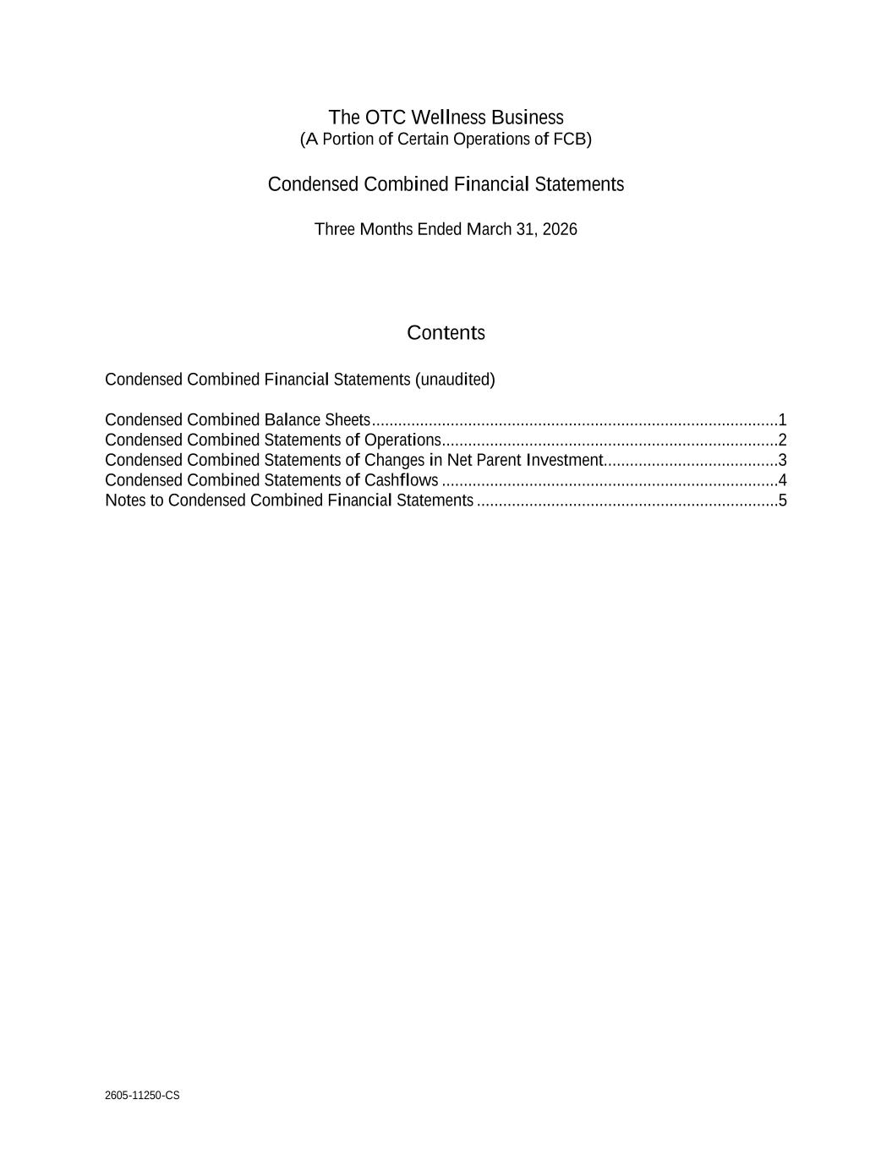
2605-11250-CS The OTC Wellness Business (A Portion of Certain Operations of FCB) Condensed Combined Financial Statements Three Months Ended March 31, 2026 Contents Condensed Combined Financial Statements (unaudited) Condensed Combined Balance Sheets .............................................................................................1 Condensed Combined Statements of Operations .............................................................................2 Condensed Combined Statements of Changes in Net Parent Investment........................................3 Condensed Combined Statements of Cashflows .............................................................................4 Notes to Condensed Combined Financial Statements .....................................................................5

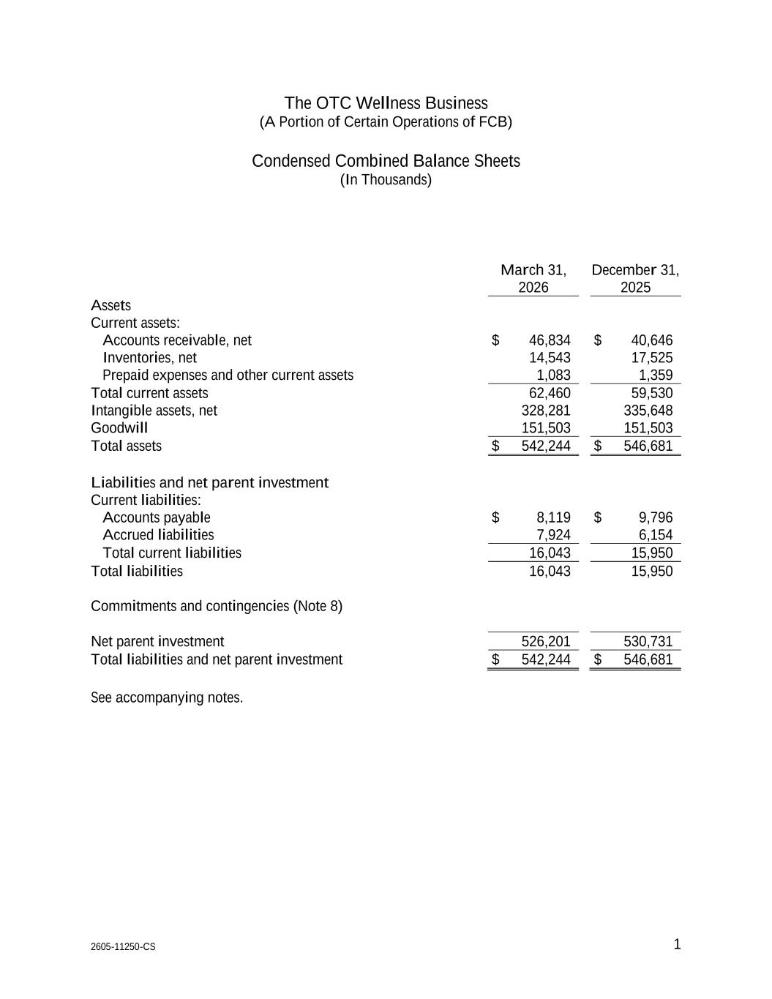
2605-11250-CS 1 1 The OTC Wellness Business (A Portion of Certain Operations of FCB) Condensed Combined Balance Sheets (In Thousands) March 31, December 31, 2026 2025 Assets Current assets: Accounts receivable, net $ 46,834 $ 40,646 Inventories, net 14,543 17,525 Prepaid expenses and other current assets 1,083 1,359 Total current assets 62,460 59,530 Intangible assets, net 328,281 335,648 Goodwill 151,503 151,503 Total assets $ 542,244 $ 546,681 Liabilities and net parent investment Current liabilities: Accounts payable $ 8,119 $ 9,796 Accrued liabilities 7,924 6,154 Total current liabilities 16,043 15,950 Total liabilities 16,043 15,950 Commitments and contingencies (Note 8) Net parent investment 526,201 530,731 Total liabilities and net parent investment $ 542,244 $ 546,681 See accompanying notes.

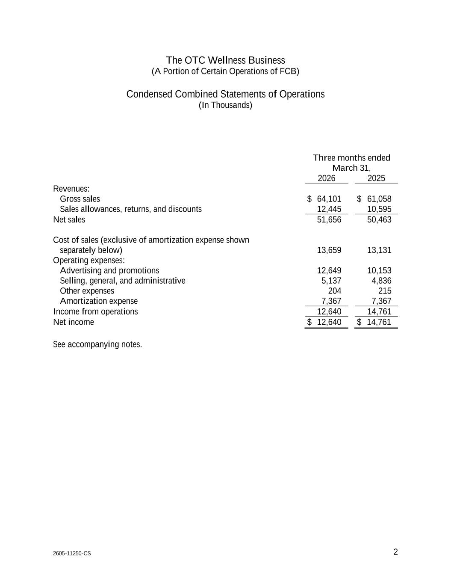
2605-11250-CS 2 1 The OTC Wellness Business (A Portion of Certain Operations of FCB) Condensed Combined Statements of Operations (In Thousands) Three months ended March 31, 2026 2025 Revenues: Gross sales $ 64,101 $ 61,058 Sales allowances, returns, and discounts 12,445 10,595 Net sales 51,656 50,463 Cost of sales (exclusive of amortization expense shown separately below) 13,659 13,131 Operating expenses: Advertising and promotions 12,649 10,153 Selling, general, and administrative 5,137 4,836 Other expenses 204 215 Amortization expense 7,367 7,367 Income from operations 12,640 14,761 Net income $ 12,640 $ 14,761 See accompanying notes.

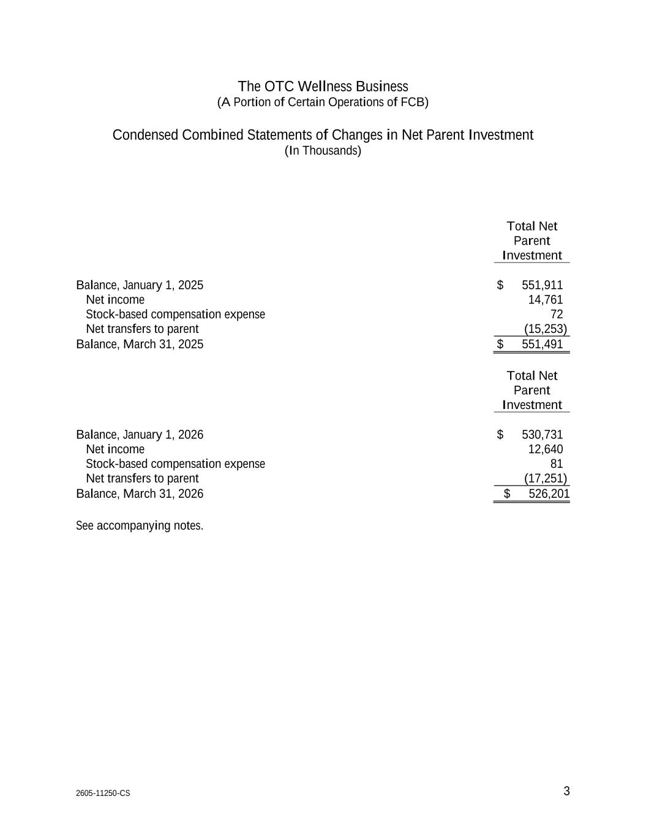
2605-11250-CS 3 1 The OTC Wellness Business (A Portion of Certain Operations of FCB) Condensed Combined Statements of Changes in Net Parent Investment (In Thousands) Total Net Parent Investment Balance, January 1, 2025 $ 551,911 Net income 14,761 Stock-based compensation expense 72 Net transfers to parent (15,253) Balance, March 31, 2025 $ 551,491 Total Net Parent Investment Balance, January 1, 2026 $ 530,731 Net income 12,640 Stock-based compensation expense 81 Net transfers to parent (17,251) Balance, March 31, 2026 $ 526,201 See accompanying notes.

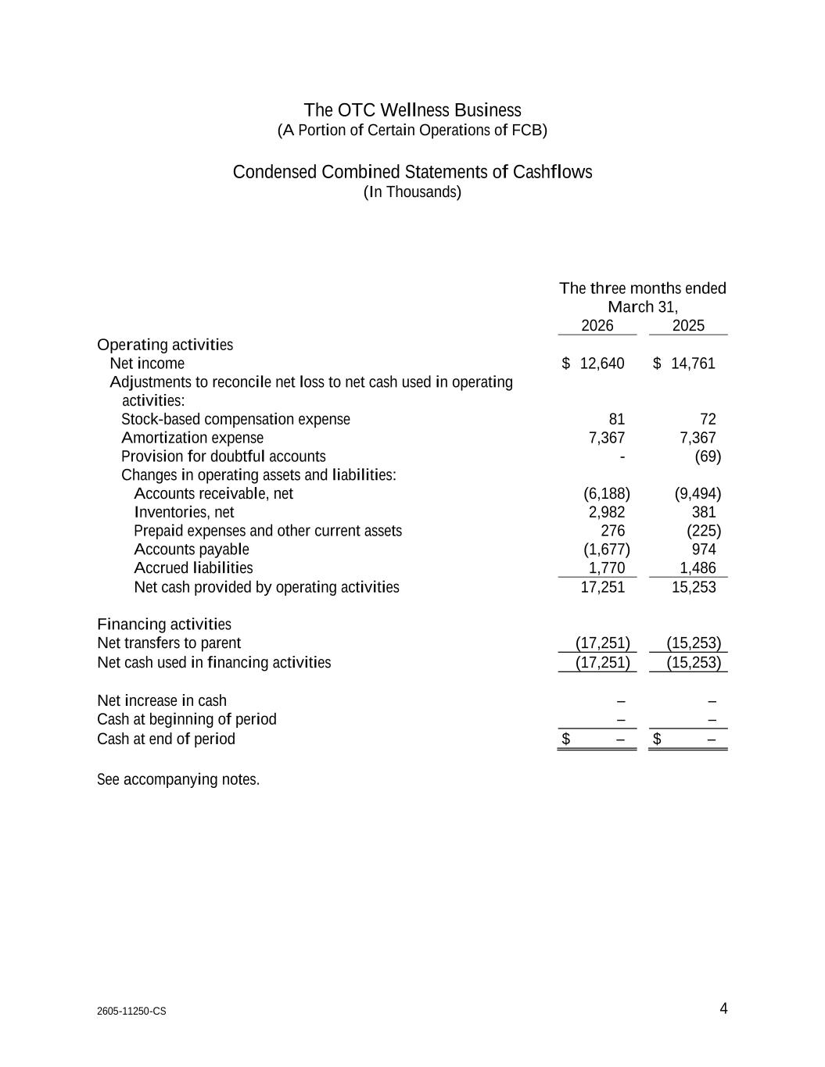
2605-11250-CS 4 1 The OTC Wellness Business (A Portion of Certain Operations of FCB) Condensed Combined Statements of Cashflows (In Thousands) The three months ended March 31, 2026 2025 Operating activities Net income $ 12,640 $ 14,761 Adjustments to reconcile net loss to net cash used in operating activities: Stock-based compensation expense 81 72 Amortization expense 7,367 7,367 Provision for doubtful accounts - (69) Changes in operating assets and liabilities: Accounts receivable, net (6,188) (9,494) Inventories, net 2,982 381 Prepaid expenses and other current assets 276 (225) Accounts payable (1,677) 974 Accrued liabilities 1,770 1,486 Net cash provided by operating activities 17,251 15,253 Financing activities Net transfers to parent (17,251) (15,253) Net cash used in financing activities (17,251) (15,253) Net increase in cash – – Cash at beginning of period – – Cash at end of period $ – $ – See accompanying notes.

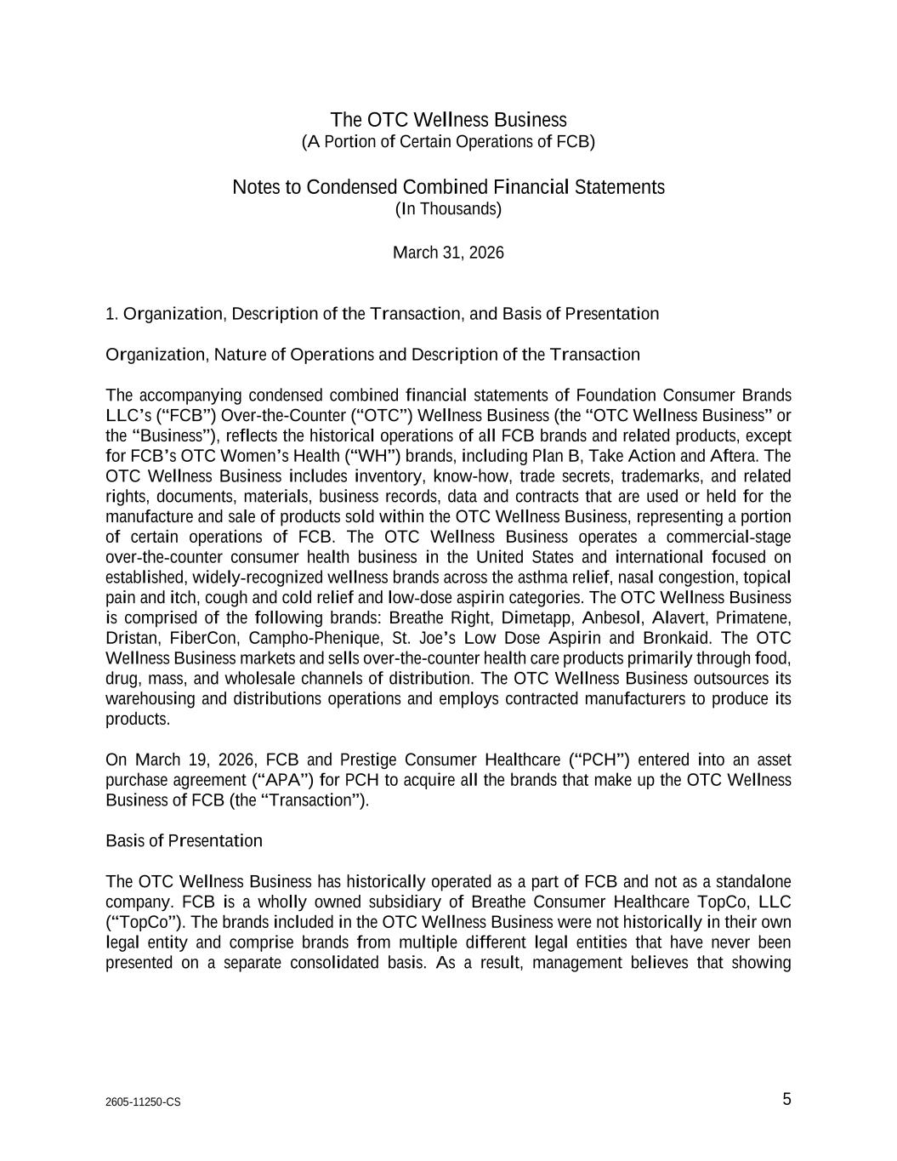
2605-11250-CS 5 The OTC Wellness Business (A Portion of Certain Operations of FCB) Notes to Condensed Combined Financial Statements (In Thousands) March 31, 2026 1. Organization, Description of the Transaction, and Basis of Presentation Organization, Nature of Operations and Description of the Transaction The accompanying condensed combined financial statements of Foundation Consumer Brands LLC’s (“FCB”) Over-the-Counter (“OTC”) Wellness Business (the “OTC Wellness Business” or the “Business”), reflects the historical operations of all FCB brands and related products, except for FCB’s OTC Women’s Health (“WH”) brands, including Plan B, Take Action and Aftera. The OTC Wellness Business includes inventory, know-how, trade secrets, trademarks, and related rights, documents, materials, business records, data and contracts that are used or held for the manufacture and sale of products sold within the OTC Wellness Business, representing a portion of certain operations of FCB. The OTC Wellness Business operates a commercial-stage over-the-counter consumer health business in the United States and international focused on established, widely-recognized wellness brands across the asthma relief, nasal congestion, topical pain and itch, cough and cold relief and low-dose aspirin categories. The OTC Wellness Business is comprised of the following brands: Breathe Right, Dimetapp, Anbesol, Alavert, Primatene, Dristan, FiberCon, Campho-Phenique, St. Joe’s Low Dose Aspirin and Bronkaid. The OTC Wellness Business markets and sells over-the-counter health care products primarily through food, drug, mass, and wholesale channels of distribution. The OTC Wellness Business outsources its warehousing and distributions operations and employs contracted manufacturers to produce its products. On March 19, 2026, FCB and Prestige Consumer Healthcare (“PCH”) entered into an asset purchase agreement (“APA”) for PCH to acquire all the brands that make up the OTC Wellness Business of FCB (the “Transaction”). Basis of Presentation The OTC Wellness Business has historically operated as a part of FCB and not as a standalone company. FCB is a wholly owned subsidiary of Breathe Consumer Healthcare TopCo, LLC (“TopCo”). The brands included in the OTC Wellness Business were not historically in their own legal entity and comprise brands from multiple different legal entities that have never been presented on a separate consolidated basis. As a result, management believes that showing

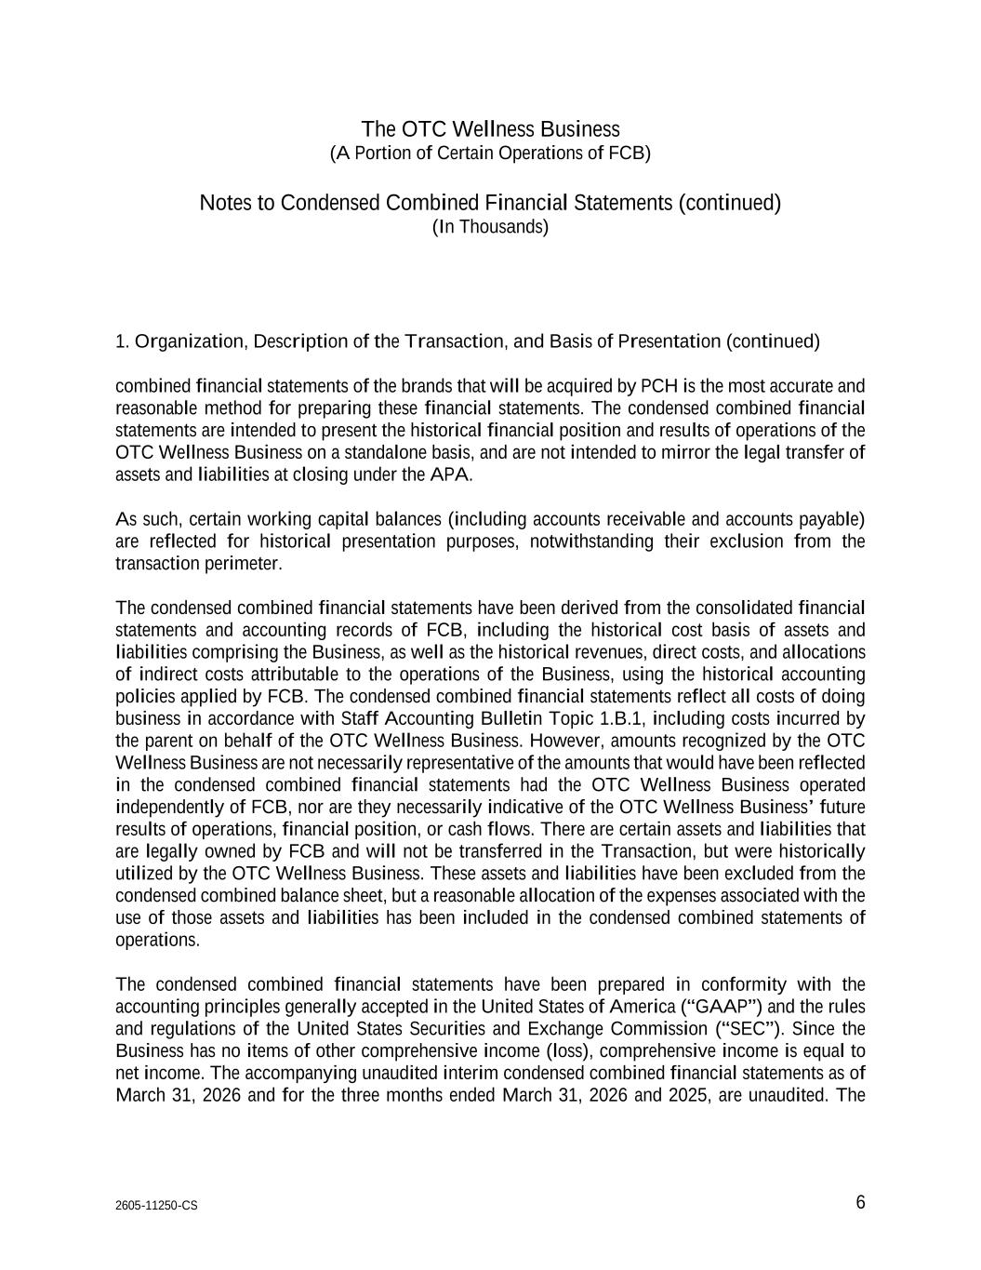
The OTC Wellness Business (A Portion of Certain Operations of FCB) Notes to Condensed Combined Financial Statements (continued) (In Thousands) 2605-11250-CS 6 1. Organization, Description of the Transaction, and Basis of Presentation (continued) combined financial statements of the brands that will be acquired by PCH is the most accurate and reasonable method for preparing these financial statements. The condensed combined financial statements are intended to present the historical financial position and results of operations of the OTC Wellness Business on a standalone basis, and are not intended to mirror the legal transfer of assets and liabilities at closing under the APA. As such, certain working capital balances (including accounts receivable and accounts payable) are reflected for historical presentation purposes, notwithstanding their exclusion from the transaction perimeter. The condensed combined financial statements have been derived from the consolidated financial statements and accounting records of FCB, including the historical cost basis of assets and liabilities comprising the Business, as well as the historical revenues, direct costs, and allocations of indirect costs attributable to the operations of the Business, using the historical accounting policies applied by FCB. The condensed combined financial statements reflect all costs of doing business in accordance with Staff Accounting Bulletin Topic 1.B.1, including costs incurred by the parent on behalf of the OTC Wellness Business. However, amounts recognized by the OTC Wellness Business are not necessarily representative of the amounts that would have been reflected in the condensed combined financial statements had the OTC Wellness Business operated independently of FCB, nor are they necessarily indicative of the OTC Wellness Business’ future results of operations, financial position, or cash flows. There are certain assets and liabilities that are legally owned by FCB and will not be transferred in the Transaction, but were historically utilized by the OTC Wellness Business. These assets and liabilities have been excluded from the condensed combined balance sheet, but a reasonable allocation of the expenses associated with the use of those assets and liabilities has been included in the condensed combined statements of operations. The condensed combined financial statements have been prepared in conformity with the accounting principles generally accepted in the United States of America (“GAAP”) and the rules and regulations of the United States Securities and Exchange Commission (“SEC”). Since the Business has no items of other comprehensive income (loss), comprehensive income is equal to net income. The accompanying unaudited interim condensed combined financial statements as of March 31, 2026 and for the three months ended March 31, 2026 and 2025, are unaudited. The

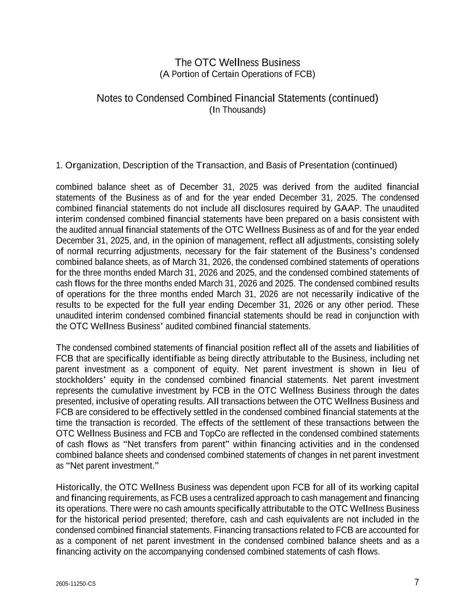
The OTC Wellness Business (A Portion of Certain Operations of FCB) Notes to Condensed Combined Financial Statements (continued) (In Thousands) 2605-11250-CS 7 1. Organization, Description of the Transaction, and Basis of Presentation (continued) combined balance sheet as of December 31, 2025 was derived from the audited financial statements of the Business as of and for the year ended December 31, 2025. The condensed combined financial statements do not include all disclosures required by GAAP. The unaudited interim condensed combined financial statements have been prepared on a basis consistent with the audited annual financial statements of the OTC Wellness Business as of and for the year ended December 31, 2025, and, in the opinion of management, reflect all adjustments, consisting solely of normal recurring adjustments, necessary for the fair statement of the Business’s condensed combined balance sheets, as of March 31, 2026, the condensed combined statements of operations for the three months ended March 31, 2026 and 2025, and the condensed combined statements of cash flows for the three months ended March 31, 2026 and 2025. The condensed combined results of operations for the three months ended March 31, 2026 are not necessarily indicative of the results to be expected for the full year ending December 31, 2026 or any other period. These unaudited interim condensed combined financial statements should be read in conjunction with the OTC Wellness Business’ audited combined financial statements. The condensed combined statements of financial position reflect all of the assets and liabilities of FCB that are specifically identifiable as being directly attributable to the Business, including net parent investment as a component of equity. Net parent investment is shown in lieu of stockholders’ equity in the condensed combined financial statements. Net parent investment represents the cumulative investment by FCB in the OTC Wellness Business through the dates presented, inclusive of operating results. All transactions between the OTC Wellness Business and FCB are considered to be effectively settled in the condensed combined financial statements at the time the transaction is recorded. The effects of the settlement of these transactions between the OTC Wellness Business and FCB and TopCo are reflected in the condensed combined statements of cash flows as “Net transfers from parent” within financing activities and in the condensed combined balance sheets and condensed combined statements of changes in net parent investment as “Net parent investment.” Historically, the OTC Wellness Business was dependent upon FCB for all of its working capital and financing requirements, as FCB uses a centralized approach to cash management and financing its operations. There were no cash amounts specifically attributable to the OTC Wellness Business for the historical period presented; therefore, cash and cash equivalents are not included in the condensed combined financial statements. Financing transactions related to FCB are accounted for as a component of net parent investment in the condensed combined balance sheets and as a financing activity on the accompanying condensed combined statements of cash flows.

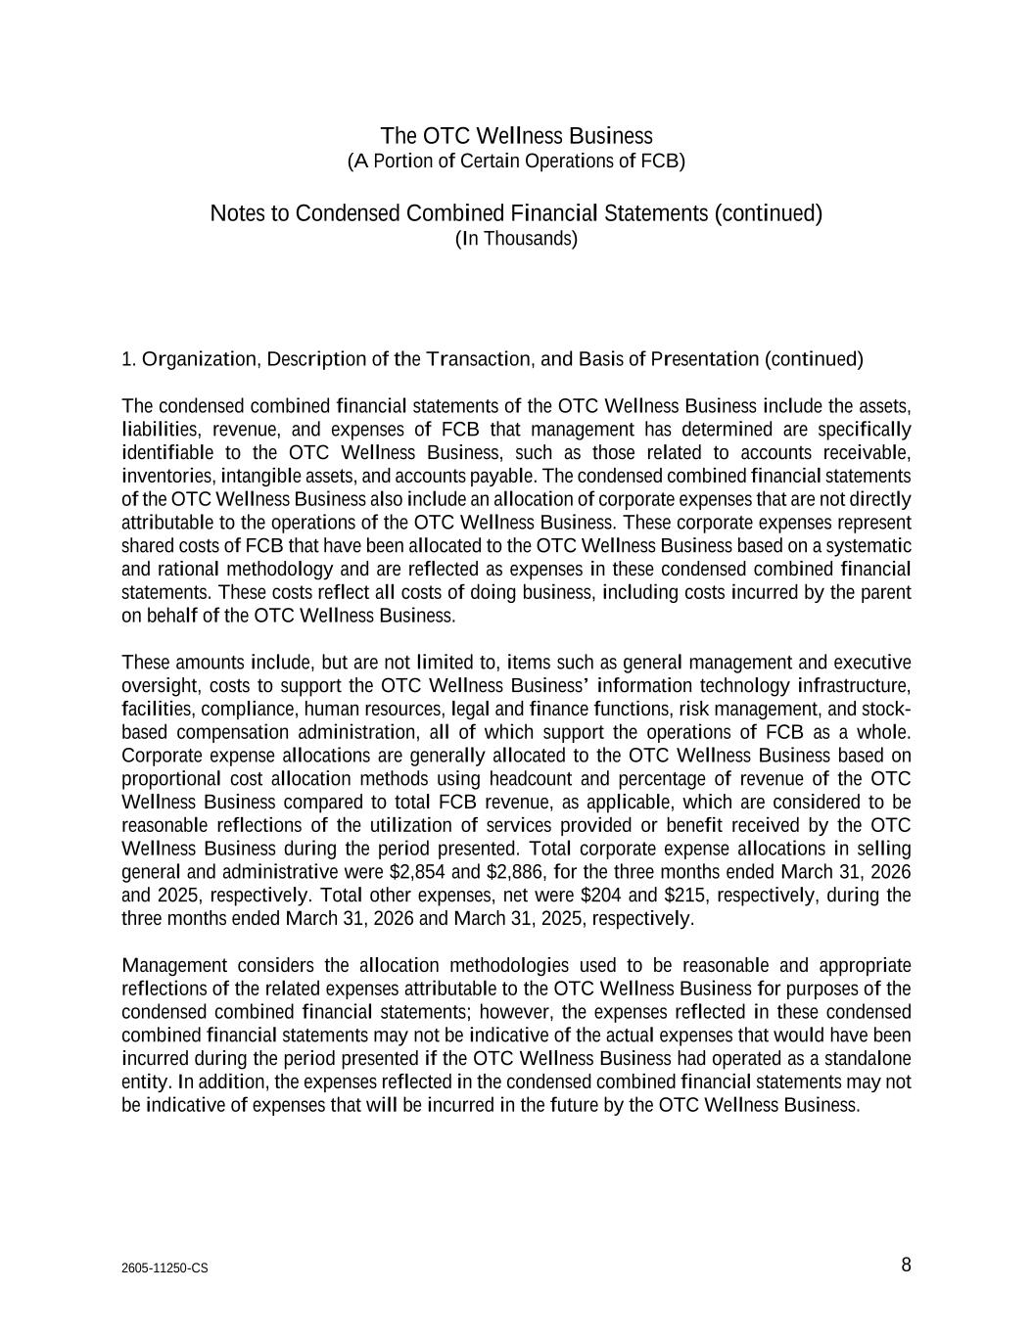
The OTC Wellness Business (A Portion of Certain Operations of FCB) Notes to Condensed Combined Financial Statements (continued) (In Thousands) 2605-11250-CS 8 1. Organization, Description of the Transaction, and Basis of Presentation (continued) The condensed combined financial statements of the OTC Wellness Business include the assets, liabilities, revenue, and expenses of FCB that management has determined are specifically identifiable to the OTC Wellness Business, such as those related to accounts receivable, inventories, intangible assets, and accounts payable. The condensed combined financial statements of the OTC Wellness Business also include an allocation of corporate expenses that are not directly attributable to the operations of the OTC Wellness Business. These corporate expenses represent shared costs of FCB that have been allocated to the OTC Wellness Business based on a systematic and rational methodology and are reflected as expenses in these condensed combined financial statements. These costs reflect all costs of doing business, including costs incurred by the parent on behalf of the OTC Wellness Business. These amounts include, but are not limited to, items such as general management and executive oversight, costs to support the OTC Wellness Business’ information technology infrastructure, facilities, compliance, human resources, legal and finance functions, risk management, and stock- based compensation administration, all of which support the operations of FCB as a whole. Corporate expense allocations are generally allocated to the OTC Wellness Business based on proportional cost allocation methods using headcount and percentage of revenue of the OTC Wellness Business compared to total FCB revenue, as applicable, which are considered to be reasonable reflections of the utilization of services provided or benefit received by the OTC Wellness Business during the period presented. Total corporate expense allocations in selling general and administrative were $2,854 and $2,886, for the three months ended March 31, 2026 and 2025, respectively. Total other expenses, net were $204 and $215, respectively, during the three months ended March 31, 2026 and March 31, 2025, respectively. Management considers the allocation methodologies used to be reasonable and appropriate reflections of the related expenses attributable to the OTC Wellness Business for purposes of the condensed combined financial statements; however, the expenses reflected in these condensed combined financial statements may not be indicative of the actual expenses that would have been incurred during the period presented if the OTC Wellness Business had operated as a standalone entity. In addition, the expenses reflected in the condensed combined financial statements may not be indicative of expenses that will be incurred in the future by the OTC Wellness Business.

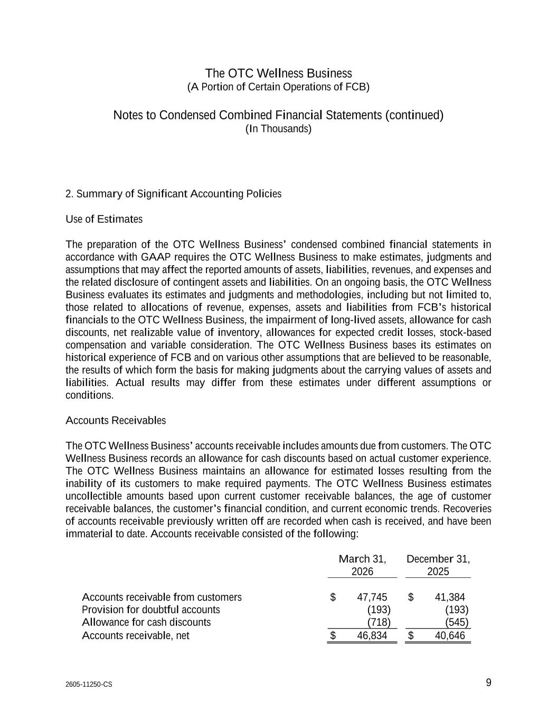
The OTC Wellness Business (A Portion of Certain Operations of FCB) Notes to Condensed Combined Financial Statements (continued) (In Thousands) 2605-11250-CS 9 2. Summary of Significant Accounting Policies Use of Estimates The preparation of the OTC Wellness Business’ condensed combined financial statements in accordance with GAAP requires the OTC Wellness Business to make estimates, judgments and assumptions that may affect the reported amounts of assets, liabilities, revenues, and expenses and the related disclosure of contingent assets and liabilities. On an ongoing basis, the OTC Wellness Business evaluates its estimates and judgments and methodologies, including but not limited to, those related to allocations of revenue, expenses, assets and liabilities from FCB’s historical financials to the OTC Wellness Business, the impairment of long-lived assets, allowance for cash discounts, net realizable value of inventory, allowances for expected credit losses, stock-based compensation and variable consideration. The OTC Wellness Business bases its estimates on historical experience of FCB and on various other assumptions that are believed to be reasonable, the results of which form the basis for making judgments about the carrying values of assets and liabilities. Actual results may differ from these estimates under different assumptions or conditions. Accounts Receivables The OTC Wellness Business’ accounts receivable includes amounts due from customers. The OTC Wellness Business records an allowance for cash discounts based on actual customer experience. The OTC Wellness Business maintains an allowance for estimated losses resulting from the inability of its customers to make required payments. The OTC Wellness Business estimates uncollectible amounts based upon current customer receivable balances, the age of customer receivable balances, the customer’s financial condition, and current economic trends. Recoveries of accounts receivable previously written off are recorded when cash is received, and have been immaterial to date. Accounts receivable consisted of the following: March 31, 2026 December 31, 2025 Accounts receivable from customers $ 47,745 $ 41,384 Provision for doubtful accounts (193) (193) Allowance for cash discounts (718) (545) Accounts receivable, net $ 46,834 $ 40,646

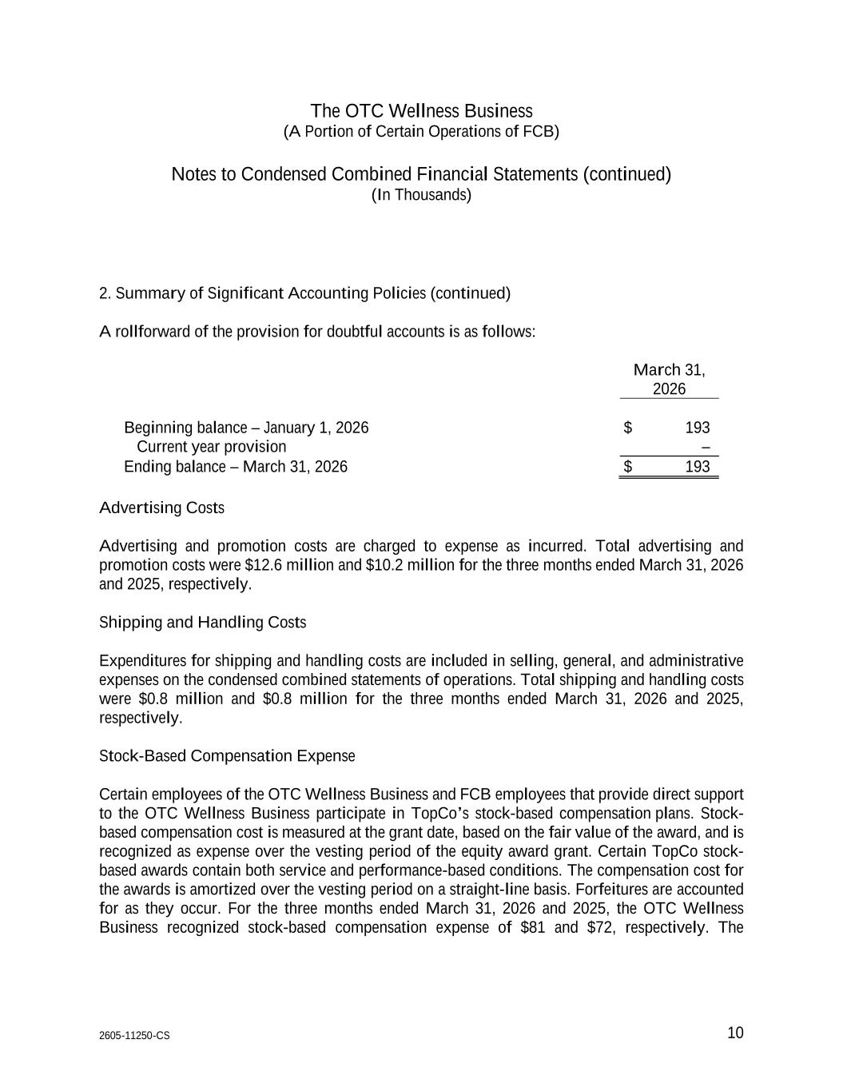
The OTC Wellness Business (A Portion of Certain Operations of FCB) Notes to Condensed Combined Financial Statements (continued) (In Thousands) 2605-11250-CS 10 2. Summary of Significant Accounting Policies (continued) A rollforward of the provision for doubtful accounts is as follows: March 31, 2026 Beginning balance – January 1, 2026 $ 193 Current year provision – Ending balance – March 31, 2026 $ 193 Advertising Costs Advertising and promotion costs are charged to expense as incurred. Total advertising and promotion costs were $12.6 million and $10.2 million for the three months ended March 31, 2026 and 2025, respectively. Shipping and Handling Costs Expenditures for shipping and handling costs are included in selling, general, and administrative expenses on the condensed combined statements of operations. Total shipping and handling costs were $0.8 million and $0.8 million for the three months ended March 31, 2026 and 2025, respectively. Stock-Based Compensation Expense Certain employees of the OTC Wellness Business and FCB employees that provide direct support to the OTC Wellness Business participate in TopCo’s stock-based compensation plans. Stock- based compensation cost is measured at the grant date, based on the fair value of the award, and is recognized as expense over the vesting period of the equity award grant. Certain TopCo stock- based awards contain both service and performance-based conditions. The compensation cost for the awards is amortized over the vesting period on a straight-line basis. Forfeitures are accounted for as they occur. For the three months ended March 31, 2026 and 2025, the OTC Wellness Business recognized stock-based compensation expense of $81 and $72, respectively. The

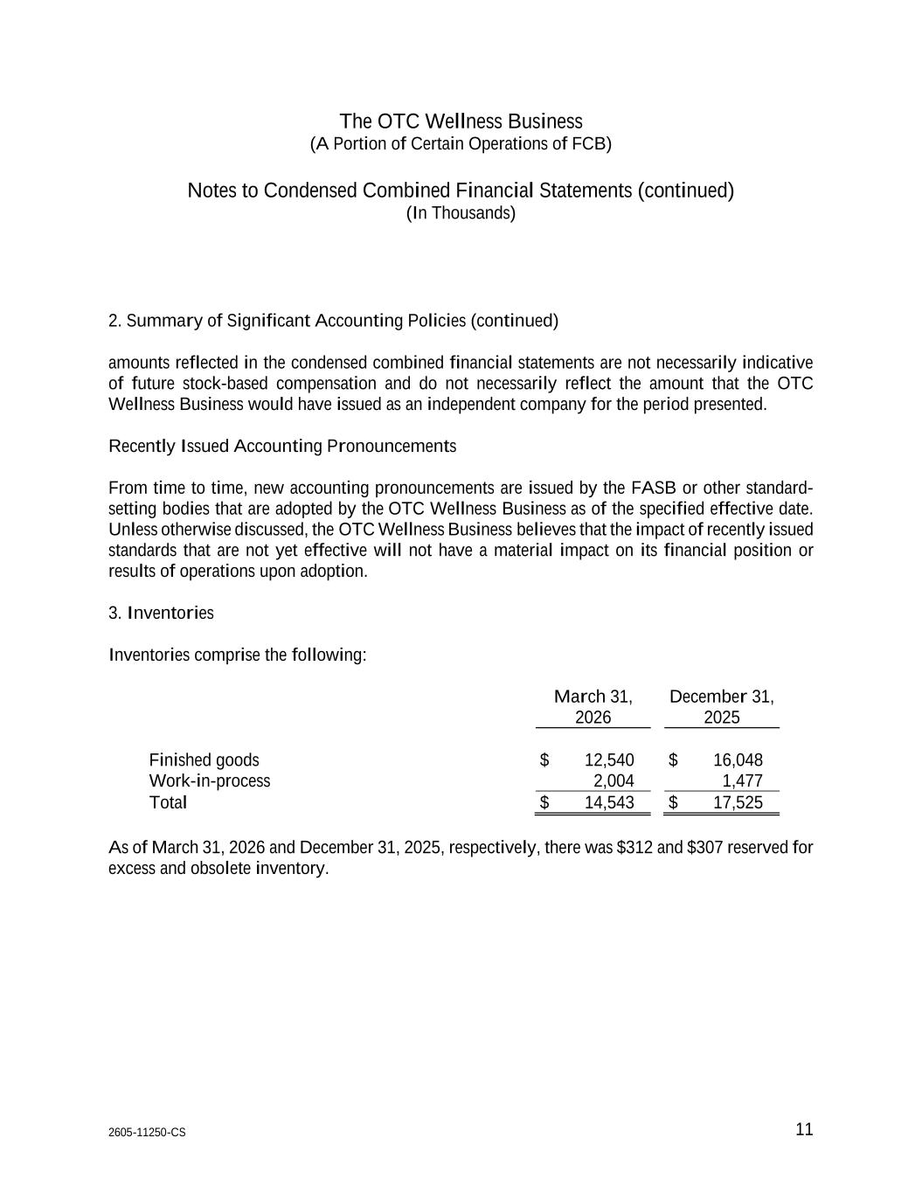
The OTC Wellness Business (A Portion of Certain Operations of FCB) Notes to Condensed Combined Financial Statements (continued) (In Thousands) 2605-11250-CS 11 2. Summary of Significant Accounting Policies (continued) amounts reflected in the condensed combined financial statements are not necessarily indicative of future stock-based compensation and do not necessarily reflect the amount that the OTC Wellness Business would have issued as an independent company for the period presented. Recently Issued Accounting Pronouncements From time to time, new accounting pronouncements are issued by the FASB or other standard- setting bodies that are adopted by the OTC Wellness Business as of the specified effective date. Unless otherwise discussed, the OTC Wellness Business believes that the impact of recently issued standards that are not yet effective will not have a material impact on its financial position or results of operations upon adoption. 3. Inventories Inventories comprise the following: March 31, 2026 December 31, 2025 Finished goods $ 12,540 $ 16,048 Work-in-process 2,004 1,477 Total $ 14,543 $ 17,525 As of March 31, 2026 and December 31, 2025, respectively, there was $312 and $307 reserved for excess and obsolete inventory.

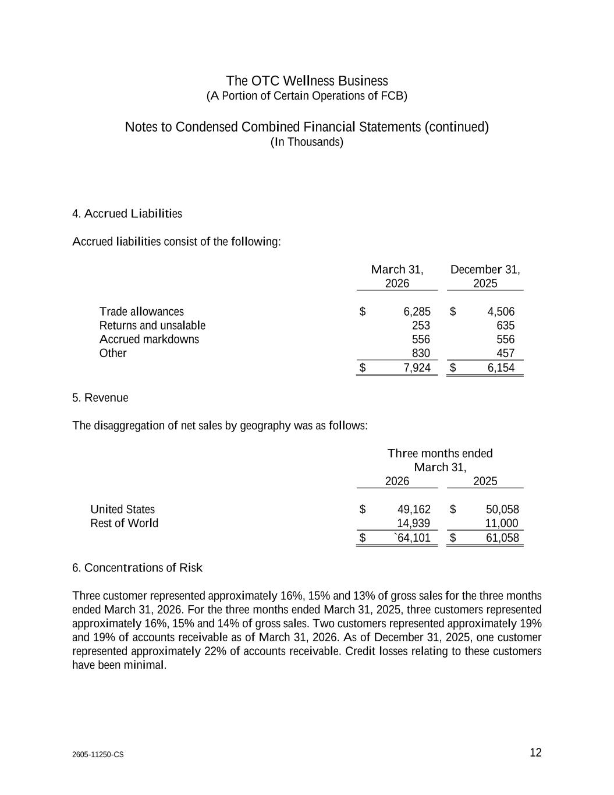
The OTC Wellness Business (A Portion of Certain Operations of FCB) Notes to Condensed Combined Financial Statements (continued) (In Thousands) 2605-11250-CS 12 4. Accrued Liabilities Accrued liabilities consist of the following: March 31, 2026 December 31, 2025 Trade allowances $ 6,285 $ 4,506 Returns and unsalable 253 635 Accrued markdowns 556 556 Other 830 457 $ 7,924 $ 6,154 5. Revenue The disaggregation of net sales by geography was as follows: Three months ended March 31, 2026 2025 United States $ 49,162 $ 50,058 Rest of World 14,939 11,000 $ `64,101 $ 61,058 6. Concentrations of Risk Three customer represented approximately 16%, 15% and 13% of gross sales for the three months ended March 31, 2026. For the three months ended March 31, 2025, three customers represented approximately 16%, 15% and 14% of gross sales. Two customers represented approximately 19% and 19% of accounts receivable as of March 31, 2026. As of December 31, 2025, one customer represented approximately 22% of accounts receivable. Credit losses relating to these customers have been minimal.

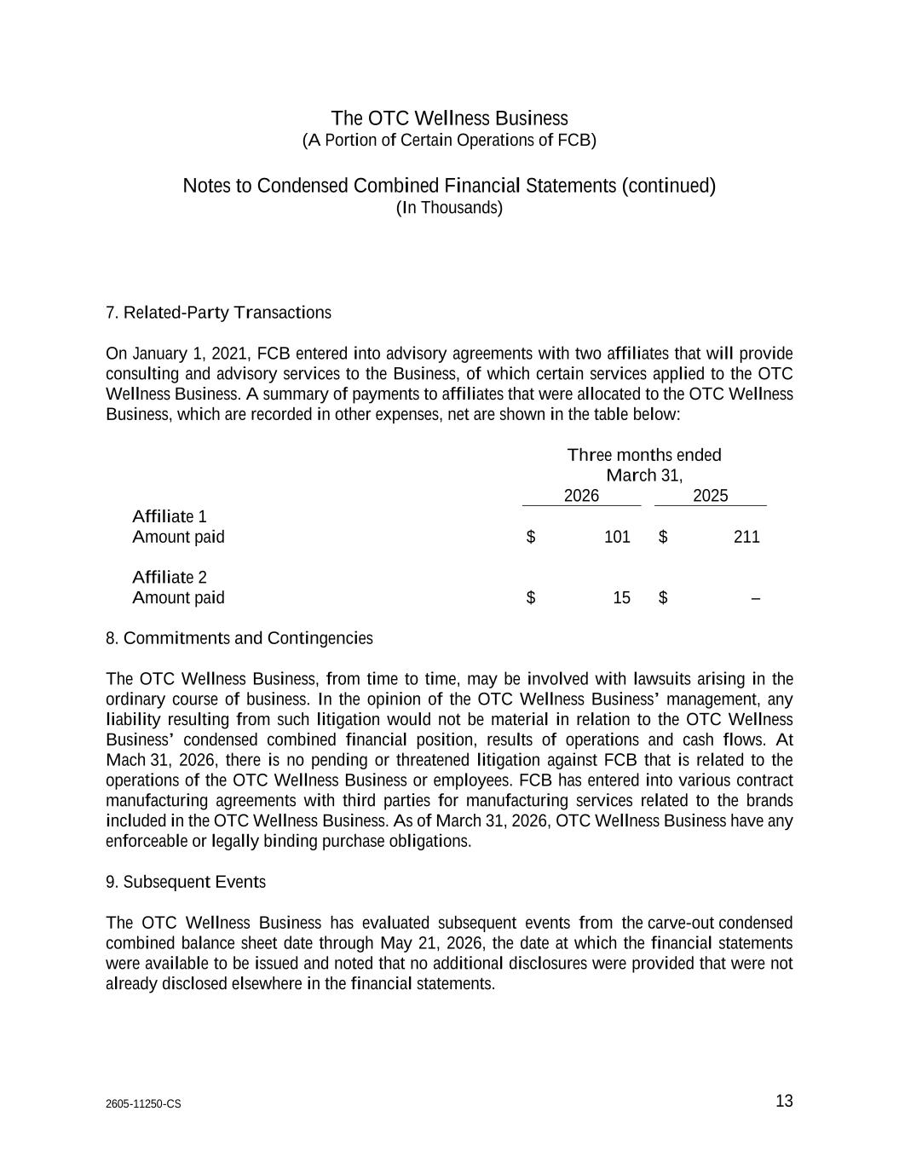
The OTC Wellness Business (A Portion of Certain Operations of FCB) Notes to Condensed Combined Financial Statements (continued) (In Thousands) 2605-11250-CS 13 7. Related-Party Transactions On January 1, 2021, FCB entered into advisory agreements with two affiliates that will provide consulting and advisory services to the Business, of which certain services applied to the OTC Wellness Business. A summary of payments to affiliates that were allocated to the OTC Wellness Business, which are recorded in other expenses, net are shown in the table below: Three months ended March 31, 2026 2025 Affiliate 1 Amount paid $ 101 $ 211 Affiliate 2 Amount paid $ 15 $ – 8. Commitments and Contingencies The OTC Wellness Business, from time to time, may be involved with lawsuits arising in the ordinary course of business. In the opinion of the OTC Wellness Business’ management, any liability resulting from such litigation would not be material in relation to the OTC Wellness Business’ condensed combined financial position, results of operations and cash flows. At Mach 31, 2026, there is no pending or threatened litigation against FCB that is related to the operations of the OTC Wellness Business or employees. FCB has entered into various contract manufacturing agreements with third parties for manufacturing services related to the brands included in the OTC Wellness Business. As of March 31, 2026, OTC Wellness Business have any enforceable or legally binding purchase obligations. 9. Subsequent Events The OTC Wellness Business has evaluated subsequent events from the carve-out condensed combined balance sheet date through May 21, 2026, the date at which the financial statements were available to be issued and noted that no additional disclosures were provided that were not already disclosed elsewhere in the financial statements.

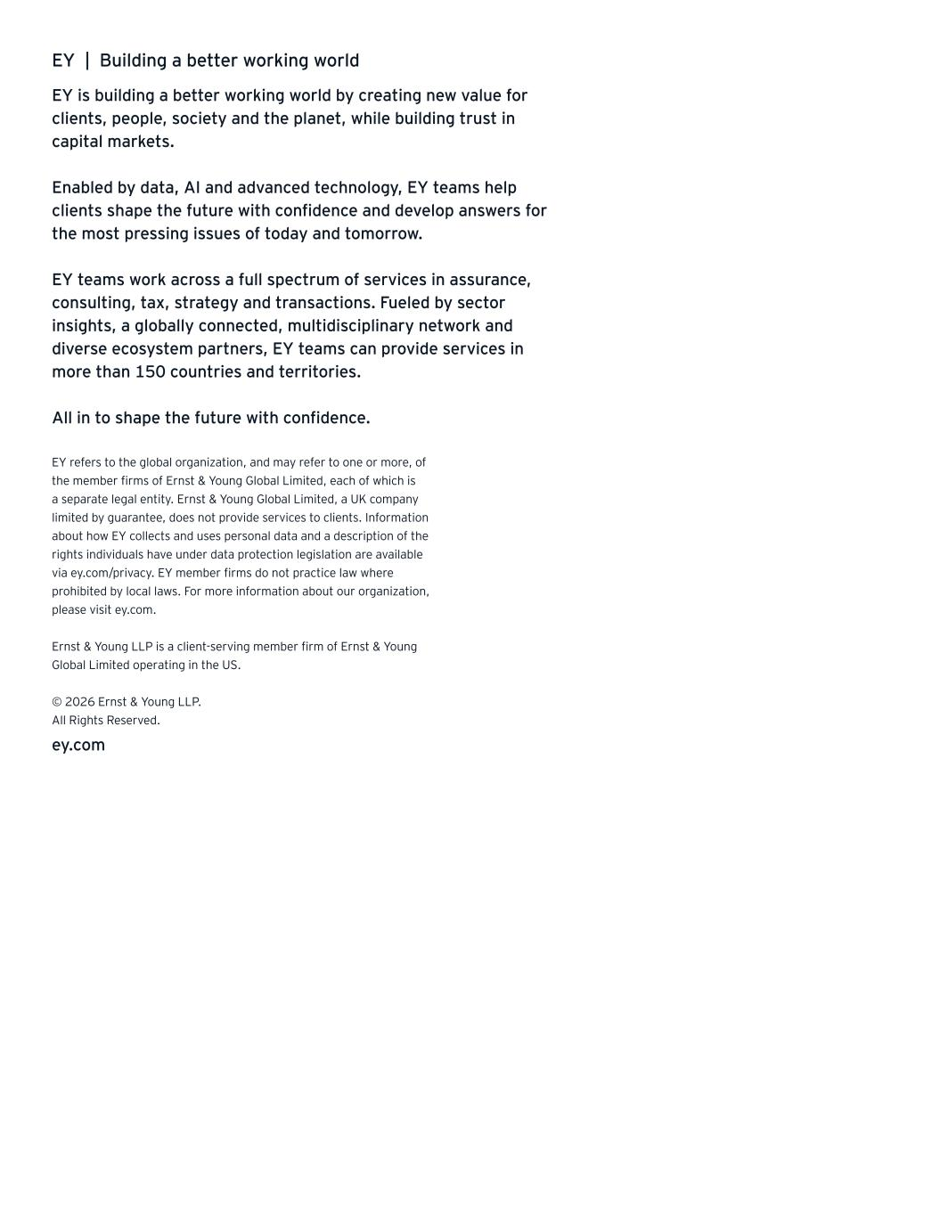
EY | Building a better working world EY is building a better working world by creating new value for clients, people, society and the planet, while building trust in capital markets. Enabled by data, AI and advanced technology, EY teams help clients shape the future with confidence and develop answers for the most pressing issues of today and tomorrow. EY teams work across a full spectrum of services in assurance, consulting, tax, strategy and transactions. Fueled by sector insights, a globally connected, multidisciplinary network and diverse ecosystem partners, EY teams can provide services in more than 150 countries and territories. All in to shape the future with confidence. EY refers to the global organization, and may refer to one or more, of the member firms of Ernst & Young Global Limited, each of which is a separate legal entity. Ernst & Young Global Limited, a UK company limited by guarantee, does not provide services to clients. Information about how EY collects and uses personal data and a description of the rights individuals have under data protection legislation are available via ey.com/privacy. EY member firms do not practice law where prohibited by local laws. For more information about our organization, please visit ey.com. Ernst & Young LLP is a client-serving member firm of Ernst & Young Global Limited operating in the US. © 2026 Ernst & Young LLP. All Rights Reserved. ey.com

