UNITED STATES
SECURITIES AND EXCHANGE COMMISSION
Washington, D.C. 20549
_______________________

FORM 8-K

CURRENT REPORT

Pursuant to Section 13 or 15(d) of the Securities Exchange Act of 1934

Date of report (Date of earliest event reported): August 6, 2026

PRESTIGE CONSUMER HEALTHCARE INC.
(Exact Name of Registrant as Specified in Charter)

Delaware |  |  |  |  |  | 001-32433 |  |  |  |  |  | 20-1297589
(State or Other Jurisdiction of Incorporation) |  |  |  |  |  | (Commission File Number) |  |  |  |  |  | (IRS Employer Identification No.)

660 White Plains Road, Tarrytown, New York 10591
(Address of Principal Executive Offices) (Zip Code)

(914) 524-6800
(Registrant's telephone number, including area code)

(Former Name or Former Address, if Changed Since Last Report.)

Check the appropriate box below if the Form 8-K filing is intended to simultaneously satisfy the filing obligation of the registrant under any of the following provisions (see General Instruction A.2. below):

☐ Written communications pursuant to Rule 425 under the Securities Act (17 CFR 230.425)

☐ Soliciting material pursuant to Rule 14a-12 under the Exchange Act (17 CFR 240.14a-12)

☐ Pre-commencement communications pursuant to Rule 14d-2(b) under the Exchange Act (17 CFR 240.14d-2(b))

☐ Pre-commencement communications pursuant to Rule 13e-4(c) under the Exchange Act (17 CFR 240.13e-4(c))
Securities registered pursuant to Section 12(b) of the Act:
Title of each class |  |  | Trading Symbol(s) |  |  | Name of each exchange on which registered
Common stock, par value $0.01 per share |  |  | PBH |  |  | New York Stock Exchange
Indicate by check mark whether the registrant is an emerging growth company as defined in Rule 405 of the Securities Act of 1933 (§ 230.405 of this chapter) or Rule 12b-2 of the Securities Exchange Act of 1934 (§ 240.12b-2 of this chapter).
Emerging Growth Company |  |  | ☐
If an emerging growth company, indicate by check mark if the registrant has elected not to use the extended transition period for complying with any new or revised financial accounting standards provided pursuant to Section 13(a) of the Exchange Act.
☐

Item 2.02 Results of Operations and Financial Condition.

On August 6, 2026, Prestige Consumer Healthcare Inc. (the “Company”) announced financial results for the fiscal quarter ended June 30, 2026. A copy of the press release announcing the Company's earnings results for the fiscal quarter ended June 30, 2026 is attached hereto as Exhibit 99.1 and incorporated herein by reference.

Item 7.01 Regulation FD Disclosure.

On August 6, 2026, representatives of the Company began making presentations to investors regarding the Company's financial results for the quarter ended June 30, 2026 using slides attached to this Current Report on Form 8-K as Exhibit 99.2 (the “Investor Presentation”) and incorporated herein by reference. The Company expects to use the Investor Presentation, in whole or in part, and possibly with modifications, in connection with presentations to investors, analysts and others during the fiscal year ended March 31, 2027.

By furnishing the information contained in this Item 7.01, the Company makes no admission as to the materiality of any information that is required to be disclosed solely by reason of Regulation FD.

The information contained in the Investor Presentation is summary information that is intended to be considered in the context of the Company's Securities and Exchange Commission (“SEC”) filings and other public announcements that the Company may make, by press release or otherwise, from time to time. The Company undertakes no duty or obligation to publicly update or revise the information contained in this report, although it may do so from time to time as its management believes is warranted. Any such updating may be made through the filing of other reports or documents with the SEC, through press releases or through other public disclosure.

The information presented in Items 2.02 and 7.01 of this Current Report on Form 8-K and Exhibits 99.1 and 99.2 shall not be deemed to be “filed” for purposes of Section 18 of the Securities Exchange Act of 1934, as amended (the “Exchange Act”), or otherwise subject to the liabilities of that section, unless the Company specifically states that the information is to be considered “filed” under the Exchange Act or specifically incorporates it by reference into a filing under the Securities Act of 1933, as amended, or the Exchange Act.

Item 9.01 Financial Statements and Exhibits.

(d) Exhibits.

Exhibit |  |  |  |  |  | Description
99.1 |  |  |  |  |  | Press Release dated August 6, 2026 announcing the Company's financial results for the fiscal quarter ended June 30, 2026 (furnished only).
99.2 |  |  |  |  |  | Investor Presentation in use beginning August 6, 2026 (furnished only).
104 |  |  |  |  |  | Cover Page Interactive Data File (the cover page XBRL tags are embedded within the Inline XBRL document).

SIGNATURES

Pursuant to the requirements of the Securities Exchange Act of 1934, the registrant has duly caused this report to be signed on its behalf by the undersigned hereunto duly authorized.

Dated: August 6, 2026 |  |  | PRESTIGE CONSUMER HEALTHCARE INC.
 |  |  | By: |  |  | /s/ Christine Sacco
 |  |  |  |  |  | Christine Sacco
 |  |  |  |  |  | Chief Financial Officer & Chief Operating Officer

Exhibit 99.1

Prestige Consumer Healthcare Inc. Reports Fiscal 2027 First Quarter Results

•Q1 Revenue of $265.7 million up 6.5% versus prior year
•Q1 Organic sales growth of 3.2%, exceeding expectations
•Q1 Diluted EPS of $0.61; Adjusted Diluted EPS of $0.98, up versus prior year $0.95
•Q1 Cash from Operating Activities $70.8 million; Q1 Adjusted Non-GAAP Free Cash Flow of $83.7 million
•Closed the Breathe Right® and LaCorium acquisitions in June and July, respectively
•Raising fiscal 2027 outlook to include acquisitions; anticipate revenue of $1,290 to $1,315 million and Adjusted Diluted EPS outlook to $4.55 to $4.65

TARRYTOWN, N.Y.--(GLOBE NEWSWIRE)-August 6, 2026-- Prestige Consumer Healthcare Inc. (NYSE:PBH) today reported financial results for its first quarter fiscal 2027 ended June 30, 2026.

“First quarter performance exceeded our sales and earnings expectations, helped by strength across multiple categories that more than offset a challenging consumer backdrop and Clear Eyes® variability. We were also pleased to close the Breathe Right® acquisition late in the quarter, which added an incremental $6 million in revenue and is positioned well for long-term growth. These strong business results generated robust record adjusted free cash flow in the first quarter, leaving us well positioned to rapidly deleverage in the quarters ahead,” said Ron Lombardi, Chief Executive Officer of Prestige Consumer Healthcare.

First Fiscal Quarter Ended June 30, 2026

Reported revenues in the first quarter of fiscal 2027 of $265.7 million increased 6.5% from $249.5 million in the first quarter of fiscal 2026 and increased 3.2% excluding the impacts of foreign currency and a $5.9 million contribution from the acquisition of Breathe Right® and its associated portfolio of brands. The revenue performance versus the prior year comparable period reflected strong organic growth in the Gastrointestinal and Dermatological categories as well as an increase in revenues associated with the acquisition of the Breathe Right® brand and its associated portfolio.

Reported net income for the first quarter of fiscal 2027 totaled $29.2 million, or $0.61 in earnings per diluted share, compared to $47.5 million, or $0.95 in diluted earnings per share, for the comparable period. On an adjusted non-GAAP basis first quarter fiscal 2027 net income totaled $46.5 million, or $0.98 in diluted earnings per share.

Adjustments to net income in the first quarter of fiscal 2027 included certain costs associated with acquisitions including integration, transition, purchase accounting, legal and various other costs, such as costs associated with improving and optimizing the acquired Pillar5 facility for increases in long-term capacity, and associated tax adjustments.

Free Cash Flow and Balance Sheet

The Company's net cash provided by operating activities for the first quarter of fiscal 2027 was $70.8 million, compared to $79.0 million during the prior year comparable period. Non-GAAP adjusted free cash flow in the first quarter of fiscal 2027 of $83.7 million increased compared to $78.2 million in the prior year first quarter. The material increase in free cash flow was attributable to the timing of working capital.

The Company's net debt position as of June 30, 2026 was approximately $2 billion. Subsequent to the quarter, on July 15, 2026 the Company issued $400 million of new 6.25% senior notes due 2034 which replaced the same principal of senior notes previously due in fiscal 2028. The new notes extend the maturity of the amount to July 15, 2034 moving the Company’s closest debt maturity to 2031.

Segment Review

In the fiscal first quarter 2027, the Company established a new product category, Wellness, Sleep & Other, and renamed certain existing product categories to help best incorporate the brands acquired in the Breathe Right® transaction.

North American OTC Healthcare: Segment revenues of $226.2 million for the first quarter fiscal 2027 increased 6.4% compared to the prior year comparable quarter's segment revenues of $212.6 million. The revenue increase was broad-based and included strong organic sales growth in the Gastrointestinal, Dermatological, and Cough, Cold & Allergy categories, as well as an increase in the newly created Wellness, Sleep & Other category from the acquisition of the Breathe Right® brand.

International OTC Healthcare: Fiscal first quarter 2027 segment revenues of $39.5 million increased 6.9% compared to $37.0 million reported in the prior year comparable period. The revenue performance was primarily driven by a $1.4 million contribution from the acquisition of the Breathe Right® brand.

Updated Fiscal 2027 Outlook

Ron Lombardi, Chief Executive Officer, stated, “Our strong initial first quarter performance gives us momentum in both revenue and earnings for full-year fiscal 2027. Our consumption remains healthy for our leading, trusted brands, and we continue to emphasize our proven marketing tactics to succeed in a challenging consumer environment. In addition, our portfolio diversity and business attributes leave us well positioned to manage the continued volatile supply for Clear Eyes®.”

“We are very excited about our recently closed Breathe Right portfolio and LaCorium Health acquisitions in mid-June and July, respectively, and both bring strong long-term growth prospects. Breathe Right® is a category-defining, global brand in the attractive better-breathing space, where we expect to grow the category domestically while expanding the brand's international presence. LaCorium's Dermal Therapy® brand is a leader in therapeutic skin care in Australia, and we anticipate strong sales growth under the Prestige Consumer Healthcare business model, driven by category growth, innovation, and continued geographic expansion."

“We are raising our fiscal 2027 financial outlook for both revenue and EPS, entirely to account for the addition of these two businesses. These acquisitions add nearly 20% to our revenue base and we expect the acquisitions to become increasingly accretive to profitability and cash flow as we move past the near-term and begin to realize business synergies and our brand growth objectives,” Mr. Lombardi concluded.
 |  |  | Initial Fiscal 2027 Outlook |  |  | Current Fiscal 2027 Outlook
Revenue |  |  | $1,100 to $1,121 million |  |  | $1,290 to $1,315 million
Organic Revenue Growth |  |  | +1.0% to +3.0% |  |  | +1.0% to +3.0%
Adjusted Diluted E.P.S. |  |  | $4.42 to $4.51 |  |  | $4.55 to $4.65
Adjusted Free Cash Flow |  |  | $250 million or more |  |  | $270 million or more

First Quarter Fiscal 2027 Conference Call, Accompanying Slide Presentation and Replay

The Company will host a conference call to review its first quarter fiscal 2027 results today, August 6, 2026 at 8:30 a.m. ET. The Company provides a live Internet webcast, a slide presentation to accompany the call, as well as an archived replay, all of which can be accessed from the Investor Relations page of the Company's website at http://www.prestigeconsumerhealthcare.com. To participate in the conference call via phone, participants may register for the call here to receive dial-in details and a unique pin. While not required, it is recommended to join 10 minutes prior to the event start. The slide presentation can be accessed from the Investor Relations page of the Company’s website by clicking on Webcasts and Presentations.

A conference call replay will be available for approximately one week following completion of the live call and can be accessed on the Company’s Investor Relations page.

Non-GAAP and Other Financial Information

In addition to financial results reported in accordance with generally accepted accounting principles (GAAP), we have provided certain non-GAAP financial information in this release to aid investors in understanding the Company's performance. Each non-GAAP financial measure is defined and reconciled to its most closely related GAAP financial measure in the “About Non-GAAP Financial Measures” section at the end of this earnings release.

Note Regarding Forward-Looking Statements

This news release contains "forward-looking statements" within the meaning of the federal securities laws that are intended to qualify for the Safe Harbor from liability established by the Private Securities Litigation Reform Act of 1995. "Forward-looking statements" generally can be identified by the use of forward-looking terminology such as "guidance," "outlook," "may," "will," "would," “believe,” “momentum,” "expect," “look forward,” "anticipate,” “increasingly,” “positioned,” or "continue" (or the negative or other derivatives of each of these terms) or similar terminology. The "forward-looking statements" include, without limitation, statements regarding the Company's future operating results including revenues, organic growth, diluted earnings per share, and adjusted free cash flow; consumption trends; the expected impact of Breathe Right® and LaCorium Health acquisitions on the Company’s revenue and cash flow; and the Company’s ability to manage through the current environment through its business strategy and diverse product portfolio. These statements are based on management's estimates and assumptions with respect to future events and financial performance and are believed to be reasonable, though are inherently uncertain and difficult to predict. Actual results could differ materially from those expected as a result of a variety of factors, including the impact of business and economic conditions, including as a result of evolving U.S. and international tariffs, labor shortages, inflation and geopolitical instability, consumer trends, the impact of the Company’s advertising and marketing and new product development initiatives, customer inventory management initiatives, fluctuating foreign exchange rates, competitive pressures, and the ability of the Company’s manufacturing operations and third party manufacturers and logistics providers and suppliers to meet demand for its products and to avoid inflationary cost increases and disruption as a result of labor shortages. A discussion of other factors that could cause results to vary is included in the Company's Annual Report on Form 10-K for the year ended March 31, 2026 and other periodic reports filed with the Securities and Exchange Commission.

About Prestige Consumer Healthcare Inc.

Prestige Consumer Healthcare markets, sells, manufactures and distributes consumer healthcare products to retail outlets throughout the U.S. and Canada, Australia, and in certain other international markets. The Company’s diverse portfolio of brands include Breathe Right® nasal strips, Monistat® and Summer’s Eve® women's health products, BC® and Goody's® pain relievers, Clear Eyes® and TheraTears® eye care products, DenTek® specialty oral care products, Dramamine® motion sickness treatments, Fleet® enemas and glycerin suppositories, Chloraseptic® and Luden's® sore throat treatments and drops, Compound W® wart treatments, Little Remedies® pediatric over-the-counter products, Boudreaux’s Butt Paste® diaper rash ointments, Nix® lice treatment, Debrox® earwax remover, Gaviscon® antacid in Canada, as well as Hydralyte® rehydration products and the Dermal Therapy® line of therapeutic skin care products in Australia. Visit the Company's website at www.prestigeconsumerhealthcare.com.

Prestige Consumer Healthcare Inc.
Condensed Consolidated Statements of Income and Comprehensive Income
(Unaudited)

 |  |  |  |  |  |  |  | Three Months Ended June 30,
(In thousands, except per share data) |  |  |  |  |  |  |  |  |  | 2026 |  |  |  |  |  | 2025
Total Revenues |  |  |  |  |  |  |  |  |  | $ | 265,710 |  |  |  |  | $ | 249,530
Cost of Sales
Cost of sales excluding depreciation |  |  |  |  |  |  |  |  |  | 126,466 |  |  |  |  |  | 106,715
Cost of sales depreciation |  |  |  |  |  |  |  |  |  | 3,056 |  |  |  |  |  | 2,484
Cost of sales |  |  |  |  |  |  |  |  |  | 129,522 |  |  |  |  |  | 109,199
Gross profit |  |  |  |  |  |  |  |  |  | 136,188 |  |  |  |  |  | 140,331
Operating Expenses
Advertising and marketing |  |  |  |  |  |  |  |  |  | 34,668 |  |  |  |  |  | 34,937
General and administrative |  |  |  |  |  |  |  |  |  | 43,303 |  |  |  |  |  | 28,456
Depreciation and amortization |  |  |  |  |  |  |  |  |  | 5,697 |  |  |  |  |  | 5,182
Total operating expenses |  |  |  |  |  |  |  |  |  | 83,668 |  |  |  |  |  | 68,575
Operating income |  |  |  |  |  |  |  |  |  | 52,520 |  |  |  |  |  | 71,756
Other expense
Interest expense, net |  |  |  |  |  |  |  |  |  | 13,945 |  |  |  |  |  | 10,203
Other expense (income), net |  |  |  |  |  |  |  |  |  | 34 |  |  |  |  |  | (224)
Total other expense, net |  |  |  |  |  |  |  |  |  | 13,979 |  |  |  |  |  | 9,979
Income before income taxes |  |  |  |  |  |  |  |  |  | 38,541 |  |  |  |  |  | 61,777
Provision for income taxes |  |  |  |  |  |  |  |  |  | 9,364 |  |  |  |  |  | 14,311
Net income |  |  |  |  |  |  |  |  |  | $ | 29,177 |  |  |  |  | $ | 47,466
Earnings per share:
Basic |  |  |  |  |  |  |  |  |  | $ | 0.61 |  |  |  |  | $ | 0.96
Diluted |  |  |  |  |  |  |  |  |  | $ | 0.61 |  |  |  |  | $ | 0.95
Weighted average shares outstanding:
Basic |  |  |  |  |  |  |  |  |  | 47,462 |  |  |  |  |  | 49,475
Diluted |  |  |  |  |  |  |  |  |  | 47,604 |  |  |  |  |  | 49,833
Comprehensive income, net of tax:
Currency translation adjustments |  |  |  |  |  |  |  |  |  | (1,310) |  |  |  |  |  | 5,404
Total other comprehensive (loss) income |  |  |  |  |  |  |  |  |  | (1,310) |  |  |  |  |  | 5,404
Comprehensive income |  |  |  |  |  |  |  |  |  | $ | 27,867 |  |  |  |  | $ | 52,870

Prestige Consumer Healthcare Inc.
Condensed Consolidated Balance Sheets
(Unaudited)
(In thousands) |  |  | June 30, 2026 |  |  |  |  |  | March 31, 2026
Assets
Current assets
Cash and cash equivalents |  |  | $ | 89,127 |  |  |  |  | $ | 63,868
Accounts receivable, net of allowance of $19,916 and $18,187, respectively |  |  | 187,355 |  |  |  |  |  | 191,920
Inventories |  |  | 190,215 |  |  |  |  |  | 159,132
Prepaid expenses and other current assets |  |  | 30,117 |  |  |  |  |  | 16,564
Total current assets |  |  | 496,814 |  |  |  |  |  | 431,484
Property, plant and equipment, net |  |  | 117,178 |  |  |  |  |  | 121,689
Operating lease right-of-use assets |  |  | 26,040 |  |  |  |  |  | 27,780
Finance lease right-of-use assets, net |  |  | 20,956 |  |  |  |  |  | 21,776
Goodwill |  |  | 650,795 |  |  |  |  |  | 581,109
Intangible assets, net |  |  | 3,243,358 |  |  |  |  |  | 2,299,605
Other long-term assets |  |  | 13,432 |  |  |  |  |  | 10,870
Total Assets |  |  | $ | 4,568,573 |  |  |  |  | $ | 3,494,313
Liabilities and Stockholders' Equity
Current liabilities
Current portion of long-term debt |  |  | 10,450 |  |  |  |  |  | —
Accounts payable |  |  | 36,849 |  |  |  |  |  | 22,791
Accrued interest payable |  |  | 18,015 |  |  |  |  |  | 15,578
Operating lease liabilities, current portion |  |  | 7,010 |  |  |  |  |  | 6,910
Finance lease liabilities, current portion |  |  | 2,699 |  |  |  |  |  | 2,656
Other accrued liabilities |  |  | 78,783 |  |  |  |  |  | 72,989
Total current liabilities |  |  | 153,806 |  |  |  |  |  | 120,924
Long-term debt, net |  |  | 2,007,235 |  |  |  |  |  | 993,953
Deferred income tax liabilities |  |  | 448,824 |  |  |  |  |  | 447,417
Long-term operating lease liabilities, net of current portion |  |  | 19,129 |  |  |  |  |  | 20,955
Long-term finance lease liabilities, net of current portion |  |  | 17,276 |  |  |  |  |  | 17,968
Other long-term liabilities |  |  | 5,587 |  |  |  |  |  | 5,580
Total Liabilities |  |  | 2,651,857 |  |  |  |  |  | 1,606,797
Total Stockholders' Equity |  |  | 1,916,716 |  |  |  |  |  | 1,887,516
Total Liabilities and Stockholders' Equity |  |  | $ | 4,568,573 |  |  |  |  | $ | 3,494,313

Prestige Consumer Healthcare Inc.
Condensed Consolidated Statements of Cash Flows
(Unaudited)
 |  |  | Three Months Ended June 30,
(In thousands) |  |  | 2026 |  |  |  |  |  | 2025
Operating Activities
Net income |  |  | $ | 29,177 |  |  |  |  | $ | 47,466
Adjustments to reconcile net income to net cash provided by operating activities:
Depreciation and amortization |  |  | 8,753 |  |  |  |  |  | 7,666
Loss on disposal of property and equipment |  |  | 191 |  |  |  |  |  | —
Deferred and other income taxes |  |  | 193 |  |  |  |  |  | 5,827
Amortization of debt origination costs |  |  | 465 |  |  |  |  |  | 442
Amortization of acquired inventory step-up |  |  | 2,840 |  |  |  |  |  | —
Stock-based compensation costs |  |  | 3,994 |  |  |  |  |  | 3,682
Non-cash operating lease cost |  |  | 2,090 |  |  |  |  |  | 1,947
Changes in operating assets and liabilities, net of the effects of acquisitions:
Accounts receivable |  |  | 3,450 |  |  |  |  |  | 27,343
Inventories |  |  | (2,828) |  |  |  |  |  | (4,441)
Prepaid expenses and other current assets |  |  | 1,557 |  |  |  |  |  | (10,946)
Accounts payable |  |  | 13,403 |  |  |  |  |  | 2,756
Accrued liabilities |  |  | 9,831 |  |  |  |  |  | (813)
Operating lease liabilities |  |  | (2,095) |  |  |  |  |  | (1,916)
Other |  |  | (233) |  |  |  |  |  | —
Net cash provided by operating activities |  |  | 70,788 |  |  |  |  |  | 79,013
Investing Activities
Purchases of property, plant and equipment |  |  | (3,703) |  |  |  |  |  | (838)
Acquisitions, net of cash acquired |  |  | (1,045,000) |  |  |  |  |  | —
Deposits for business acquisitions and other |  |  | (15,034) |  |  |  |  |  | (1,100)
Net cash (used in) investing activities |  |  | (1,063,737) |  |  |  |  |  | (1,938)
Financing Activities
Proceeds from issuance of Term Loan |  |  | 1,045,000 |  |  |  |  |  | —
Net (decrease) increase in line of credit |  |  | 653 |  |  |  |  |  | —
Payments of debt costs |  |  | (22,476) |  |  |  |  |  | —
Payments of finance leases |  |  | (576) |  |  |  |  |  | (608)
Proceeds from exercise of stock options |  |  | — |  |  |  |  |  | 3,155
Fair value of shares surrendered as payment of tax withholding |  |  | (2,661) |  |  |  |  |  | (4,054)
Repurchase of common stock |  |  | — |  |  |  |  |  | (34,775)
Other |  |  | (1,486) |  |  |  |  |  | 0
Net cash provided by (used in) financing activities |  |  | 1,018,454 |  |  |  |  |  | (36,282)
Effects of exchange rate changes on cash and cash equivalents |  |  | (246) |  |  |  |  |  | 825
Increase in cash and cash equivalents |  |  | 25,259 |  |  |  |  |  | 41,618
Cash and cash equivalents - beginning of period |  |  | 63,868 |  |  |  |  |  | 97,884
Cash and cash equivalents - end of period |  |  | $ | 89,127 |  |  |  |  | $ | 139,502
Interest paid |  |  | $ | 11,379 |  |  |  |  | $ | 11,501
Income taxes paid |  |  | $ | 1,988 |  |  |  |  | $ | 3,253

Prestige Consumer Healthcare Inc.
Condensed Consolidated Statements of Income
Business Segments
(Unaudited)
 |  |  | Three Months Ended June 30, 2026
(In thousands) |  |  | North American OTC Healthcare |  |  |  |  |  | International OTC Healthcare |  |  |  |  |  |  |  |  |  | Consolidated
Total segment revenues* |  |  | $ | 226,206 |  |  |  |  | $ | 39,504 |  |  |  |  |  |  |  |  | $ | 265,710
Cost of sales |  |  | 110,265 |  |  |  |  |  | 19,257 |  |  |  |  |  |  |  |  |  | 129,522
Gross profit |  |  | 115,941 |  |  |  |  |  | 20,247 |  |  |  |  |  |  |  |  |  | 136,188
Advertising and marketing |  |  | 28,930 |  |  |  |  |  | 5,738 |  |  |  |  |  |  |  |  |  | 34,668
Contribution margin |  |  | $ | 87,011 |  |  |  |  | $ | 14,509 |  |  |  |  |  |  |  |  | $ | 101,520
Other operating expenses |  |  |  |  |  |  |  |  |  |  |  |  |  |  |  |  |  |  | 49,000
Operating income |  |  |  |  |  |  |  |  |  |  |  |  |  |  |  |  |  |  | $ | 52,520
*Intersegment revenues of $0.7 million were eliminated from the North American OTC Healthcare segment.

 |  |  | Three Months Ended June 30, 2025
(In thousands) |  |  | North American OTC Healthcare |  |  |  |  |  | International OTC Healthcare |  |  |  |  |  |  |  | Consolidated
Total segment revenues* |  |  | $ | 212,578 |  |  |  |  | $ | 36,952 |  |  |  |  |  |  | $ | 249,530
Cost of sales |  |  | 92,178 |  |  |  |  |  | 17,021 |  |  |  |  |  |  |  | 109,199
Gross profit |  |  | 120,400 |  |  |  |  |  | 19,931 |  |  |  |  |  |  |  | 140,331
Advertising and marketing |  |  | 28,954 |  |  |  |  |  | 5,983 |  |  |  |  |  |  |  | 34,937
Contribution margin |  |  | $ | 91,446 |  |  |  |  | $ | 13,948 |  |  |  |  |  |  | $ | 105,394
Other operating expenses |  |  |  |  |  |  |  |  |  |  |  |  |  |  |  |  | 33,638
Operating income |  |  |  |  |  |  |  |  |  |  |  |  |  |  |  |  | $ | 71,756
* Intersegment revenues of $0.6 million were eliminated from the North American OTC Healthcare segment.

About Non-GAAP Financial Measures
In addition to financial results reported in accordance with GAAP, we disclose certain Non-GAAP financial measures ("NGFMs"), including, but not limited to, Non-GAAP Organic Revenues, Non-GAAP Organic Revenue Change Percentage, Non-GAAP Adjusted Gross Margin, Non-GAAP Adjusted Gross Margin Percentage, Non-GAAP Adjusted General and Administrative Expense, Non-GAAP Adjusted General and Administrative Expense Percentage, Non-GAAP EBITDA, Non-GAAP EBITDA Margin, Non-GAAP Adjusted EBITDA, Non-GAAP Adjusted EBITDA Margin, Non-GAAP Adjusted Net Income, Non-GAAP Adjusted Diluted EPS, Non-GAAP Free Cash Flow, Non-GAAP Adjusted Free Cash Flow, and Net Debt. We use these NGFMs internally, along with GAAP information, in evaluating our operating performance and in making financial and operational decisions. We believe that the presentation of these NGFMs provides investors with greater transparency, and provides a more complete understanding of our business than could be obtained absent these disclosures, because the supplemental data relating to our financial condition and results of operations provides additional ways to view our operation when considered with both our GAAP results and the reconciliations below. In addition, we believe that the presentation of each of these NGFMs is useful to investors for period-to-period comparisons of results in assessing shareholder value, and we use these NGFMs internally to evaluate the performance of our personnel and also to evaluate our operating performance and compare our performance to that of our competitors.
These NGFMs are not in accordance with GAAP, should not be considered as a measure of profitability or liquidity, and may not be directly comparable to similarly titled NGFMs reported by other companies. These NGFMs have limitations and they should not be considered in isolation from or as an alternative to their most closely related GAAP measures reconciled below. Investors should not rely on any single financial measure when evaluating our business. We recommend investors review the GAAP financial measures included in this earnings release. When viewed in conjunction with our GAAP results and the reconciliations below, we believe these NGFMs provide greater transparency and a more complete understanding of factors affecting our business than GAAP measures alone.
NGFMs Defined
We define our NGFMs presented herein as follows:
•Non-GAAP Organic Revenues: GAAP Total Revenues excluding revenues associated with acquisition and the impact of foreign currency exchange rates in the periods presented.
•Non-GAAP Organic Revenue Change Percentage: Calculated as the change in Non-GAAP Organic Revenues from prior year divided by prior year Non-GAAP Organic Revenues.
•Non-GAAP Adjusted Gross Margin: GAAP Gross Profit minus amortization of inventory fair value step-up, acquired facility remediation, period overhead and idle capacity costs.
•Non-GAAP Adjusted Gross Margin Percentage: Calculated as Non-GAAP Adjusted Gross Margin divided by GAAP Total Revenues.
•Non-GAAP Adjusted General and Administrative Expense: GAAP General and Administrative expenses minus costs associated with acquisition.
•Non-GAAP Adjusted General and Administrative Expense Percentage: Calculated as Non-GAAP Adjusted General and Administrative expense divided by GAAP Total Revenues.
•Non-GAAP EBITDA: GAAP Net Income before interest expense, net, provision for income taxes, and depreciation and amortization.
•Non-GAAP EBITDA Margin: Calculated as Non-GAAP EBITDA divided by GAAP Total Revenues.
•Non-GAAP Adjusted EBITDA: Non-GAAP EBITDA before amortization of inventory fair value step-up, acquired facility remediation, period overhead and idle capacity costs and costs associated with acquisitions.
•Non-GAAP Adjusted EBITDA Margin: Calculated as Non-GAAP adjusted EBITDA divided by GAAP Total Revenues.
•Non-GAAP Adjusted Net Income: GAAP Net Income before amortization of inventory fair value step-up, depreciation of idle assets during remediation period, acquired facility remediation, period overhead and idle capacity costs, costs associated with acquisitions in General and Administrative Expense, and applicable tax impact associated with these items.
•Non-GAAP Adjusted Diluted EPS: Calculated as Non-GAAP Adjusted Net Income, divided by the diluted weighted average number of shares outstanding during the period.
•Non-GAAP Free Cash Flow: Calculated as GAAP Net cash provided by operating activities less cash paid for capital expenditures.
•Non-GAAP Adjusted Free Cash Flow: Non-GAAP free cash flow plus acquisition costs paid.
•Net Debt: Calculated as total principal amount of debt outstanding ($2,045,000 at June 30, 2026) less cash and cash equivalents ($89,127 at June 30, 2026). Amounts in thousands.

The following tables set forth the reconciliations of each of our NGFMs (other than Net Debt, which is reconciled above) to their most directly comparable financial measures presented in accordance with GAAP.

Reconciliation of GAAP Total Revenues to Non-GAAP Organic Revenues and related Non-GAAP Organic Revenue Change percentage:
 |  |  |  |  | Three Months Ended June 30,
 |  |  |  |  |  |  |  |  | 2026 |  |  |  |  |  | 2025
(In thousands)
GAAP Total Revenues |  |  |  |  |  |  |  |  | $ | 265,710 |  |  |  |  | $ | 249,530
Revenue Change |  |  |  |  |  |  |  |  | 6.5 |  | %
Adjustments:
Revenues associated with acquisition (a) |  |  |  |  |  |  |  |  | (5,945) |  |  |  |  |  | —
Impact of foreign currency exchange rates |  |  |  |  |  |  |  |  | — |  |  |  |  |  | 2,086
Total adjustments |  |  |  |  |  |  |  |  | (5,945) |  |  |  |  |  | 2,086
Non-GAAP Organic Revenues |  |  |  |  |  |  |  |  | $ | 259,765 |  |  |  |  | $ | 251,616
Non-GAAP Organic Revenue Change |  |  |  |  |  |  |  |  | 3.2 |  | %
(a) Revenues of our OTC Wellness Business acquisition are excluded for purposes of calculating Non-GAAP organic revenues. These revenue adjustments relate to our North America and International OTC Healthcare segments.

Reconciliation of GAAP Gross Profit to Non-GAAP Adjusted Gross Margin and related Non-GAAP Adjusted Gross Margin percentage:
 |  |  |  |  | Three Months Ended June 30,
 |  |  |  |  |  |  |  |  | 2026 |  |  |  |  |  | 2025
(In thousands)
GAAP Total Revenues |  |  |  |  |  |  |  |  | $ | 265,710 |  |  |  |  | $ | 249,530
GAAP Gross Profit |  |  |  |  |  |  |  |  | $ | 136,188 |  |  |  |  | $ | 140,331
GAAP Gross Profit as a Percentage of GAAP Total Revenue |  |  |  |  |  |  |  |  | 51.3 |  | % |  |  |  | 56.2 |  | %
Adjustments:
Amortization of inventory fair value step-up |  |  |  |  |  |  |  |  | 2,840 |  |  |  |  |  | —
Acquired facility remediation, period overhead and idle capacity costs (a) |  |  |  |  |  |  |  |  | 7,148 |  |  |  |  |  | —
Total adjustments |  |  |  |  |  |  |  |  | 9,988 |  |  |  |  |  | —
Non-GAAP Adjusted Gross Margin |  |  |  |  |  |  |  |  | $ | 146,176 |  |  |  |  | $ | 140,331
Non-GAAP Adjusted Gross Margin as a Percentage of GAAP Total Revenues |  |  |  |  |  |  |  |  | 55.0 |  | % |  |  |  | 56.2 |  | %
(a) Represents manufacturing and administrative overhead incurred during a remediation period following the acquisition of Pillar5, during which production was significantly constrained. As a result, normal overhead absorption levels were not achieved, leading to elevated unit costs. Management believes these costs are not indicative of the Company’s expected ongoing operating cost structure once the facility is fully remediated and operating at normal production levels.

Reconciliation of GAAP General and Administrative Expense and related GAAP General and Administrative Expense percentage to Non-GAAP Adjusted General and Administrative expense and related Non-GAAP Adjusted General and Administrative Expense percentage:
 |  |  |  |  | Three Months Ended June 30,
 |  |  |  |  |  |  |  |  | 2026 |  |  |  |  |  | 2025
(In thousands)
GAAP General and Administrative Expense |  |  |  |  |  |  |  |  | $ | 43,303 |  |  |  |  | $ | 28,456
GAAP General and Administrative Expense as a Percentage of GAAP Total Revenue |  |  |  |  |  |  |  |  | 16.3 |  | % |  |  |  | 11.4 |  | %
Adjustments:
Costs associated with acquisition (a) |  |  |  |  |  |  |  |  | 12,823 |  |  |  |  |  | —
Total adjustments |  |  |  |  |  |  |  |  | 12,823 |  |  |  |  |  | —
Non-GAAP Adjusted General and Administrative Expense |  |  |  |  |  |  |  |  | $ | 30,480 |  |  |  |  | $ | 28,456
Non-GAAP Adjusted General and Administrative Expense Percentage as a Percentage of GAAP Total Revenues |  |  |  |  |  |  |  |  | 11.5 |  | % |  |  |  | 11.4 |  | %
(a) Costs related to the consummation of the acquisition process such as legal and other acquisition-related professional fees.

Reconciliation of GAAP Net Income to Non-GAAP EBITDA and related Non-GAAP EBITDA Margin, Non-GAAP Adjusted EBITDA and related Non-GAAP Adjusted EBITDA Margin:
 |  |  |  |  | Three Months Ended June 30,
 |  |  |  |  |  |  |  |  | 2026 |  |  |  |  |  | 2025
(In thousands)
GAAP Net Income |  |  |  |  |  |  |  |  | $ | 29,177 |  |  |  |  | $ | 47,466
Interest expense, net |  |  |  |  |  |  |  |  | 13,945 |  |  |  |  |  | 10,203
Provision for income taxes |  |  |  |  |  |  |  |  | 9,364 |  |  |  |  |  | 14,311
Depreciation and amortization |  |  |  |  |  |  |  |  | 8,753 |  |  |  |  |  | 7,666
Non-GAAP EBITDA |  |  |  |  |  |  |  |  | $ | 61,239 |  |  |  |  | $ | 79,646
Non-GAAP EBITDA Margin |  |  |  |  |  |  |  |  | 23.0 |  | % |  |  |  | 31.9 |  | %
Adjustments:
Amortization of inventory fair value step-up |  |  |  |  |  |  |  |  | 2,840 |  |  |  |  |  | —
Acquired facility remediation, period overhead and idle capacity costs (a) |  |  |  |  |  |  |  |  | 7,148 |  |  |  |  |  | —
Costs associated with acquisitions in G&A (b) |  |  |  |  |  |  |  |  | 12,823 |  |  |  |  |  | —
Total adjustments |  |  |  |  |  |  |  |  | 22,811 |  |  |  |  |  | —
Non-GAAP Adjusted EBITDA |  |  |  |  |  |  |  |  | $ | 84,050 |  |  |  |  | $ | 79,646
Non-GAAP Adjusted EBITDA Margin |  |  |  |  |  |  |  |  | 31.6 |  | % |  |  |  | 31.9 |  | %
(a) Represents manufacturing and administrative overhead incurred during a remediation period following the acquisition of Pillar5, during which production was significantly constrained. As a result, normal overhead absorption levels were not achieved, leading to elevated unit costs. Management believes these costs are not indicative of the Company’s expected ongoing operating cost structure once the facility is fully remediated and operating at normal production levels.
(b) Costs related to the consummation of the acquisition process such as legal and other acquisition-related professional fees.

Reconciliation of GAAP Net Income and GAAP Diluted Earnings Per Share to Non-GAAP Adjusted Net Income and related Non-GAAP Adjusted Diluted Earnings Per Share:
 |  |  |  |  | Three Months Ended June 30,
 |  |  |  |  |  |  |  |  |  |  | 2026 |  |  | 2026 Diluted EPS |  |  |  |  |  | 2025 |  |  | 2025 Diluted EPS
(In thousands, except per share data)
GAAP Net Income and Diluted EPS |  |  |  |  |  |  |  |  |  |  | $ | 29,177 |  | $ | 0.61 |  |  |  |  | $ | 47,466 |  | $ | 0.95
Adjustments:
Amortization of inventory fair value step-up |  |  |  |  |  |  |  |  |  |  | 2,840 |  |  | 0.06 |  |  |  |  |  | — |  |  | —
Depreciation of idle assets during remediation period (a) |  |  |  |  |  |  |  |  |  |  | 70 |  |  | — |  |  |  |  |  | — |  |  | —
Acquired facility remediation, period overhead and idle capacity costs (b) |  |  |  |  |  |  |  |  |  |  | 7,148 |  |  | 0.15 |  |  |  |  |  | — |  |  | —
Costs associated with acquisition in General and Administrative Expense (c) |  |  |  |  |  |  |  |  |  |  | 12,823 |  |  | 0.27 |  |  |  |  |  | — |  |  | —
Tax impact of adjustments (d) |  |  |  |  |  |  |  |  |  |  | (5,559) |  |  | (0.12) |  |  |  |  |  | — |  |  | —
Total adjustments |  |  |  |  |  |  |  |  |  |  | 17,322 |  |  | 0.36 |  |  |  |  |  | — |  |  | —
Non-GAAP Adjusted Net Income and Adjusted Diluted EPS |  |  |  |  |  |  |  |  |  |  | $ | 46,499 |  | $ | 0.98 |  |  |  |  | $ | 47,466 |  | $ | 0.95
(a) Represents depreciation expense recorded during the remediation period following the acquisition of Pillar5, during which certain production lines were not operating. Management believes this depreciation is not reflective of expected ongoing depreciation levels once the facility is fully remediated and operating at normal production levels.
(b) Represents manufacturing and administrative overhead incurred during a remediation period following the acquisition of Pillar5, during which production was significantly constrained. As a result, normal overhead absorption levels were not achieved, leading to elevated unit costs. Management believes these costs are not indicative of the Company’s expected ongoing operating cost structure once the facility is fully remediated and operating at normal production levels.
(c) Costs related to the consummation of the acquisition process such as legal and other acquisition-related professional fees.
(d) The income tax adjustments are determined using applicable rates in the taxing jurisdictions in which the above adjustments relate and includes both current and deferred income tax expense (benefit) based on the specific nature of specific Non-GAAP performance measure.
Note: Amounts may not add due to rounding.

Reconciliation of GAAP Net Income to Non-GAAP Free Cash Flow and Non-GAAP Adjusted Free Cash Flow:
 |  |  |  |  | Three Months Ended June 30,
 |  |  |  |  |  |  |  |  | 2026 |  |  |  |  |  | 2025
(In thousands)
GAAP Net Income |  |  |  |  |  |  |  |  | $ | 29,177 |  |  |  |  | $ | 47,466
Adjustments:
Adjustments to reconcile net income to net cash provided by operating activities as shown in the Statement of Cash Flows |  |  |  |  |  |  |  |  | 18,526 |  |  |  |  |  | 19,564
Changes in operating assets and liabilities, net of effects of acquisitions as shown in the Statement of Cash Flows |  |  |  |  |  |  |  |  | 23,085 |  |  |  |  |  | 11,983
Total adjustments |  |  |  |  |  |  |  |  | 41,611 |  |  |  |  |  | 31,547
GAAP Net cash provided by operating activities |  |  |  |  |  |  |  |  | 70,788 |  |  |  |  |  | 79,013
Purchases of property and equipment |  |  |  |  |  |  |  |  | (3,703) |  |  |  |  |  | (838)
Non-GAAP Free Cash Flow |  |  |  |  |  |  |  |  | 67,085 |  |  |  |  |  | 78,175
Acquisition and other costs paid |  |  |  |  |  |  |  |  | 16,664 |  |  |  |  |  | —
Non-GAAP Adjusted Free Cash Flow |  |  |  |  |  |  |  |  | $ | 83,749 |  |  |  |  | $ | 78,175

Outlook for Fiscal Year 2027:
​
Reconciliation of Projected GAAP Net cash provided by operating activities to Projected Non-GAAP Free Cash Flow
and Projected Non-GAAP Adjusted Free Cash Flow:
(In millions)
Projected FY'27 GAAP Net cash provided by operating activities |  |  | $ | 277
Additions to property and equipment for cash |  |  | (26)
Projected FY'27 Non-GAAP Free Cash Flow |  |  | 251
Acquisition and other costs paid |  |  | 19
Projected FY'27 Non-GAAP Adjusted Free Cash Flow |  |  | $ | 270

Reconciliation of Projected GAAP Diluted EPS to Projected Non-GAAP Adjusted Diluted EPS (a):
 |  |  | Low |  |  |  |  |  | High
Projected FY'27 GAAP Diluted EPS |  |  | $ | 4.18 |  |  |  |  | $ | 4.28
Adjustments:
Costs associated with Pillar5 manufacturing optimization and integration |  |  | 0.13 |  |  |  |  |  | 0.13
Costs associated with acquisitions of the Breathe Right portfolio and LaCorium Health |  |  | 0.24 |  |  |  |  |  | 0.24
Projected FY'27 Non-GAAP Adjusted Diluted EPS |  |  | $ | 4.55 |  |  |  |  | $ | 4.65

(a) The above reconciliation of this forward-looking non-GAAP financial measure only includes adjustments for Q1 2027 and does not include additional adjustments for the remainder of fiscal 2027. These future adjustments are highly uncertain, given the significant variability and difficulty in making accurate projections of the adjustments related to the Breathe Right portfolio and LaCorium Health acquisitions and the costs associated with Pillar5 manufacturing optimization and integration. As a result, the Company is unable to quantify those future adjustments, which are likely significant, without unreasonable efforts.


First Quarter FY 2027 Results August 6th, 2026 Exhibit 99.2

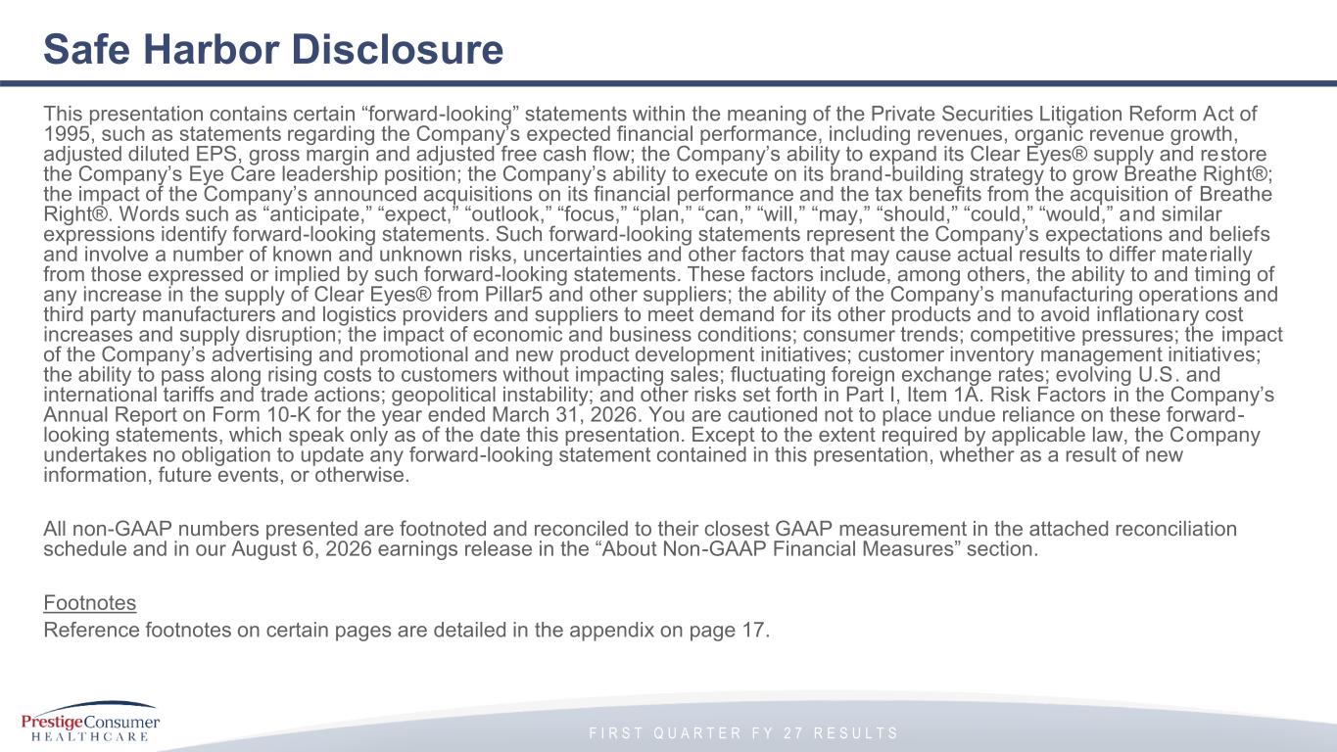
F I R S T Q U A R T E R F Y 2 7 R E S U L T S Safe Harbor Disclosure This presentation contains certain “forward-looking” statements within the meaning of the Private Securities Litigation Reform Act of 1995, such as statements regarding the Company’s expected financial performance, including revenues, organic revenue growth, adjusted diluted EPS, gross margin and adjusted free cash flow; the Company’s ability to expand its Clear Eyes® supply and restore the Company’s Eye Care leadership position; the Company’s ability to execute on its brand-building strategy to grow Breathe Right®; the impact of the Company’s announced acquisitions on its financial performance and the tax benefits from the acquisition of Breathe Right®. Words such as “anticipate,” “expect,” “outlook,” “focus,” “plan,” “can,” “will,” “may,” “should,” “could,” “would,” and similar expressions identify forward-looking statements. Such forward-looking statements represent the Company’s expectations and beliefs and involve a number of known and unknown risks, uncertainties and other factors that may cause actual results to differ materially from those expressed or implied by such forward-looking statements. These factors include, among others, the ability to and timing of any increase in the supply of Clear Eyes® from Pillar5 and other suppliers; the ability of the Company’s manufacturing operat ions and third party manufacturers and logistics providers and suppliers to meet demand for its other products and to avoid inflationary cost increases and supply disruption; the impact of economic and business conditions; consumer trends; competitive pressures; the impact of the Company’s advertising and promotional and new product development initiatives; customer inventory management initiatives; the ability to pass along rising costs to customers without impacting sales; fluctuating foreign exchange rates; evolving U.S. and international tariffs and trade actions; geopolitical instability; and other risks set forth in Part I, Item 1A. Risk Factors in the Company’s Annual Report on Form 10-K for the year ended March 31, 2026. You are cautioned not to place undue reliance on these forward- looking statements, which speak only as of the date this presentation. Except to the extent required by applicable law, the Company undertakes no obligation to update any forward-looking statement contained in this presentation, whether as a result of new information, future events, or otherwise. All non-GAAP numbers presented are footnoted and reconciled to their closest GAAP measurement in the attached reconciliation schedule and in our August 6, 2026 earnings release in the “About Non-GAAP Financial Measures” section. Footnotes Reference footnotes on certain pages are detailed in the appendix on page 17.


F I R S T Q U A R T E R F Y 2 7 R E S U L T S I. Performance Highlights

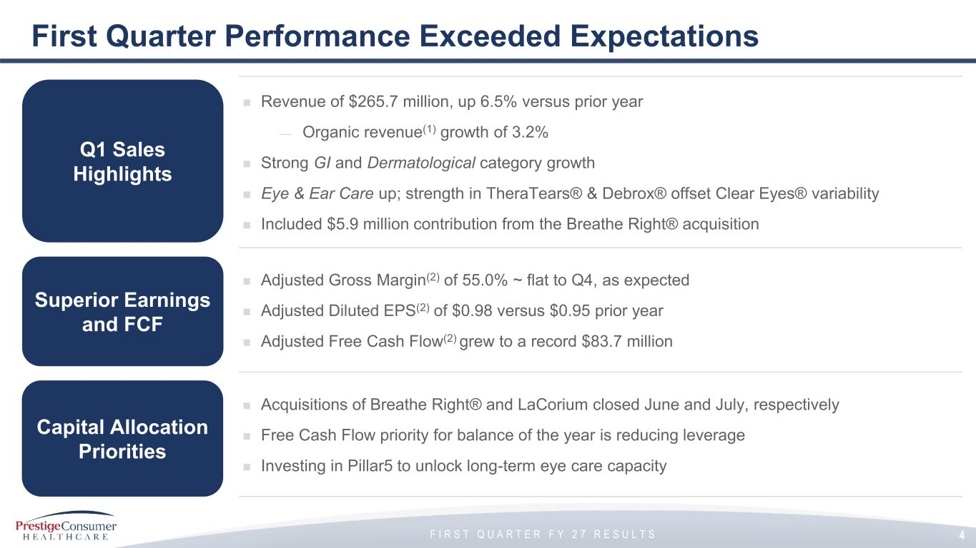
F I R S T Q U A R T E R F Y 2 7 R E S U L T S First Quarter Performance Exceeded Expectations ◼ Revenue of $265.7 million, up 6.5% versus prior year — Organic revenue(1) growth of 3.2% ◼ Strong GI and Dermatological category growth ◼ Eye & Ear Care up; strength in TheraTears® & Debrox® offset Clear Eyes® variability ◼ Included $5.9 million contribution from the Breathe Right® acquisition ◼ Adjusted Gross Margin(2) of 55.0% ~ flat to Q4, as expected ◼ Adjusted Diluted EPS(2) of $0.98 versus $0.95 prior year ◼ Adjusted Free Cash Flow(2) grew to a record $83.7 million ◼ Acquisitions of Breathe Right® and LaCorium closed June and July, respectively ◼ Free Cash Flow priority for balance of the year is reducing leverage ◼ Investing in Pillar5 to unlock long-term eye care capacity Q1 Sales Highlights Capital Allocation Priorities Superior Earnings and FCF 4

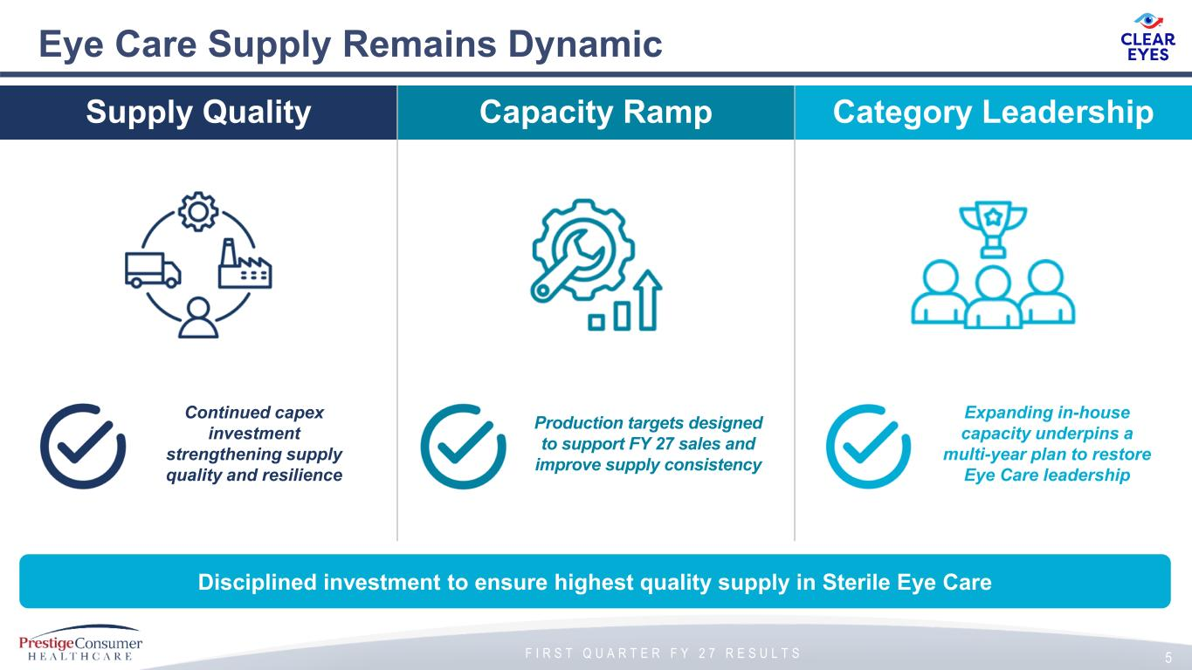
F I R S T Q U A R T E R F Y 2 7 R E S U L T S Eye Care Supply Remains Dynamic 5 Supply Quality Capacity Ramp Category Leadership Disciplined investment to ensure highest quality supply in Sterile Eye Care Continued capex investment strengthening supply quality and resilience Production targets designed to support FY 27 sales and improve supply consistency Expanding in-house capacity underpins a multi-year plan to restore Eye Care leadership


F I R S T Q U A R T E R F Y 2 7 R E S U L T S II. M&A Update

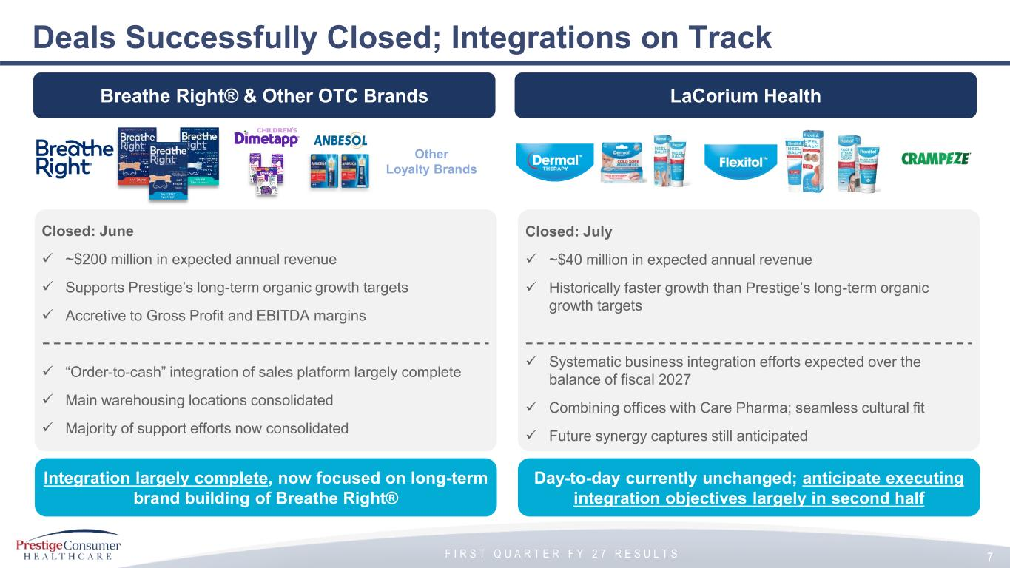
F I R S T Q U A R T E R F Y 2 7 R E S U L T S Deals Successfully Closed; Integrations on Track 7 Breathe Right® & Other OTC Brands LaCorium Health Other Loyalty Brands Integration largely complete, now focused on long-term brand building of Breathe Right® Day-to-day currently unchanged; anticipate executing integration objectives largely in second half Closed: June ✓ ~$200 million in expected annual revenue ✓ Supports Prestige’s long-term organic growth targets ✓ Accretive to Gross Profit and EBITDA margins ✓ “Order-to-cash” integration of sales platform largely complete ✓ Main warehousing locations consolidated ✓ Majority of support efforts now consolidated Closed: July ✓ ~$40 million in expected annual revenue ✓ Historically faster growth than Prestige’s long-term organic growth targets ✓ Systematic business integration efforts expected over the balance of fiscal 2027 ✓ Combining offices with Care Pharma; seamless cultural fit ✓ Future synergy captures still anticipated

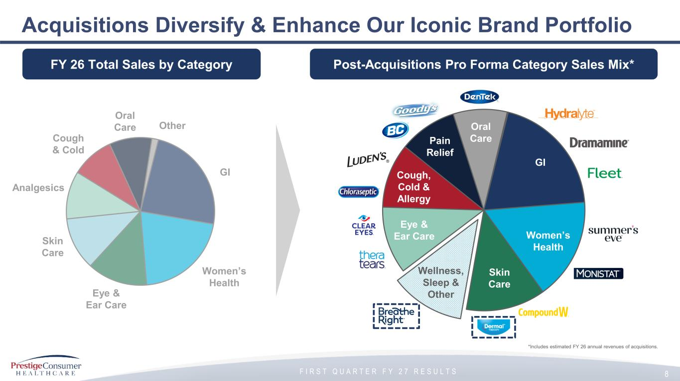
F I R S T Q U A R T E R F Y 2 7 R E S U L T S Acquisitions Diversify & Enhance Our Iconic Brand Portfolio 8 GI Skin Care Analgesics Oral Care Cough & Cold Women’s Health Eye & Ear Care Other ~12% GI Skin Care Pain Relief Oral Care Cough, Cold & Allergy Women’s Health Wellness, Sleep & Other Eye & Ear Care *Includes estimated FY 26 annual revenues of acquisitions. Post-Acquisitions Pro Forma Category Sales Mix*FY 26 Total Sales by Category

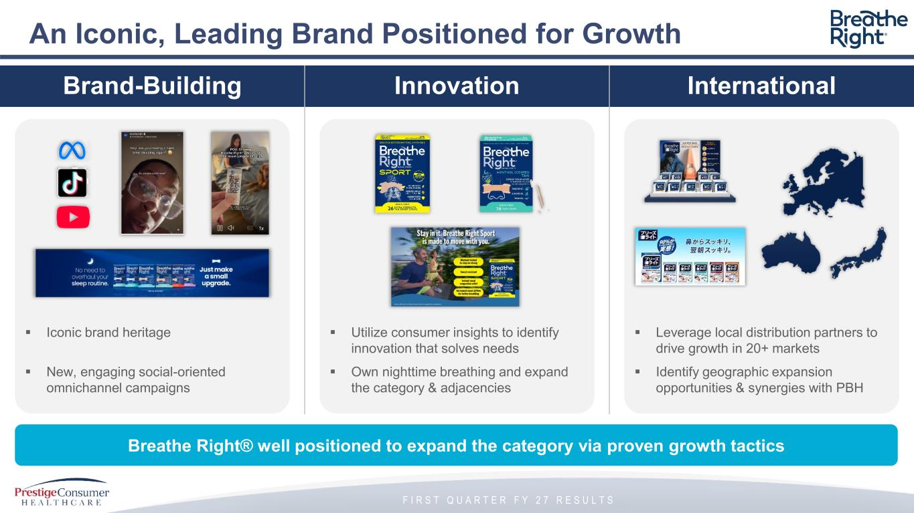
F I R S T Q U A R T E R F Y 2 7 R E S U L T S An Iconic, Leading Brand Positioned for Growth Brand-Building Innovation International Breathe Right® well positioned to expand the category via proven growth tactics ▪ Iconic brand heritage ▪ New, engaging social-oriented omnichannel campaigns ▪ Utilize consumer insights to identify innovation that solves needs ▪ Own nighttime breathing and expand the category & adjacencies ▪ Leverage local distribution partners to drive growth in 20+ markets ▪ Identify geographic expansion opportunities & synergies with PBH


F I R S T Q U A R T E R F Y 2 7 R E S U L T S III. Financial Overview

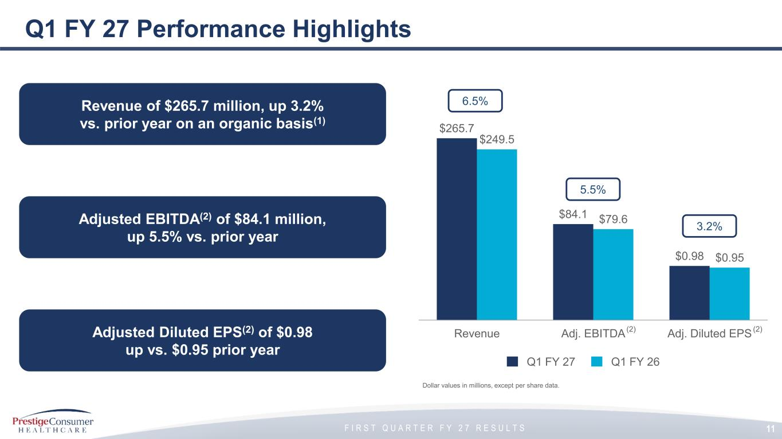
F I R S T Q U A R T E R F Y 2 7 R E S U L T S Q1 FY 27 Performance Highlights Q1 FY 27 Q1 FY 26 Dollar values in millions, except per share data. $265.7 $84.1 $0.98 $249.5 $79.6 $0.95 Revenue Adj. EBITDA Adj. Diluted EPS 6.5% 5.5% 3.2% Revenue of $265.7 million, up 3.2% vs. prior year on an organic basis(1) Adjusted Diluted EPS(2) of $0.98 up vs. $0.95 prior year Adjusted EBITDA(2) of $84.1 million, up 5.5% vs. prior year 11 (2) (2)

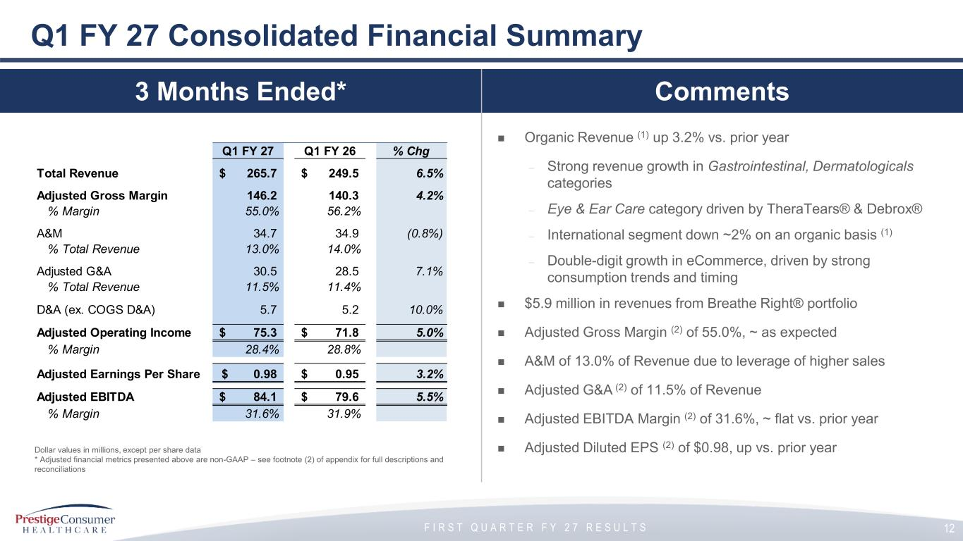
F I R S T Q U A R T E R F Y 2 7 R E S U L T S ◼ Organic Revenue (1) up 3.2% vs. prior year – Strong revenue growth in Gastrointestinal, Dermatologicals categories – Eye & Ear Care category driven by TheraTears® & Debrox® – International segment down ~2% on an organic basis (1) – Double-digit growth in eCommerce, driven by strong consumption trends and timing ◼ $5.9 million in revenues from Breathe Right® portfolio ◼ Adjusted Gross Margin (2) of 55.0%, ~ as expected ◼ A&M of 13.0% of Revenue due to leverage of higher sales ◼ Adjusted G&A (2) of 11.5% of Revenue ◼ Adjusted EBITDA Margin (2) of 31.6%, ~ flat vs. prior year ◼ Adjusted Diluted EPS (2) of $0.98, up vs. prior year Q1 FY 27 Consolidated Financial Summary Dollar values in millions, except per share data * Adjusted financial metrics presented above are non-GAAP – see footnote (2) of appendix for full descriptions and reconciliations 12 Q1 FY 27 Q1 FY 26 % Chg Total Revenue 265.7$ 249.5$ 6.5% Adjusted Gross Margin 146.2 140.3 4.2% % Margin 55.0% 56.2% A&M 34.7 34.9 (0.8%) % Total Revenue 13.0% 14.0% Adjusted G&A 30.5 28.5 7.1% % Total Revenue 11.5% 11.4% D&A (ex. COGS D&A) 5.7 5.2 10.0% Adjusted Operating Income 75.3$ 71.8$ 5.0% % Margin 28.4% 28.8% Adjusted Earnings Per Share 0.98$ 0.95$ 3.2% Adjusted EBITDA 84.1$ 79.6$ 5.5% % Margin 31.6% 31.9% 3 Months Ended* Comments

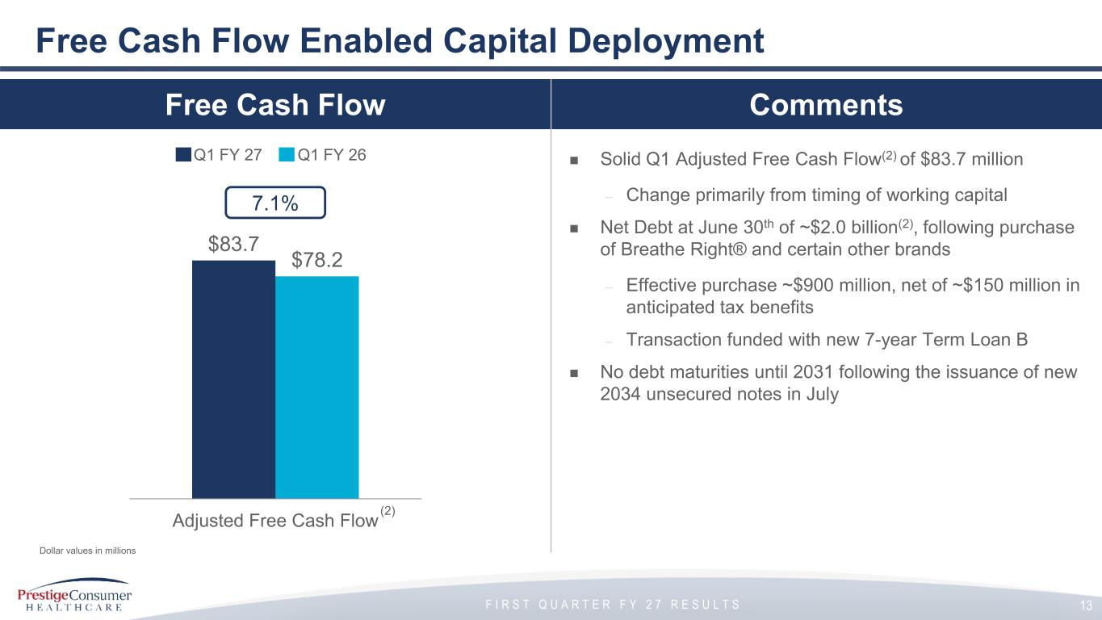
F I R S T Q U A R T E R F Y 2 7 R E S U L T S Free Cash Flow Comments ◼ Solid Q1 Adjusted Free Cash Flow(2) of $83.7 million – Change primarily from timing of working capital ◼ Net Debt at June 30th of ~$2.0 billion(2), following purchase of Breathe Right® and certain other brands – Effective purchase ~$900 million, net of ~$150 million in anticipated tax benefits – Transaction funded with new 7-year Term Loan B ◼ No debt maturities until 2031 following the issuance of new 2034 unsecured notes in July Free Cash Flow Enabled Capital Deployment $83.7 $78.2 Adjusted Free Cash Flow Q1 FY 27 Q1 FY 26 7.1% (2) Dollar values in millions 13


F I R S T Q U A R T E R F Y 2 7 R E S U L T S IV. FY 27 Outlook

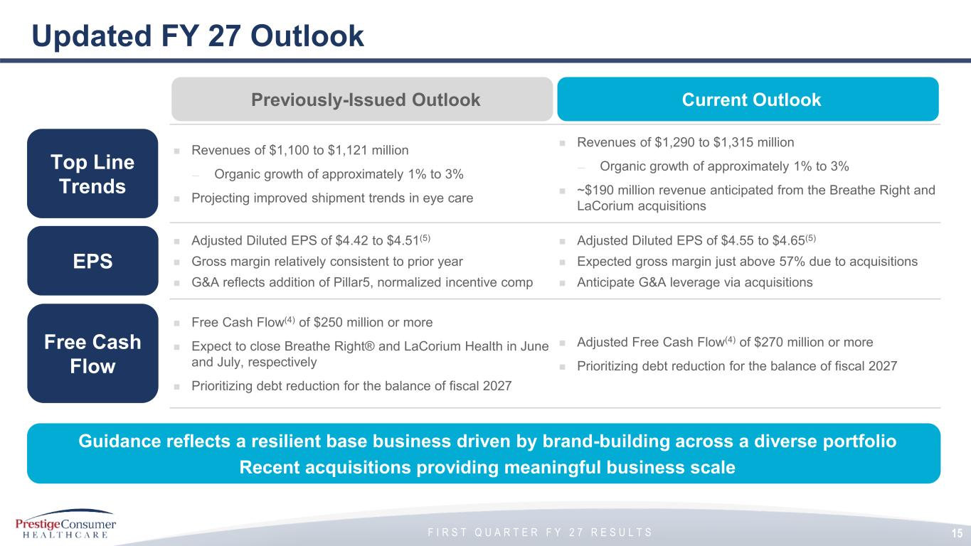
F I R S T Q U A R T E R F Y 2 7 R E S U L T S Updated FY 27 Outlook ◼ Revenues of $1,100 to $1,121 million — Organic growth of approximately 1% to 3% ◼ Projecting improved shipment trends in eye care ◼ Revenues of $1,290 to $1,315 million — Organic growth of approximately 1% to 3% ◼ ~$190 million revenue anticipated from the Breathe Right and LaCorium acquisitions ◼ Adjusted Diluted EPS of $4.42 to $4.51(5) ◼ Gross margin relatively consistent to prior year ◼ G&A reflects addition of Pillar5, normalized incentive comp ◼ Adjusted Diluted EPS of $4.55 to $4.65(5) ◼ Expected gross margin just above 57% due to acquisitions ◼ Anticipate G&A leverage via acquisitions ◼ Free Cash Flow(4) of $250 million or more ◼ Expect to close Breathe Right® and LaCorium Health in June and July, respectively ◼ Prioritizing debt reduction for the balance of fiscal 2027 ◼ Adjusted Free Cash Flow(4) of $270 million or more ◼ Prioritizing debt reduction for the balance of fiscal 2027 Top Line Trends Free Cash Flow EPS 15 Previously-Issued Outlook Current Outlook Guidance reflects a resilient base business driven by brand-building across a diverse portfolio Recent acquisitions providing meaningful business scale


F I R S T Q U A R T E R F Y 2 7 R E S U L T S Appendix

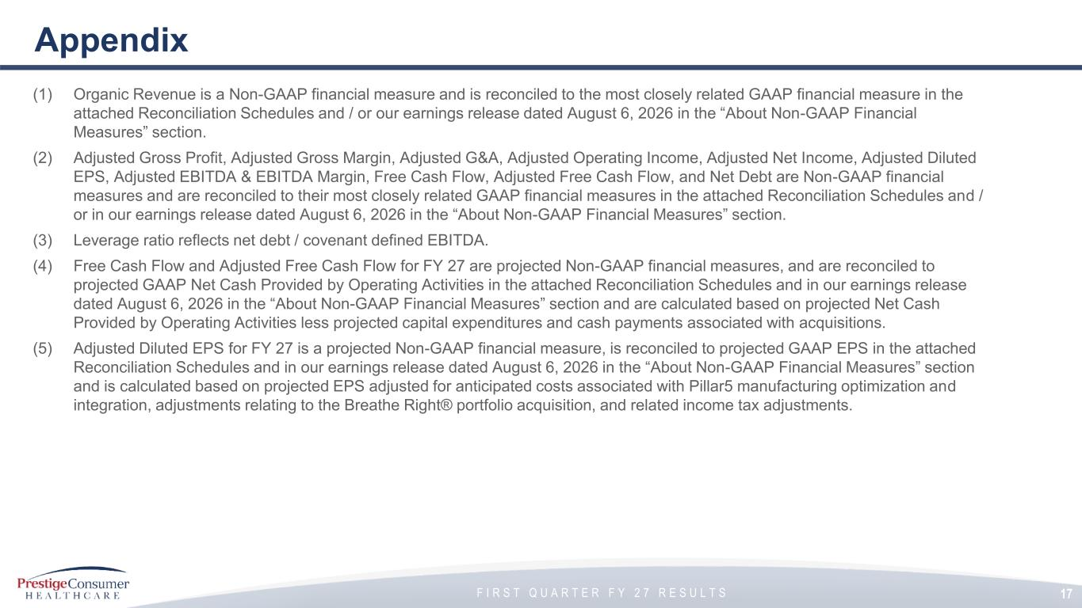
F I R S T Q U A R T E R F Y 2 7 R E S U L T S Appendix (1) Organic Revenue is a Non-GAAP financial measure and is reconciled to the most closely related GAAP financial measure in the attached Reconciliation Schedules and / or our earnings release dated August 6, 2026 in the “About Non-GAAP Financial Measures” section. (2) Adjusted Gross Profit, Adjusted Gross Margin, Adjusted G&A, Adjusted Operating Income, Adjusted Net Income, Adjusted Diluted EPS, Adjusted EBITDA & EBITDA Margin, Free Cash Flow, Adjusted Free Cash Flow, and Net Debt are Non-GAAP financial measures and are reconciled to their most closely related GAAP financial measures in the attached Reconciliation Schedules and / or in our earnings release dated August 6, 2026 in the “About Non-GAAP Financial Measures” section. (3) Leverage ratio reflects net debt / covenant defined EBITDA. (4) Free Cash Flow and Adjusted Free Cash Flow for FY 27 are projected Non-GAAP financial measures, and are reconciled to projected GAAP Net Cash Provided by Operating Activities in the attached Reconciliation Schedules and in our earnings release dated August 6, 2026 in the “About Non-GAAP Financial Measures” section and are calculated based on projected Net Cash Provided by Operating Activities less projected capital expenditures and cash payments associated with acquisitions. (5) Adjusted Diluted EPS for FY 27 is a projected Non-GAAP financial measure, is reconciled to projected GAAP EPS in the attached Reconciliation Schedules and in our earnings release dated August 6, 2026 in the “About Non-GAAP Financial Measures” section and is calculated based on projected EPS adjusted for anticipated costs associated with Pillar5 manufacturing optimization and integration, adjustments relating to the Breathe Right® portfolio acquisition, and related income tax adjustments. 17

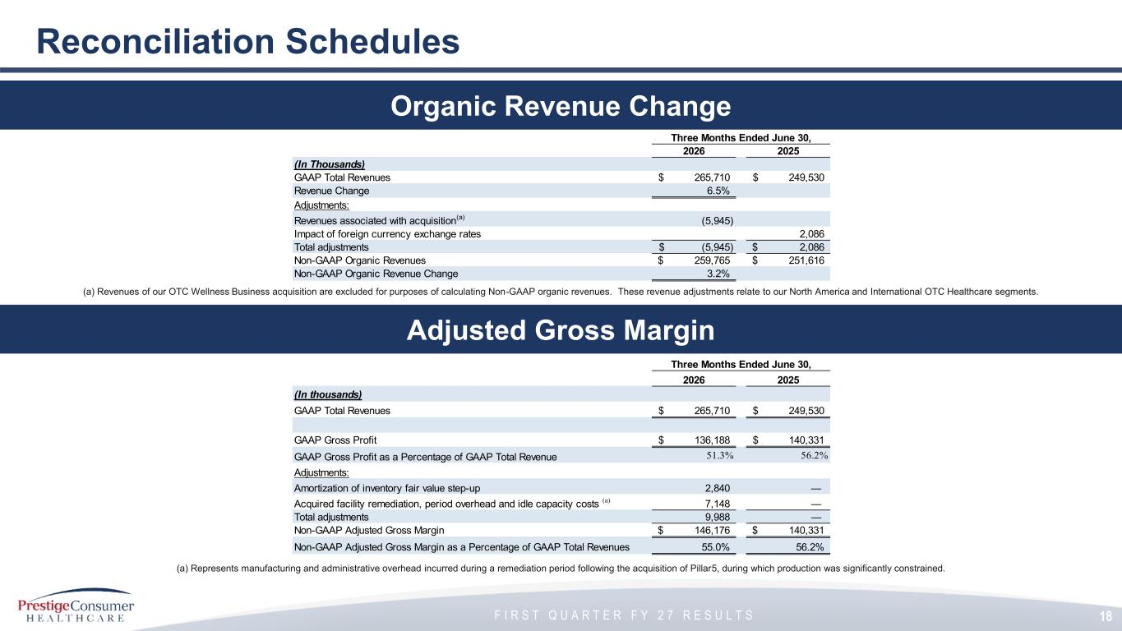
F I R S T Q U A R T E R F Y 2 7 R E S U L T S 18 Reconciliation Schedules Adjusted Gross Margin Organic Revenue Change (a) Represents manufacturing and administrative overhead incurred during a remediation period following the acquisition of Pillar5, during which production was significantly constrained. Three Months Ended June 30, 2026 2025 (In thousands) GAAP Total Revenues 265,710$ 249,530$ GAAP Gross Profit 136,188$ 140,331$ GAAP Gross Profit as a Percentage of GAAP Total Revenue 51.3% 56.2% Adjustments: Amortization of inventory fair value step-up 2,840 — Acquired facility remediation, period overhead and idle capacity costs (a) 7,148 — Total adjustments 9,988 — Non-GAAP Adjusted Gross Margin 146,176$ 140,331$ Non-GAAP Adjusted Gross Margin as a Percentage of GAAP Total Revenues 55.0% 56.2% (a) Revenues of our OTC Wellness Business acquisition are excluded for purposes of calculating Non-GAAP organic revenues. These revenue adjustments relate to our North America and International OTC Healthcare segments. Three Months Ended June 30, 2026 2025 (In Thousands) GAAP Total Revenues 265,710$ 249,530$ Revenue Change 6.5% Adjustments: Revenues associated with acquisition (a) (5,945) Impact of foreign currency exchange rates 2,086 Total adjustments (5,945)$ 2,086$ Non-GAAP Organic Revenues 259,765$ 251,616$ Non-GAAP Organic Revenue Change 3.2%

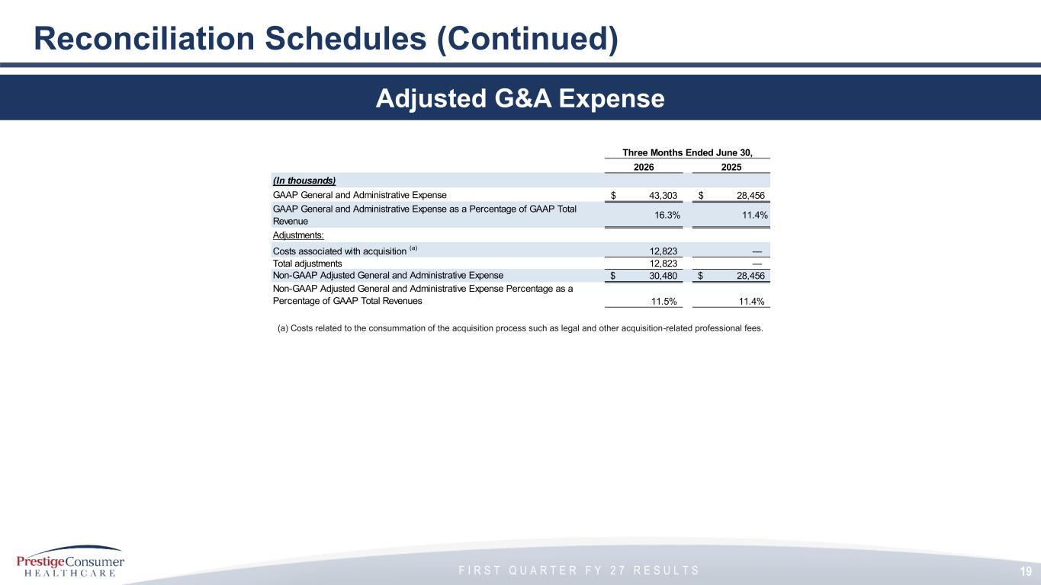
F I R S T Q U A R T E R F Y 2 7 R E S U L T S 19 Reconciliation Schedules (Continued) Adjusted G&A Expense (a) Costs related to the consummation of the acquisition process such as legal and other acquisition-related professional fees. Three Months Ended June 30, 2026 2025 (In thousands) GAAP General and Administrative Expense 43,303$ 28,456$ GAAP General and Administrative Expense as a Percentage of GAAP Total Revenue 16.3% 11.4% Adjustments: Costs associated with acquisition (a) 12,823 — Total adjustments 12,823 — Non-GAAP Adjusted General and Administrative Expense 30,480$ 28,456$ Non-GAAP Adjusted General and Administrative Expense Percentage as a Percentage of GAAP Total Revenues 11.5% 11.4%

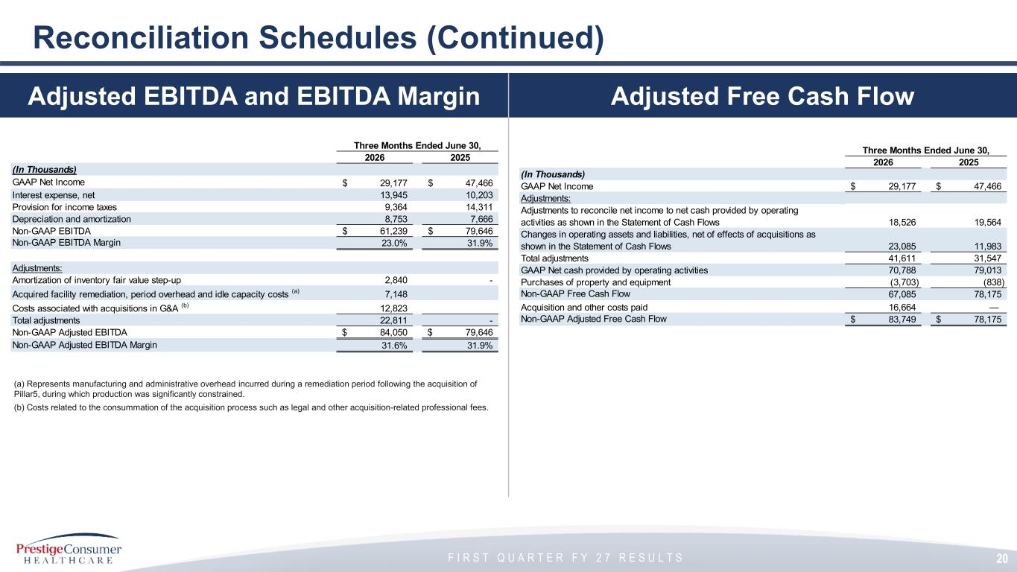
F I R S T Q U A R T E R F Y 2 7 R E S U L T S 20 Reconciliation Schedules (Continued) Adjusted EBITDA and EBITDA Margin (a) Represents manufacturing and administrative overhead incurred during a remediation period following the acquisition of Pillar5, during which production was significantly constrained. (b) Costs related to the consummation of the acquisition process such as legal and other acquisition-related professional fees. Three Months Ended June 30, 2026 2025 (In Thousands) GAAP Net Income 29,177$ 47,466$ Interest expense, net 13,945 10,203 Provision for income taxes 9,364 14,311 Depreciation and amortization 8,753 7,666 Non-GAAP EBITDA 61,239$ 79,646$ Non-GAAP EBITDA Margin 23.0% 31.9% Adjustments: Amortization of inventory fair value step-up 2,840 - Acquired facility remediation, period overhead and idle capacity costs (a) 7,148 Costs associated with acquisitions in G&A (b) 12,823 Total adjustments 22,811 - Non-GAAP Adjusted EBITDA 84,050$ 79,646$ Non-GAAP Adjusted EBITDA Margin 31.6% 31.9% Adjusted Free Cash Flow Three Months Ended June 30, 2026 2025 (In Thousands) GAAP Net Income 29,177$ 47,466$ Adjustments: Adjustments to reconcile net income to net cash provided by operating activities as shown in the Statement of Cash Flows 18,526 19,564 Changes in operating assets and liabilities, net of effects of acquisitions as shown in the Statement of Cash Flows 23,085 11,983 Total adjustments 41,611 31,547 GAAP Net cash provided by operating activities 70,788 79,013 Purchases of property and equipment (3,703) (838) Non-GAAP Free Cash Flow 67,085 78,175 Acquisition and other costs paid 16,664 — Non-GAAP Adjusted Free Cash Flow 83,749$ 78,175$

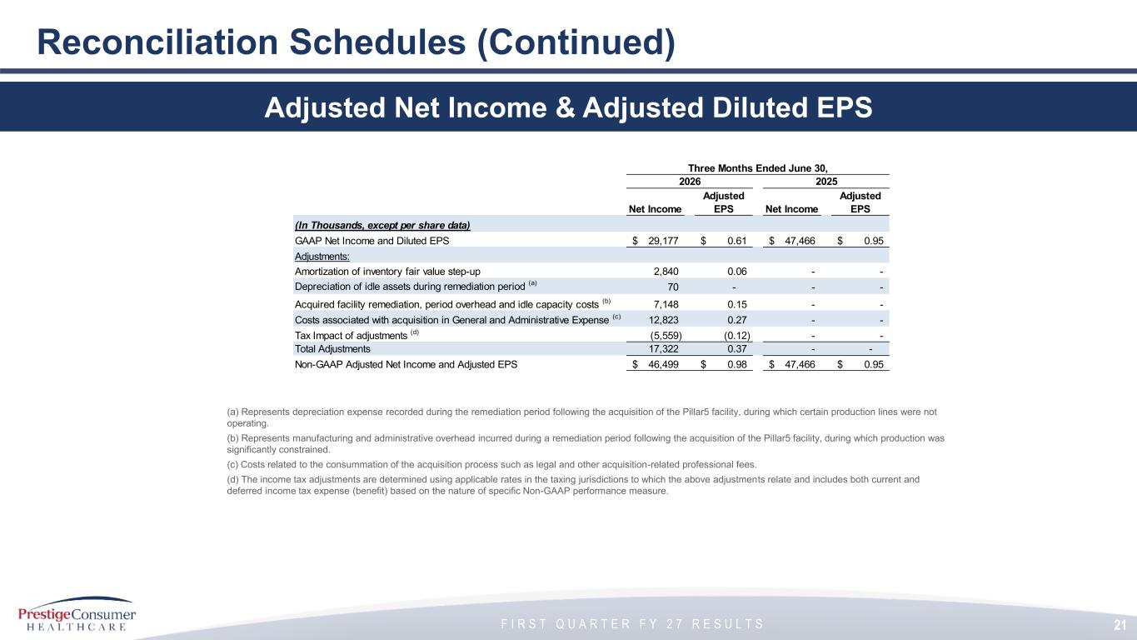
F I R S T Q U A R T E R F Y 2 7 R E S U L T S 21 Reconciliation Schedules (Continued) Adjusted Net Income & Adjusted Diluted EPS (a) Represents depreciation expense recorded during the remediation period following the acquisition of the Pillar5 facility, during which certain production lines were not operating. (b) Represents manufacturing and administrative overhead incurred during a remediation period following the acquisition of the Pillar5 facility, during which production was significantly constrained. (c) Costs related to the consummation of the acquisition process such as legal and other acquisition-related professional fees. (d) The income tax adjustments are determined using applicable rates in the taxing jurisdictions to which the above adjustments relate and includes both current and deferred income tax expense (benefit) based on the nature of specific Non-GAAP performance measure. Three Months Ended June 30, Nine Months Ended December 31, 2026 2025 Net Income Adjusted EPS Net Income Adjusted EPS (In Thousands, except per share data) GAAP Net Income and Diluted EPS 29,177$ 0.61$ 47,466$ 0.95$ Adjustments: Amortization of inventory fair value step-up 2,840 0.06 - - Depreciation of idle assets during remediation period (a) 70 - - - Acquired facility remediation, period overhead and idle capacity costs (b) 7,148 0.15 - - Costs associated with acquisition in General and Administrative Expense (c) 12,823 0.27 - - Tax Impact of adjustments (d) (5,559) (0.12) - - Total Adjustments 17,322 0.37 - - Non-GAAP Adjusted Net Income and Adjusted EPS 46,499$ 0.98$ 47,466$ 0.95$

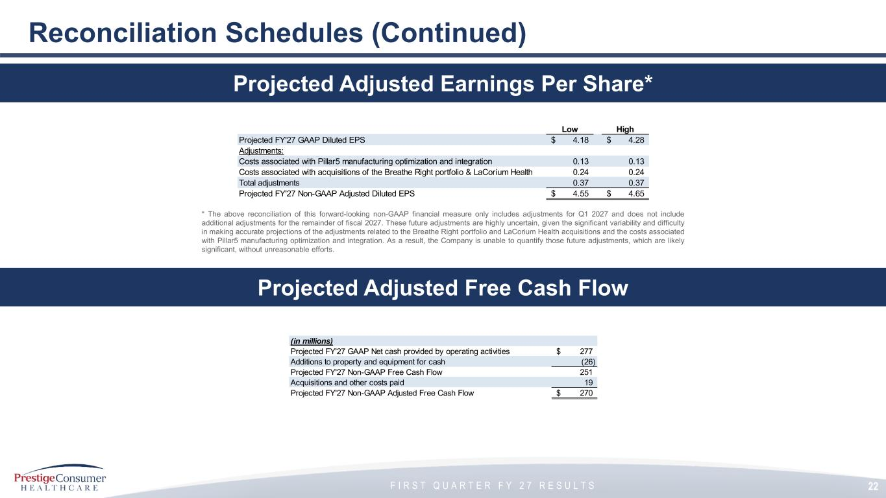
F I R S T Q U A R T E R F Y 2 7 R E S U L T S 22 Reconciliation Schedules (Continued) Projected Adjusted Free Cash Flow Projected Adjusted Earnings Per Share* Low High Projected FY'27 GAAP Diluted EPS 4.18$ 4.28$ Adjustments: Costs associated with Pillar5 manufacturing optimization and integration 0.13 0.13 Costs associated with acquisitions of the Breathe Right portfolio & LaCorium Health 0.24 0.24 Total adjustments 0.37 0.37 Projected FY'27 Non-GAAP Adjusted Diluted EPS 4.55$ 4.65$ * The above reconciliation of this forward-looking non-GAAP financial measure only includes adjustments for Q1 2027 and does not include additional adjustments for the remainder of fiscal 2027. These future adjustments are highly uncertain, given the significant variability and difficulty in making accurate projections of the adjustments related to the Breathe Right portfolio and LaCorium Health acquisitions and the costs associated with Pillar5 manufacturing optimization and integration. As a result, the Company is unable to quantify those future adjustments, which are likely significant, without unreasonable efforts. (in millions) Projected FY'27 GAAP Net cash provided by operating activities 277$ Additions to property and equipment for cash (26) Projected FY'27 Non-GAAP Free Cash Flow 251 Acquisitions and other costs paid 19 Projected FY'27 Non-GAAP Adjusted Free Cash Flow 270$

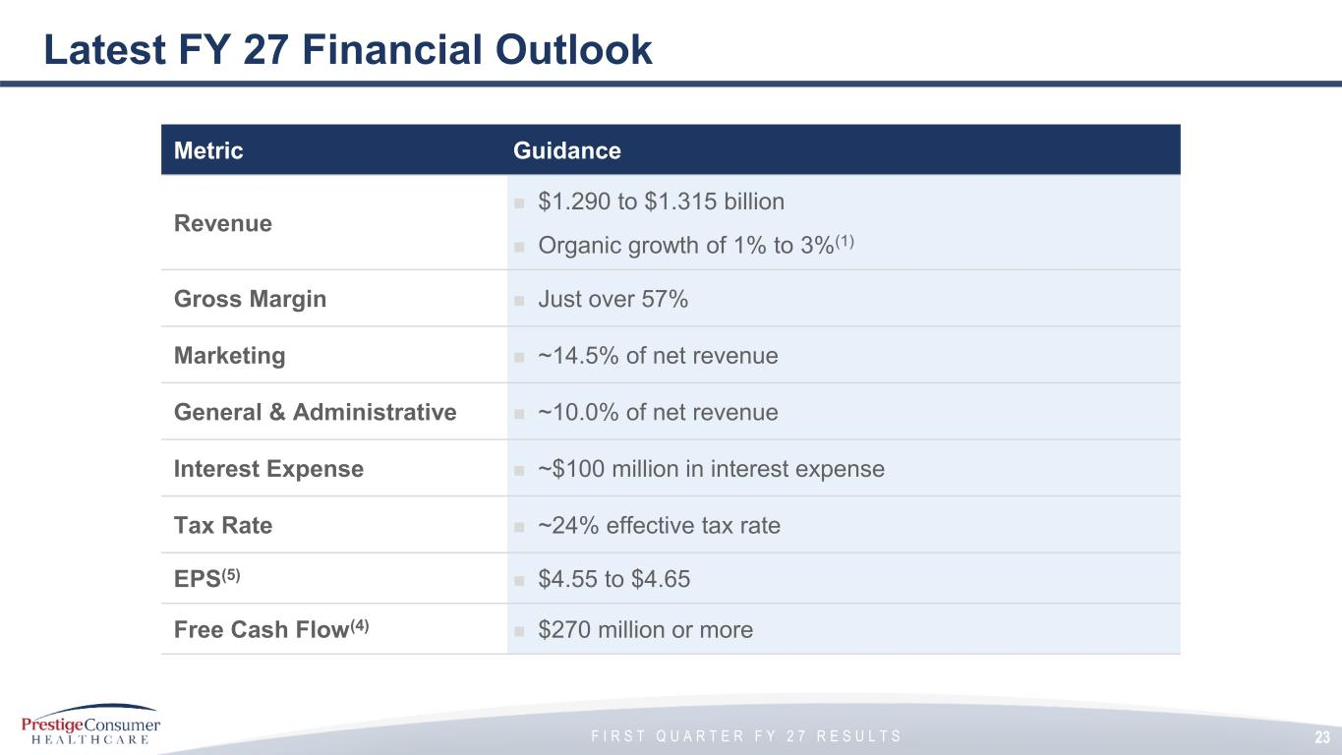
F I R S T Q U A R T E R F Y 2 7 R E S U L T S Latest FY 27 Financial Outlook Metric Guidance Revenue ◼ $1.290 to $1.315 billion ◼ Organic growth of 1% to 3%(1) Gross Margin ◼ Just over 57% Marketing ◼ ~14.5% of net revenue General & Administrative ◼ ~10.0% of net revenue Interest Expense ◼ ~$100 million in interest expense Tax Rate ◼ ~24% effective tax rate EPS(5) ◼ $4.55 to $4.65 Free Cash Flow(4) ◼ $270 million or more 23

