UNITED STATES

SECURITIES AND EXCHANGE COMMISSION

Washington, D.C. 20549

FORM 8-K/A

CURRENT REPORT

Pursuant to Section 13 or 15(d) of The Securities Exchange Act of 1934

Date of Report (Date of earliest event reported): September 3, 2014


PRESTIGE BRANDS HOLDINGS, INC.

(Exact name of Registrant as specified in its charter)

 | Delaware |  | 001-32433 |  |  | 20-1297589
(State or other jurisdiction of |  |  |  |  |  | (I.R.S. Employer Identification No.)
incorporation) |  |  | (Commission file number)
 |  |  | 660 White Plains Road
 |  |  | Tarrytown, New York 10591
 |  |  | (Address of principal executive offices) (Zip Code)
 |  |  | (914) 524-6800
 |  |  | (Registrant's telephone number, including area code)
 |  |  | (Former name or former address, if changed since last report)

Check the appropriate box below if the Form 8-K filing is intended to simultaneously satisfy the filing obligation of the registrant under any of the following provisions (see: General Instructions A.2. below)

- Written communications pursuant to Rule 425 under the Securities Act (17 CFR 230.425)

- Soliciting material pursuant to Rule 14a-12 under the Exchange Act (17 CFR 240.14a-12)

- Pre-commencement communications pursuant to Rule 14d-2(b) under the Exchange Act (17 CFR 240.14d-2(b))

- Pre-commencement communications pursuant to Rule 13e-4(c) under the Exchange Act (17 CFR 240.13e-4(c))

EXPLANATORY NOTE

This Current Report on Form 8-K/A is being filed as an amendment to the Current Report on Form 8-K filed by Prestige Brands Holdings, Inc. (the “Company”) with the Securities and Exchange Commission (the “Commission”) on September 3, 2014 (the “Original Form 8-K”) announcing the completion of its previously announced acquisition of Insight Pharmaceuticals Corporation and Subsidiary ("Insight"), a marketer and distributor of feminine care and other OTC healthcare products in North America.This Current Report on Form 8-K/A amends Item 9.01 of the Original Form 8-K to present certain audited financial statements of Insight and to present certain unaudited pro forma financial information in connection with the Company’s business combination with Insight, which financial statements and unaudited pro forma information are filed as exhibits hereto. All of the other Items in the Original Form 8-K remain the same and are hereby incorporated herein by reference.

Item 9.01 Financial Statements and Exhibits.

(a)Financial Statements of Business Acquired.

(i) The audited financial statements listed below for Insight are set forth in exhibit 99.1 to this Current Report on Form 8-K/A and are incorporated herein by reference.

Independent Auditors Report

Audited Consolidated Balance Sheets at December 31, 2013 and 2012

Audited Consolidated Statements of Operations for the years ended December 31, 2013 and 2012

Audited Consolidated Statements of Changes in Stockholders' Equity for the years ended December 31, 2013 and 2012

Audited Consolidated Statements of Cash Flows for the years ended December 31, 2013 and 2012

Notes to Consolidated Financial Statements for the years ended December 31, 2013 and 2012

(ii) The interim financial statements listed below for Insight are set forth in exhibit 99.2 to this Current Report on Form 8-K/A and are incorporated herein by reference.

Unaudited Consolidated Balance Sheets at June 30, 2014 and December 31, 2013

Unaudited Consolidated Statements of Operations for the six months ended June 30, 2014 and 2013

Unaudited Consolidated Statements of Changes in Stockholders' Equity for the six months ended June 30, 2014

Unaudited Consolidated Statements of Cash Flows for the six months ended June 30, 2014 and 2013

Notes to Consolidated Financial Statements for the six months ended June 30, 2014 and 2013

(b)Pro Forma Financial Information.

The unaudited pro forma combined financial statements listed below of the Company giving effect to the acquisition of Insight are set forth in exhibit 99.3 to this Current Report on Form 8-K/A and are incorporated herein by reference.

Unaudited Pro Forma Combined Statement of Operations for the twelve months ended March 31, 2014

Unaudited Pro Forma Combined Statement of Operations for the six months ended September 30, 2014

Notes to Pro Forma Combined Financial Statements

(d)Exhibits.

See Exhibit Index immediately following the signature page to this Current Report on Form 8-K/A.

SIGNATURES

Pursuant to the requirements of the Securities Exchange Act of 1934, the registrant has duly caused this report to be signed on its behalf by the undersigned hereunto duly authorized.

PRESTIGE BRANDS HOLDINGS, INC.

Date: November 19, 2014 By: /s/ Ronald M. Lombardi

Ronald M. Lombardi

Chief Financial Officer

EXHIBIT INDEX

Exhibit No. Description

23.1 Consent of KPMG, LLP

99.1 Audited Consolidated Financial Statements of Insight for the years ended December 31, 2013 and 2012

99.2 Unaudited Consolidated Financial Statements of Insight for the six months ended June 30, 2014 and 2013

99.3 Unaudited Pro Forma Combined Statements of Operations of the Company giving effect to the acquisition of Insight.

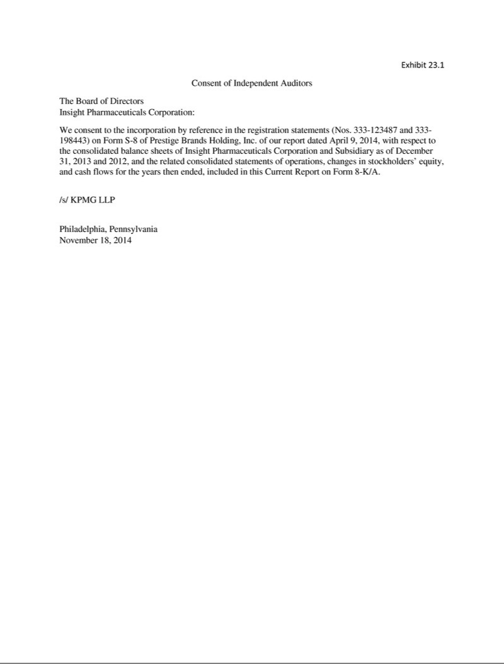

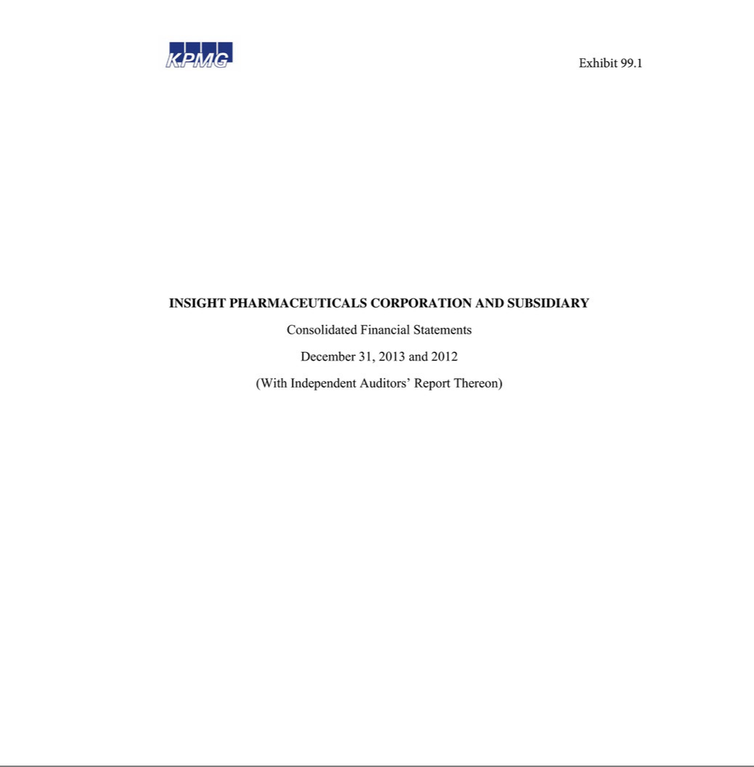

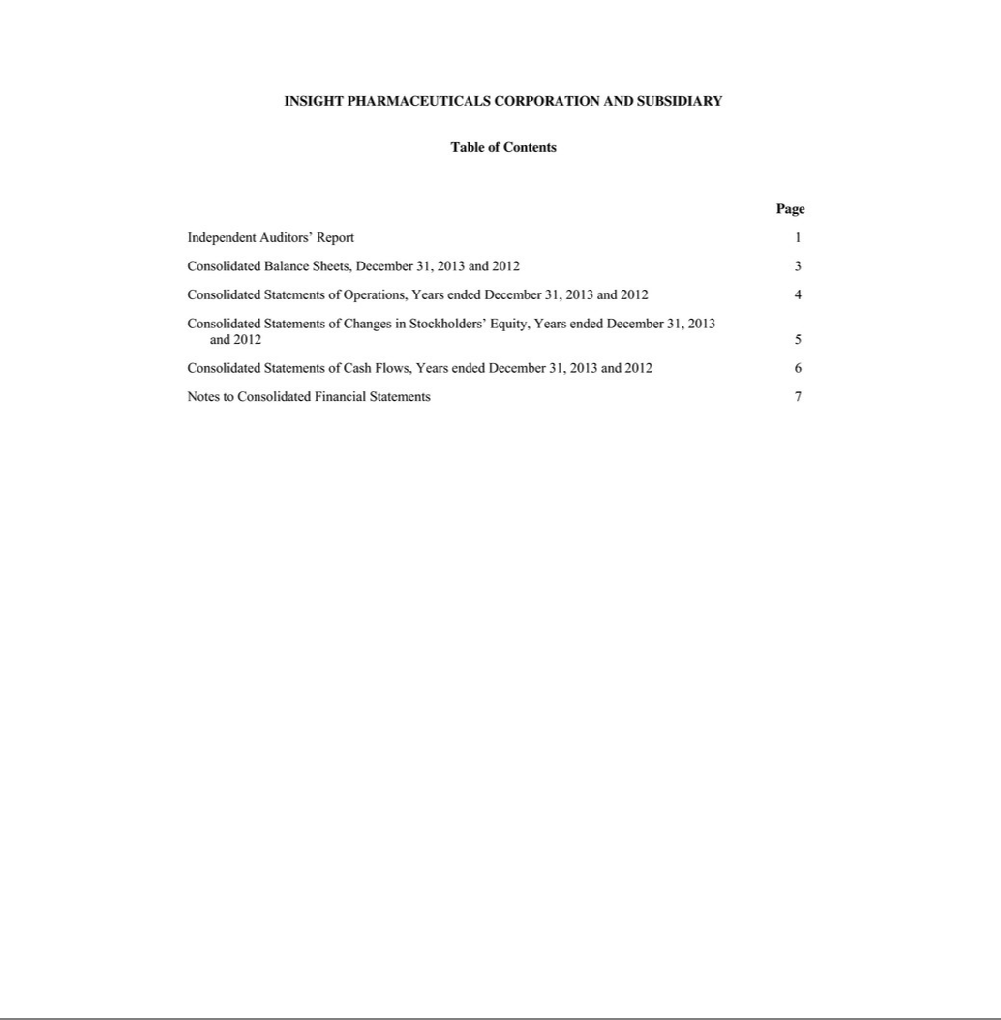

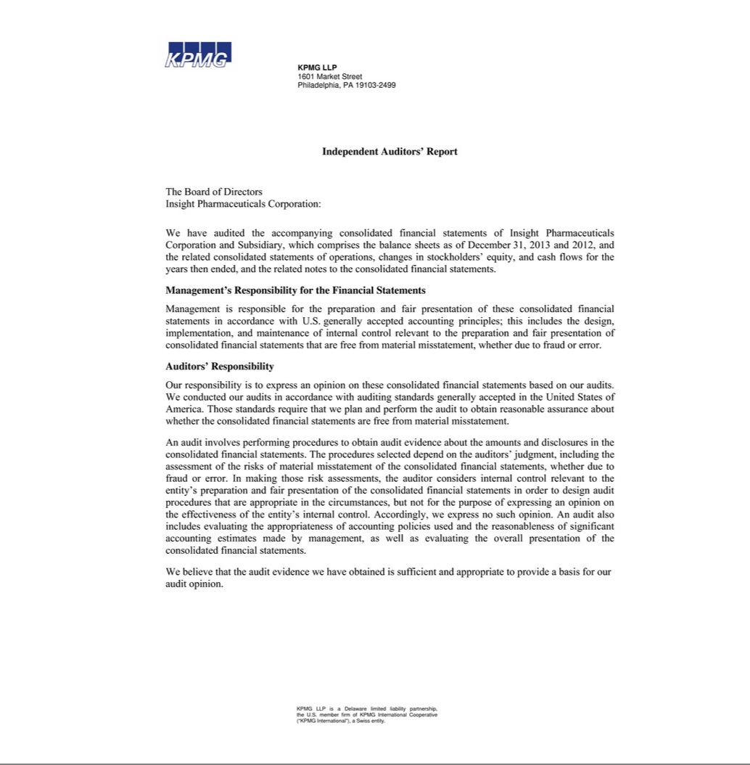

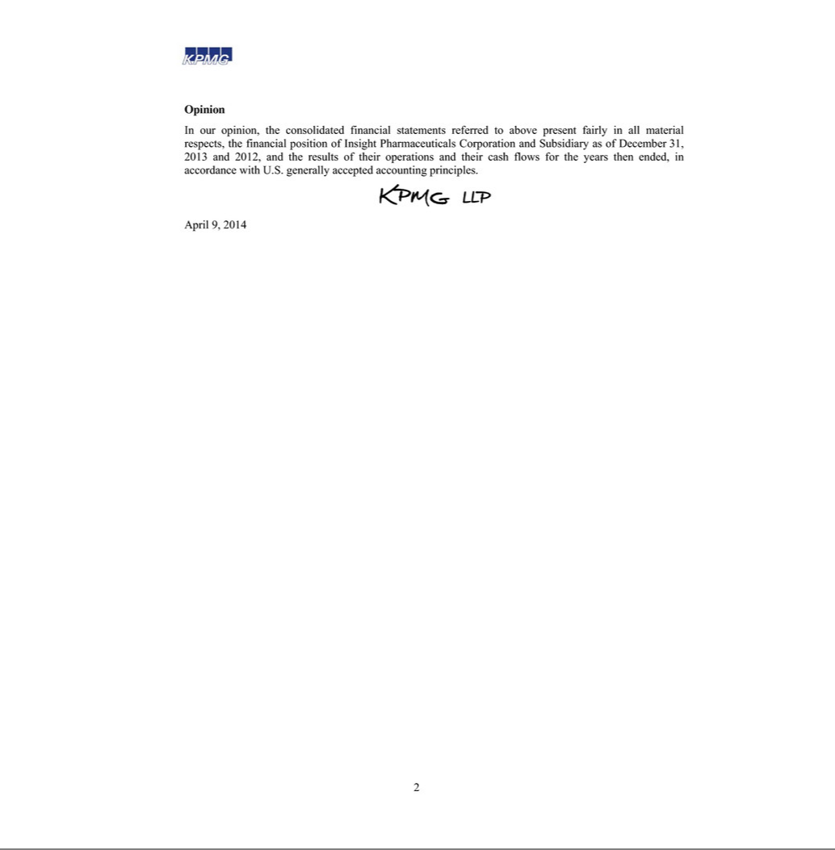

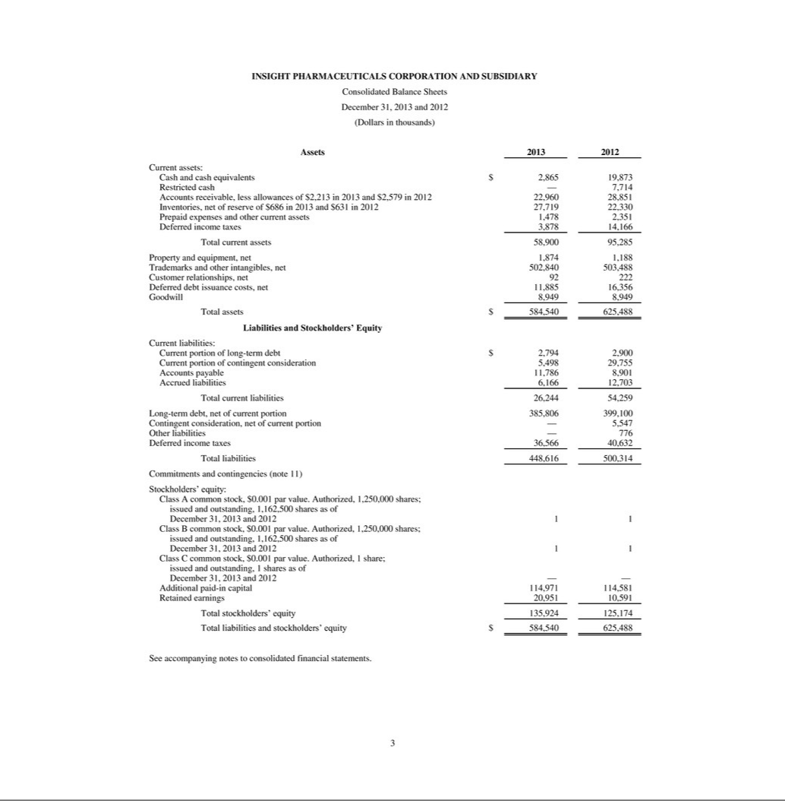

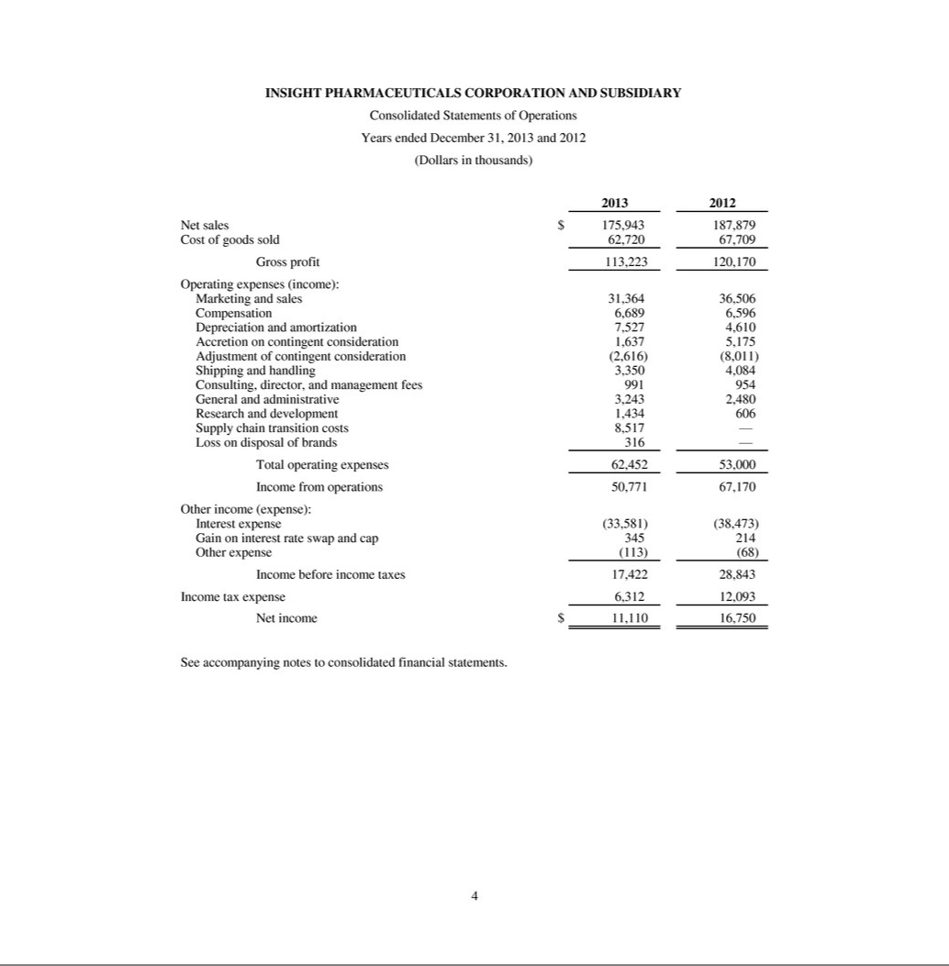

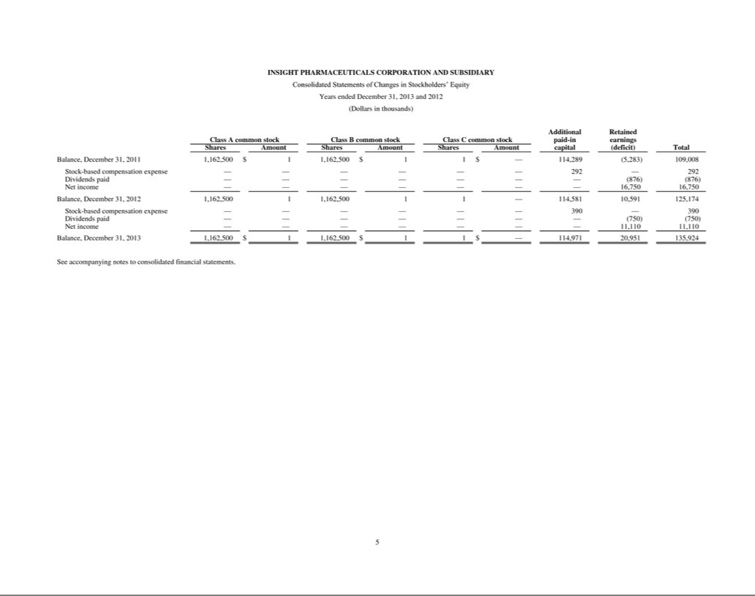

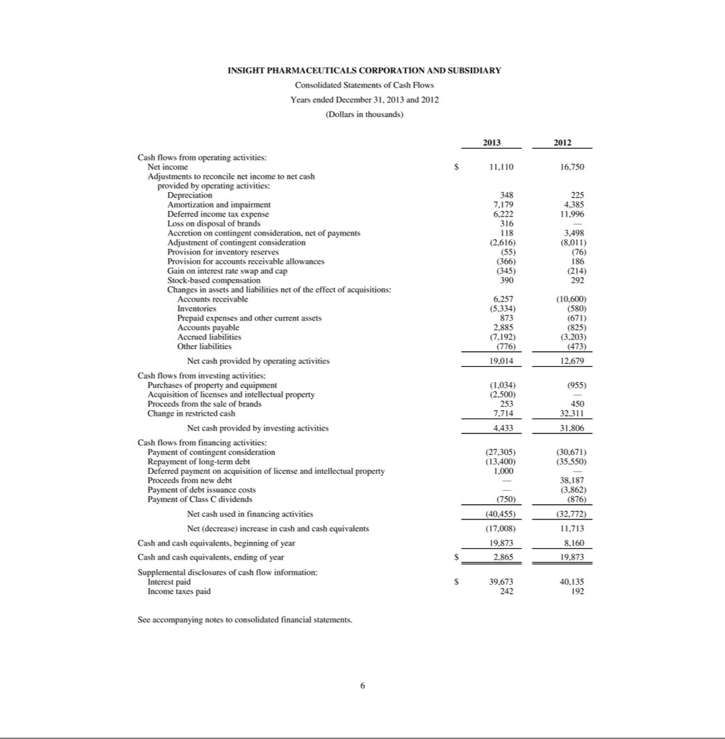

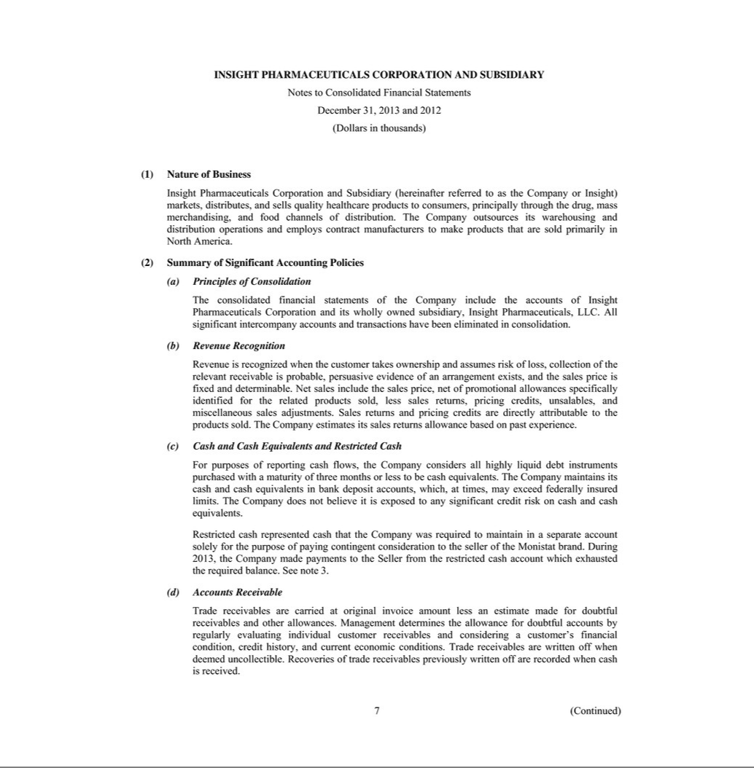

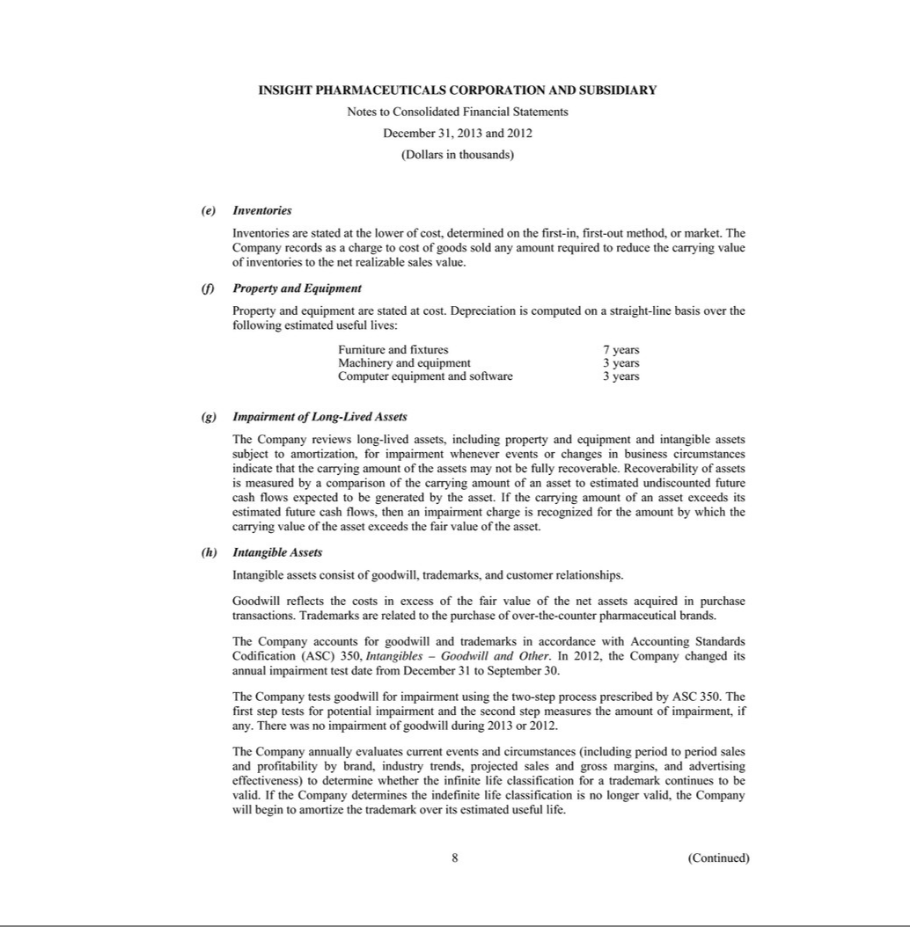

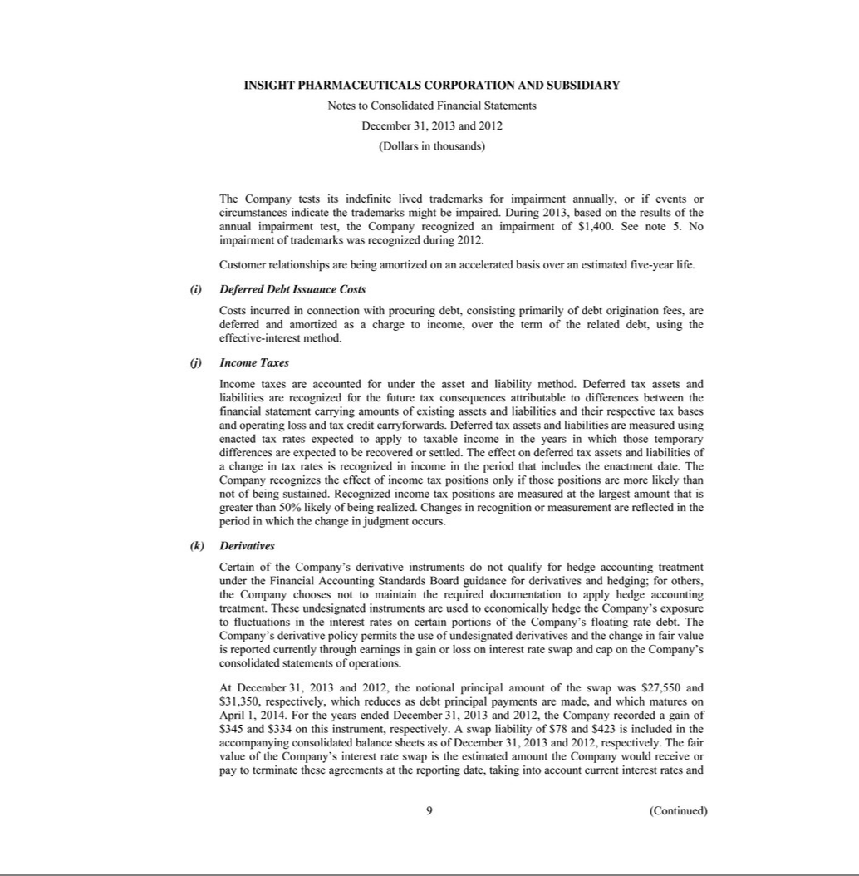

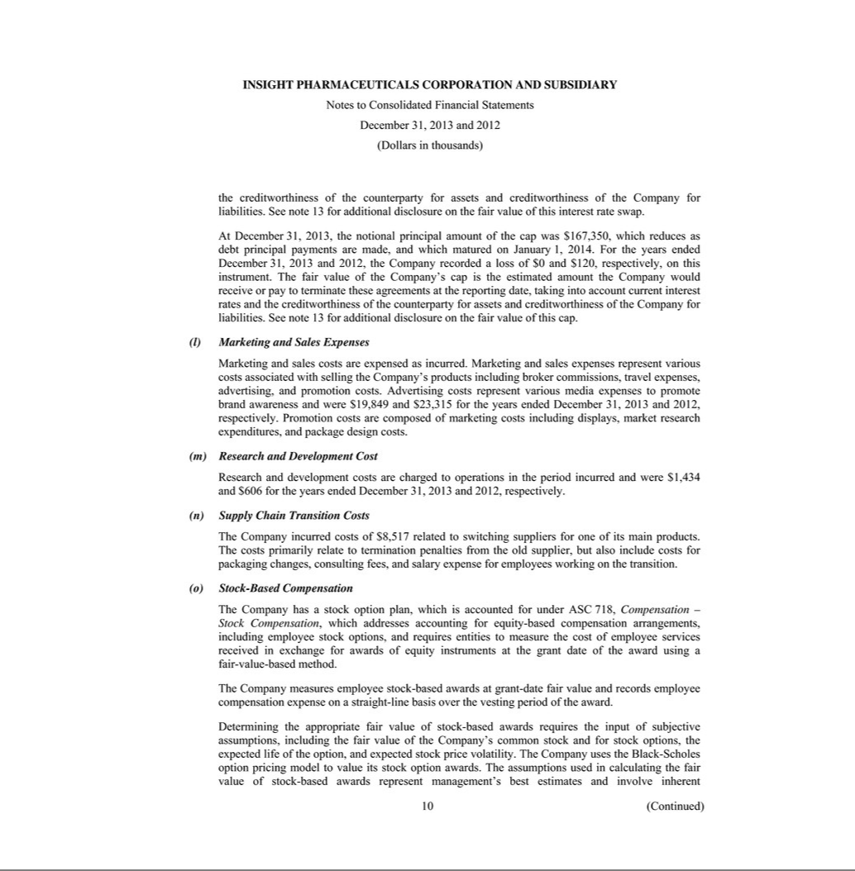

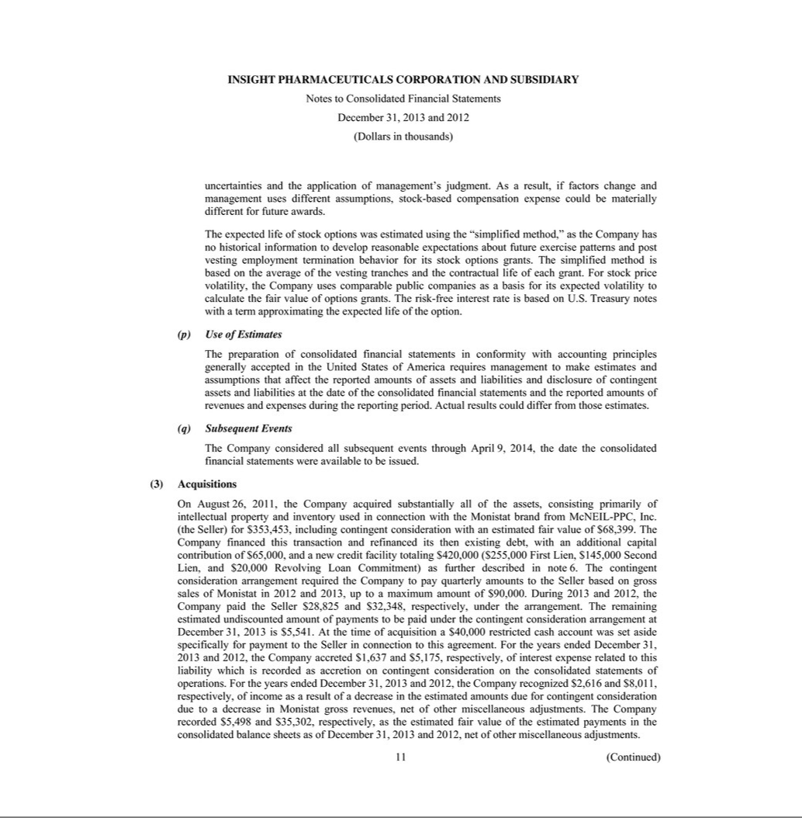

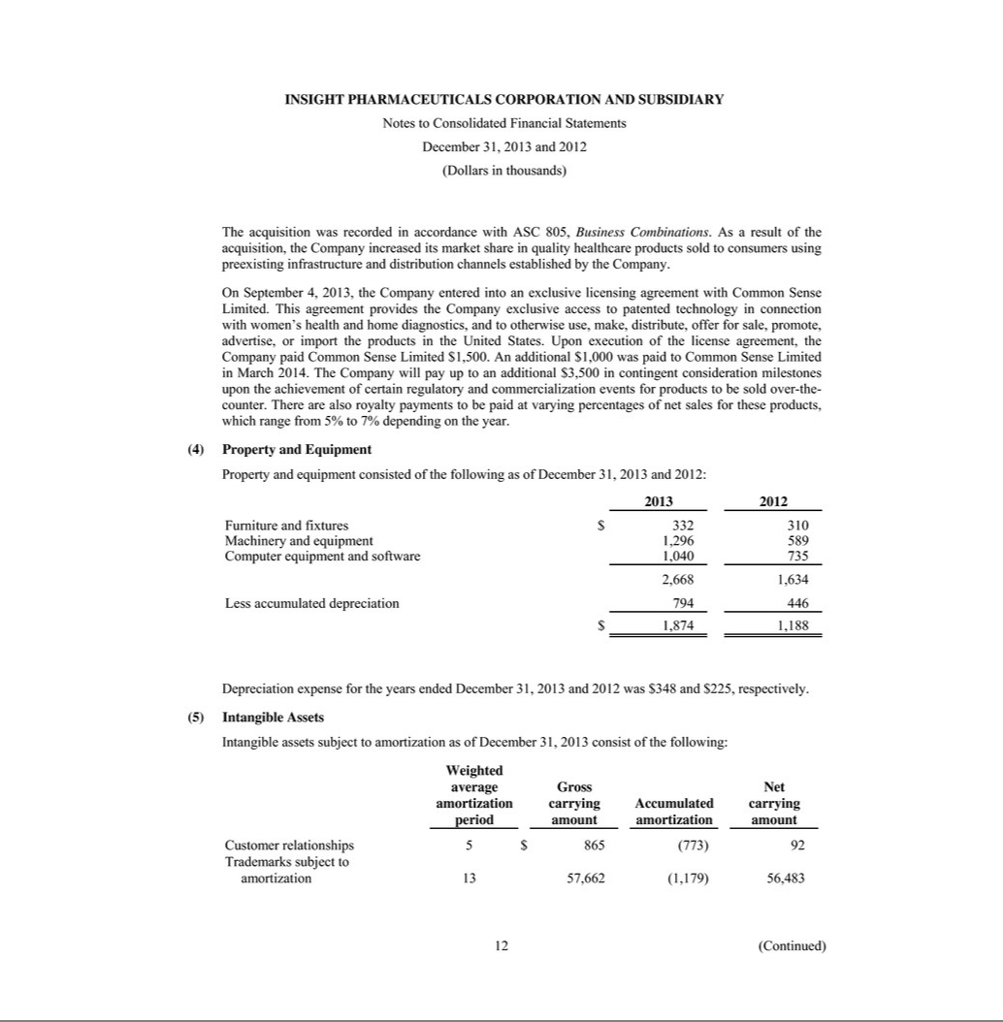

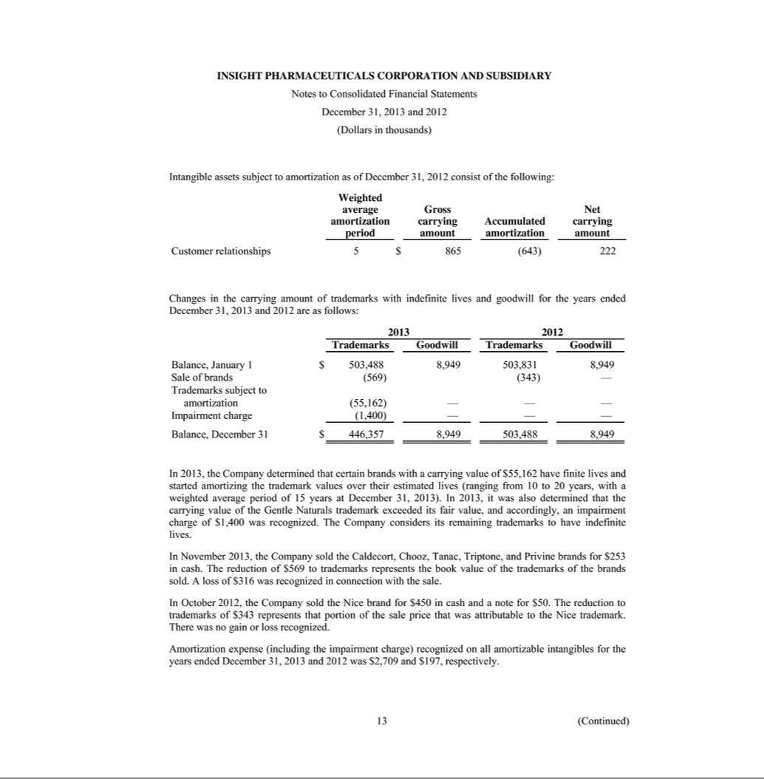

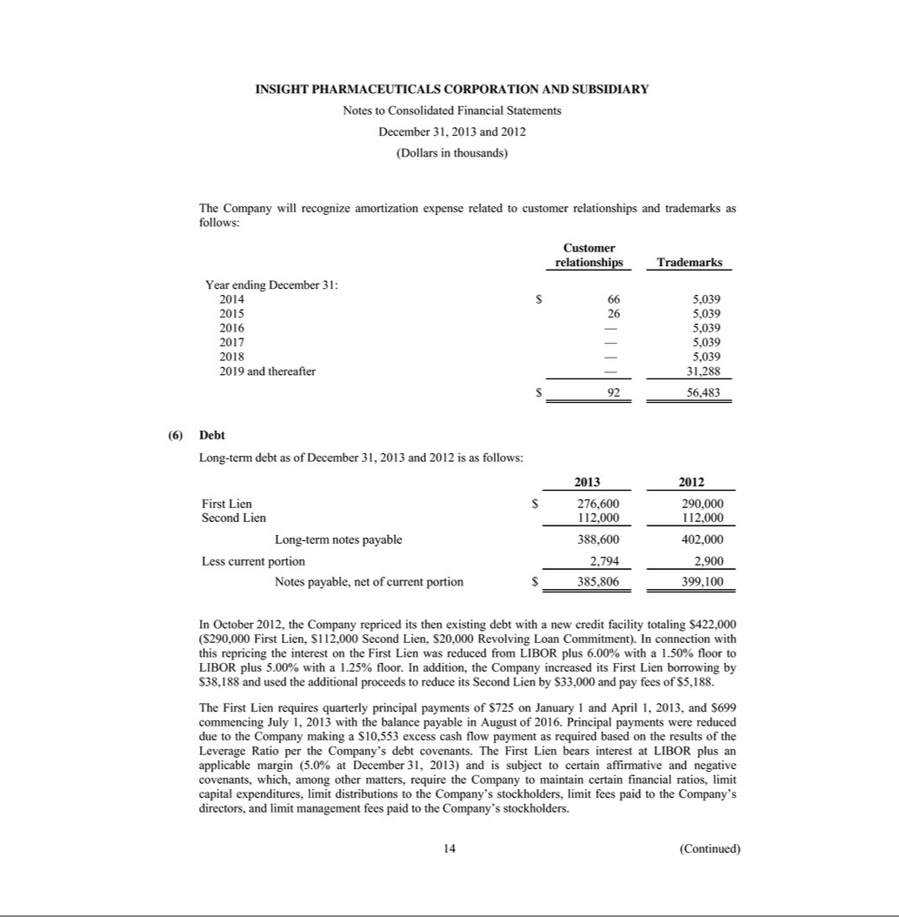

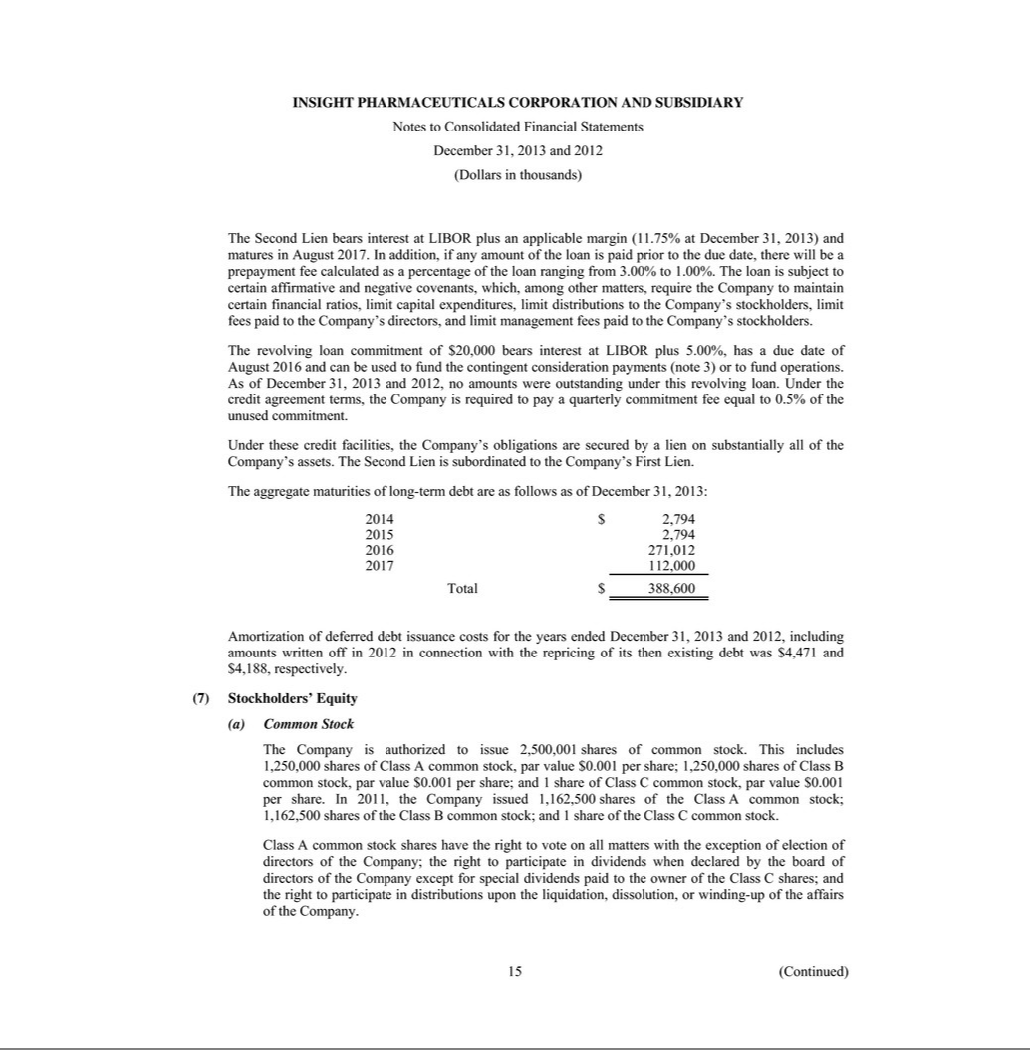

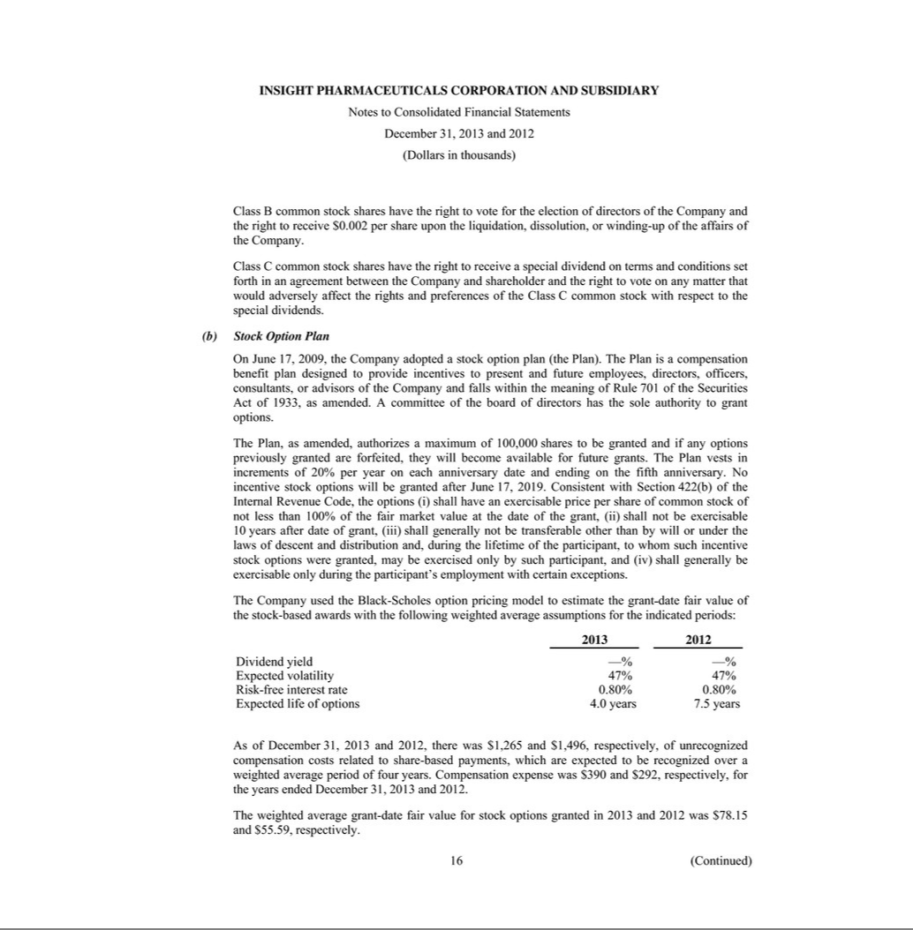

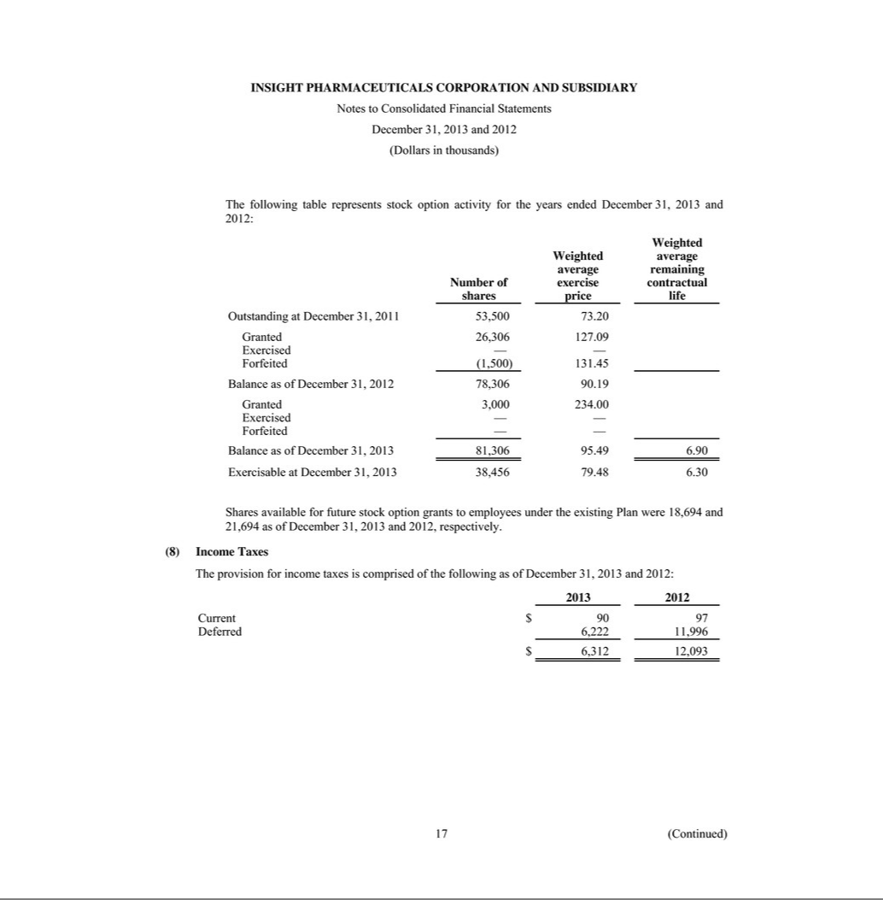

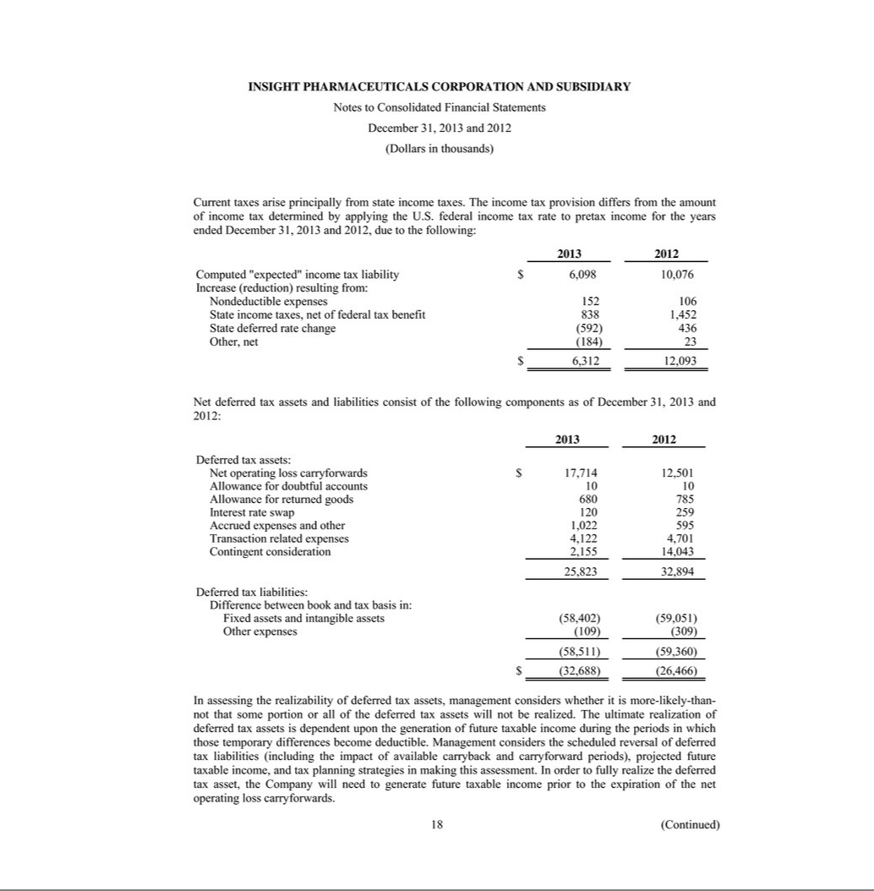

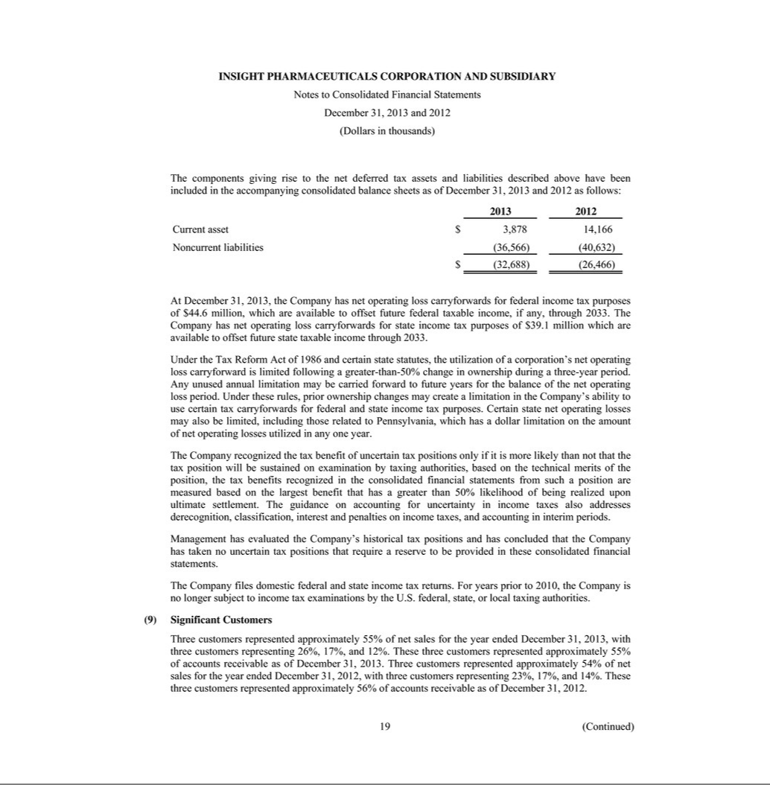

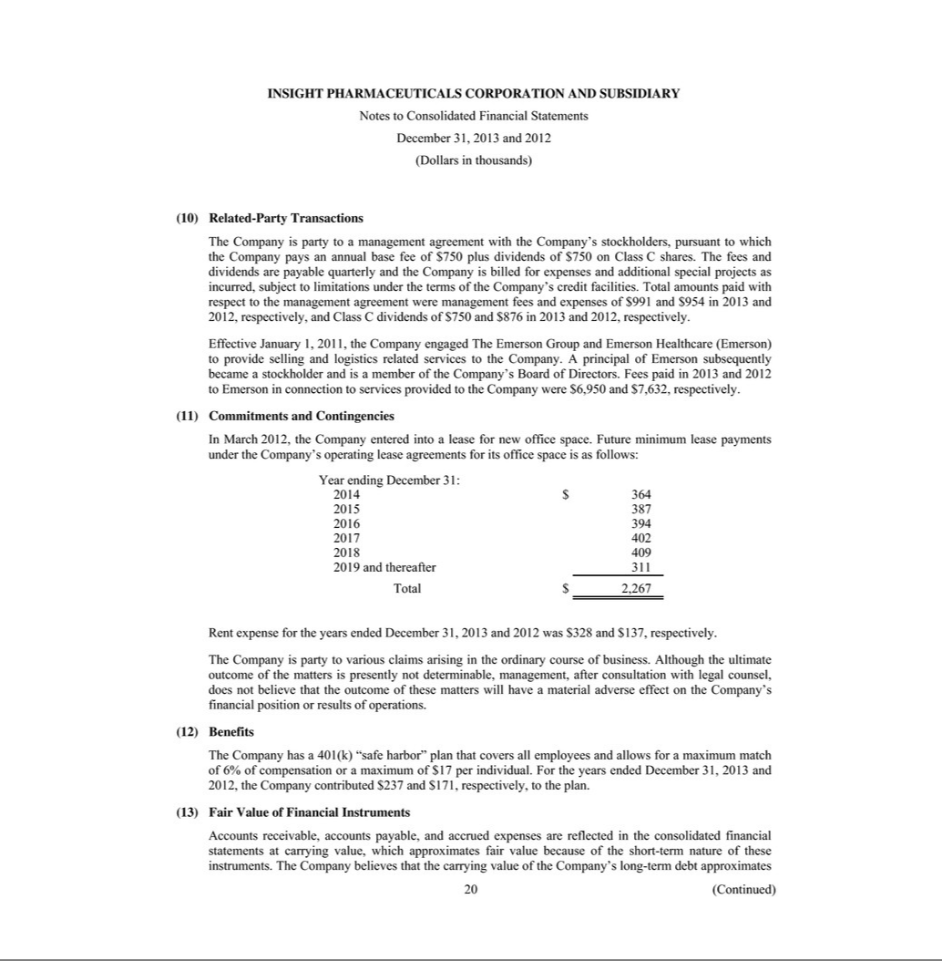

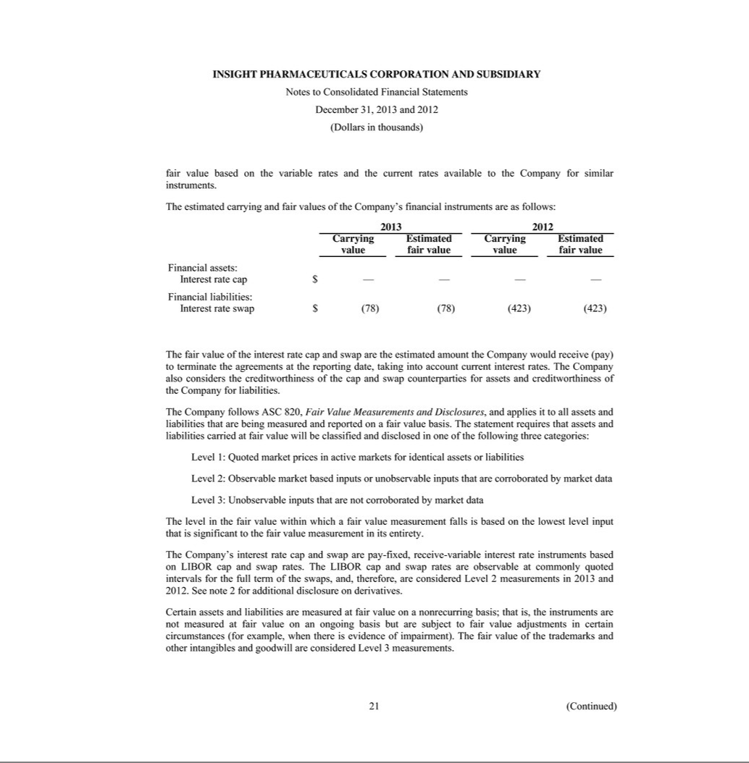

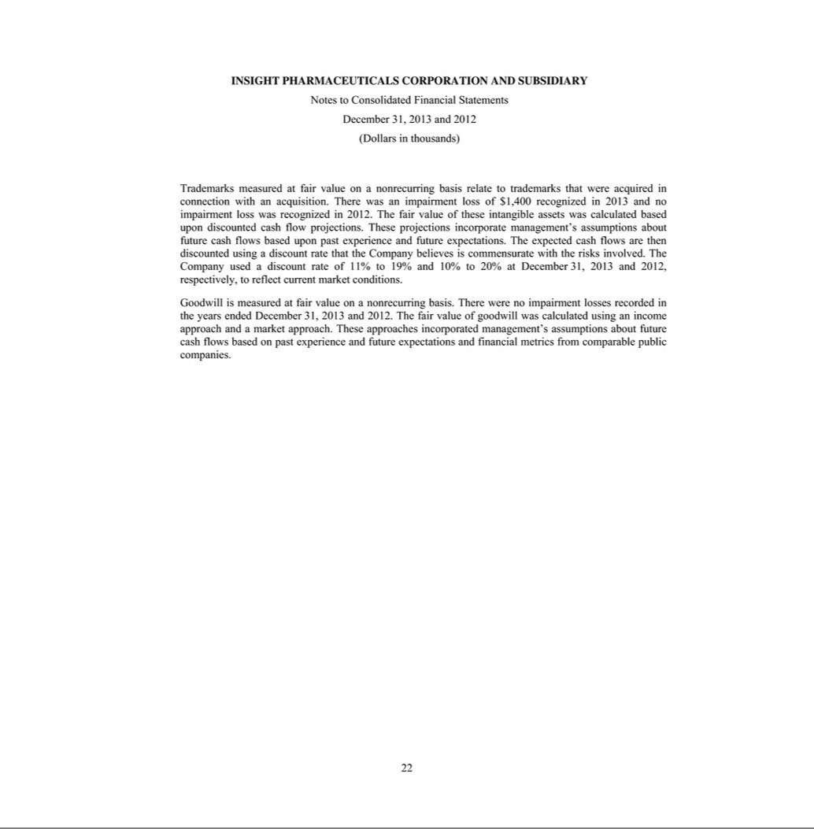

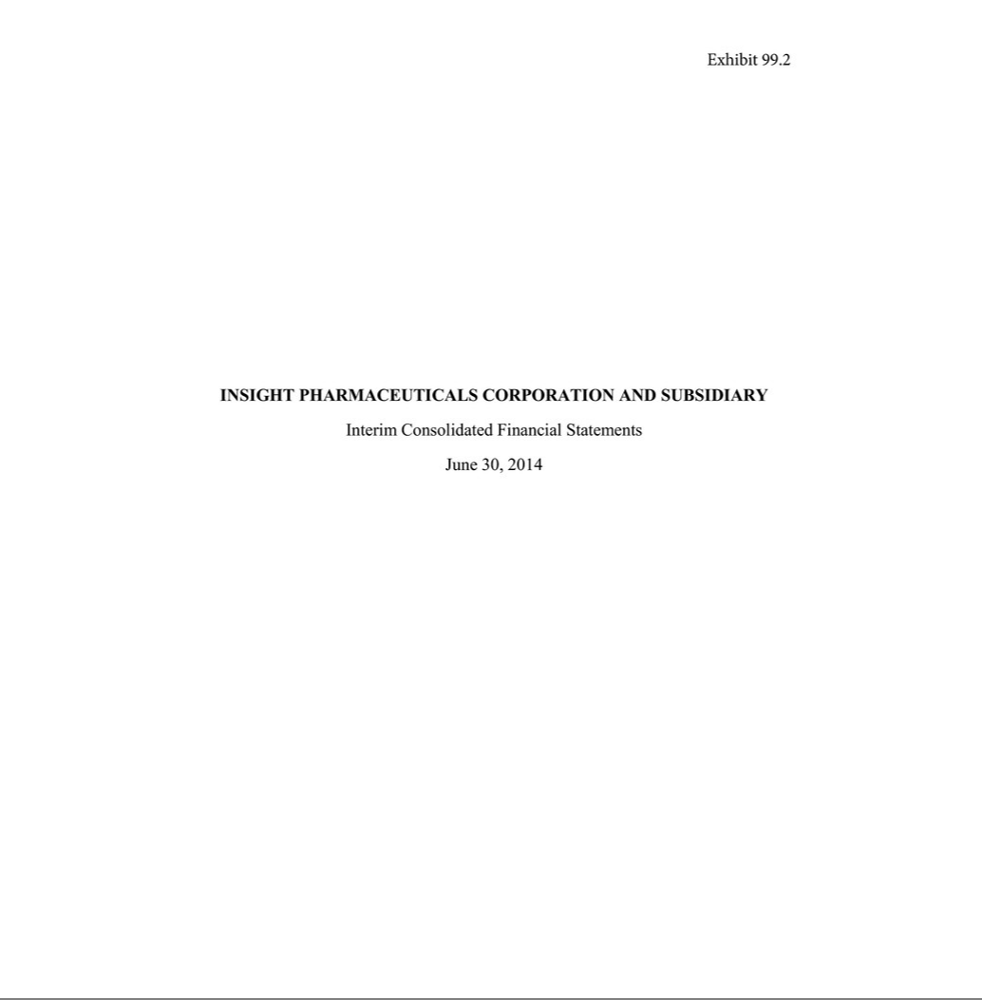

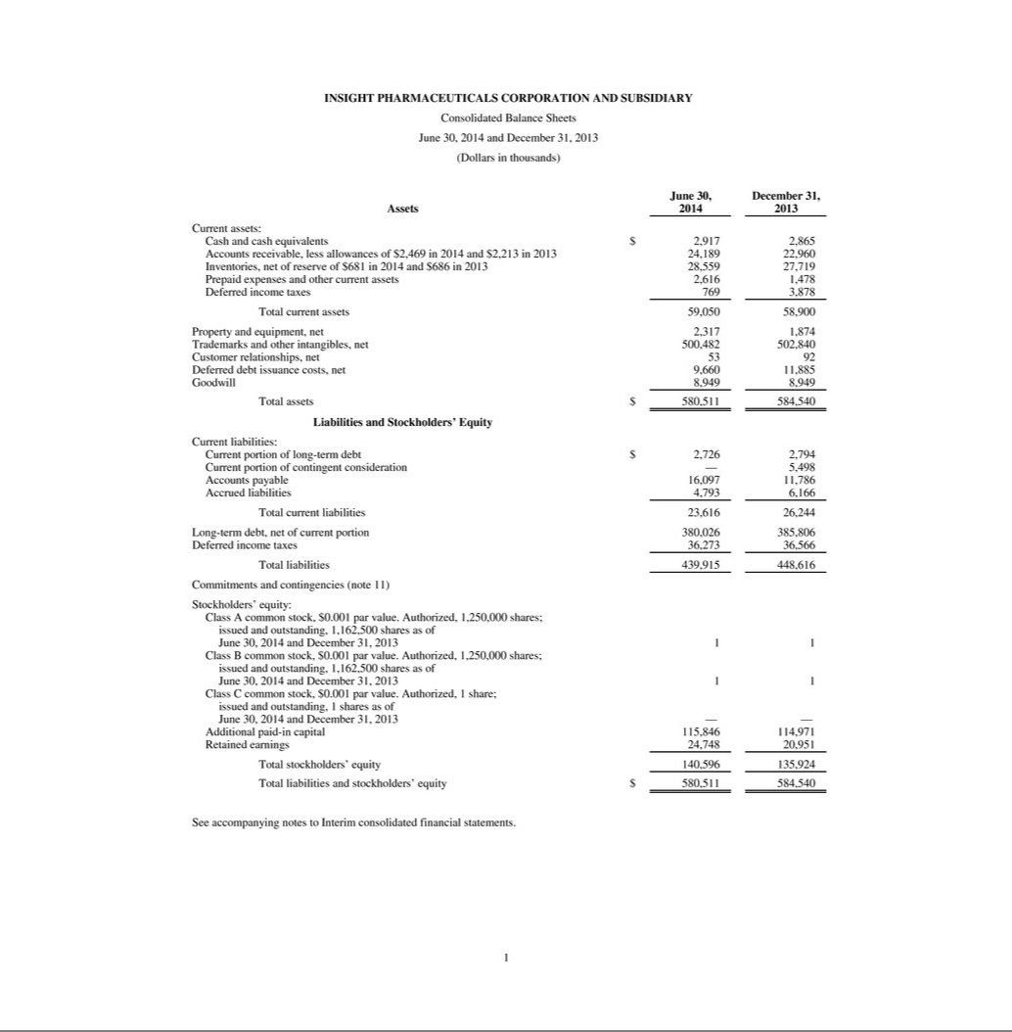

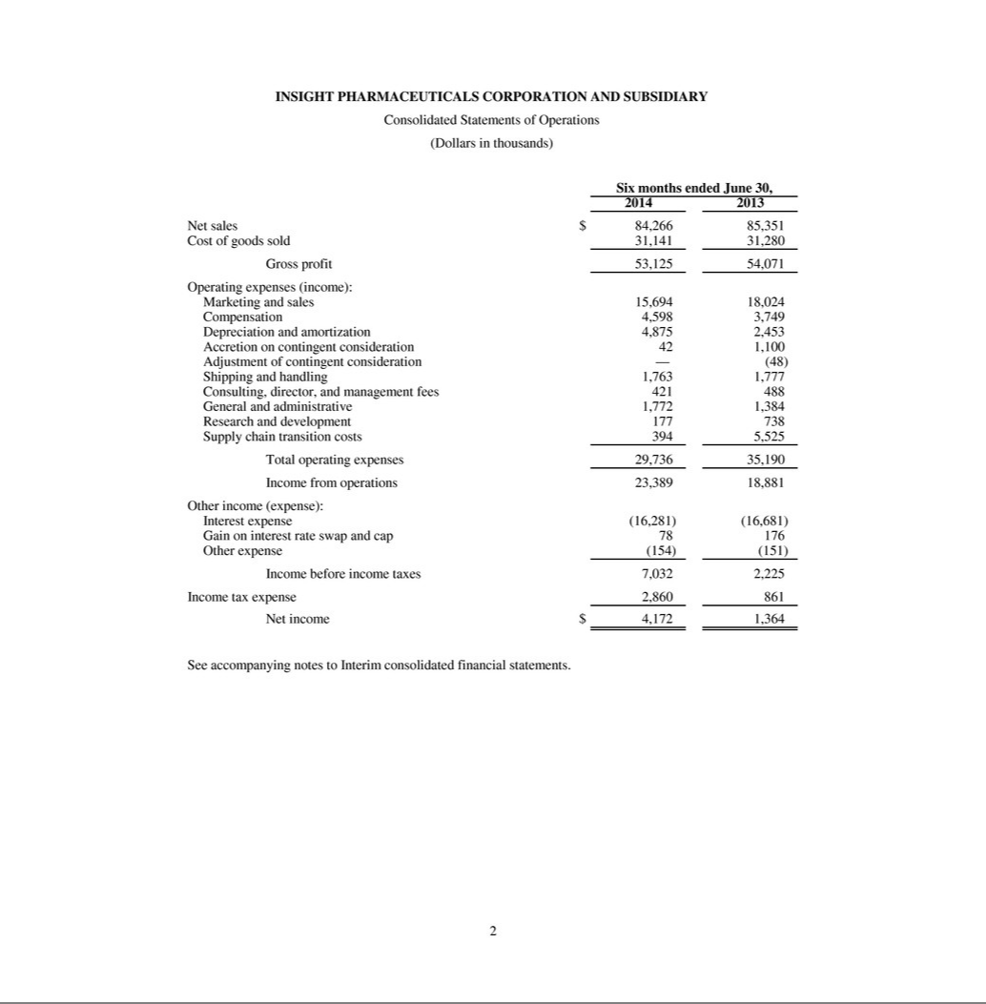

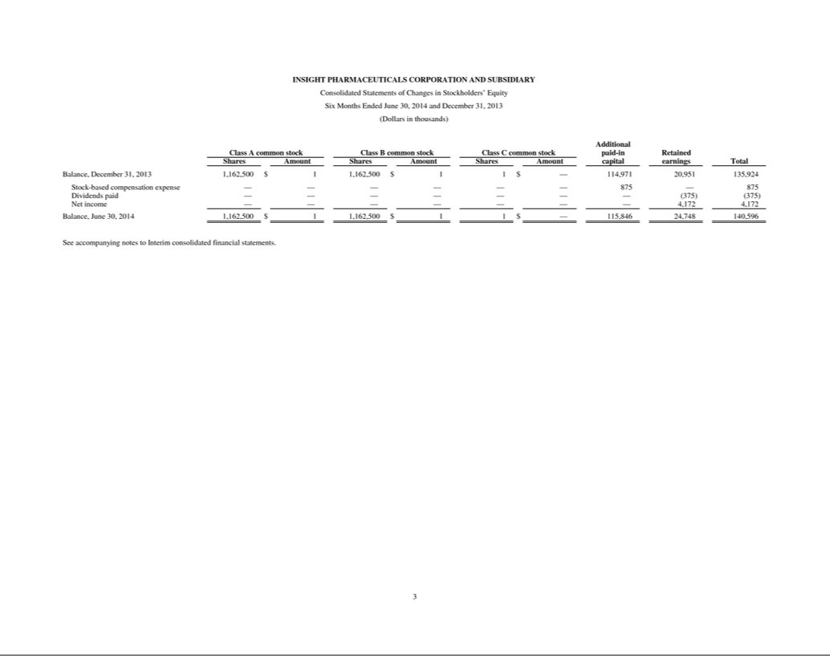

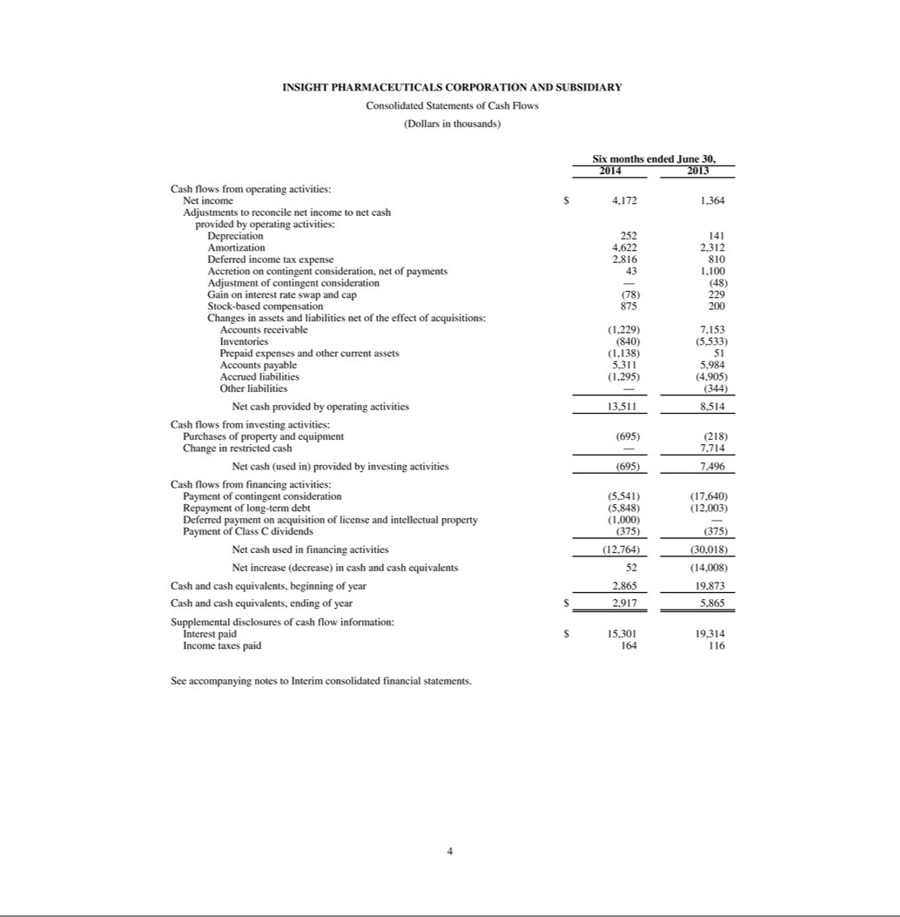

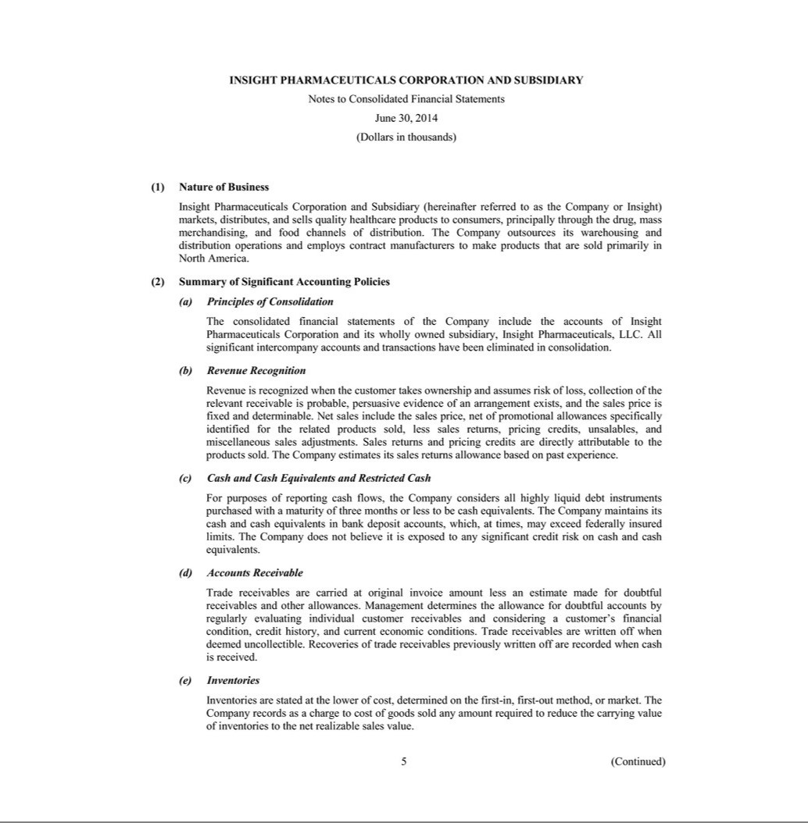

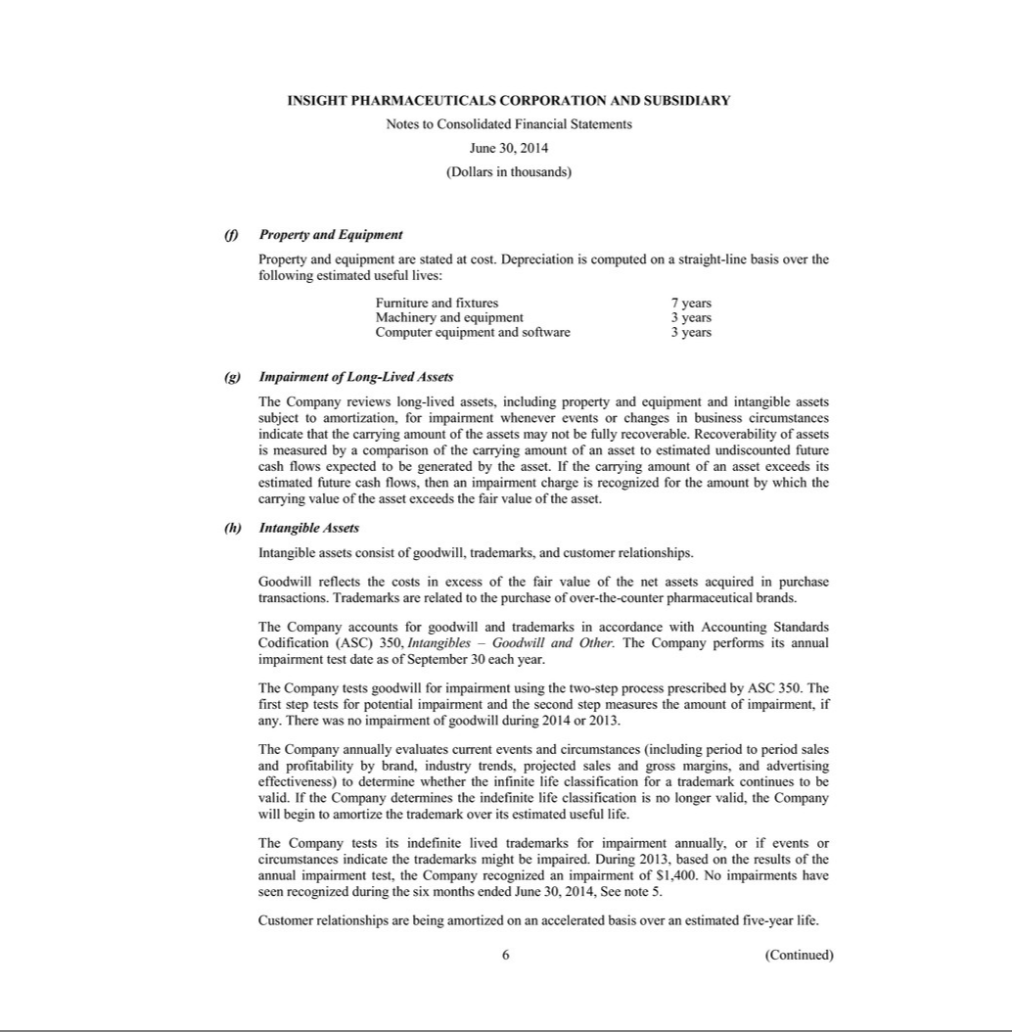

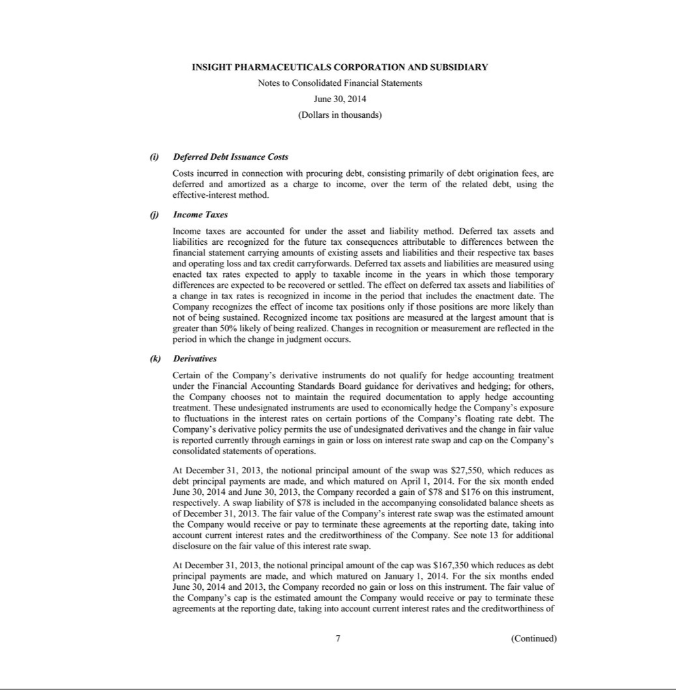

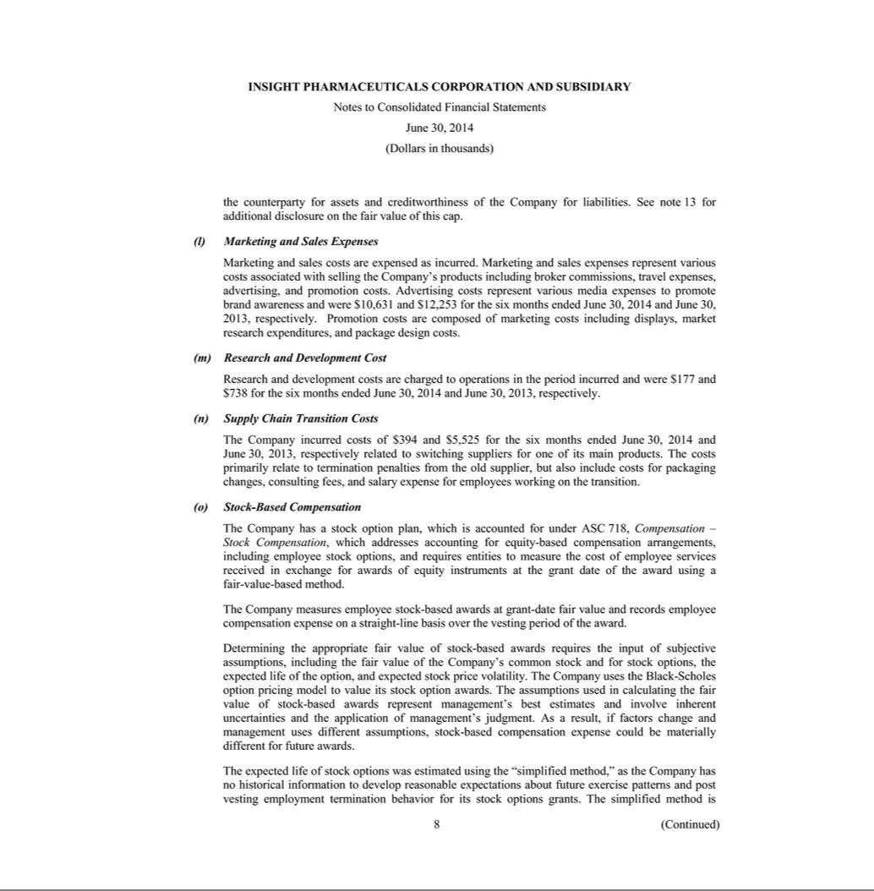

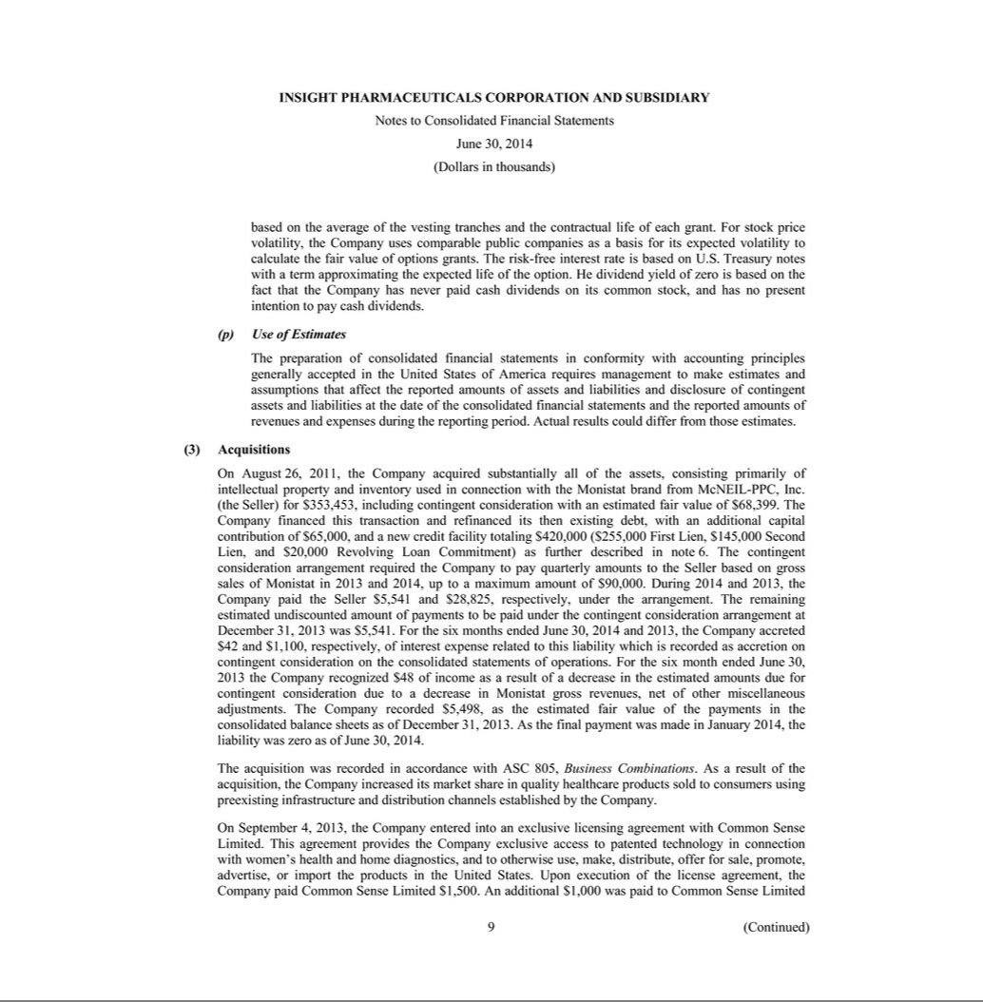

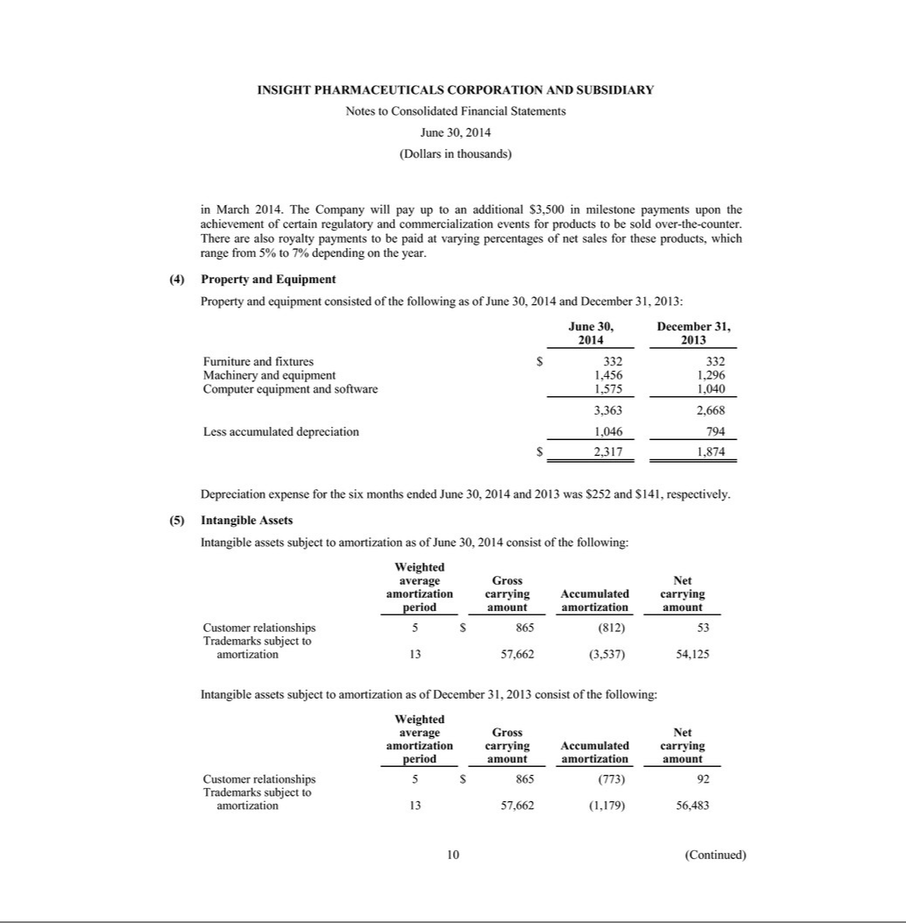

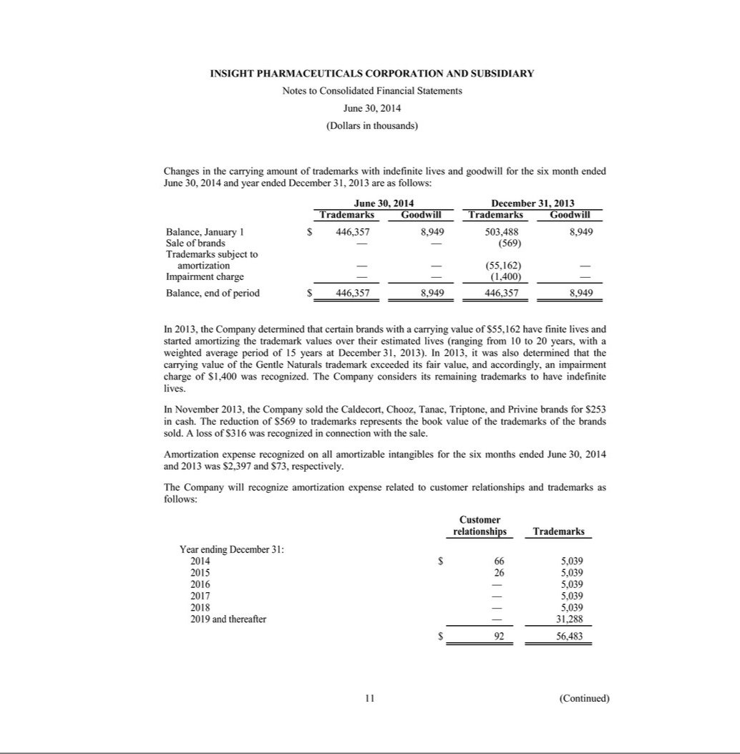

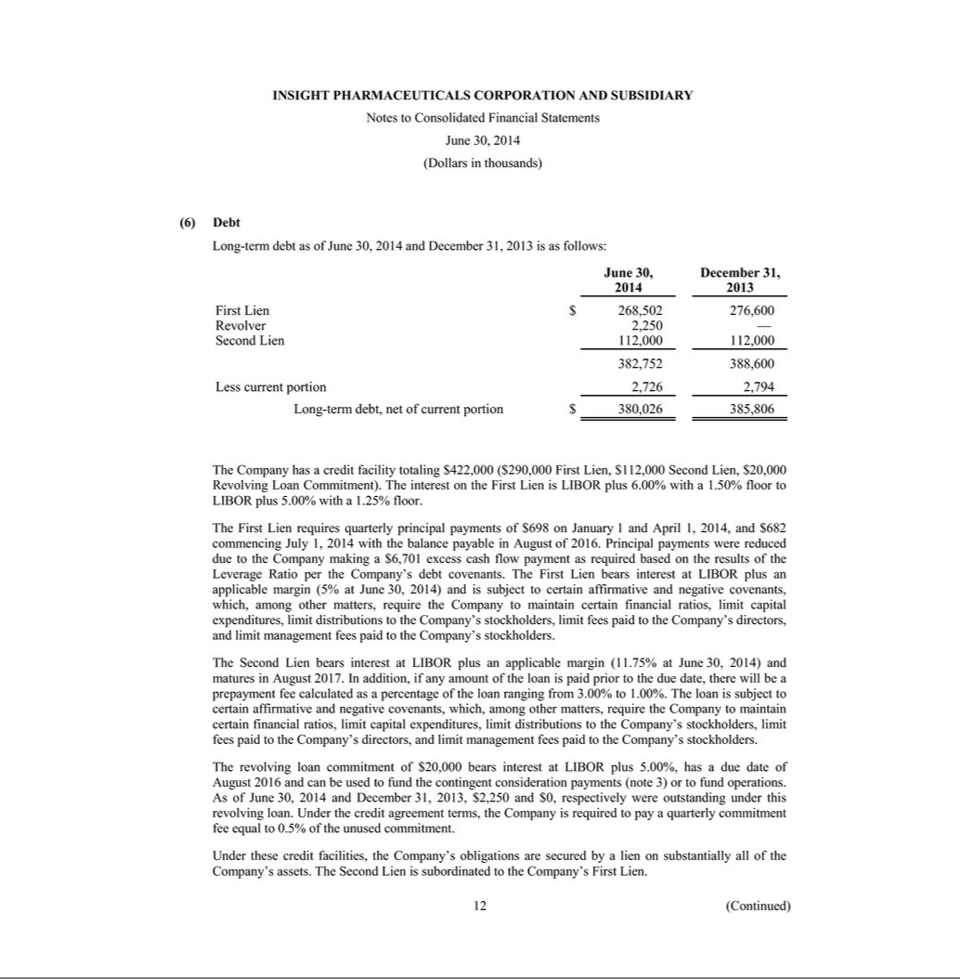

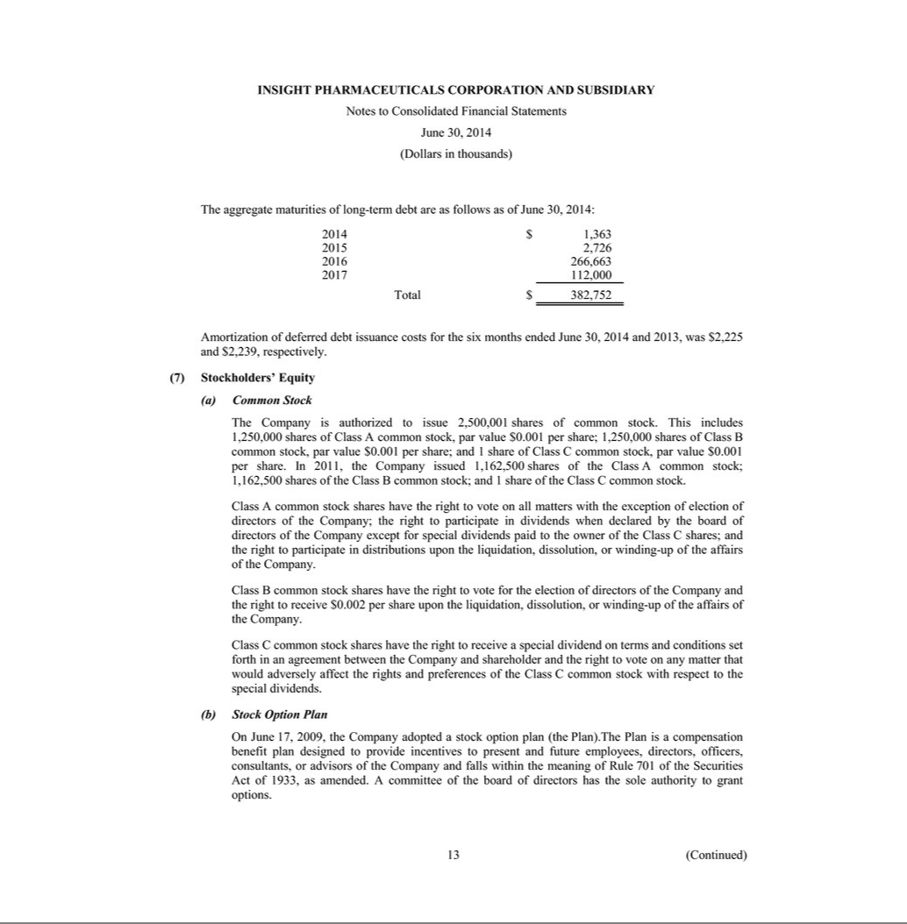

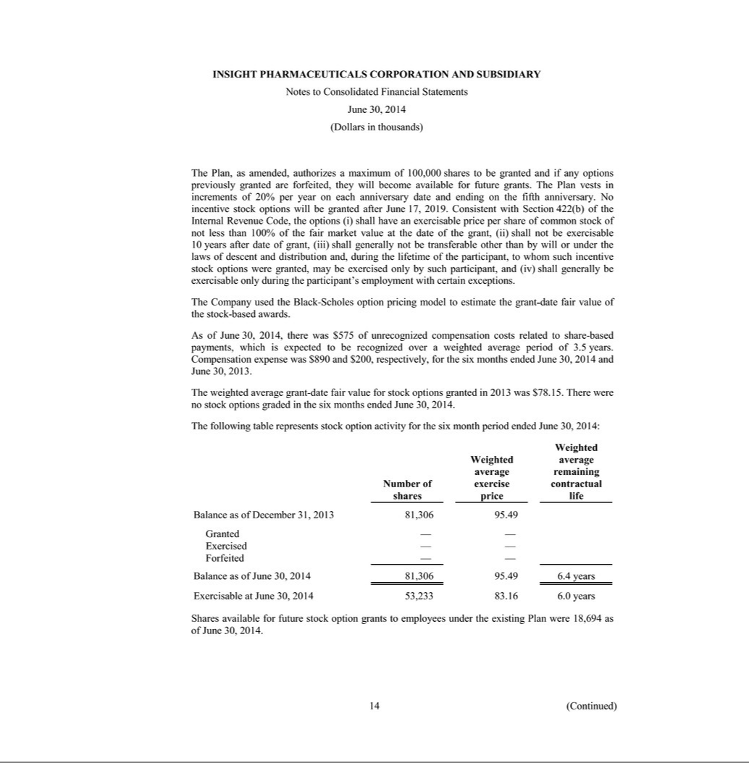

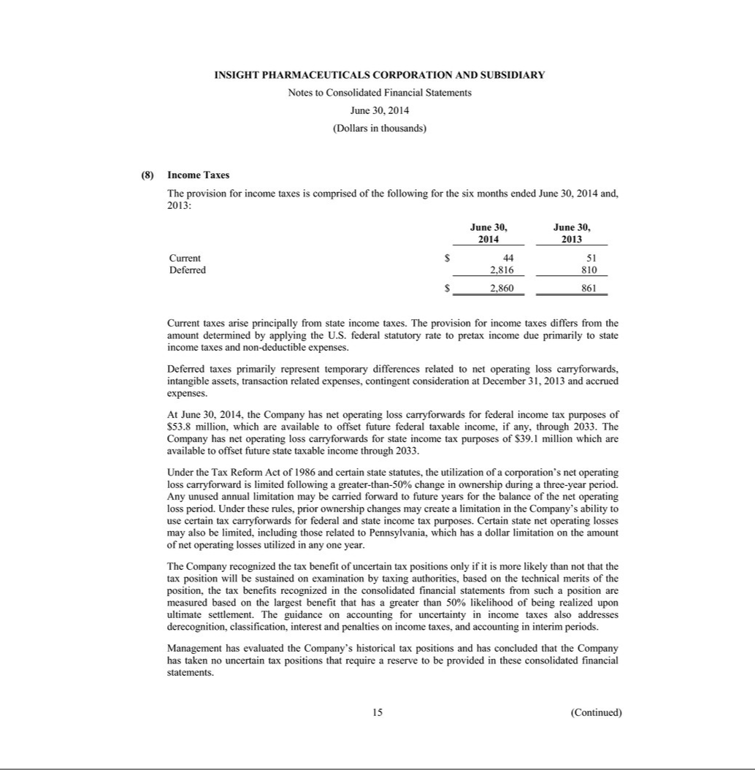

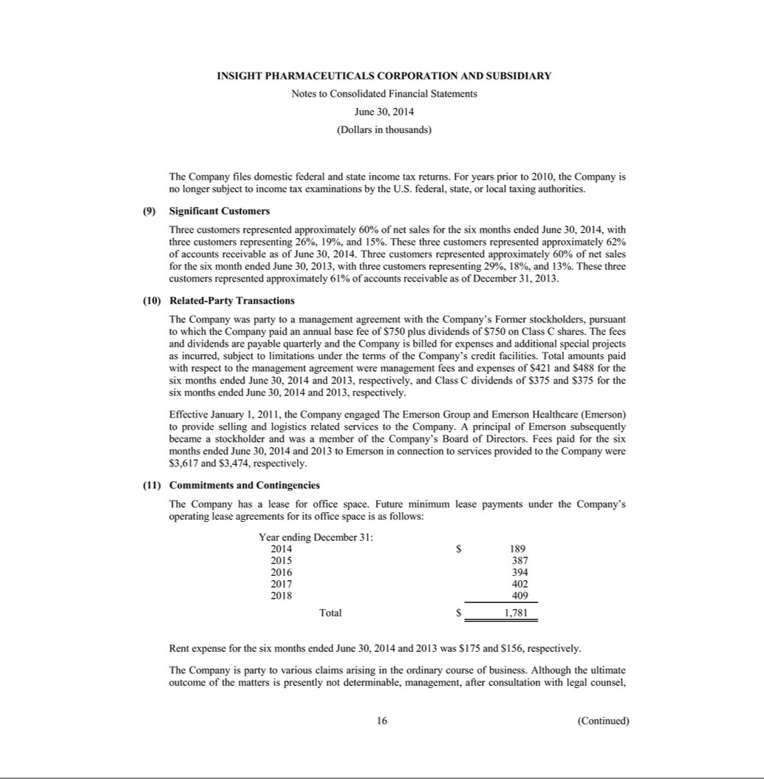

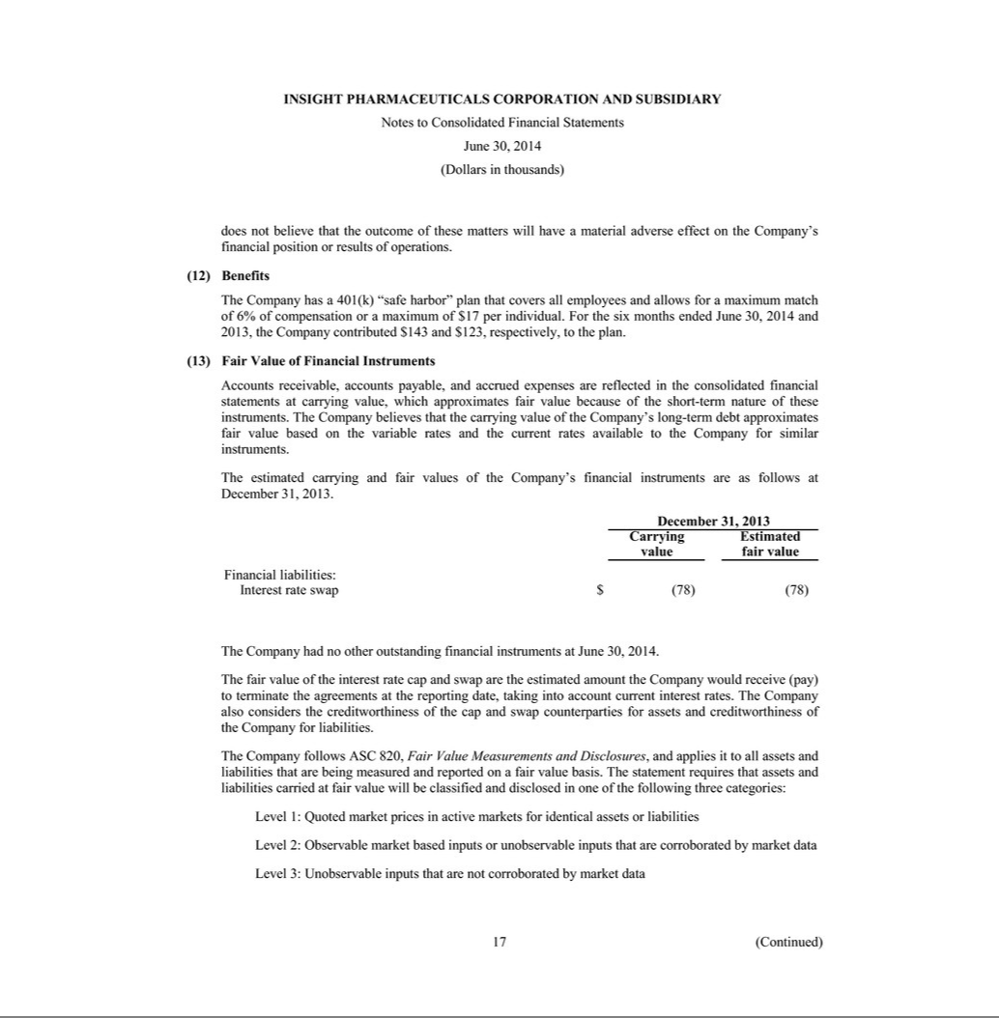

Exhibit 99.3

Prestige Brands Holdings, Inc.

Pro-Forma Combined Financial Information Introduction

(unaudited)

On September 3, 2014, Prestige Brands Holdings, Inc. (referred to herein as "Prestige", the "Company" or "we", which reference shall, unless the context requires otherwise, be deemed to refer to Prestige Brands Holdings, Inc. and all of its direct and indirect 100% owned subsidiaries on a consolidated basis) completed its previously announced acquisition of Insight Pharmaceuticals Corporation and Subsidiary ("Insight"), a marketer and distributor of feminine care and other OTC healthcare products in North America for $753.2 million in cash. The closing followed the Federal Trade Commission’s (“FTC”) approval of the acquisition, and was finalized pursuant to the terms of the purchase agreement announced on April 25, 2014. Pursuant to the Insight purchase agreement, the Company acquired 27 over-the-counter (OTC) pharmaceutical brands sold in North America (including related trademarks, contracts and inventory), which extends the Company's portfolio of OTC brands to include a leading feminine care platform in the U.S. and Canada anchored by Monistat®, the #1 brand in OTC yeast infection treatment. The acquisition will also add brands to Prestige’s cough/cold, pain relief, ear care and dermatological platforms.

On the closing date, the Company and Prestige Brands, Inc. (the "Borrower") entered into Amendment No. 2 (the "Term Loan Amendment") to the credit agreement governing the Company's term loan facility (the "Term Loan Credit Agreement"). The Term Loan Amendment provides for (i) the creation of a new class of Term B-2 Loans under the Term Loan Credit Agreement in an aggregate principal amount of $720.0 million, (ii) increased flexibility under the Term Loan Credit Agreement, including but not limited to additional investment, restricted payment and debt incurrence flexibility and financial maintenance covenant relief and (iii) an interest rate on (x) the Term B-1 Loans that is based, at the Borrower’s option, on a LIBOR rate plus a margin of 3.125% per annum, with a LIBOR floor of 1.00%, or an alternate base rate plus a margin, and (y) the Term B-2 Loans that is based, at the Borrower’s option, on a LIBOR rate plus a margin of

3.50% per annum, with a LIBOR floor of 1.00%, or an alternate base rate plus a margin (with a margin step-down to 3.25% per annum, based upon achievement of specified secured net leverage ratio). A portion of the proceeds from the sale were used by Insight to repay debt.

The unaudited pro forma combined statements of operations for the fiscal year ended March 31, 2014 and for the six months ended September 30, 2014 have been prepared to illustrate the effects of the acquisition and related financings (collectively, the "Transactions"), as if they had occurred on April 1, 2013. The Company has not included an unaudited pro forma combined balance sheet below, as the Insight transaction is reflected in the unaudited balance sheet of the Company as of September 30, 2014, which was included in the Company's Quarterly Report on Form 10-Q for the quarter ended September 30, 2014. The pro forma data has been derived from the audited financial statements of Prestige for the fiscal year ended March 31, 2014 and the unaudited financial statements of Prestige for the six months ended September 30, 2014, the audited financial statements of Insight for the fiscal year ended December 31, 2013 and the unaudited financial statements of Insight for the six months ended June 30, 2014. Insight has historically used a December 31 fiscal year end. For purposes of the pro forma combined financial information for the fiscal year ended March 31, 2014 and for the six months ended September 30, 2014 herein, the year ended December 31, 2013 and the six months ended June 30, 2014 was used for Insight, respectively.

The pro forma adjustments contained in the unaudited pro forma combined financial information are based on the latest available information and certain adjustments that management believes are reasonable. These unaudited pro forma adjustments include a preliminary allocation of the purchase price of Insight to the assets acquired and liabilities assumed based on a preliminary valuation analysis; however, the final valuation may differ from this preliminary valuation. The actual results reported by the combined company in periods following the Transactions may differ materially from that reflected in this unaudited pro forma combined financial information.

The unaudited pro forma combined financial information presented herein is based on the assumptions and adjustments described in the accompanying notes. The unaudited pro forma combined financial information gives effect to events that are (1) directly attributable to the Transactions, (2) factually supportable and (3) expected to have a continuing impact on the combined company. The unaudited pro forma combined financial information is presented for illustrative purposes and does not purport to represent what the financial position or results of operations would actually have been if the Transactions had occurred as of the dates indicated or what the results of operations would be for any future periods.

The unaudited pro forma combined financial information, including the notes thereto, should be read in conjunction with the historical consolidated financial statements and accompanying notes contained in Prestige Brands Holdings, Inc.'s Quarterly Report on Form 10-Q for the quarter ended September 30, 2014, filed on November 6, 2014, and the Annual Report on Form 10-K for the year ended March 31, 2014, filed on May 19, 2014.

It is management's opinion that these pro forma financial statements represent the fair presentation, in all material respects, of the transaction described above applied on a basis consistent with Prestige’s accounting policies. No adjustments have been made to reflect potential cost savings that may occur subsequent to completion of the transaction.

Prestige Brands Holdings, Inc.

Pro Forma Combined Statement of Operations

For the Twelve Months ended March 31, 2014

(Unaudited)

 |  |  |  |  |  |  |  | Divested Brand
 |  | Prestige Brands |  |  |  |  |  | included in |  |  | Pro Forma
(In thousands, except per share data) |  | Holdings, Inc. |  |  | Insight |  |  | Insight (a) |  |  | Adjustments |  |  | Pro Forma *
Revenues
Net sales | $ | 596,954 | $ |  | 175,943 |  | $ | (5,457) |  | $ | — | $ |  | 767,440
Other revenues |  | 4,927 |  |  | — |  |  | — |  |  | — |  |  | 4,927
Total revenues |  | 601,881 |  |  | 175,943 |  |  | (5,457) |  |  | — |  |  | 772,367
Cost of Sales
Cost of sales (exclusive of depreciation shown below) |  | 261,830 |  |  | 62,720 |  |  | (699) |  |  | 3,306 | (c) |  | 327,157
Gross profit |  | 340,051 |  |  | 113,223 |  |  | (4,758) |  |  | (3,306) |  |  | 445,210
Operating Expenses
Advertising and promotion |  | 89,468 |  |  | 31,364 |  |  | (642) |  |  | — |  |  | 120,190
General and administrative |  | 48,481 |  |  | 23,561 |  |  | (44) |  |  | (3,306) | (d) |  | 68,692
Depreciation and amortization |  | 13,486 |  |  | 7,527 |  |  | — |  |  | (569) | (e) |  | 20,444
Total operating expenses |  | 151,435 |  |  | 62,452 |  |  | (686) |  |  | (3,875) |  |  | 209,326
Operating income |  | 188,616 |  |  | 50,771 |  |  | (4,072) |  |  | 569 |  |  | 235,884
Other (income) expense
Interest expense, net |  | 68,582 |  |  | 33,236 |  |  | — |  |  | 2,895 | (f) |  | 104,713
Other non-operating (income) expense |  | 18,286 |  |  | 113 |  |  | — |  |  | — |  |  | 18,399
Total other expense |  | 86,868 |  |  | 33,349 |  |  | — |  |  | 2,895 |  |  | 123,112
Income before income taxes |  | 101,748 |  |  | 17,422 |  |  | (4,072) |  |  | (2,326) |  |  | 112,772
Provision for income taxes |  | 29,133 |  |  | 6,312 |  |  | (1,475) |  |  | (930) | (g) |  | 33,040
Net income (loss) | $ | 72,615 | $ |  | 11,110 |  | $ | (2,597) |  | $ | (1,396) | $ |  | 79,732
Earnings per share:
Basic | $ | 1.41 |  |  |  |  |  |  |  |  |  |  | $ | 1.54
Diluted | $ | 1.39 |  |  |  |  |  |  |  |  |  | $ |  | 1.52
Weighted average shares outstanding:
Basic |  | 51,641 |  |  |  |  |  |  |  |  |  |  |  | 51,641
Diluted |  | 52,349 |  |  |  |  |  |  |  |  |  |  |  | 52,349

The accompanying notes are an integral part of this pro forma combined statement of operations.

Prestige Brands Holdings, Inc.

Pro Forma Combined Statement of Operations

For the Six Months ended September 30, 2014

(Unaudited)

 |  |  |  |  |  |  |  |  |  |  | Divested Brand
 |  | Prestige Brands |  |  |  |  |  | Insight included |  |  | included in |  |  | Pro Forma
(In thousands, except per share data) |  | Holdings, Inc. |  |  | Insight |  |  | in PBH (b) |  |  | Insight (a) |  |  | Adjustments |  |  | Pro Forma *
Revenues
Net sales | $ | 324,546 | $ |  | 84,266 |  | $ | (12,659) |  | $ | (3,013) |  | $ | — | $ |  | 393,140
Other revenues |  | 2,425 |  |  | — |  |  | — |  |  | — |  |  | — |  |  | 2,425
Total revenues |  | 326,971 |  |  | 84,266 |  |  | (12,659) |  |  | (3,013) |  |  | — |  |  | 395,565
Cost of Sales
Cost of sales (exclusive of depreciation shown below) |  | 142,563 |  |  | 31,141 |  |  | (5,064) |  |  | (510) |  |  | 1,721 | (c) |  | 169,851
Gross profit |  | 184,408 |  |  | 53,125 |  |  | (7,595) |  |  | (2,503) |  |  | (1,721) |  |  | 225,714
Operating Expenses
Advertising and promotion |  | 44,140 |  |  | 15,694 |  |  | (3,316) |  |  | (455) |  |  |  |  |  | 56,063
General and administrative |  | 44,134 |  |  | 9,167 |  |  | (3,694) |  |  | (42) |  |  | (10,739) | (d) |  | 38,826
Depreciation and amortization |  | 6,813 |  |  | 4,875 |  |  | (758) |  |  | (11) |  |  | (1,318) | (e) |  | 9,601
Total operating expenses |  | 95,087 |  |  | 29,736 |  |  | (7,768) |  |  | (508) |  |  | (12,057) |  |  | 104,490
Operating income |  | 89,321 |  |  | 23,389 |  |  | 173 |  |  | (1,995) |  |  | 10,336 |  |  | 121,224
Other (income) expense
Interest expense, net |  | 32,846 |  |  | 16,203 |  |  | — |  |  | — |  |  | 1,900 | (f) |  | 50,949
Other non-operating (income) expense |  | — |  |  | 154 |  |  | — |  |  | — |  |  | — |  |  | 154
Total other expense |  | 32,846 |  |  | 16,357 |  |  | — |  |  | — |  |  | 1,900 |  |  | 51,103
Income before income taxes |  | 56,475 |  |  | 7,032 |  |  | 173 |  |  | (1,995) |  |  | 8,436 |  |  | 70,121
Provision for income taxes |  | 23,280 |  |  | 2,860 |  |  | 306 |  |  | (811) |  |  | 3,374 | (g) |  | 29,009
Net income (loss) | $ | 33,195 | $ |  | 4,172 |  | $ | (133) |  | $ | (1,184) |  | $ | 5,062 | $ |  | 41,112
Earnings per share:
Basic | $ | 0.64 |  |  |  |  |  |  |  |  |  |  |  |  |  | $ | 0.79
Diluted | $ | 0.63 |  |  |  |  |  |  |  |  |  |  |  |  | $ |  | 0.78
Weighted average shares outstanding:
Basic |  | 52,023 |  |  |  |  |  |  |  |  |  |  |  |  |  |  | 52,023
Diluted |  | 52,564 |  |  |  |  |  |  |  |  |  |  |  |  |  |  | 52,564

The accompanying notes are an integral part of this pro forma combined statement of operations.

Notes to Pro Forma Combined Statements of Operations

(unaudited)

- The unaudited pro forma consolidated financial statements have been prepared to reflect the acquisition of Insight and the application of purchase accounting under ASC 805 "Business Combinations". The unaudited pro forma combined statement of operations for the fiscal year ended March 31, 2014 and for the six months ended September 30, 2014 have been prepared to illustrate the effects of the Insight acquisition as if it occurred on April 1, 2013. Insight has historically used a December 31 fiscal year end. For purposes of the fiscal year ended March 31, 2014 data herein, a historical year ended December 31, 2013 was used for Insight. Similarly for the six months ended September 30, 2014, a historical six months ended June 30, 2014 was used for Insight.

- Pursuant to the terms of the FTC approval of the acquisition, we were required to divest a competing brand that was acquired from Insight. We completed the sale of such brand on the same day that we acquired it from Insight. Therefore, we have excluded the operating results of this brand from our pro forma data.

- Since the acquisition occurred on September 3, 2014, the results of the acquired Insight business are included in the historical Prestige column for approximately one month in the six months ended September 30, 2014. Therefore, these results are being eliminated to avoid double counting in our pro forma data as they are also included in the Insight historical column.

- Reflects a reclassification of Insight's shipping and warehousing costs from General and Administrative costs to Cost of Sales to conform with the Prestige presentation.

 |  |  |  |  | Fiscal Year Ended March 31, |  |  |  |  | Six Months Ended September 30,
($ in thousands) Cost of Sales |  |  |  | 2014 |  |  |  |  |  |  | 2014
Reclassification of Shipping costs from G&A to Cost of Sales |  |  | $ | 3,306 |  |  |  |  |  | $ | 1,721
Total adjustments |  |  | $ | 3,306 |  |  |  |  |  | $ | 1,721

- Reflects a reclassification of the Insight's shipping costs from General and Administrative costs to Cost of Sales to conform with the Prestige presentation. Also reflects an adjustment to remove the costs and expenses of the transaction, as these costs would not have a continuing impact on the combined company.

 |  |  |  | Fiscal Year Ended March 31, |  |  |  |  | Six Months Ended September
($ in thousands) General and Administrative |  |  |  | 2014 |  |  |  |  |  |  | 30, 2014
Reclassification of Shipping costs from G&A to Cost of Sales |  |  | $ | (3,306) |  |  |  |  | $ |  | (1,721)
Transaction costs |  |  |  |  |  | — |  |  |  |  | (9,018)
Total adjustments |  |  | $ | (3,306) |  |  |  |  | $ |  | (10,739)

- These adjustments represent the amortization expense related to the finite-lived amortizable intangible assets recognized for the Insight acquisition. The amounts associated with the Insight acquisition have been estimated based upon preliminary valuations. The following table summarizes the preliminary purchase price allocation.

 |  | ($ in thousands) |  |  |  |  |  |  |  | Allocation of |  |  |  |  |  |  |  |  |  |  |  | Total
 |  | purchase price
 |  | Cash |  |  |  |  |  |  |  |  |  |  |  |  | $ |  |  |  |  |  | 3,507
 |  | Accounts receivable |  |  |  |  |  |  |  |  |  |  |  |  |  |  |  |  |  |  | 25,784
 |  | Inventories |  |  |  |  |  |  |  |  |  |  |  |  |  |  |  |  |  |  | 23,559
 |  | Deferred income taxes-current |  |  |  |  |  |  |  |  |  |  |  |  |  |  |  |  |  |  | 860
 |  | Prepaid expenses and other current assets |  |  |  |  |  |  |  |  |  |  |  |  |  |  |  |  |  |  | 1,407
 |  | Property and equipment |  |  |  |  |  |  |  |  |  |  |  |  |  |  |  |  |  |  | 2,308
 |  | Goodwill |  |  |  |  |  |  |  |  |  |  |  |  |  |  |  |  |  |  | 103,255
 |  | Intangible assets |  |  |  |  |  |  |  |  |  |  |  |  |  |  |  |  |  |  | 724,374
 |  | Accounts payable |  |  |  |  |  |  |  |  |  |  |  |  |  |  |  |  |  |  | (16,079)
 |  | Accrued expenses |  |  |  |  |  |  |  |  |  |  |  |  |  |  |  |  |  |  | (8,003)
 |  | Deferred income tax liabilities-long term |  |  |  |  |  |  |  |  |  |  |  |  |  |  |  |  |  |  | (107,799)
 |  | Net assets acquired |  |  |  |  |  |  |  |  |  |  |  |  |  |  |  | $ |  |  | 753,173
($ in thousands) | Intangible Assets |  |  |  |  | Total |  |  |  | Total excluding |  |  |  |  | Insight Intangible |  |  |  |  |  | Incremental Intangible |  |  |  |  |  | Deferred finance cost |  |  |  |  | Total adjustments
($ in thousands) |  |  |  |  |  |  |  |  |  | divested brand (1) |  |  |  |  | amortization |  |  |  |  |  |  | amortization (2) |  |  |  |  |  | amortization (2)
Total intangible assets acquired | $ |  |  |  |  | 724,374 |  | $ |  | 706,700
Non-amortizable intangible assets |  |  |  |  |  | 599,600 |  |  |  | 599,600
Amortizable intangible assets | $ |  |  |  |  | 124,774 |  | $ |  | 107,100
Estimated weighted average useful life |  |  |  |  |  |  |  |  |  | 16.20
Pro-forma annual amortization-12 months (3) |  |  |  |  |  |  |  | $ |  | 6,610 |  |  |  | $ | 2,708 |  |  |  |  | $ | 3,902 |  |  |  |  | $ | 4,471 |  |  |  | $ | (569)
Pro-forma annual amortization-6 months (3) |  |  |  |  |  |  |  | $ |  | 3,305 |  |  |  | $ | 2,398 |  |  |  |  | $ | 907 |  |  |  |  | $ | 2,225 |  |  |  | $ | (1,318)

- Pursuant to the terms of the FTC approval of the acquisition, we divested a competing brand acquired from Insight on the same day we acquired Insight. Therefore, we have excluded this brand from our pro forma data.

- Incremental amortization expense related to the amortizable assets have been included for the acquisition of Insight. Accordingly, the pro forma adjustments for the fiscal year ended March 31, 2014 and the six months ended June 30, 2014 represent the additional amortization that would be required to be recorded over the amortization that Insight already recorded in the income statement for the same period. Additionally, the amortization of deferred financing costs classified by Insight in depreciation and amortization expense have been reclassified to interest expense to conform with the Company's presentation.

The table below provides the breakdown of the historical depreciation and amortization included in the Insight historical financial statements, including the reclassification of the amortization of deferred finance costs to interest expense to conform with the Company's presentation.

($ in thousands) Insight Depreciation and amortization |  |  |  | Fiscal Year Ended March 31, 2014 |  |  | Six Months Ended September 30, 2014
Depreciation of property & equipment |  |  | $ | 348 |  |  | $ |  | 252
Amortization of intangible assets |  |  |  | 2,708 |  |  |  |  | 2,398
Amortization of deferred finance costs |  |  |  | 4,471 |  |  |  |  | 2,225
 |  |  | $ | 7,527 |  |  | $ |  | 4,875

  - A hypothetical increase or decrease of 10% of the preliminary fair value of the finite-lived amortizable intangible assets would result in an increase or decrease of approximately $0.7 million in annual amortization expense and $0.3 million in amortization expense for the six month period.

- Reflects the interest expense as a result of the Insight acquisition, which is calculated as:

 | ($ in thousands) |  | Long term debt |  |  |  |  |  |  | Six Months Ended September 30,
 | and interest expense |  |  |  |  | Fiscal Year Ended March 31, 2014
 | and interest expense |  |  |  |  |  |  |  |  |  | 2014
 | Additional Term Loan interest |  |  | (1) | $ |  | 32,850 |  | $ |  | 16,470
 | Additional ABL Revolver Interest |  |  | (2) |  |  | 1,235 |  |  |  | 619
 | Amortization of deferred financing costs and debt discount |  |  | (3) |  |  | 2,046 |  |  |  | 1,014
 | Total additional interest expense |  |  |  |  |  | 36,131 |  |  |  | 18,103
 | Add: Amortization of Insight Deferred Finance Costs reclassifed from depreciation and amortization |  |  | (4) |  |  | 4,471 |  |  |  | 2,225
 |  |  |  |  |  |  | 40,602 |  |  |  | 20,328
 | Less: Insight historical interest expense |  |  | (5) |  |  | 37,707 |  |  |  | 18,428
 | Incremental interest expense (6) |  |  |  | $ |  | 2,895 |  | $ |  | 1,900

  - Represents the interest on the additional $720 million Term Loan Credit Facility, assuming an interest rate of 4.5%.

  - Represents the additional interest on the ABL Revolver on the additional $59.6 million borrowed for the Insight acquisition, less $18.5 million repaid from the sale of one of the Insight brands on the same day, assuming an interest rate of 2.154% on the ABL Revolver plus using a 0.5% rate on the unused portion of the ABL Revolver.

  - Represents the additional amortization of the capitalized debt fees and the debt discount of approximately $2.0 million annually using an effective interest method.

  - Reflects the reclassification of the deferred finance costs included in depreciation and amortization in the Insight historical financial statements and reclassified to interest expense to conform with the Company's presentation included in interest expense.

  - Reflects the reduction of Insight's historical interest expense, including the amortization of deferred finance costs reclassified to interest expense as the Insight debt was repaid in its entirety at the date of acquisition with the proceeds of the transactions.

  - The effect of a hypothetical 1/8% change in the variable interest rate would change interest expense by $1.0 million per year.

- Reflects the estimated income tax rate applied to the pro forma adjustments of 40%, the expected statutory rate. All other tax amounts are stated at their historical amounts, as the combined company's overall effective tax rate has not yet been determined.

