UNITED STATES
SECURITIES AND EXCHANGE COMMISSION
Washington, D.C. 20549
_______________________

FORM 8-K/A

CURRENT REPORT

Pursuant to Section 13 or 15(d) of the Securities Exchange Act of 1934

Date of report (Date of earliest event reported): June 12, 2026

PRESTIGE CONSUMER HEALTHCARE INC.
(Exact Name of Registrant as Specified in Charter)

Delaware |  |  |  |  |  | 001-32433 |  |  |  |  |  | 20-1297589
(State or Other Jurisdiction of Incorporation) |  |  |  |  |  | (Commission File Number) |  |  |  |  |  | (IRS Employer Identification No.)

660 White Plains Road, Tarrytown, New York 10591
(Address of Principal Executive Offices) (Zip Code)

(914) 524-6800
(Registrant's telephone number, including area code)

(Former Name or Former Address, if Changed Since Last Report.)

Check the appropriate box below if the Form 8-K filing is intended to simultaneously satisfy the filing obligation of the registrant under any of the following provisions (see General Instruction A.2. below):

☐ Written communications pursuant to Rule 425 under the Securities Act (17 CFR 230.425)

☐ Soliciting material pursuant to Rule 14a-12 under the Exchange Act (17 CFR 240.14a-12)

☐ Pre-commencement communications pursuant to Rule 14d-2(b) under the Exchange Act (17 CFR 240.14d-2(b))

☐ Pre-commencement communications pursuant to Rule 13e-4(c) under the Exchange Act (17 CFR 240.13e-4(c))
Securities registered pursuant to Section 12(b) of the Act:
Title of each class |  |  | Trading Symbol(s) |  |  | Name of each exchange on which registered
Common stock, par value $0.01 per share |  |  | PBH |  |  | New York Stock Exchange
Indicate by check mark whether the registrant is an emerging growth company as defined in Rule 405 of the Securities Act of 1933 (§ 230.405 of this chapter) or Rule 12b-2 of the Securities Exchange Act of 1934 (§ 240.12b-2 of this chapter).
Emerging Growth Company |  |  | ☐
If an emerging growth company, indicate by check mark if the registrant has elected not to use the extended transition period for complying with any new or revised financial accounting standards provided pursuant to Section 13(a) of the Exchange Act.
☐

Explanatory Note.

On June 16, 2026, Prestige Consumer Healthcare Inc. (the “Company,” “we,” “us,” or “our”) filed a Current Report on Form 8-K with the Securities and Exchange Commission (the “Original 8-K”), which reported that on June 12, 2026, Prestige Brands, Inc. and Medtech Products Inc., both wholly-owned subsidiaries of the Company, completed the previously announced acquisition of Breathe Right® and certain other brands (the "OTC Wellness Business”) from Foundation Consumer Brands, LLC and certain of its affiliates, pursuant to an Asset Purchase Agreement, dated as of March 19, 2026.

This Current Report on Form 8-K/A to the Original 8-K is being filed for the purpose of satisfying the Company’s undertaking to file the historical and pro forma financial statements required by Items 9.01(a) and (b) of Form 8-K. The Company had previously indicated in the Original 8-K that such financial statements and pro forma financial information would be provided not later than 71 calendar days after the date on which the Original 8-K was required to be filed. This Current Report on Form 8-K/A should be read in conjunction with the Original 8-K. Except as set forth herein, no modifications have been made to information contained in the Original 8-K.

Item 9.01 Financial Statements and Exhibits.

(a) Financial Statements of Business Acquired.

The audited combined balance sheet of the OTC Wellness Business (a portion of the operations of Foundation Consumer Brands, LLC) as of December 31, 2025, the audited combined statements of operations, changes in net parent investment and cash flows for the year ended December 31, 2025, the notes related thereto and the related independent auditor’s report of Ernst & Young LLP, as required by Item 9.01(a) of Form 8-K, are filed as Exhibit 99.1 hereto and are incorporated herein by reference.

The unaudited condensed combined balance sheets of the OTC Wellness Business (a portion of the operations of Foundation Consumer Brands, LLC) as of March 31, 2026 and December 31, 2025 and the unaudited condensed combined statements of operations, changes in net parent investment and cashflows for the three months ended March 31, 2026 and 2025, with the related notes thereto, as required by Item 9.01(a) of Form 8-K, are filed as Exhibit 99.2 hereto and incorporated herein by reference.

(b) Pro Forma Financial Information

The unaudited pro forma condensed combined balance sheet of the Company as of March 31, 2026, and the unaudited pro forma condensed combined statement of income of the Company for the year ended March 31, 2026 , as required by Item 9.01(b) of Form 8-K, are filed as Exhibit 99.3 hereto and are incorporated herein by reference.

(d) Exhibits.
Exhibit |  |  |  |  |  | Description
23.1 |  |  |  |  |  | Consent of Ernst & Young LLP
99.1 |  |  |  |  |  | Audited Combined Financial Statements of the OTC Wellness Business (A portion of the operations of Foundation Consumer Brands, LLC) as of and for the year ended December 31, 2025
99.2 |  |  |  |  |  | Unaudited Condensed Combined Financial Statements of the OTC Wellness Business (a portion of the operations of Foundation Consumer Brands, LLC) as of December 31, 2025 and March 31, 2026 and for the three months ended March 31, 2026
99.3 |  |  |  |  |  | Unaudited Pro Forma Condensed Combined Balance Sheet of the Company as of March 31, 2026 and Unaudited Pro Forma Condensed Combined Statement of Income of the Company for the year ended March 31, 2026
104 |  |  |  |  |  | Cover Page Interactive Data File (embedded within the Inline XBRL document)

SIGNATURES

Pursuant to the requirements of the Securities Exchange Act of 1934, the registrant has duly caused this report to be signed on its behalf by the undersigned hereunto duly authorized.

Dated: June 30, 2026 |  |  | PRESTIGE CONSUMER HEALTHCARE INC.
 |  |  | By: |  |  | /s/ Christine Sacco
 |  |  |  |  |  | Christine Sacco
 |  |  |  |  |  | Chief Financial Officer & Chief Operating Officer

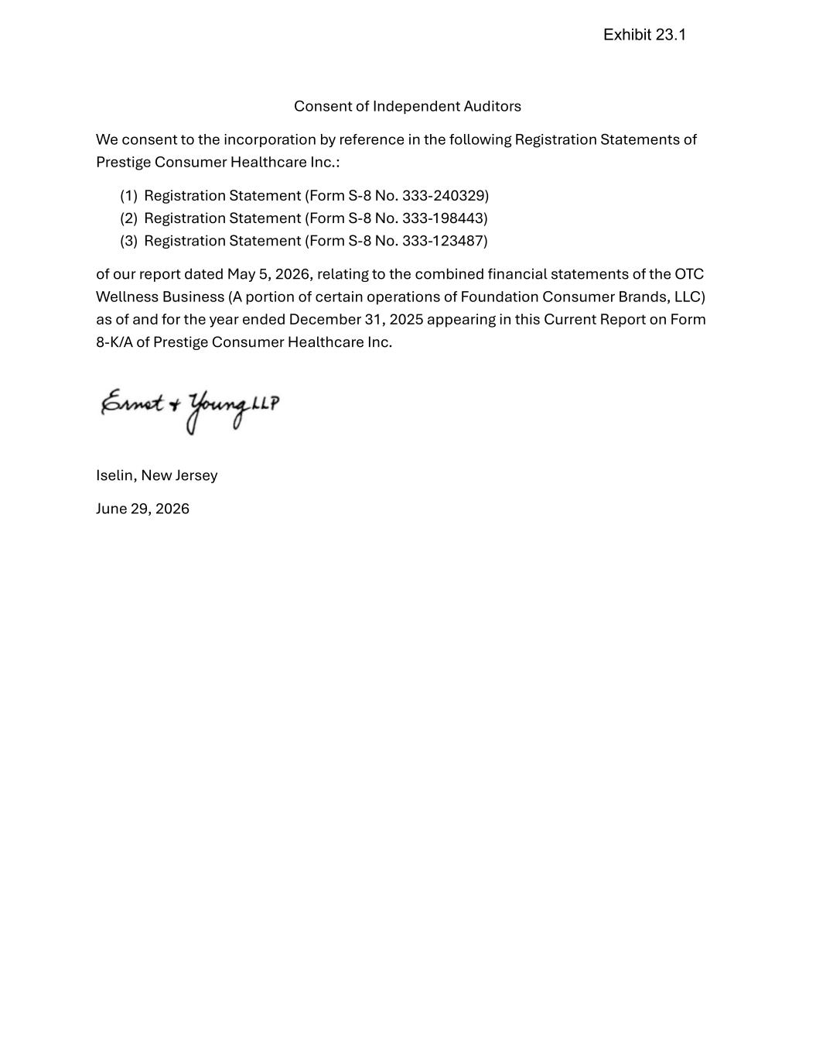

Consent of Independent Auditors We consent to the incorporation by reference in the following Registration Statements of Prestige Consumer Healthcare Inc.: (1) Registration Statement (Form S-8 No. 333-240329) (2) Registration Statement (Form S-8 No. 333-198443) (3) Registration Statement (Form S-8 No. 333-123487) of our report dated May 5, 2026, relating to the combined financial statements of the OTC Wellness Business (A portion of certain operations of Foundation Consumer Brands, LLC) as of and for the year ended December 31, 2025 appearing in this Current Report on Form 8-K/A of Prestige Consumer Healthcare Inc. Iselin, New Jersey June 29, 2026 Exhibit 23.1

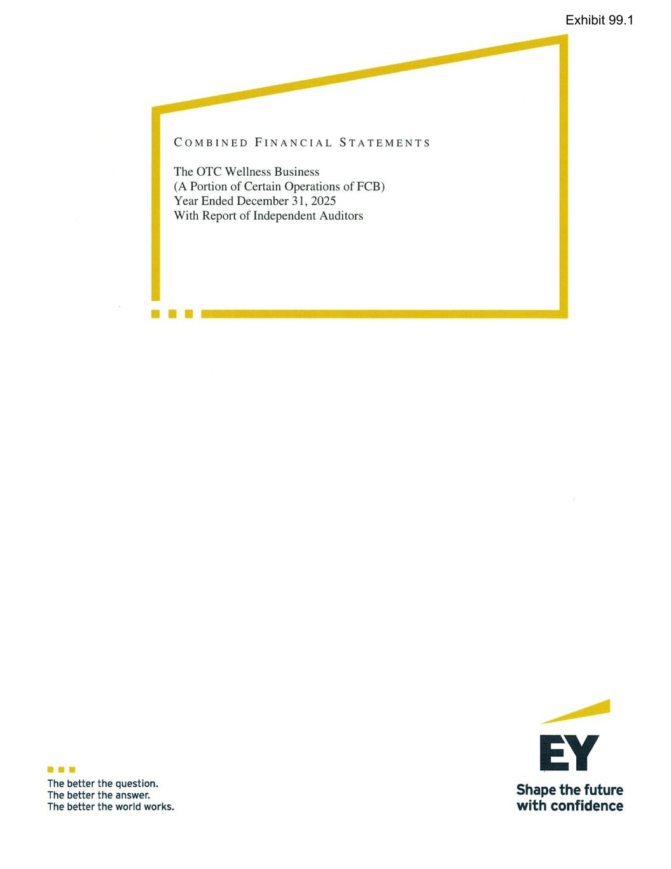
Exhibit 99.1

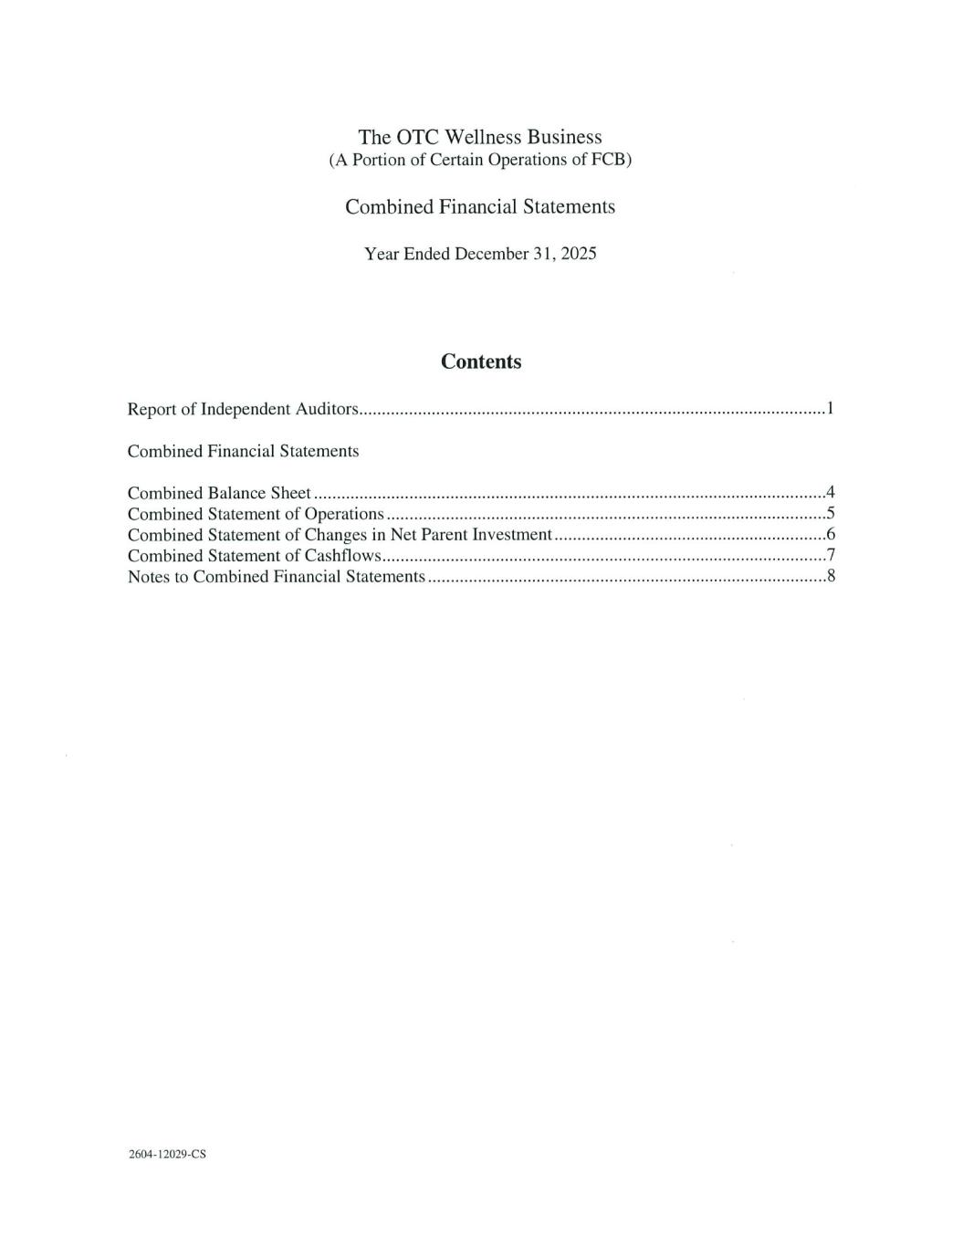

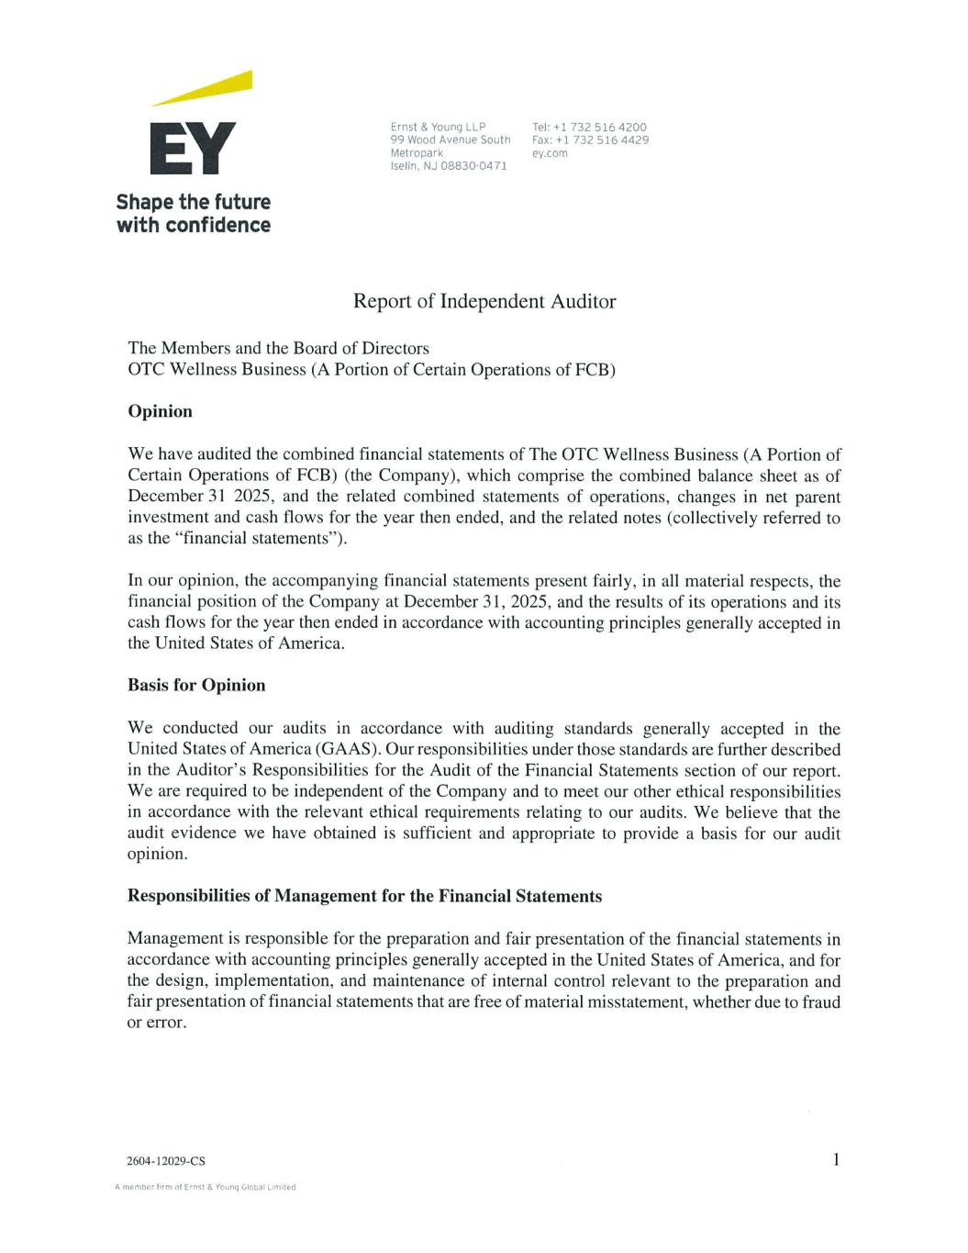

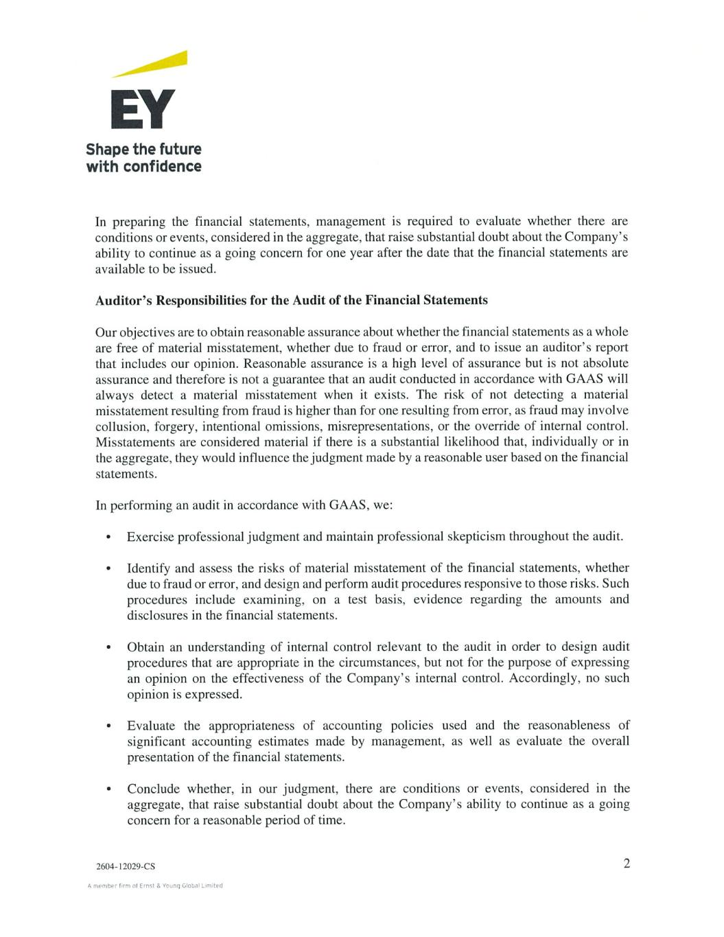

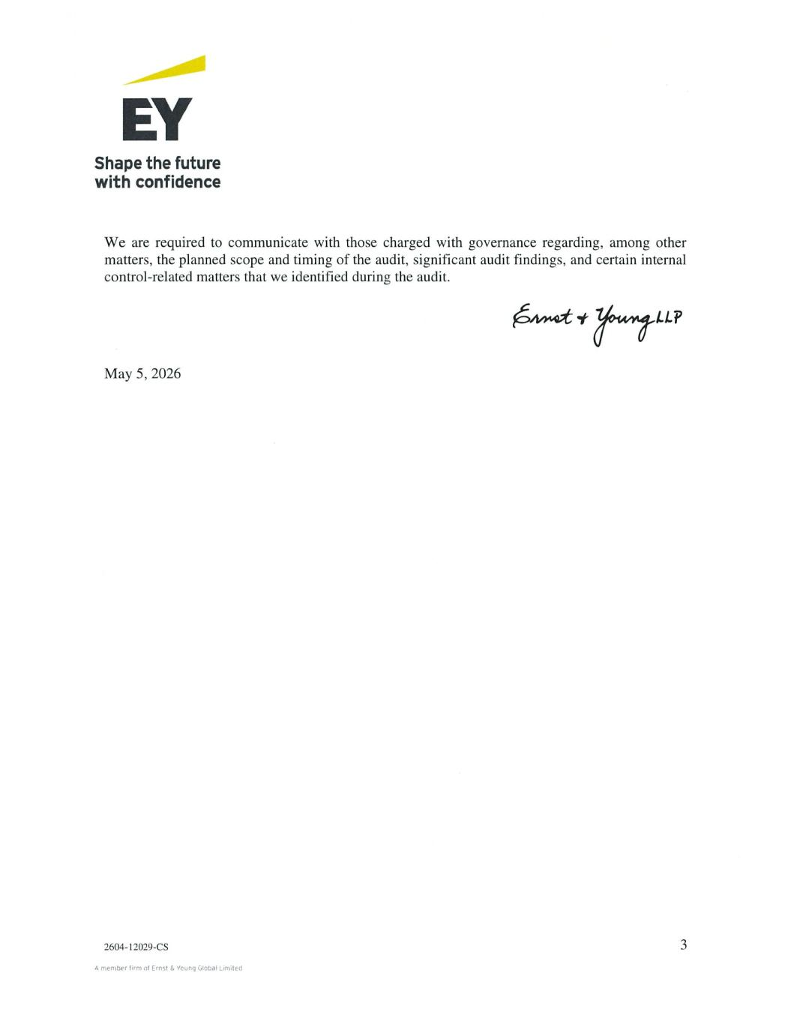

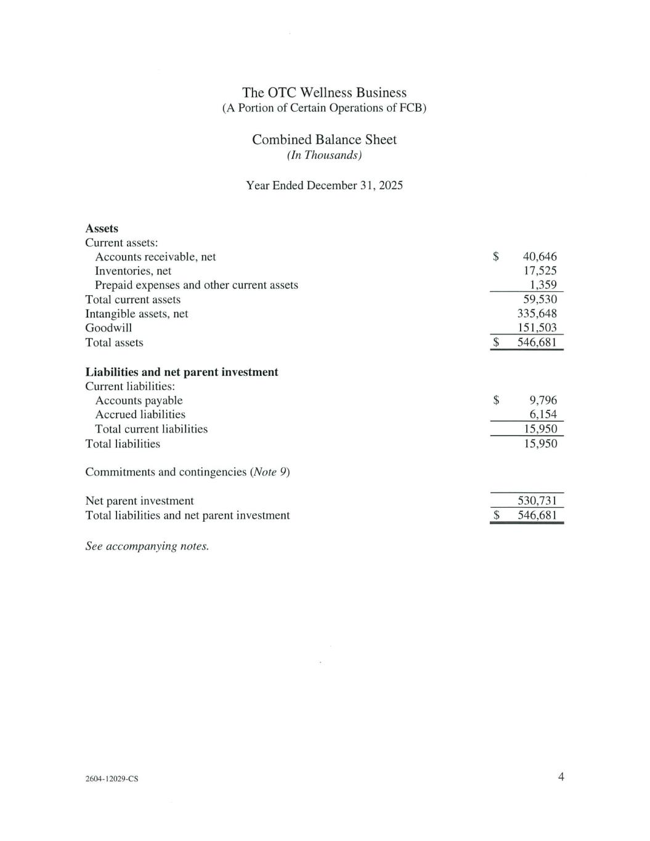

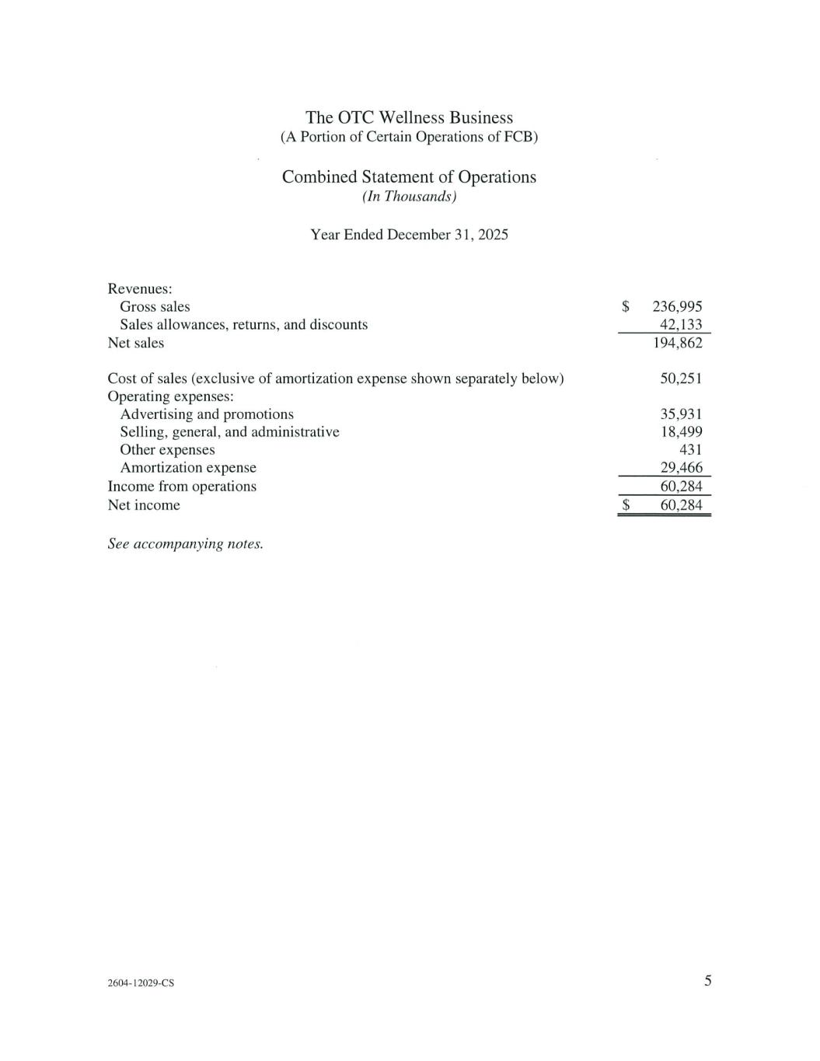

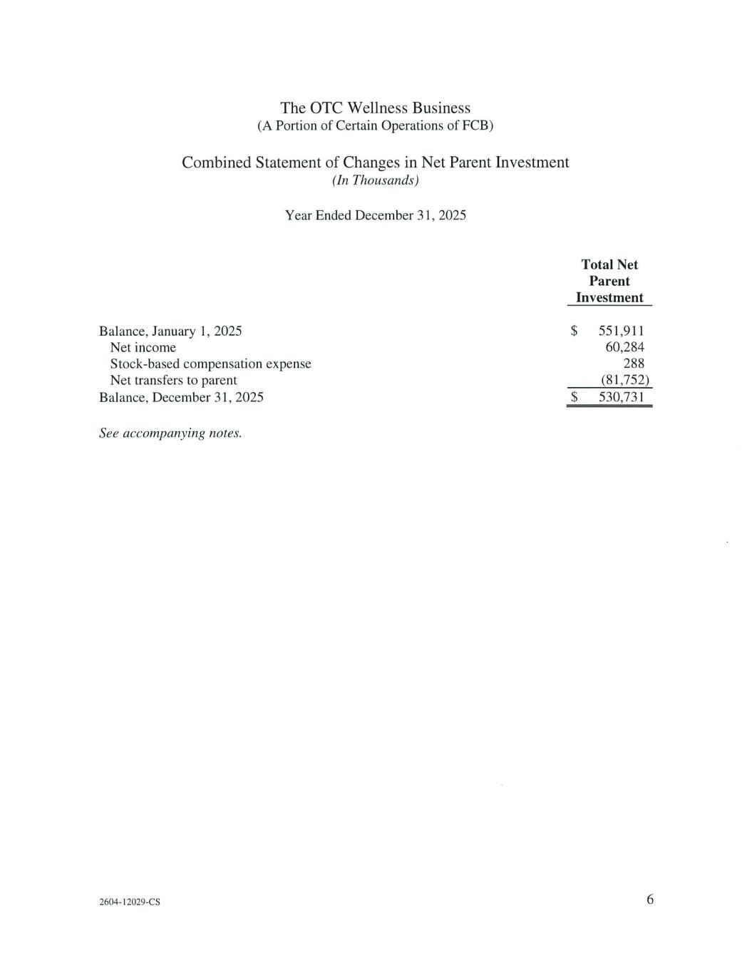

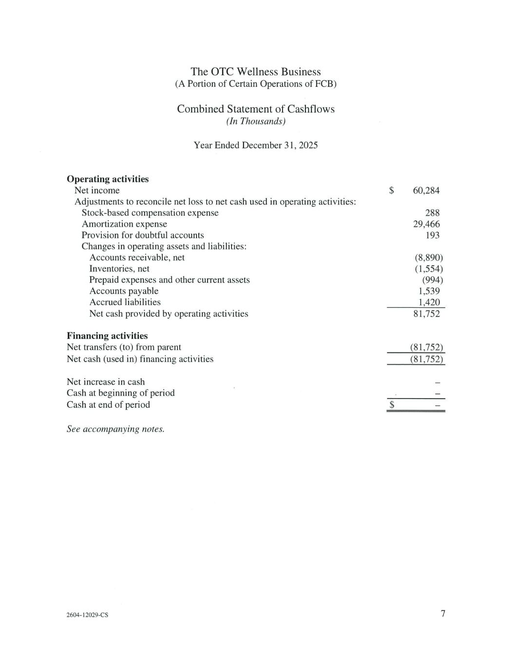

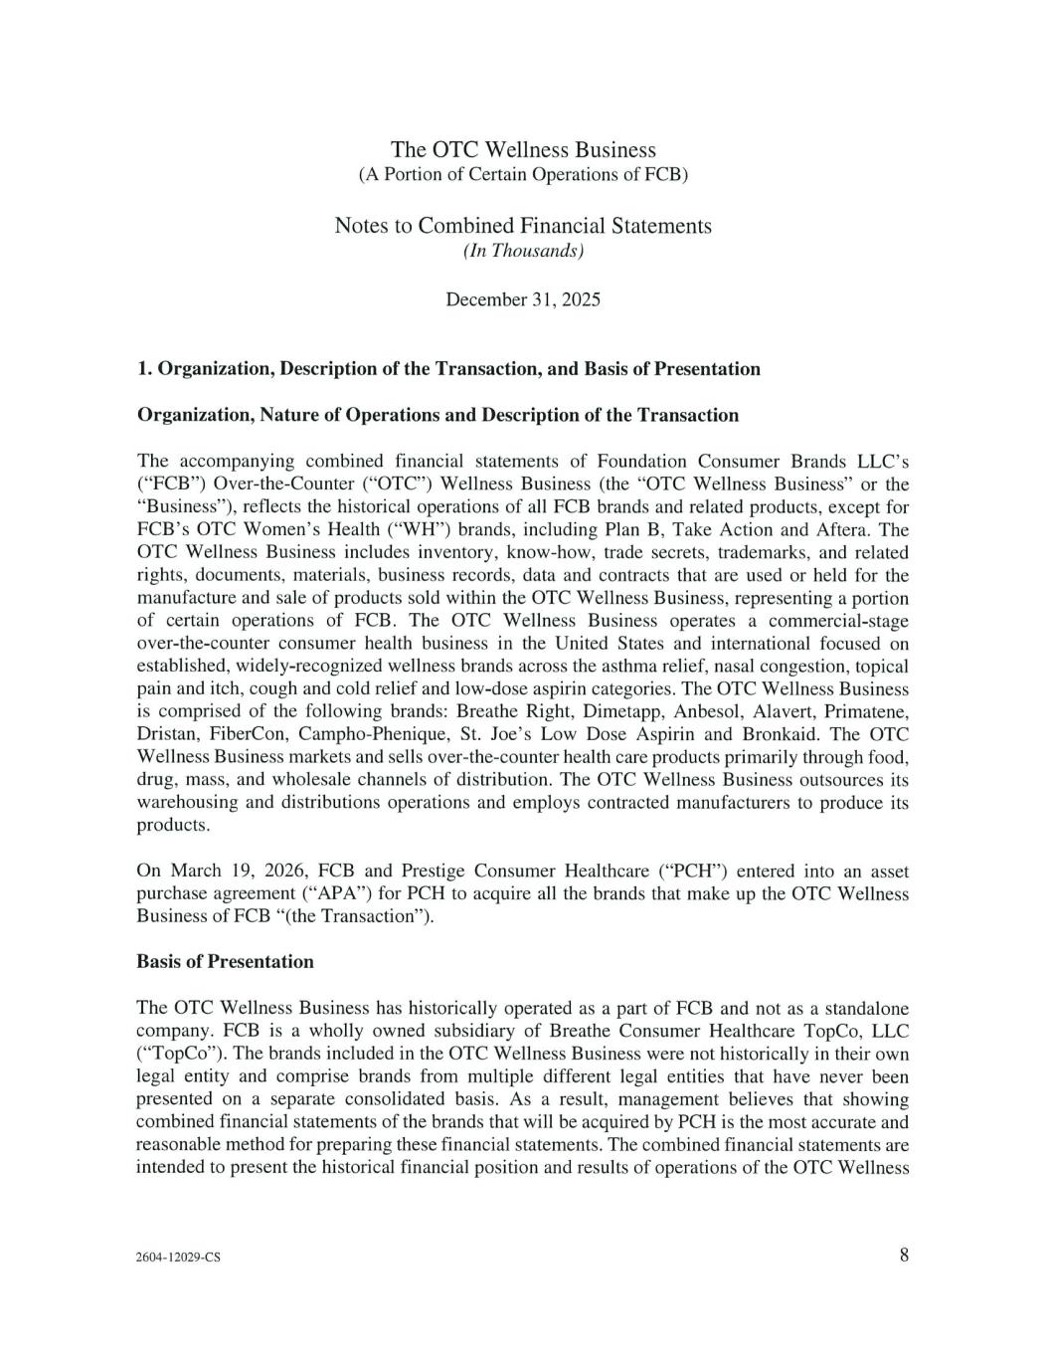

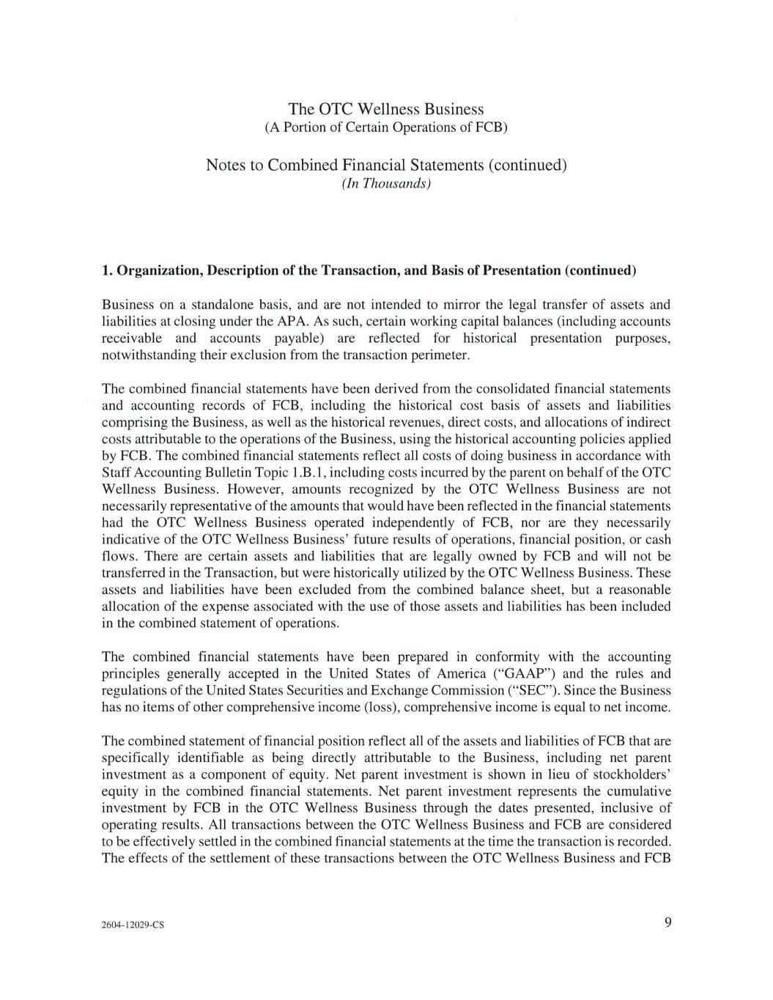

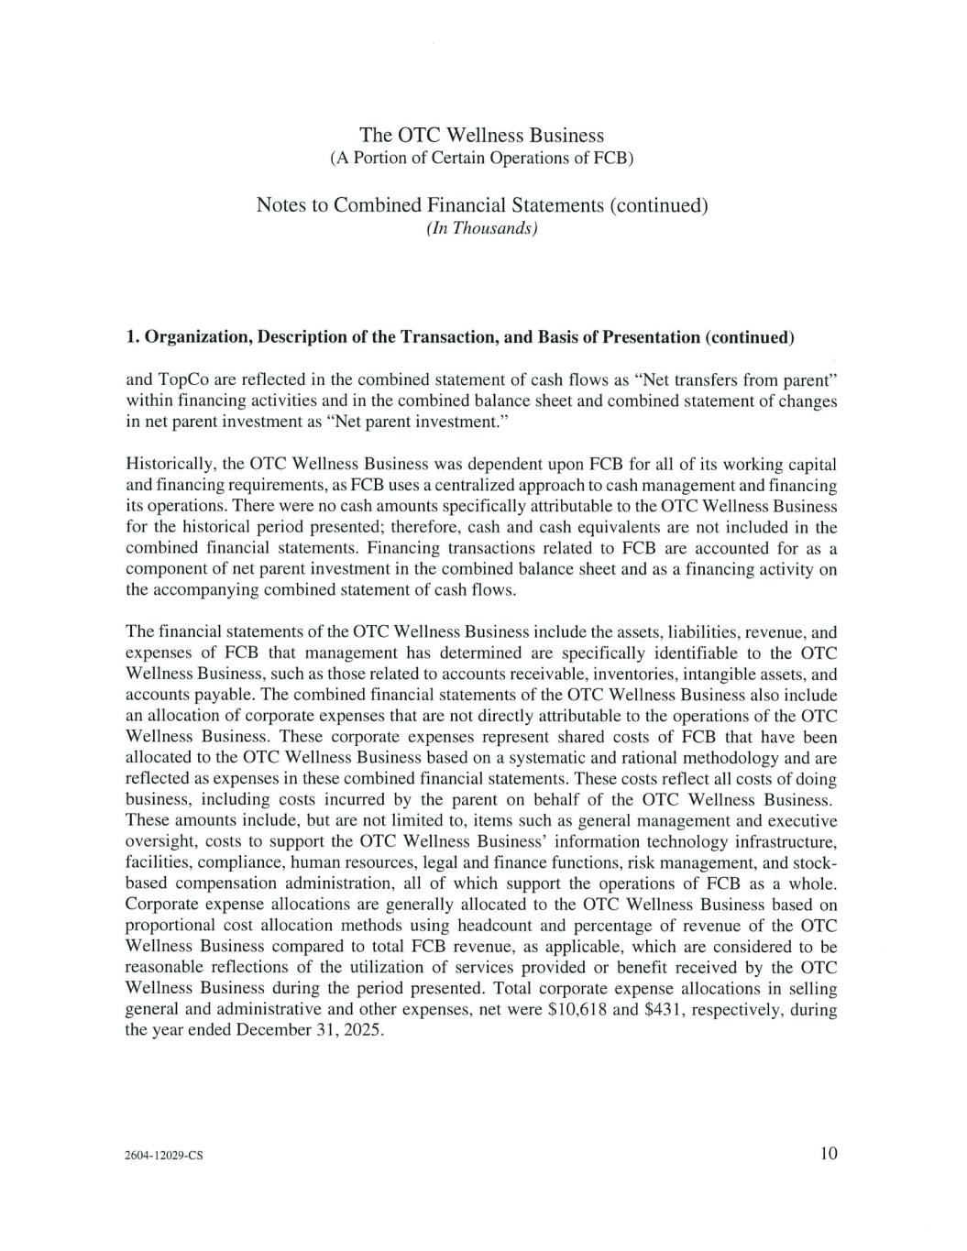

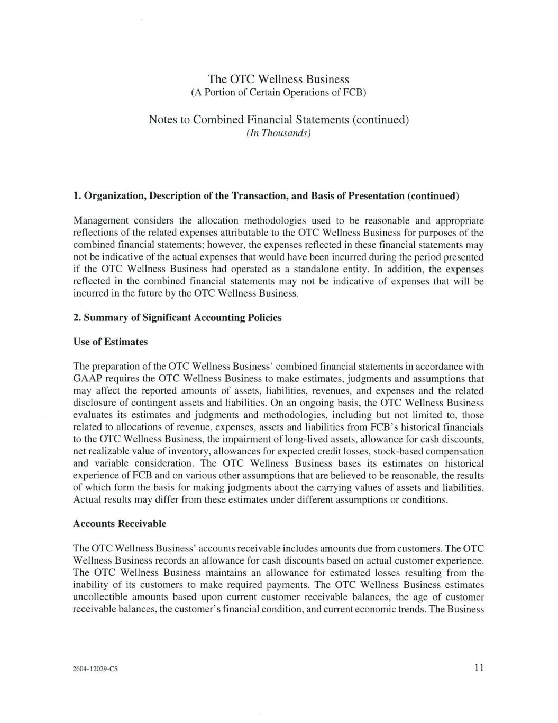

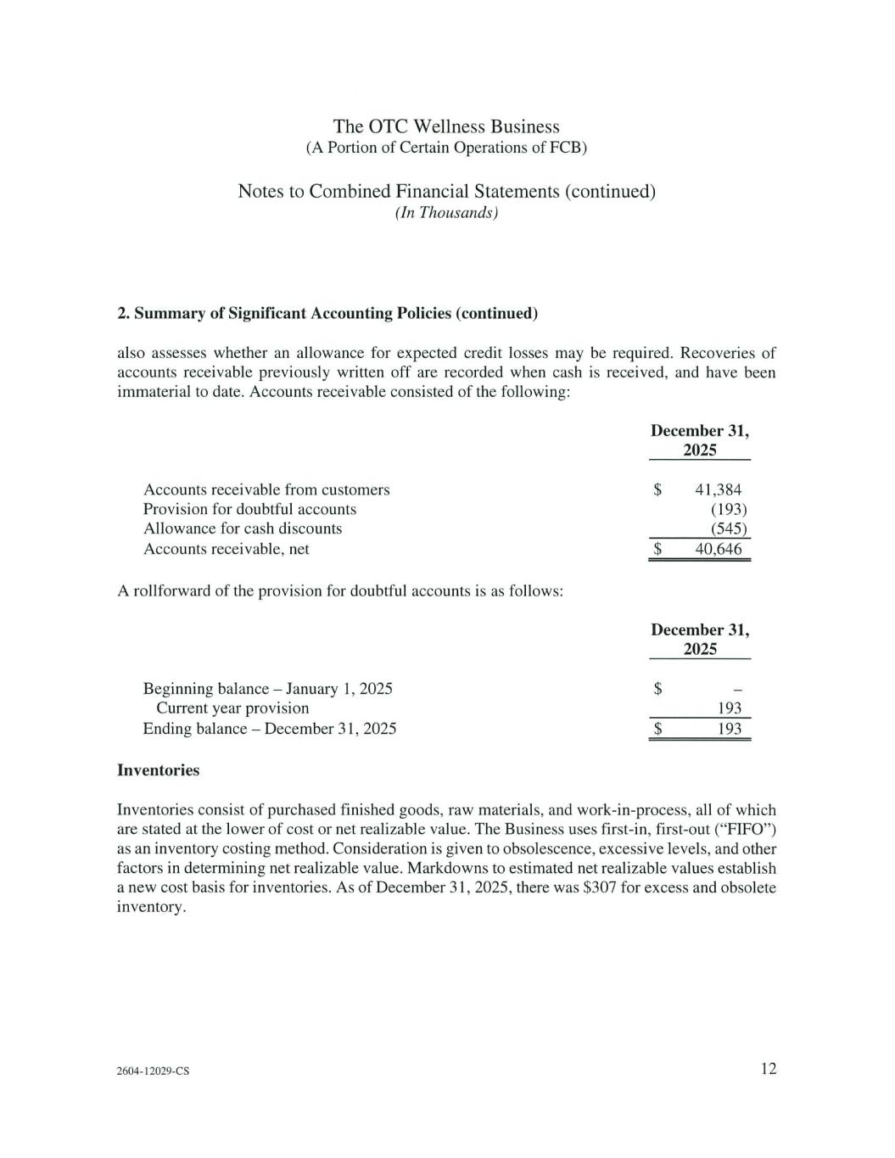

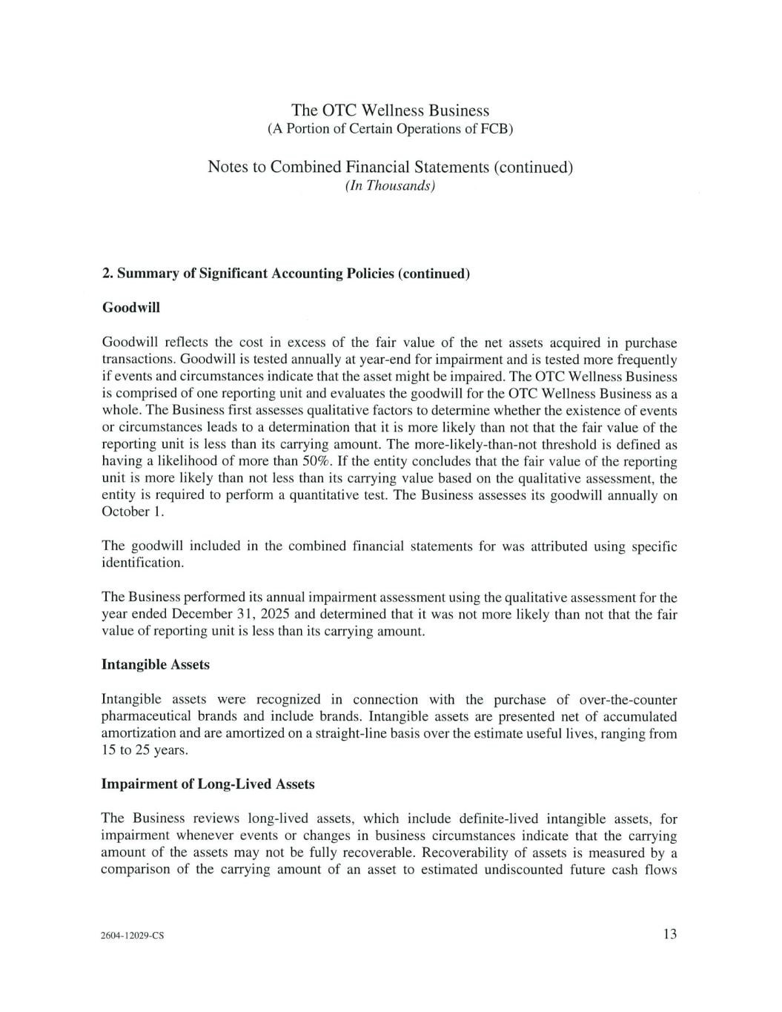

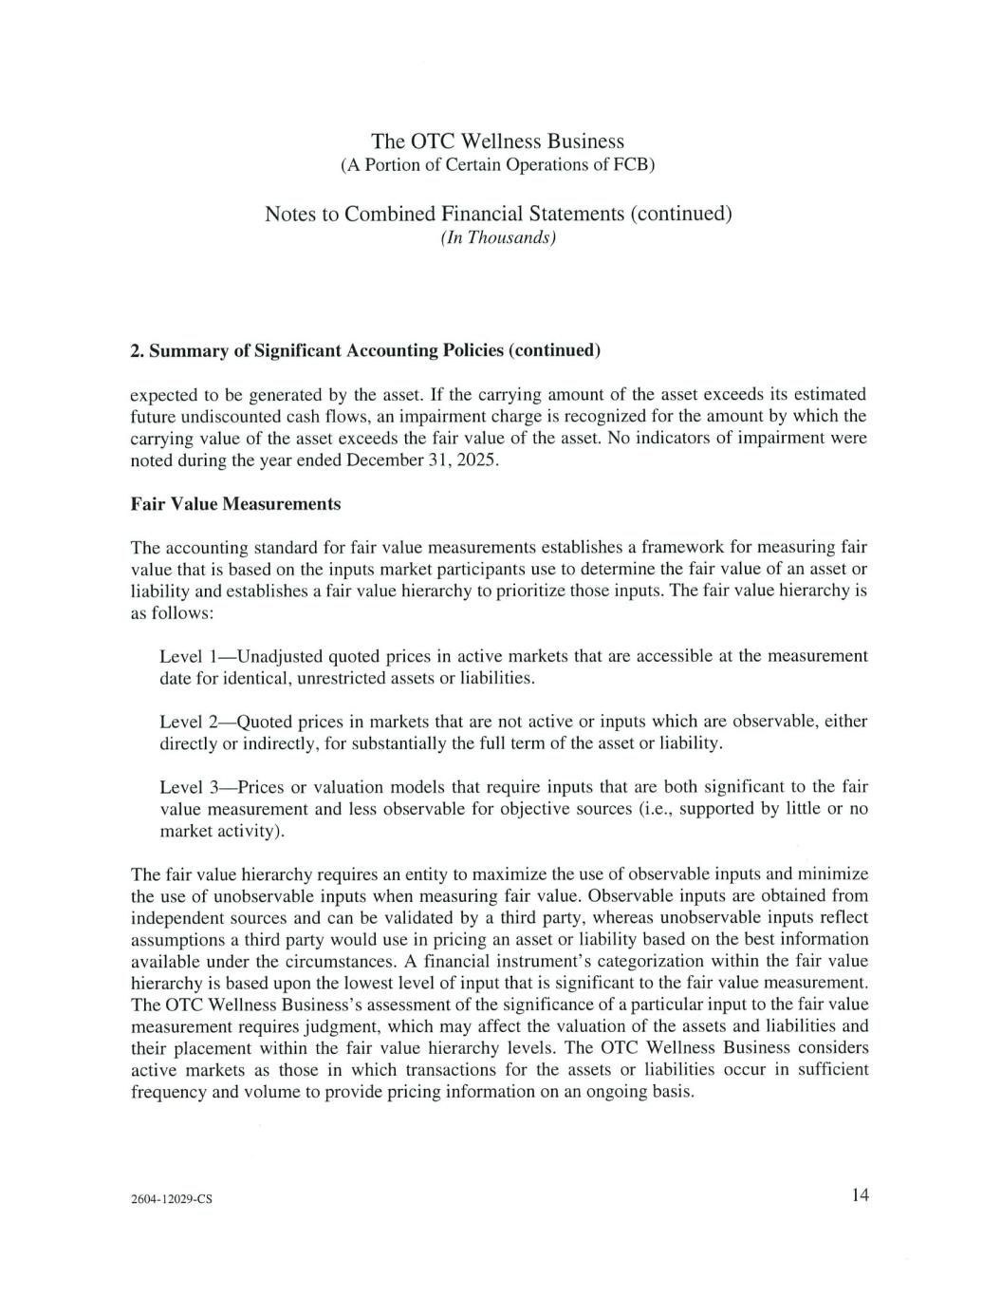

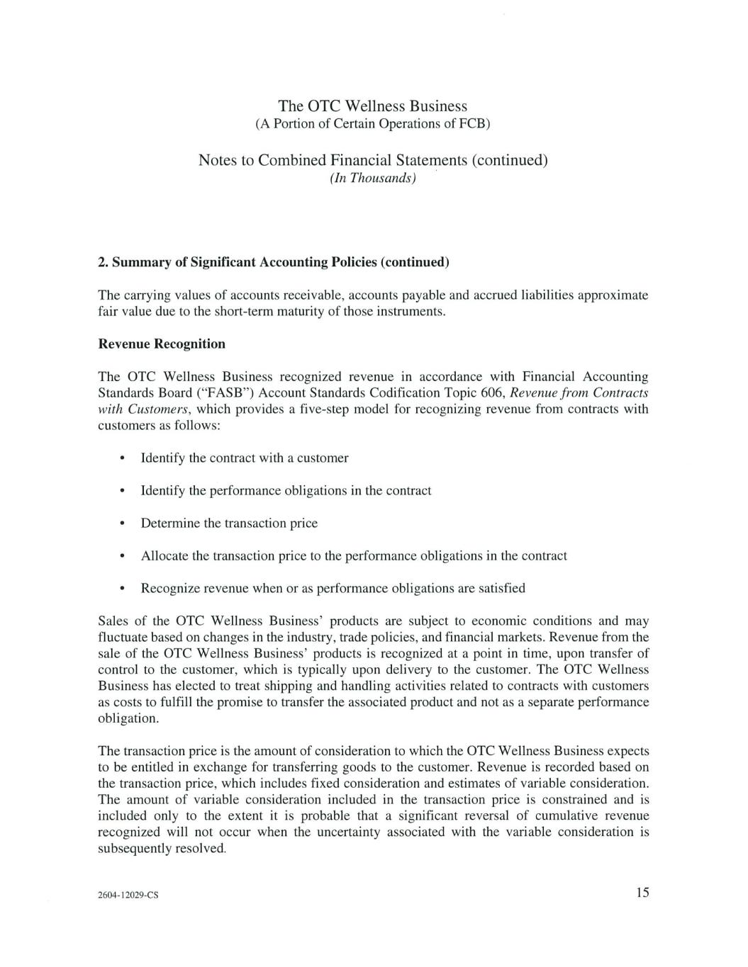

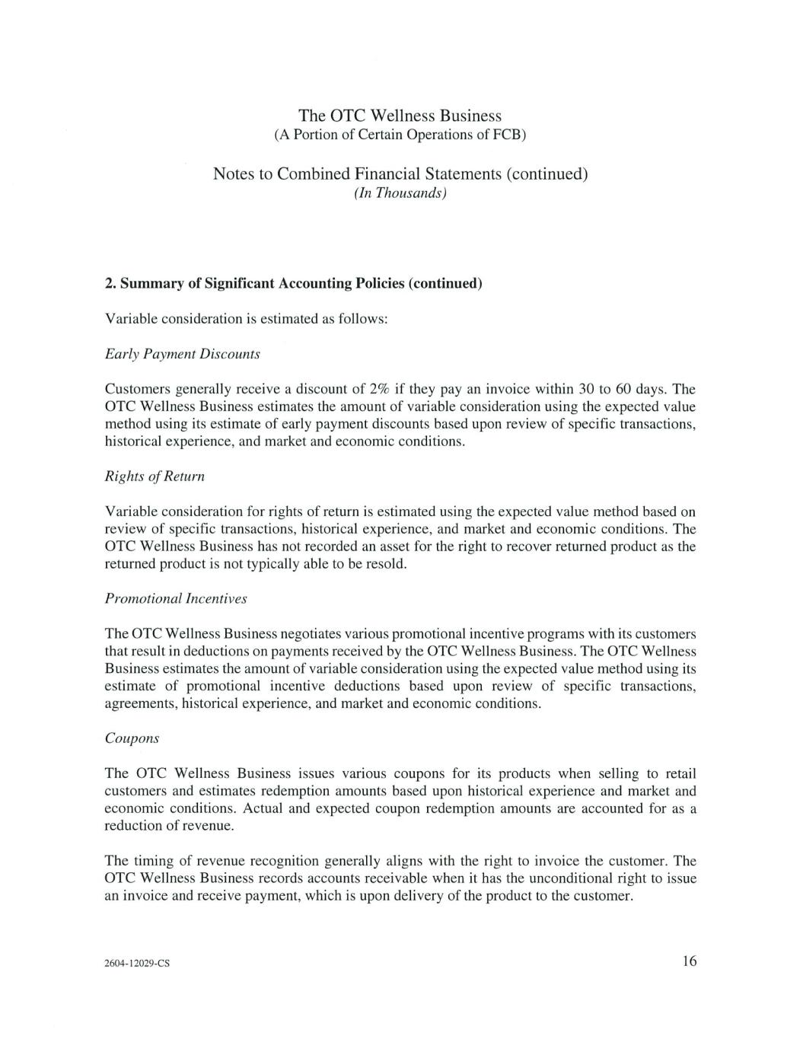

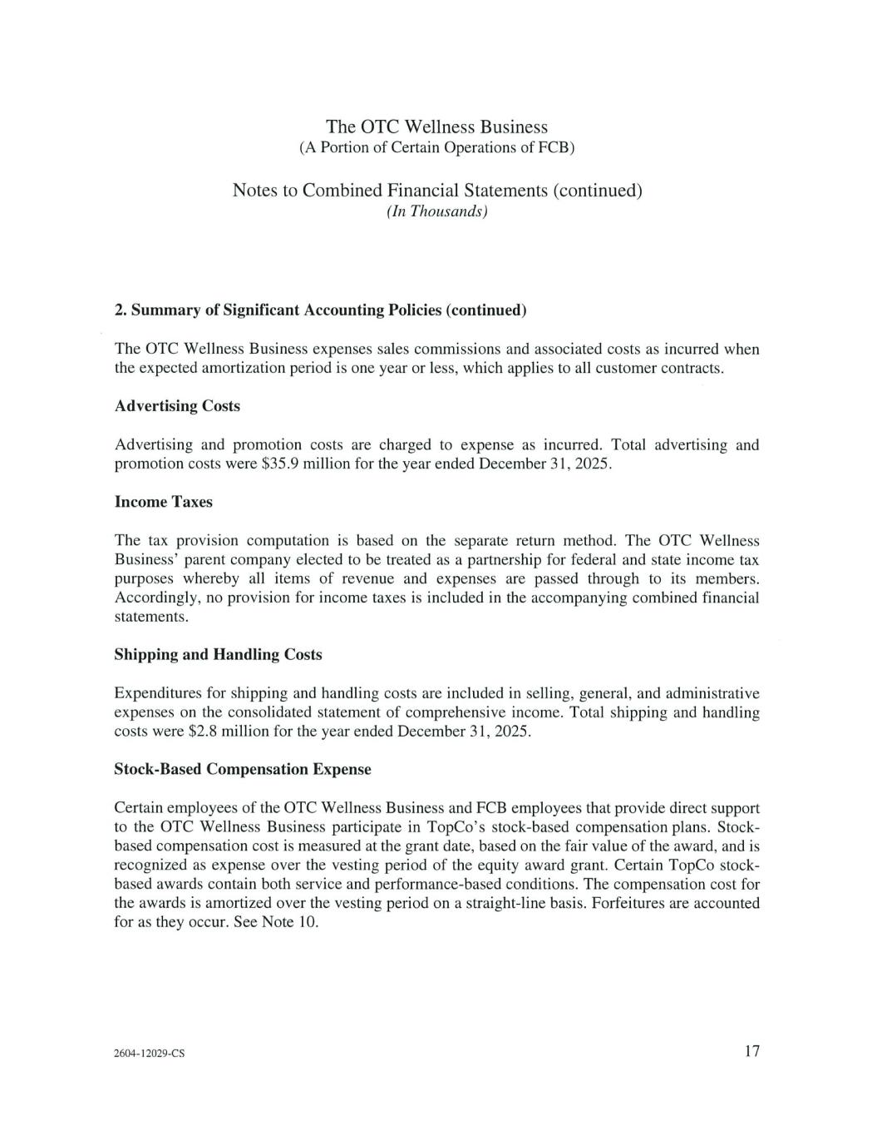

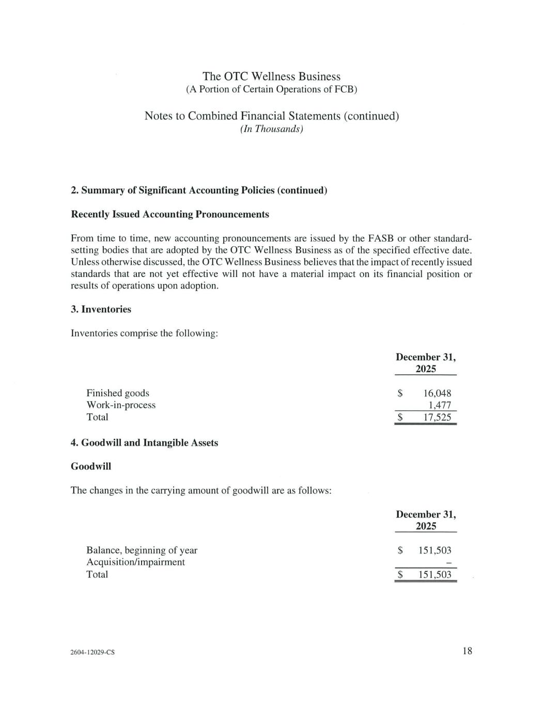

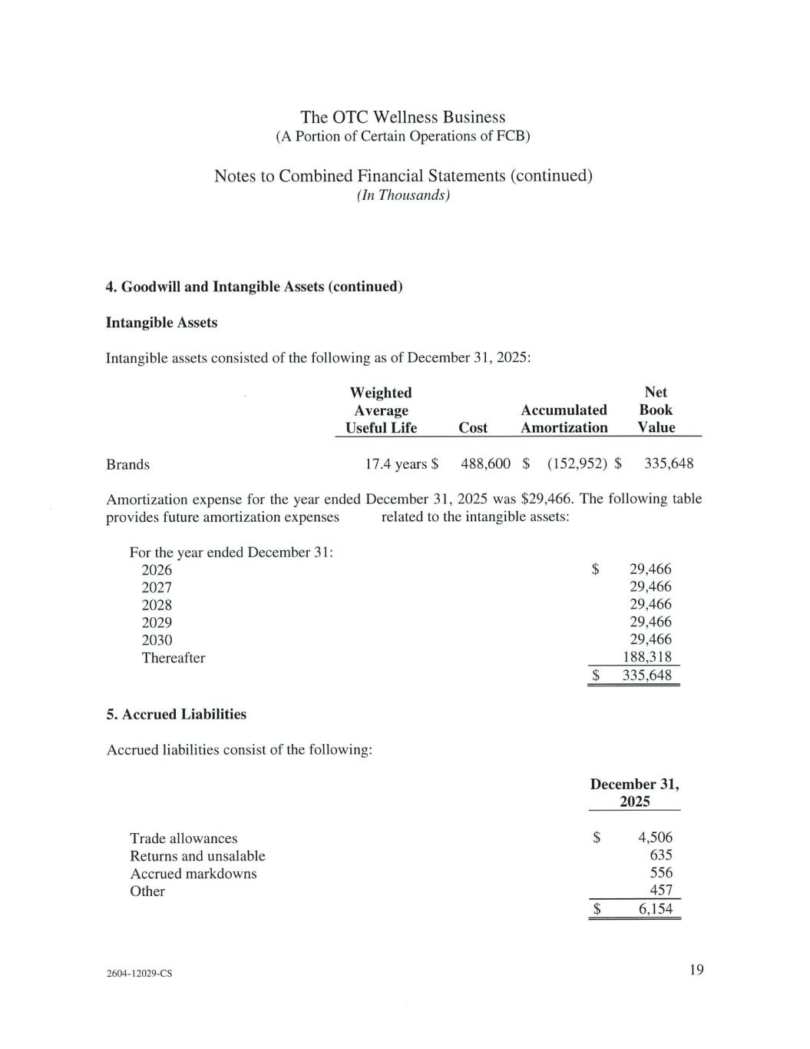

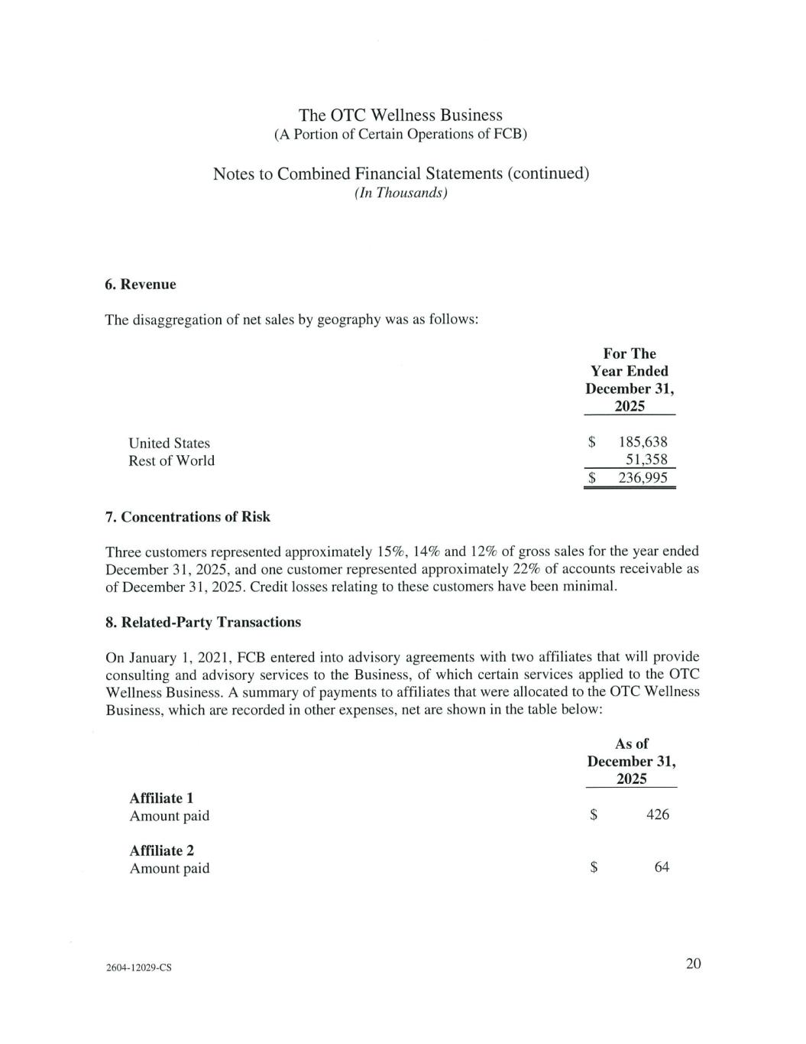

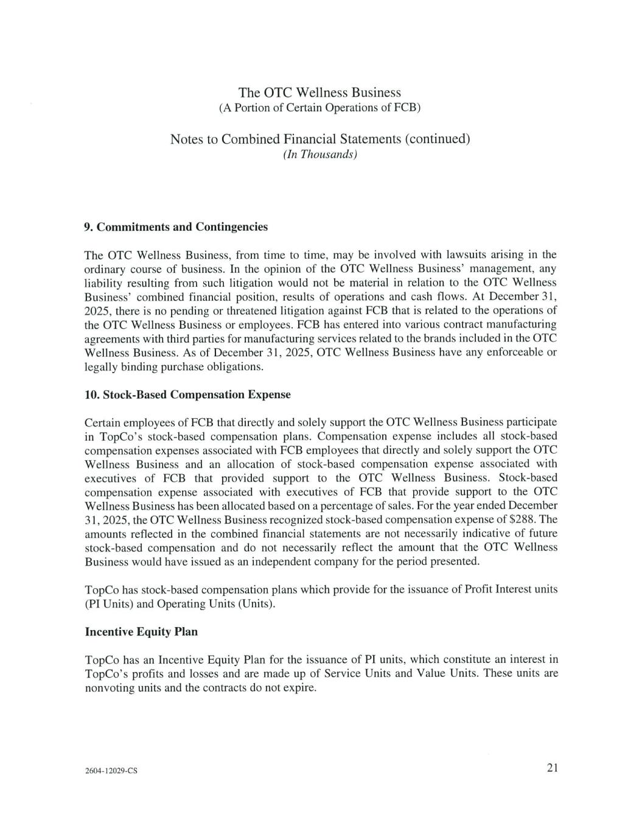

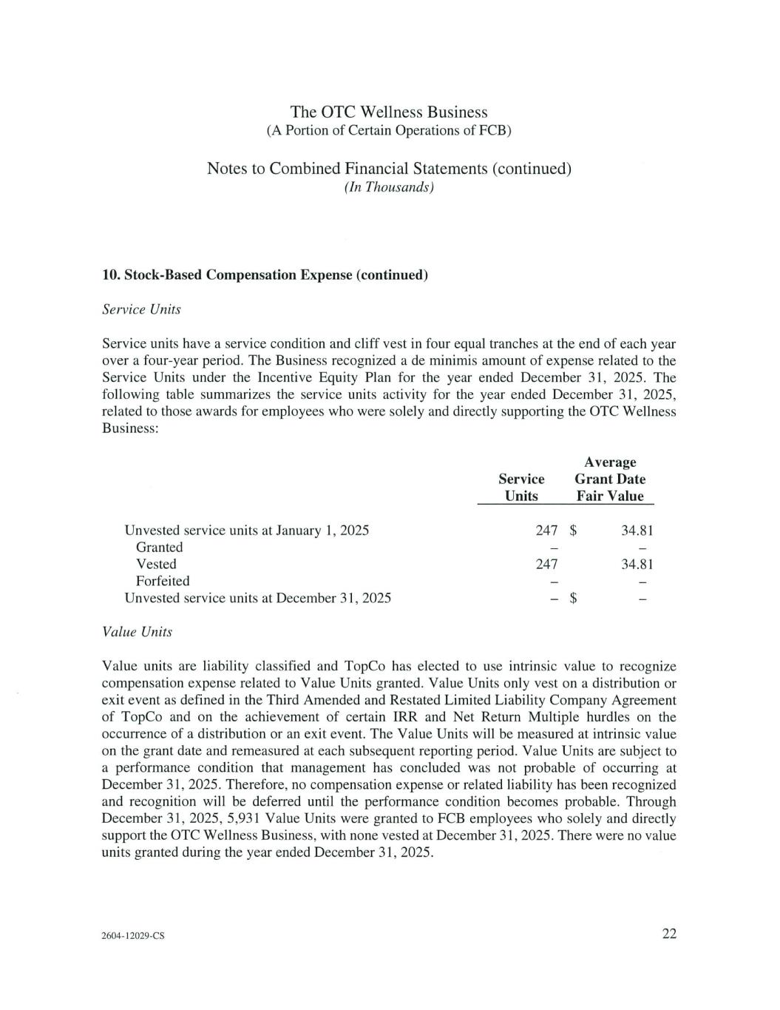

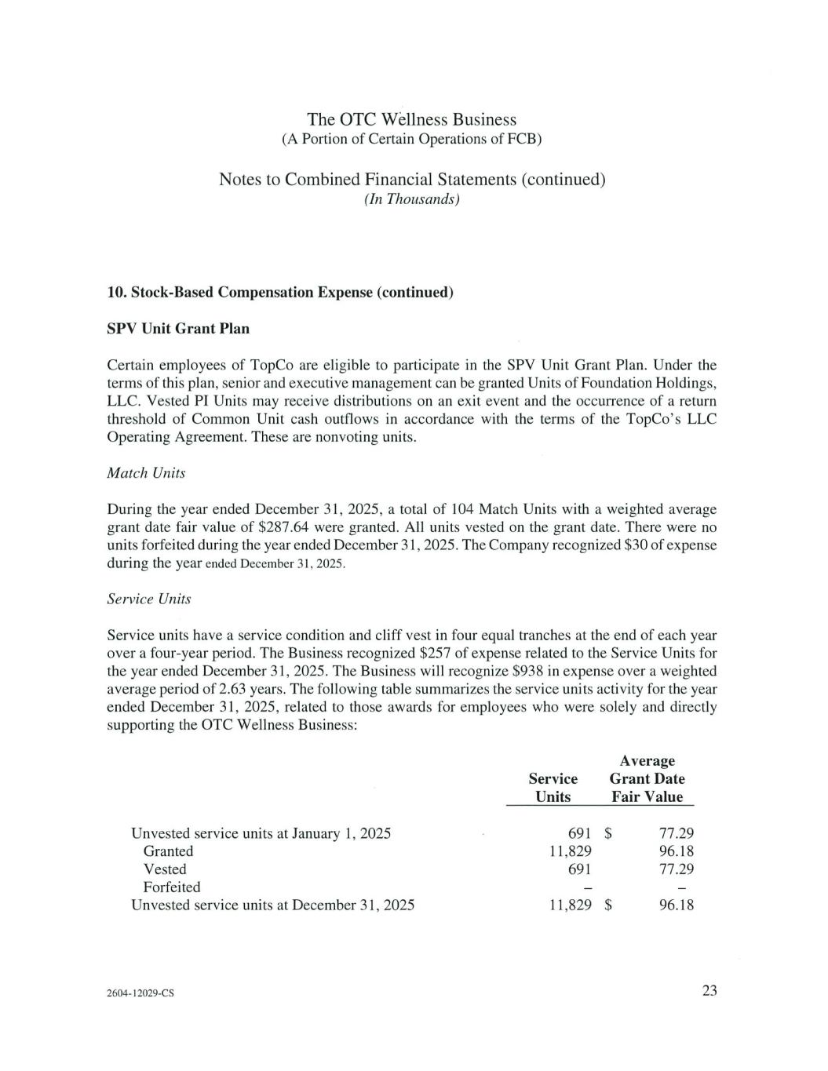

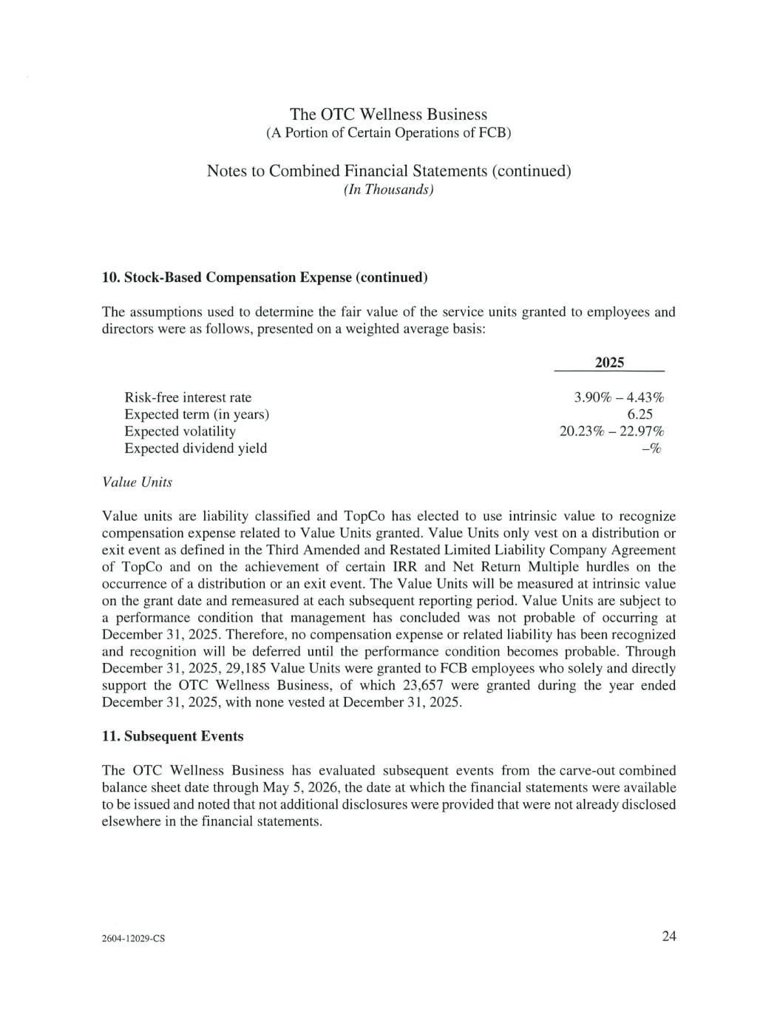

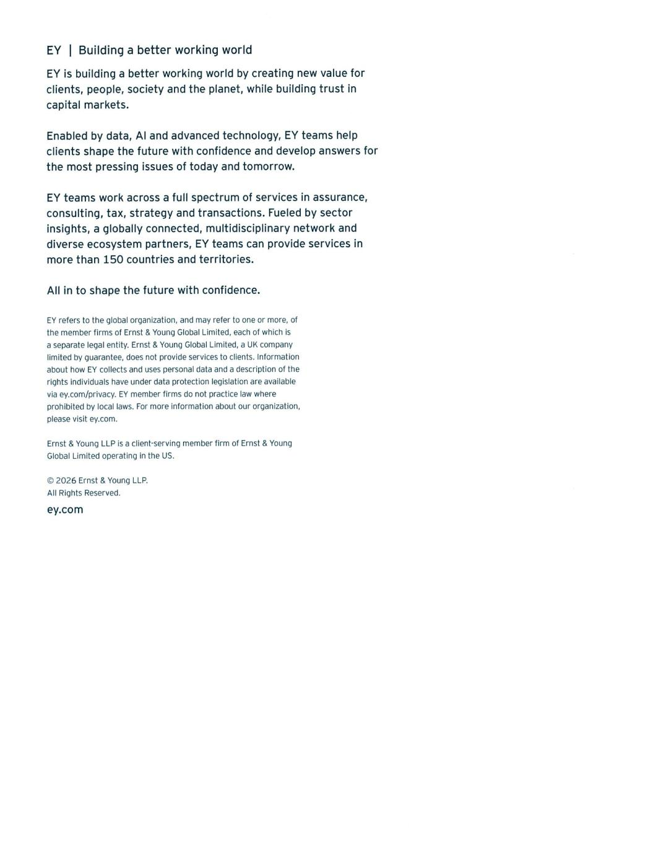

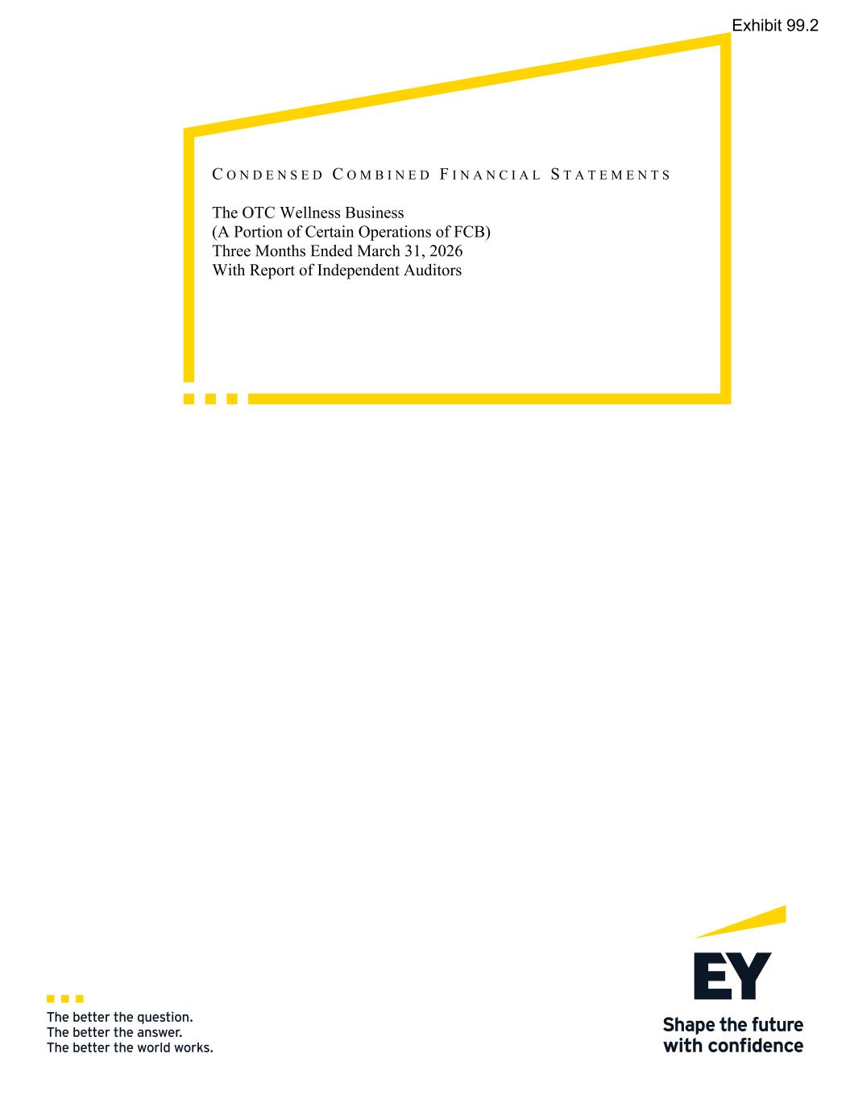
C O N D E N S E D C O M B I N E D F I N A N C I A L S T A T E M E N T S The OTC Wellness Business (A Portion of Certain Operations of FCB) Three Months Ended March 31, 2026 With Report of Independent Auditors Exhibit 99.2

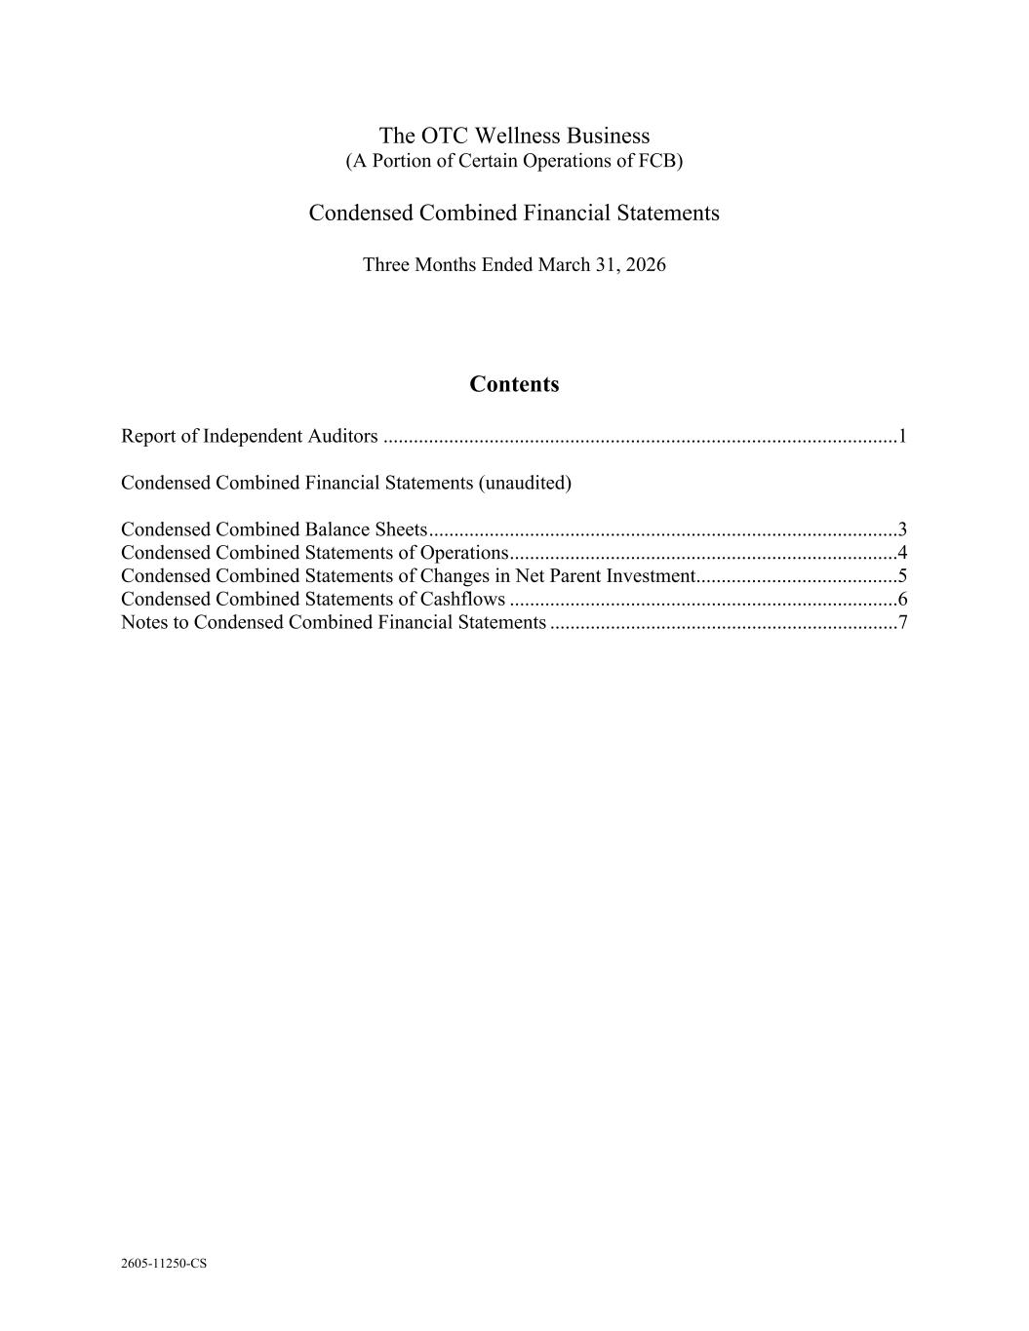
2605-11250-CS The OTC Wellness Business (A Portion of Certain Operations of FCB) Condensed Combined Financial Statements Three Months Ended March 31, 2026 Contents Report of Independent Auditors ......................................................................................................1 Condensed Combined Financial Statements (unaudited) Condensed Combined Balance Sheets .............................................................................................3 Condensed Combined Statements of Operations .............................................................................4 Condensed Combined Statements of Changes in Net Parent Investment ........................................5 Condensed Combined Statements of Cashflows .............................................................................6 Notes to Condensed Combined Financial Statements .....................................................................7

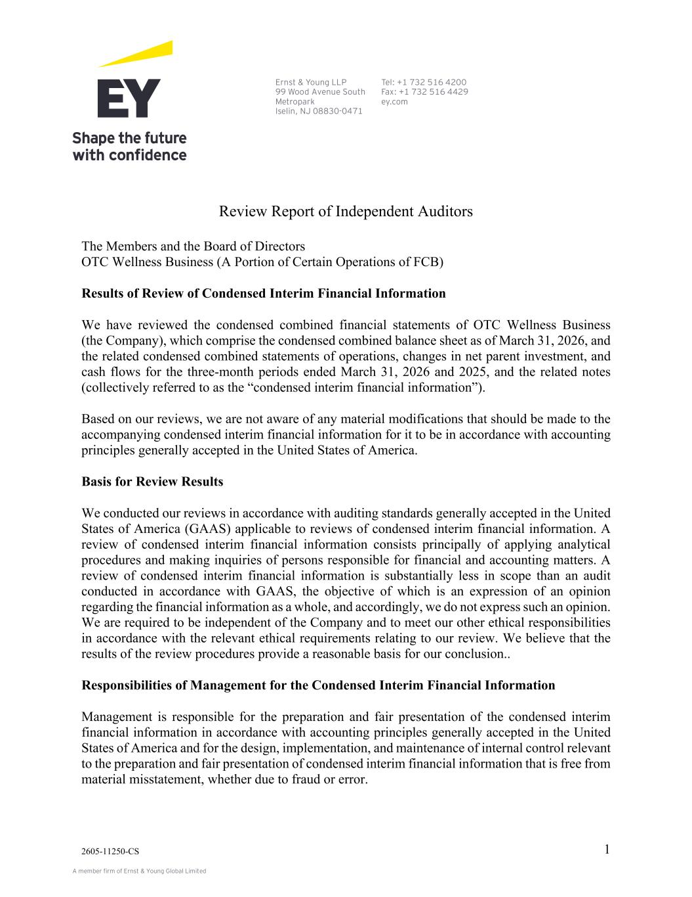
A member firm of Ernst & Young Global Limited Ernst & Young LLP 99 Wood Avenue South Metropark Iselin, NJ 08830-0471 Tel: +1 732 516 4200 Fax: +1 732 516 4429 ey.com 2605-11250-CS 1 Review Report of Independent Auditors The Members and the Board of Directors OTC Wellness Business (A Portion of Certain Operations of FCB) Results of Review of Condensed Interim Financial Information We have reviewed the condensed combined financial statements of OTC Wellness Business (the Company), which comprise the condensed combined balance sheet as of March 31, 2026, and the related condensed combined statements of operations, changes in net parent investment, and cash flows for the three-month periods ended March 31, 2026 and 2025, and the related notes (collectively referred to as the “condensed interim financial information”). Based on our reviews, we are not aware of any material modifications that should be made to the accompanying condensed interim financial information for it to be in accordance with accounting principles generally accepted in the United States of America. Basis for Review Results We conducted our reviews in accordance with auditing standards generally accepted in the United States of America (GAAS) applicable to reviews of condensed interim financial information. A review of condensed interim financial information consists principally of applying analytical procedures and making inquiries of persons responsible for financial and accounting matters. A review of condensed interim financial information is substantially less in scope than an audit conducted in accordance with GAAS, the objective of which is an expression of an opinion regarding the financial information as a whole, and accordingly, we do not express such an opinion. We are required to be independent of the Company and to meet our other ethical responsibilities in accordance with the relevant ethical requirements relating to our review. We believe that the results of the review procedures provide a reasonable basis for our conclusion.. Responsibilities of Management for the Condensed Interim Financial Information Management is responsible for the preparation and fair presentation of the condensed interim financial information in accordance with accounting principles generally accepted in the United States of America and for the design, implementation, and maintenance of internal control relevant to the preparation and fair presentation of condensed interim financial information that is free from material misstatement, whether due to fraud or error.

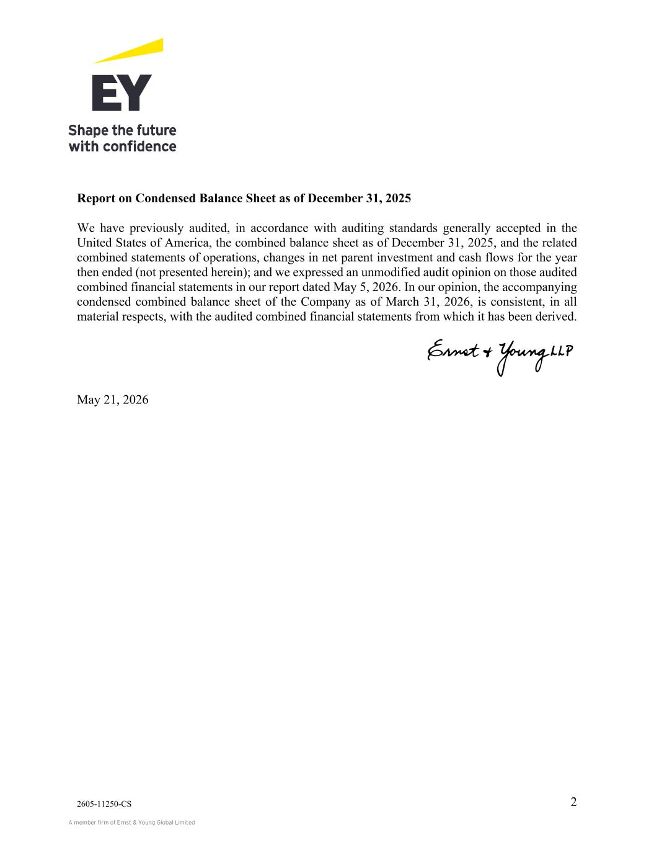
A member firm of Ernst & Young Global Limited 2605-11250-CS 2 Report on Condensed Balance Sheet as of December 31, 2025 We have previously audited, in accordance with auditing standards generally accepted in the United States of America, the combined balance sheet as of December 31, 2025, and the related combined statements of operations, changes in net parent investment and cash flows for the year then ended (not presented herein); and we expressed an unmodified audit opinion on those audited combined financial statements in our report dated May 5, 2026. In our opinion, the accompanying condensed combined balance sheet of the Company as of March 31, 2026, is consistent, in all material respects, with the audited combined financial statements from which it has been derived. ey May 21, 2026

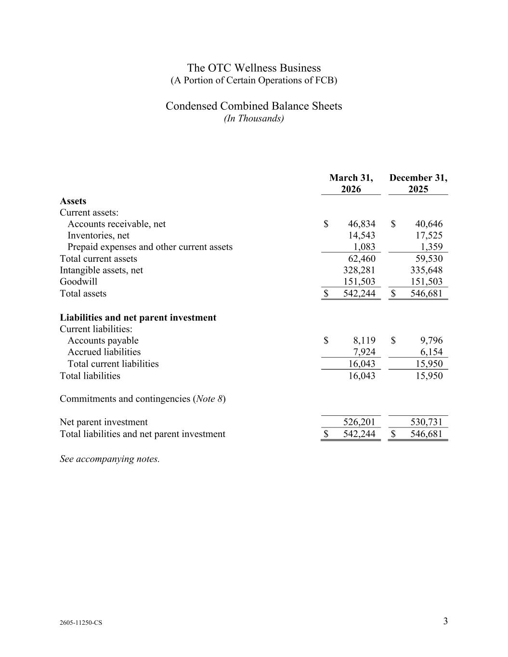
2605-11250-CS 3 1 The OTC Wellness Business (A Portion of Certain Operations of FCB) Condensed Combined Balance Sheets (In Thousands) March 31, December 31, 2026 2025 Assets Current assets: Accounts receivable, net $ 46,834 $ 40,646 Inventories, net 14,543 17,525 Prepaid expenses and other current assets 1,083 1,359 Total current assets 62,460 59,530 Intangible assets, net 328,281 335,648 Goodwill 151,503 151,503 Total assets $ 542,244 $ 546,681 Liabilities and net parent investment Current liabilities: Accounts payable $ 8,119 $ 9,796 Accrued liabilities 7,924 6,154 Total current liabilities 16,043 15,950 Total liabilities 16,043 15,950 Commitments and contingencies (Note 8) Net parent investment 526,201 530,731 Total liabilities and net parent investment $ 542,244 $ 546,681 See accompanying notes.

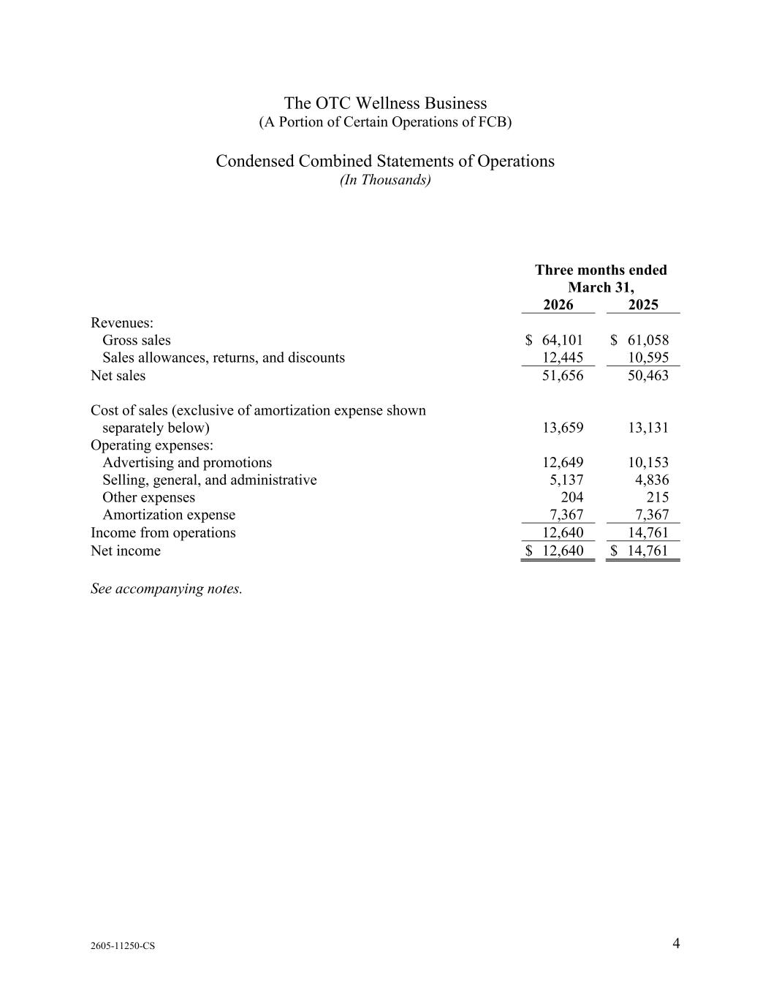
2605-11250-CS 4 1 The OTC Wellness Business (A Portion of Certain Operations of FCB) Condensed Combined Statements of Operations (In Thousands) Three months ended March 31, 2026 2025 Revenues: Gross sales $ 64,101 $ 61,058 Sales allowances, returns, and discounts 12,445 10,595 Net sales 51,656 50,463 Cost of sales (exclusive of amortization expense shown separately below) 13,659 13,131 Operating expenses: Advertising and promotions 12,649 10,153 Selling, general, and administrative 5,137 4,836 Other expenses 204 215 Amortization expense 7,367 7,367 Income from operations 12,640 14,761 Net income $ 12,640 $ 14,761 See accompanying notes.

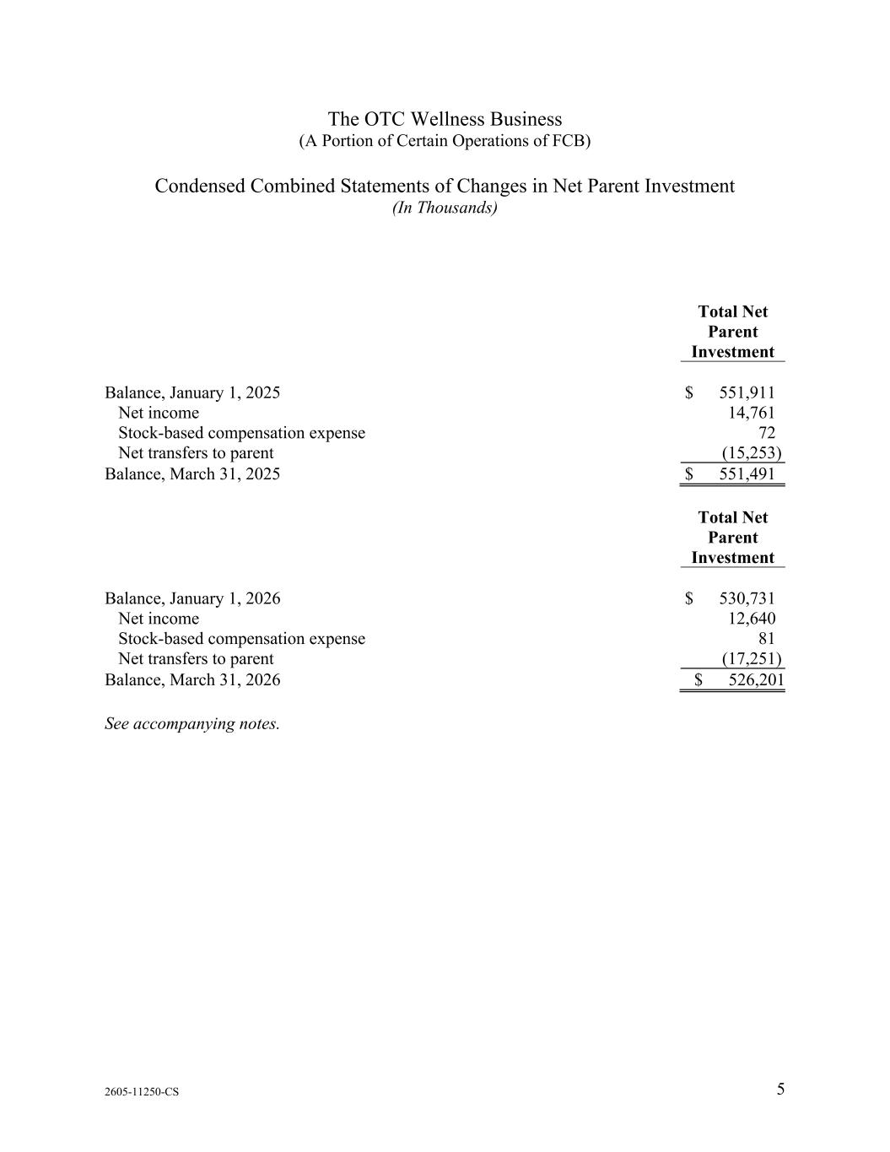
2605-11250-CS 5 1 The OTC Wellness Business (A Portion of Certain Operations of FCB) Condensed Combined Statements of Changes in Net Parent Investment (In Thousands) Total Net Parent Investment Balance, January 1, 2025 $ 551,911 Net income 14,761 Stock-based compensation expense 72 Net transfers to parent (15,253) Balance, March 31, 2025 $ 551,491 Total Net Parent Investment Balance, January 1, 2026 $ 530,731 Net income 12,640 Stock-based compensation expense 81 Net transfers to parent (17,251) Balance, March 31, 2026 $ 526,201 See accompanying notes.

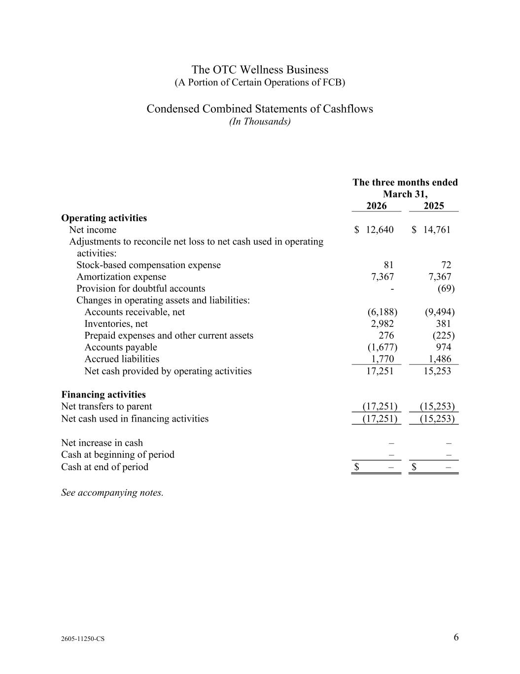
2605-11250-CS 6 1 The OTC Wellness Business (A Portion of Certain Operations of FCB) Condensed Combined Statements of Cashflows (In Thousands) The three months ended March 31, 2026 2025 Operating activities Net income $ 12,640 $ 14,761 Adjustments to reconcile net loss to net cash used in operating activities: Stock-based compensation expense 81 72 Amortization expense 7,367 7,367 Provision for doubtful accounts - (69) Changes in operating assets and liabilities: Accounts receivable, net (6,188) (9,494) Inventories, net 2,982 381 Prepaid expenses and other current assets 276 (225) Accounts payable (1,677) 974 Accrued liabilities 1,770 1,486 Net cash provided by operating activities 17,251 15,253 Financing activities Net transfers to parent (17,251) (15,253) Net cash used in financing activities (17,251) (15,253) Net increase in cash – – Cash at beginning of period – – Cash at end of period $ – $ – See accompanying notes.

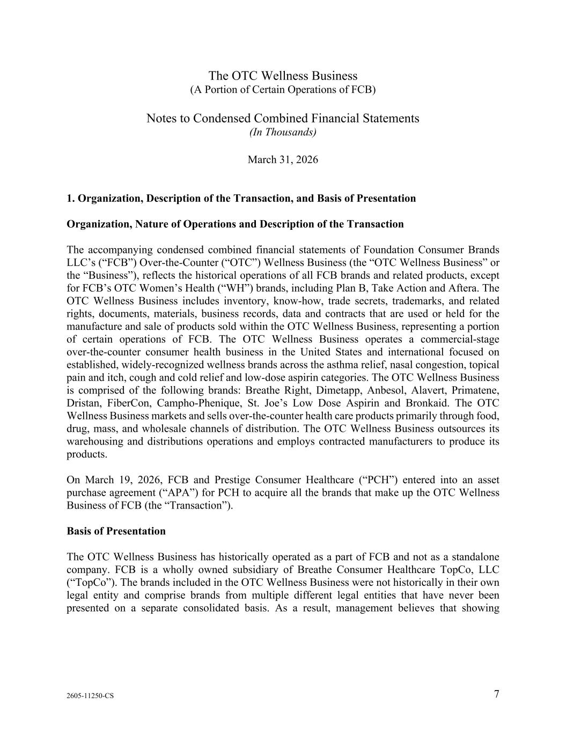
2605-11250-CS 7 The OTC Wellness Business (A Portion of Certain Operations of FCB) Notes to Condensed Combined Financial Statements (In Thousands) March 31, 2026 1. Organization, Description of the Transaction, and Basis of Presentation Organization, Nature of Operations and Description of the Transaction The accompanying condensed combined financial statements of Foundation Consumer Brands LLC’s (“FCB”) Over-the-Counter (“OTC”) Wellness Business (the “OTC Wellness Business” or the “Business”), reflects the historical operations of all FCB brands and related products, except for FCB’s OTC Women’s Health (“WH”) brands, including Plan B, Take Action and Aftera. The OTC Wellness Business includes inventory, know-how, trade secrets, trademarks, and related rights, documents, materials, business records, data and contracts that are used or held for the manufacture and sale of products sold within the OTC Wellness Business, representing a portion of certain operations of FCB. The OTC Wellness Business operates a commercial-stage over-the-counter consumer health business in the United States and international focused on established, widely-recognized wellness brands across the asthma relief, nasal congestion, topical pain and itch, cough and cold relief and low-dose aspirin categories. The OTC Wellness Business is comprised of the following brands: Breathe Right, Dimetapp, Anbesol, Alavert, Primatene, Dristan, FiberCon, Campho-Phenique, St. Joe’s Low Dose Aspirin and Bronkaid. The OTC Wellness Business markets and sells over-the-counter health care products primarily through food, drug, mass, and wholesale channels of distribution. The OTC Wellness Business outsources its warehousing and distributions operations and employs contracted manufacturers to produce its products. On March 19, 2026, FCB and Prestige Consumer Healthcare (“PCH”) entered into an asset purchase agreement (“APA”) for PCH to acquire all the brands that make up the OTC Wellness Business of FCB (the “Transaction”). Basis of Presentation The OTC Wellness Business has historically operated as a part of FCB and not as a standalone company. FCB is a wholly owned subsidiary of Breathe Consumer Healthcare TopCo, LLC (“TopCo”). The brands included in the OTC Wellness Business were not historically in their own legal entity and comprise brands from multiple different legal entities that have never been presented on a separate consolidated basis. As a result, management believes that showing

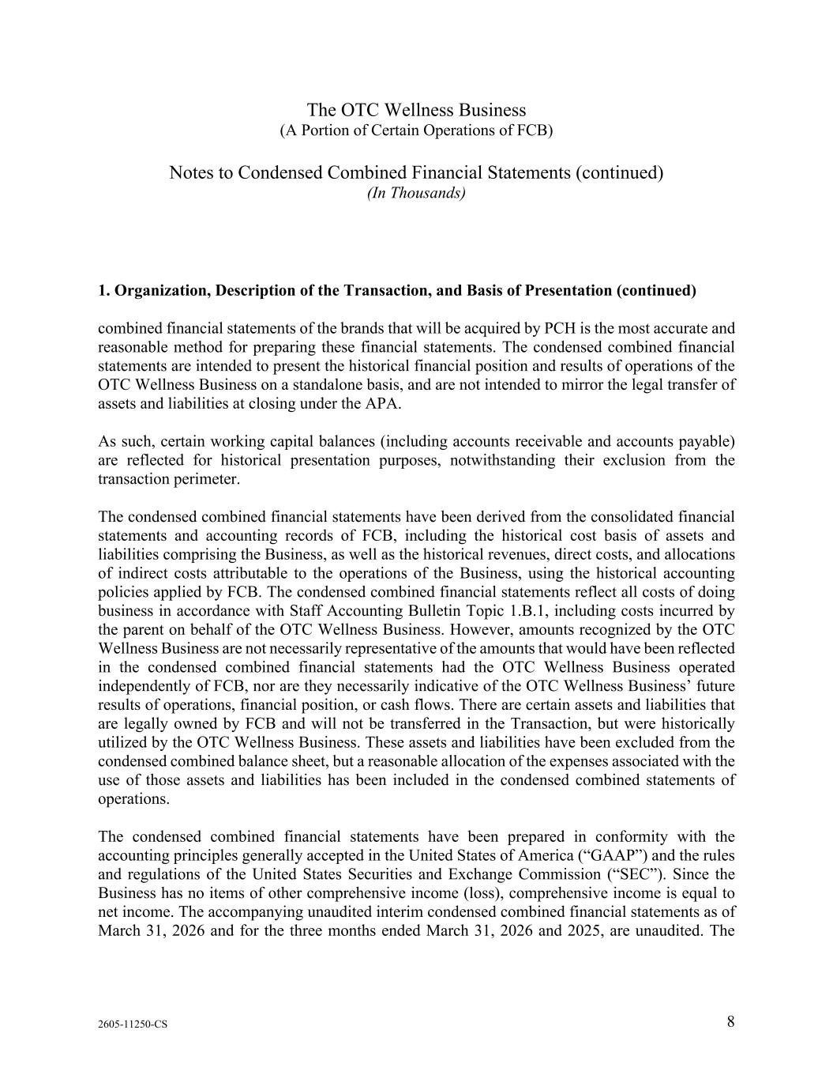
The OTC Wellness Business (A Portion of Certain Operations of FCB) Notes to Condensed Combined Financial Statements (continued) (In Thousands) 2605-11250-CS 8 1. Organization, Description of the Transaction, and Basis of Presentation (continued) combined financial statements of the brands that will be acquired by PCH is the most accurate and reasonable method for preparing these financial statements. The condensed combined financial statements are intended to present the historical financial position and results of operations of the OTC Wellness Business on a standalone basis, and are not intended to mirror the legal transfer of assets and liabilities at closing under the APA. As such, certain working capital balances (including accounts receivable and accounts payable) are reflected for historical presentation purposes, notwithstanding their exclusion from the transaction perimeter. The condensed combined financial statements have been derived from the consolidated financial statements and accounting records of FCB, including the historical cost basis of assets and liabilities comprising the Business, as well as the historical revenues, direct costs, and allocations of indirect costs attributable to the operations of the Business, using the historical accounting policies applied by FCB. The condensed combined financial statements reflect all costs of doing business in accordance with Staff Accounting Bulletin Topic 1.B.1, including costs incurred by the parent on behalf of the OTC Wellness Business. However, amounts recognized by the OTC Wellness Business are not necessarily representative of the amounts that would have been reflected in the condensed combined financial statements had the OTC Wellness Business operated independently of FCB, nor are they necessarily indicative of the OTC Wellness Business’ future results of operations, financial position, or cash flows. There are certain assets and liabilities that are legally owned by FCB and will not be transferred in the Transaction, but were historically utilized by the OTC Wellness Business. These assets and liabilities have been excluded from the condensed combined balance sheet, but a reasonable allocation of the expenses associated with the use of those assets and liabilities has been included in the condensed combined statements of operations. The condensed combined financial statements have been prepared in conformity with the accounting principles generally accepted in the United States of America (“GAAP”) and the rules and regulations of the United States Securities and Exchange Commission (“SEC”). Since the Business has no items of other comprehensive income (loss), comprehensive income is equal to net income. The accompanying unaudited interim condensed combined financial statements as of March 31, 2026 and for the three months ended March 31, 2026 and 2025, are unaudited. The

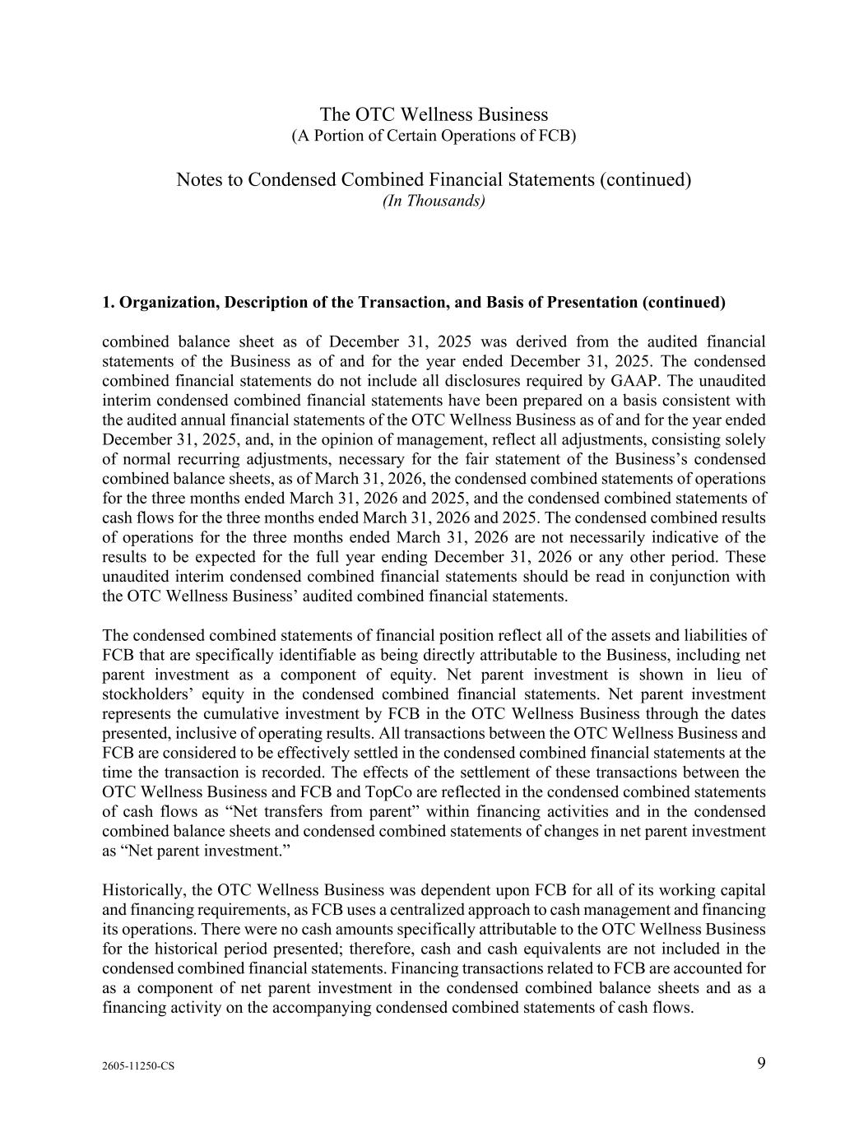
The OTC Wellness Business (A Portion of Certain Operations of FCB) Notes to Condensed Combined Financial Statements (continued) (In Thousands) 2605-11250-CS 9 1. Organization, Description of the Transaction, and Basis of Presentation (continued) combined balance sheet as of December 31, 2025 was derived from the audited financial statements of the Business as of and for the year ended December 31, 2025. The condensed combined financial statements do not include all disclosures required by GAAP. The unaudited interim condensed combined financial statements have been prepared on a basis consistent with the audited annual financial statements of the OTC Wellness Business as of and for the year ended December 31, 2025, and, in the opinion of management, reflect all adjustments, consisting solely of normal recurring adjustments, necessary for the fair statement of the Business’s condensed combined balance sheets, as of March 31, 2026, the condensed combined statements of operations for the three months ended March 31, 2026 and 2025, and the condensed combined statements of cash flows for the three months ended March 31, 2026 and 2025. The condensed combined results of operations for the three months ended March 31, 2026 are not necessarily indicative of the results to be expected for the full year ending December 31, 2026 or any other period. These unaudited interim condensed combined financial statements should be read in conjunction with the OTC Wellness Business’ audited combined financial statements. The condensed combined statements of financial position reflect all of the assets and liabilities of FCB that are specifically identifiable as being directly attributable to the Business, including net parent investment as a component of equity. Net parent investment is shown in lieu of stockholders’ equity in the condensed combined financial statements. Net parent investment represents the cumulative investment by FCB in the OTC Wellness Business through the dates presented, inclusive of operating results. All transactions between the OTC Wellness Business and FCB are considered to be effectively settled in the condensed combined financial statements at the time the transaction is recorded. The effects of the settlement of these transactions between the OTC Wellness Business and FCB and TopCo are reflected in the condensed combined statements of cash flows as “Net transfers from parent” within financing activities and in the condensed combined balance sheets and condensed combined statements of changes in net parent investment as “Net parent investment.” Historically, the OTC Wellness Business was dependent upon FCB for all of its working capital and financing requirements, as FCB uses a centralized approach to cash management and financing its operations. There were no cash amounts specifically attributable to the OTC Wellness Business for the historical period presented; therefore, cash and cash equivalents are not included in the condensed combined financial statements. Financing transactions related to FCB are accounted for as a component of net parent investment in the condensed combined balance sheets and as a financing activity on the accompanying condensed combined statements of cash flows.

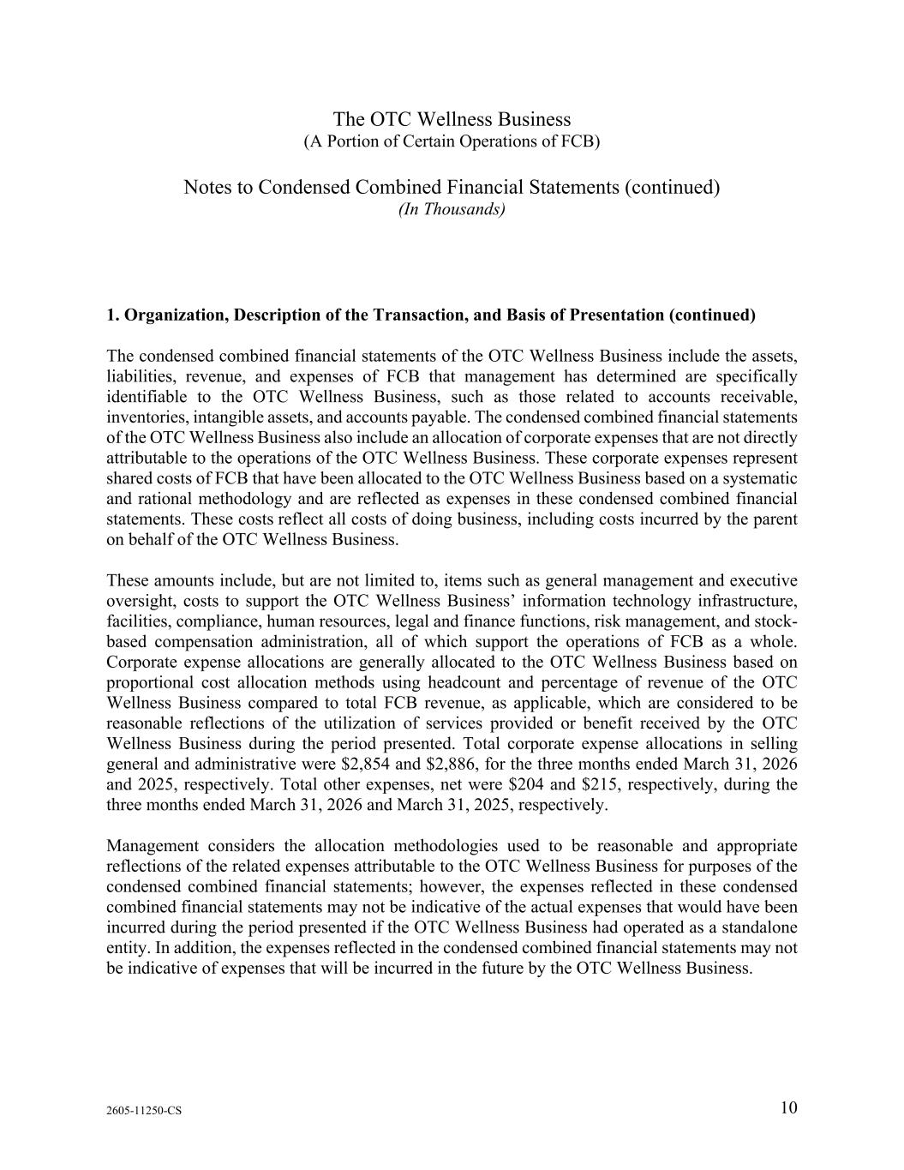
The OTC Wellness Business (A Portion of Certain Operations of FCB) Notes to Condensed Combined Financial Statements (continued) (In Thousands) 2605-11250-CS 10 1. Organization, Description of the Transaction, and Basis of Presentation (continued) The condensed combined financial statements of the OTC Wellness Business include the assets, liabilities, revenue, and expenses of FCB that management has determined are specifically identifiable to the OTC Wellness Business, such as those related to accounts receivable, inventories, intangible assets, and accounts payable. The condensed combined financial statements of the OTC Wellness Business also include an allocation of corporate expenses that are not directly attributable to the operations of the OTC Wellness Business. These corporate expenses represent shared costs of FCB that have been allocated to the OTC Wellness Business based on a systematic and rational methodology and are reflected as expenses in these condensed combined financial statements. These costs reflect all costs of doing business, including costs incurred by the parent on behalf of the OTC Wellness Business. These amounts include, but are not limited to, items such as general management and executive oversight, costs to support the OTC Wellness Business’ information technology infrastructure, facilities, compliance, human resources, legal and finance functions, risk management, and stock- based compensation administration, all of which support the operations of FCB as a whole. Corporate expense allocations are generally allocated to the OTC Wellness Business based on proportional cost allocation methods using headcount and percentage of revenue of the OTC Wellness Business compared to total FCB revenue, as applicable, which are considered to be reasonable reflections of the utilization of services provided or benefit received by the OTC Wellness Business during the period presented. Total corporate expense allocations in selling general and administrative were $2,854 and $2,886, for the three months ended March 31, 2026 and 2025, respectively. Total other expenses, net were $204 and $215, respectively, during the three months ended March 31, 2026 and March 31, 2025, respectively. Management considers the allocation methodologies used to be reasonable and appropriate reflections of the related expenses attributable to the OTC Wellness Business for purposes of the condensed combined financial statements; however, the expenses reflected in these condensed combined financial statements may not be indicative of the actual expenses that would have been incurred during the period presented if the OTC Wellness Business had operated as a standalone entity. In addition, the expenses reflected in the condensed combined financial statements may not be indicative of expenses that will be incurred in the future by the OTC Wellness Business.

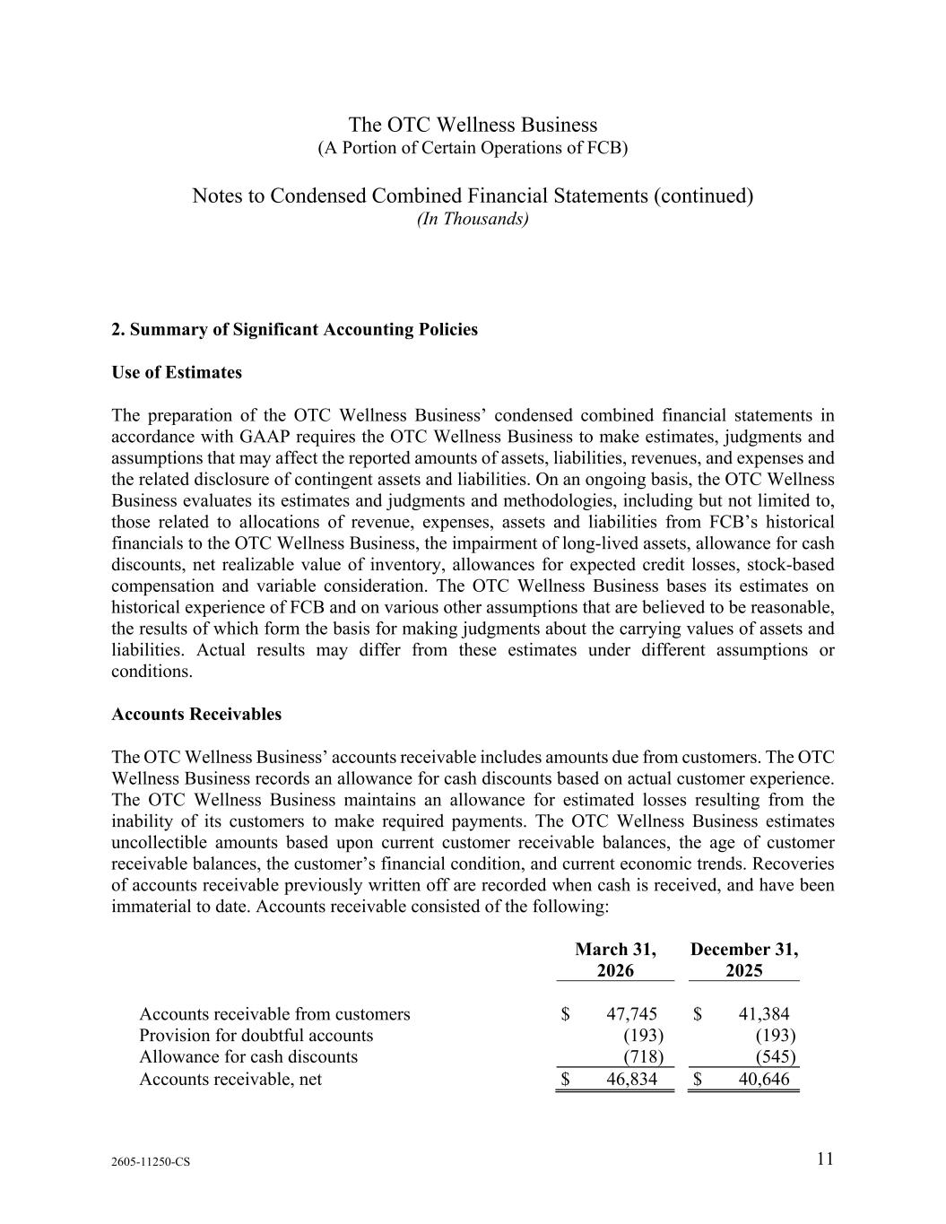
The OTC Wellness Business (A Portion of Certain Operations of FCB) Notes to Condensed Combined Financial Statements (continued) (In Thousands) 2605-11250-CS 11 2. Summary of Significant Accounting Policies Use of Estimates The preparation of the OTC Wellness Business’ condensed combined financial statements in accordance with GAAP requires the OTC Wellness Business to make estimates, judgments and assumptions that may affect the reported amounts of assets, liabilities, revenues, and expenses and the related disclosure of contingent assets and liabilities. On an ongoing basis, the OTC Wellness Business evaluates its estimates and judgments and methodologies, including but not limited to, those related to allocations of revenue, expenses, assets and liabilities from FCB’s historical financials to the OTC Wellness Business, the impairment of long-lived assets, allowance for cash discounts, net realizable value of inventory, allowances for expected credit losses, stock-based compensation and variable consideration. The OTC Wellness Business bases its estimates on historical experience of FCB and on various other assumptions that are believed to be reasonable, the results of which form the basis for making judgments about the carrying values of assets and liabilities. Actual results may differ from these estimates under different assumptions or conditions. Accounts Receivables The OTC Wellness Business’ accounts receivable includes amounts due from customers. The OTC Wellness Business records an allowance for cash discounts based on actual customer experience. The OTC Wellness Business maintains an allowance for estimated losses resulting from the inability of its customers to make required payments. The OTC Wellness Business estimates uncollectible amounts based upon current customer receivable balances, the age of customer receivable balances, the customer’s financial condition, and current economic trends. Recoveries of accounts receivable previously written off are recorded when cash is received, and have been immaterial to date. Accounts receivable consisted of the following: March 31, 2026 December 31, 2025 Accounts receivable from customers $ 47,745 $ 41,384 Provision for doubtful accounts (193) (193) Allowance for cash discounts (718) (545) Accounts receivable, net $ 46,834 $ 40,646

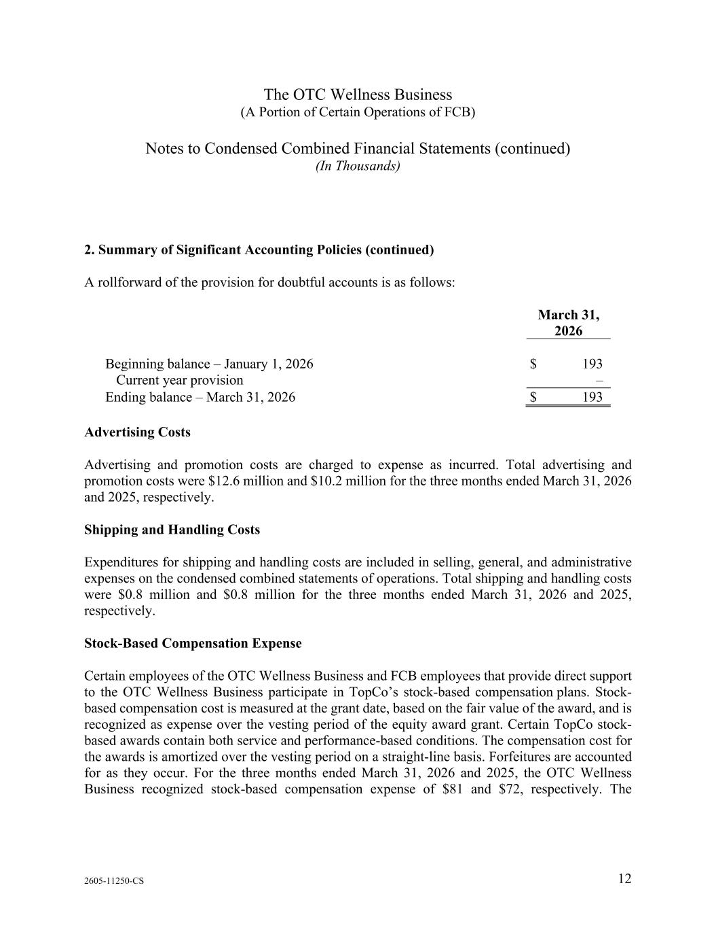
The OTC Wellness Business (A Portion of Certain Operations of FCB) Notes to Condensed Combined Financial Statements (continued) (In Thousands) 2605-11250-CS 12 2. Summary of Significant Accounting Policies (continued) A rollforward of the provision for doubtful accounts is as follows: March 31, 2026 Beginning balance – January 1, 2026 $ 193 Current year provision – Ending balance – March 31, 2026 $ 193 Advertising Costs Advertising and promotion costs are charged to expense as incurred. Total advertising and promotion costs were $12.6 million and $10.2 million for the three months ended March 31, 2026 and 2025, respectively. Shipping and Handling Costs Expenditures for shipping and handling costs are included in selling, general, and administrative expenses on the condensed combined statements of operations. Total shipping and handling costs were $0.8 million and $0.8 million for the three months ended March 31, 2026 and 2025, respectively. Stock-Based Compensation Expense Certain employees of the OTC Wellness Business and FCB employees that provide direct support to the OTC Wellness Business participate in TopCo’s stock-based compensation plans. Stock- based compensation cost is measured at the grant date, based on the fair value of the award, and is recognized as expense over the vesting period of the equity award grant. Certain TopCo stock- based awards contain both service and performance-based conditions. The compensation cost for the awards is amortized over the vesting period on a straight-line basis. Forfeitures are accounted for as they occur. For the three months ended March 31, 2026 and 2025, the OTC Wellness Business recognized stock-based compensation expense of $81 and $72, respectively. The

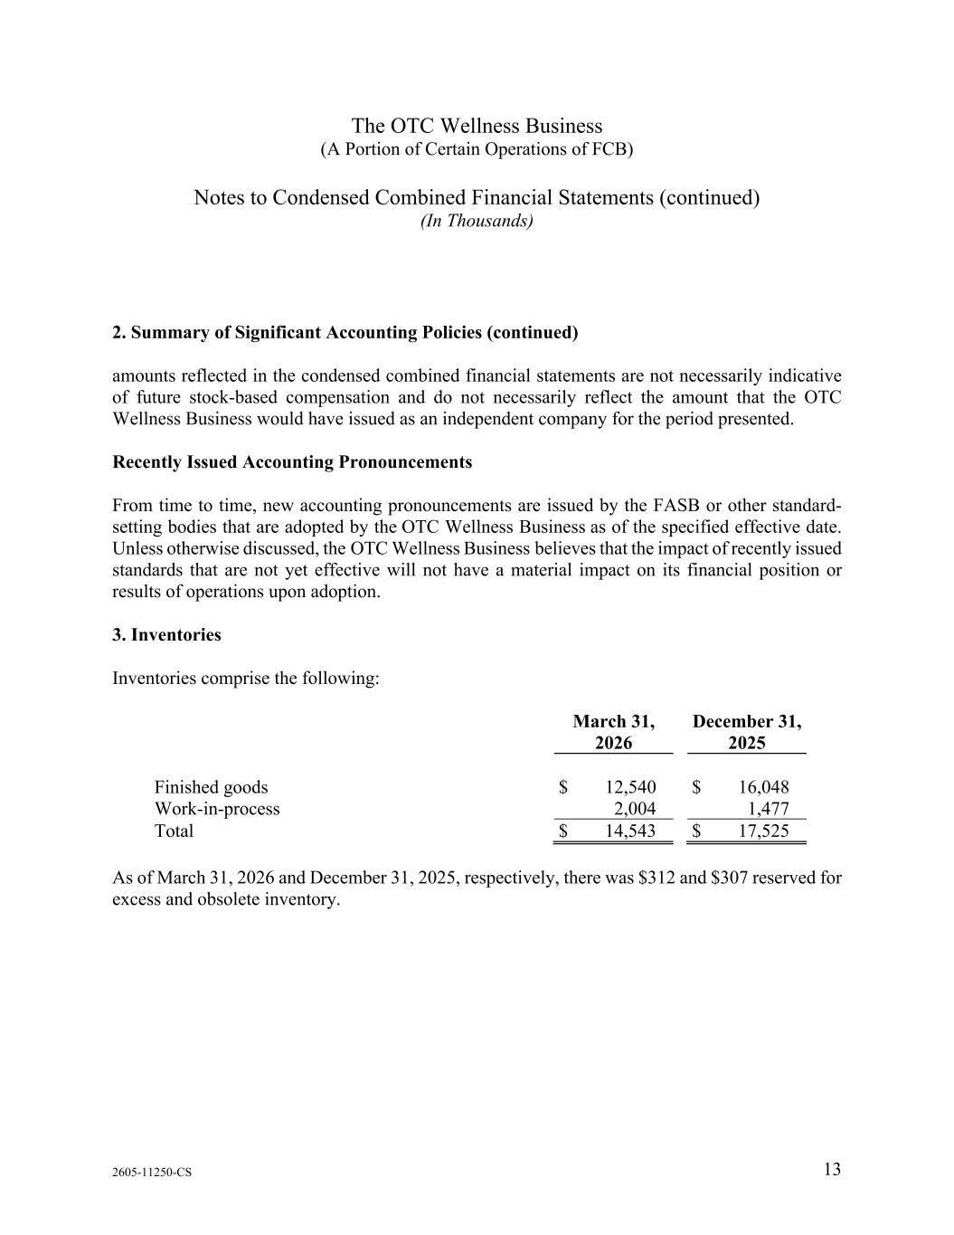
The OTC Wellness Business (A Portion of Certain Operations of FCB) Notes to Condensed Combined Financial Statements (continued) (In Thousands) 2605-11250-CS 13 2. Summary of Significant Accounting Policies (continued) amounts reflected in the condensed combined financial statements are not necessarily indicative of future stock-based compensation and do not necessarily reflect the amount that the OTC Wellness Business would have issued as an independent company for the period presented. Recently Issued Accounting Pronouncements From time to time, new accounting pronouncements are issued by the FASB or other standard- setting bodies that are adopted by the OTC Wellness Business as of the specified effective date. Unless otherwise discussed, the OTC Wellness Business believes that the impact of recently issued standards that are not yet effective will not have a material impact on its financial position or results of operations upon adoption. 3. Inventories Inventories comprise the following: March 31, 2026 December 31, 2025 Finished goods $ 12,540 $ 16,048 Work-in-process 2,004 1,477 Total $ 14,543 $ 17,525 As of March 31, 2026 and December 31, 2025, respectively, there was $312 and $307 reserved for excess and obsolete inventory.

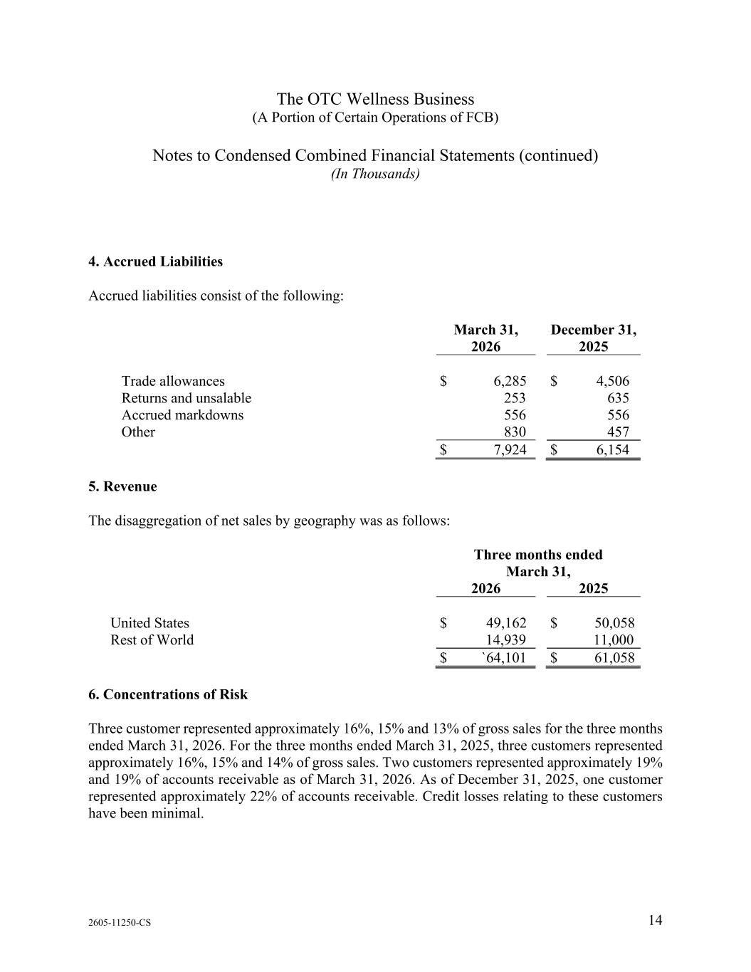
The OTC Wellness Business (A Portion of Certain Operations of FCB) Notes to Condensed Combined Financial Statements (continued) (In Thousands) 2605-11250-CS 14 4. Accrued Liabilities Accrued liabilities consist of the following: March 31, 2026 December 31, 2025 Trade allowances $ 6,285 $ 4,506 Returns and unsalable 253 635 Accrued markdowns 556 556 Other 830 457 $ 7,924 $ 6,154 5. Revenue The disaggregation of net sales by geography was as follows: Three months ended March 31, 2026 2025 United States $ 49,162 $ 50,058 Rest of World 14,939 11,000 $ `64,101 $ 61,058 6. Concentrations of Risk Three customer represented approximately 16%, 15% and 13% of gross sales for the three months ended March 31, 2026. For the three months ended March 31, 2025, three customers represented approximately 16%, 15% and 14% of gross sales. Two customers represented approximately 19% and 19% of accounts receivable as of March 31, 2026. As of December 31, 2025, one customer represented approximately 22% of accounts receivable. Credit losses relating to these customers have been minimal.

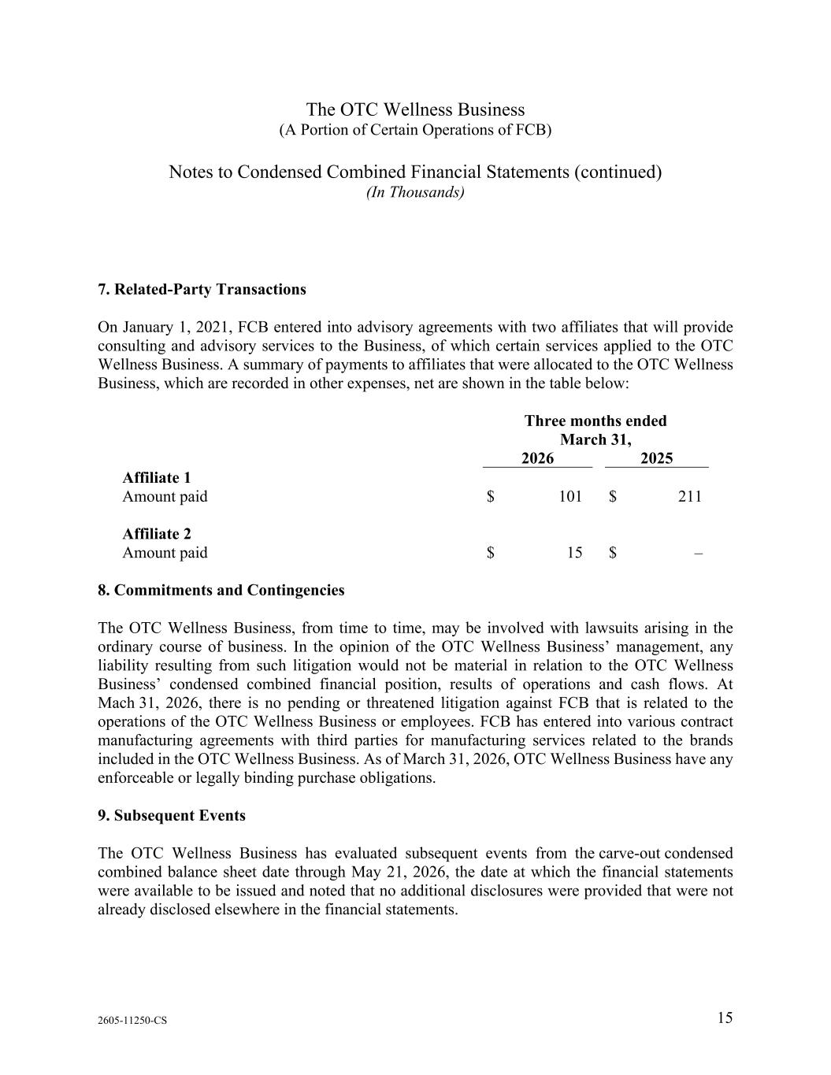
The OTC Wellness Business (A Portion of Certain Operations of FCB) Notes to Condensed Combined Financial Statements (continued) (In Thousands) 2605-11250-CS 15 7. Related-Party Transactions On January 1, 2021, FCB entered into advisory agreements with two affiliates that will provide consulting and advisory services to the Business, of which certain services applied to the OTC Wellness Business. A summary of payments to affiliates that were allocated to the OTC Wellness Business, which are recorded in other expenses, net are shown in the table below: Three months ended March 31, 2026 2025 Affiliate 1 Amount paid $ 101 $ 211 Affiliate 2 Amount paid $ 15 $ – 8. Commitments and Contingencies The OTC Wellness Business, from time to time, may be involved with lawsuits arising in the ordinary course of business. In the opinion of the OTC Wellness Business’ management, any liability resulting from such litigation would not be material in relation to the OTC Wellness Business’ condensed combined financial position, results of operations and cash flows. At Mach 31, 2026, there is no pending or threatened litigation against FCB that is related to the operations of the OTC Wellness Business or employees. FCB has entered into various contract manufacturing agreements with third parties for manufacturing services related to the brands included in the OTC Wellness Business. As of March 31, 2026, OTC Wellness Business have any enforceable or legally binding purchase obligations. 9. Subsequent Events The OTC Wellness Business has evaluated subsequent events from the carve-out condensed combined balance sheet date through May 21, 2026, the date at which the financial statements were available to be issued and noted that no additional disclosures were provided that were not already disclosed elsewhere in the financial statements.

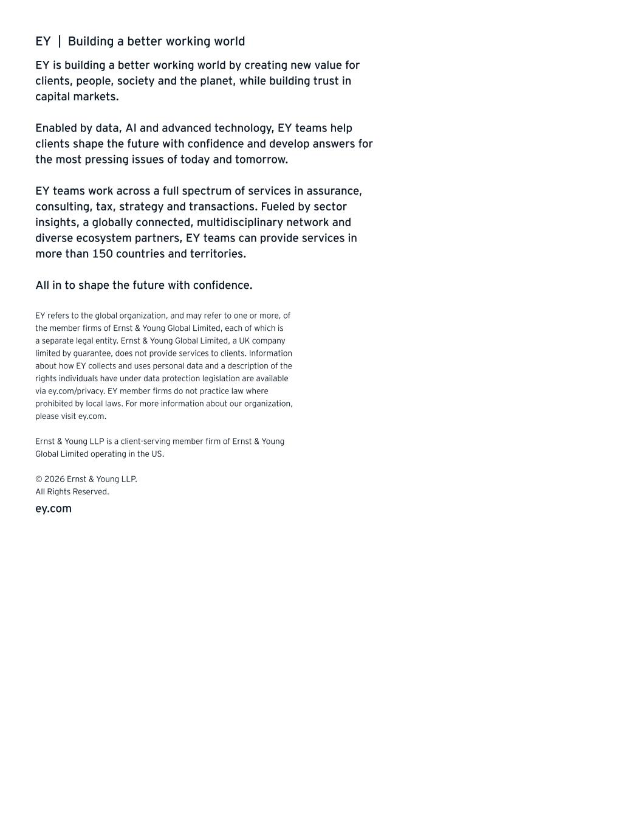
EY | Building a better working world EY is building a better working world by creating new value for clients, people, society and the planet, while building trust in capital markets. Enabled by data, AI and advanced technology, EY teams help clients shape the future with confidence and develop answers for the most pressing issues of today and tomorrow. EY teams work across a full spectrum of services in assurance, consulting, tax, strategy and transactions. Fueled by sector insights, a globally connected, multidisciplinary network and diverse ecosystem partners, EY teams can provide services in more than 150 countries and territories. All in to shape the future with confidence. EY refers to the global organization, and may refer to one or more, of the member firms of Ernst & Young Global Limited, each of which is a separate legal entity. Ernst & Young Global Limited, a UK company limited by guarantee, does not provide services to clients. Information about how EY collects and uses personal data and a description of the rights individuals have under data protection legislation are available via ey.com/privacy. EY member firms do not practice law where prohibited by local laws. For more information about our organization, please visit ey.com. Ernst & Young LLP is a client-serving member firm of Ernst & Young Global Limited operating in the US. © 2026 Ernst & Young LLP. All Rights Reserved. ey.com

Exhibit 99.3

Prestige Consumer Healthcare Inc.
Unaudited Pro-Forma Condensed Combined Financial Information

Introduction
On June 12, 2026 (the “Closing Date”), Prestige Brands, Inc. and Medtech Products Inc., both wholly-owned subsidiaries of Prestige Consumer Healthcare Inc. (referred to herein as "Prestige", the "Company" or "we", which reference shall, unless the context requires otherwise, be deemed to refer to Prestige Consumer Healthcare Inc. and all of its direct and indirect 100% owned subsidiaries on a consolidated basis) completed the previously announced acquisition of Breathe Right® and certain other brands (the “OTC Wellness Business"), from Foundation Consumer Brands, LLC and certain of its affiliates, pursuant to an Asset Purchase Agreement, dated as of March 19, 2026 (the “Breathe Right Purchase Agreement”), for a purchase price of $1,045.0 million in cash (the “Breathe Right Acquisition”). The Breathe Right Acquisition was accounted for using the acquisition method of accounting for business combinations under the provisions of Financial Accounting Standards Board (“FASB”) Accounting Standard Codification (“ASC”) Topic 805, Business Combinations (“ASC 805”). Pursuant to the Breathe Right Purchase Agreement, the Company acquired certain assets primarily related to a portfolio of over-the-counter consumer health products.

In connection with this acquisition, on the Closing Date, the Company entered into a Term Loan Credit Agreement with a seven-year maturity. Proceeds of the term loans borrowed under the Term Loan Credit Agreement in the amount of $1,045.0 million were used to, along with cash on hand, finance the Breathe Right Acquisition and fees and expenses incurred in connection with the closing of the Term Loan Credit Agreement and the Breathe Right Acquisition. The Term Loan Credit Agreement also permits, subject to the satisfaction of certain conditions as more specifically set forth in the Term Loan Credit Agreement, a second draw (on an uncommitted basis) of term loans in an amount not to exceed $95.0 million that may be used by the Company to finance, in part, the previously announced acquisition of LaCorium Health (the “LaCorium Health Acquisition”), which is expected to close in the second quarter of fiscal 2027, together with fees and expenses incurred in connection with the LaCorium Health Acquisition. The Term Loan Credit Agreement also allows the Company to borrow additional funds under the Term Loan Credit Agreement on an uncommitted basis, subject to certain limitations and conditions set forth in the Term Loan Credit Agreement.

Term loans borrowed under the Term Loan Credit Agreement bear interest, at the option of Prestige Brands, Inc. (the “Borrower”), at a rate per annum equal to (i) Term SOFR plus 2.00% or (ii) an alternate base rate based on the highest of Citibank, N.A.’s prime rate, the overnight Federal Funds Rate plus 0.50% and Term SOFR plus 1.00%. Each of Term SOFR and the alternate base rate are subject to a floor of 0% and 1.00%, respectively.

The Term Loan Credit Agreement requires the Borrower to make quarterly amortization payments equal to 0.25% of the aggregate principal amount of the term loans made on the Closing Date, plus the aggregate principal amount of any additional term loans advanced to fund the LaCorium Health Acquisition. The Borrower is permitted to prepay all or a portion of the term loans under the Term Loan Credit Agreement at any time, subject to a 1.0% premium if the Borrower effects a certain repricing transactions (where the primary purpose thereof is to lower the all-in yield of the Term Loan Credit Agreement) prior to December 12, 2026. Borrowings under the Term Loan Credit Agreement are subject to mandatory prepayments with the net cash proceeds of certain issuances of debt, certain asset sales and other dispositions and certain casualty events, and, starting with the fiscal year ending March 31, 2028, with a portion of excess cash flow if the Company’s consolidated first lien net leverage ratio is greater than 2.75 to 1.00.

Also, on the Closing Date, the Company and the Borrower entered into Amendment No. 10 (“ABL Amendment No. 10”) to the credit agreement governing the Company’s asset-based revolving line of credit (as amended, the “ABL Credit Agreement”) originally entered into on January 31, 2012, by and among the Company, the Borrower, certain subsidiaries party thereto as guarantors, the lenders party thereto and Citibank, N.A., as the administrative agent. Among other modifications, ABL Amendment No. 10 (i) increased the aggregate commitments under the ABL Credit Agreement to $225 million and (ii) extended the maturity date of the ABL Credit Agreement to June 12, 2031, subject to a springing maturity if any other debt in an amount equal to or greater than $125 million that has a scheduled repayment before the line of credit under the ABL Credit Agreement has not been repaid within 91 days of such scheduled repayment. For purposes of the unaudited pro forma condensed combined financial information, management preliminarily determined that ABL Amendment No. 10 qualifies to be accounted for as a debt modification. The evaluation and finalization of such accounting conclusions are ongoing and subject to change, which could result in an impact to the Company’s results of operations in the future. Proceeds of borrowings under the ABL Credit Agreement may be used for the LaCorium Health Acquisition if, after giving effect to such borrowing, excess availability under the ABL Credit Agreement is no less than the greater of (A) $30,625,000 and (B) 17.5% of the lesser of (i) aggregate commitments under the ABL Credit Agreement and (ii) the borrowing base under the ABL Credit Agreement.

Basis of Pro Forma Presentation
The unaudited pro forma condensed combined statement of income for the fiscal year ended March 31, 2026 has been prepared to illustrate the effects of the Breathe Right Acquisition and related financings (collectively, the "Transactions"), as if they had occurred on April 1, 2025. The unaudited pro forma condensed combined balance sheet has been prepared to illustrate the effects of the Transactions as if they had occurred on March 31, 2026. The pro forma data has been derived from the audited financial statements of the Company for the fiscal year ended March 31, 2026, the audited combined financial statements of the OTC Wellness Business for the fiscal year ended December 31, 2025 (excluding the unaudited three month period ended March 31, 2025 for which total revenues were $50.5 million and net income was $14.8 million) and the unaudited condensed combined financial statements of the OTC Wellness Business for the three months ended March 31, 2026 (included elsewhere in this Current Report on Form 8-K/A).

The pro forma adjustments contained in the unaudited pro forma condensed combined financial information are based on the latest available information and adjustments that management believes are reasonable. These unaudited pro forma adjustments include a preliminary allocation of the purchase price of OTC Wellness Business to the assets acquired and liabilities assumed based on a preliminary valuation analysis; however, the final valuation may differ from this preliminary valuation. The actual results reported by the combined company in periods following the Transactions may differ materially from that reflected in this unaudited pro forma condensed combined financial information.

The unaudited pro forma condensed combined financial information presented herein is based on the assumptions and adjustments described in the accompanying notes. The pro forma adjustments have been prepared in accordance with Article 11 of Regulation S-X and include Transaction Accounting Adjustments that reflect the application of U.S. GAAP to the Transactions. The unaudited pro forma condensed combined financial information does not reflect any anticipated synergies or dis-synergies, operating efficiencies, or cost savings that may result from the integration costs that may be incurred. The unaudited pro forma condensed combined financial information is presented for illustrative purposes only and does not purport to represent what the financial position or results of operations would actually have been if the Transactions had occurred as of the dates indicated, nor does it purport to project the financial position or results of operations for any future periods.

The unaudited pro forma condensed combined financial information, including the notes thereto, should be read in conjunction with the historical consolidated financial statements and accompanying notes contained in the Company's Annual Report on Form 10-K for the year ended March 31, 2026, filed with the SEC on May 14, 2026, and the historical audited combined financial statements of the OTC Wellness Business for the year ended December 31, 2025 and unaudited interim condensed combined financial statements for the period ended March 31, 2026 (included elsewhere in this Current Report on Form 8-K/A).

The pro forma adjustments represent management’s estimates based on information available as of the date of this Current Report on Form 8-K/A and are subject to change as additional information becomes available and additional analyses are performed.

Prestige Consumer Healthcare Inc.
Unaudited Pro Forma Condensed Combined Statement of Income
For the Year Ended March 31, 2026

(In thousands, except per share data) |  |  |  |  |  | Prestige Consumer Healthcare Inc. |  |  |  |  |  | Historical OTC Wellness Business (1) |  |  |  |  |  | Pro Forma Adjustments |  |  |  |  |  |  |  | Pro Forma Combined
Revenues
Net sales |  |  |  |  |  | $ | 1,084,744 |  |  |  |  | $ | 196,055 |  |  |  |  | $ | — |  |  |  |  |  |  | $ | 1,280,799
Other revenues |  |  |  |  |  | 3,961 |  |  |  |  |  | — |  |  |  |  |  | — |  |  |  |  |  |  |  | 3,961
Total Revenues |  |  |  |  |  | 1,088,705 |  |  |  |  |  | 196,055 |  |  |  |  |  | — |  |  |  |  |  |  |  | 1,284,760
Cost of Sales
Cost of sales excluding depreciation |  |  |  |  |  | 482,794 |  |  |  |  |  | 54,157 |  |  |  |  |  | 13,408 |  |  |  |  | (4a) |  |  | 550,359
Cost of sales depreciation |  |  |  |  |  | 10,333 |  |  |  |  |  | — |  |  |  |  |  | — |  |  |  |  |  |  |  | 10,333
Cost of sales |  |  |  |  |  | 493,127 |  |  |  |  |  | 54,157 |  |  |  |  |  | 13,408 |  |  |  |  |  |  |  | 560,692
Gross profit |  |  |  |  |  | 595,578 |  |  |  |  |  | 141,898 |  |  |  |  |  | (13,408) |  |  |  |  |  |  |  | 724,068
Operating Expenses
Advertising and marketing |  |  |  |  |  | 148,782 |  |  |  |  |  | 43,600 |  |  |  |  |  | — |  |  |  |  |  |  |  | 192,382
General and administrative |  |  |  |  |  | 116,447 |  |  |  |  |  | 10,249 |  |  |  |  |  | 11,000 |  |  |  |  | (4b) |  |  | 137,696
Depreciation and amortization |  |  |  |  |  | 20,940 |  |  |  |  |  | 29,466 |  |  |  |  |  | (15,684) |  |  |  |  | (4c) |  |  | 34,722
Other expenses |  |  |  |  |  | — |  |  |  |  |  | 420 |  |  |  |  |  | — |  |  |  |  |  |  |  | 420
Total operating expenses |  |  |  |  |  | 286,169 |  |  |  |  |  | 83,735 |  |  |  |  |  | (4,684) |  |  |  |  |  |  |  | 365,220
Operating income |  |  |  |  |  | 309,409 |  |  |  |  |  | 58,163 |  |  |  |  |  | (8,724) |  |  |  |  |  |  |  | 358,848
Other expense (income)
Interest expense, net |  |  |  |  |  | 42,339 |  |  |  |  |  | — |  |  |  |  |  | 62,164 |  |  |  |  | (4d) |  |  | 104,503
Other expense (income) |  |  |  |  |  | 9,574 |  |  |  |  |  | — |  |  |  |  |  | — |  |  |  |  |  |  |  | 9,574
Total other expense |  |  |  |  |  | 51,913 |  |  |  |  |  | — |  |  |  |  |  | 62,164 |  |  |  |  |  |  |  | 114,077
Income before income taxes |  |  |  |  |  | 257,496 |  |  |  |  |  | 58,163 |  |  |  |  |  | (70,888) |  |  |  |  |  |  |  | 244,771
Provision for income taxes |  |  |  |  |  | 67,195 |  |  |  |  |  | — |  |  |  |  |  | (3,054) |  |  |  |  | (4e) |  |  | 64,141
Net income |  |  |  |  |  | $ | 190,301 |  |  |  |  | $ | 58,163 |  |  |  |  | $ | (67,834) |  |  |  |  |  |  | $ | 180,630
Earnings per share:
Basic |  |  |  |  |  | $ | 3.93 |  |  |  |  |  |  |  |  |  |  |  |  |  |  |  |  |  |  | $ | 3.73 |  | (4f)
Diluted |  |  |  |  |  | $ | 3.91 |  |  |  |  |  |  |  |  |  |  |  |  |  |  |  |  |  |  | $ | 3.71 |  | (4f)
Weighted average shares outstanding:
Basic |  |  |  |  |  | 48,456 |  |  |  |  |  |  |  |  |  |  |  |  |  |  |  |  |  |  |  | 48,456
Diluted |  |  |  |  |  | 48,720 |  |  |  |  |  |  |  |  |  |  |  |  |  |  |  |  |  |  |  | 48,720

Prestige Consumer Healthcare Inc.
Unaudited Pro Forma Condensed Combined Balance Sheet
As of March 31, 2026
(In thousands) |  |  | Prestige Consumer Healthcare Inc. |  |  |  |  |  | Historical OTC Wellness Business (1) |  |  |  |  |  | Assets and Liabilities Not Acquired (1) |  |  |  |  |  | Acquired OTC Wellness Business (1) |  |  |  |  |  | Pro Forma Adjustments |  |  |  |  |  |  |  |  |  |  |  |  |  | Pro Forma Combined
Assets
Current assets
Cash and cash equivalents |  |  | $ | 63,868 |  |  |  |  | $ | — |  |  |  |  | $ | — |  |  |  |  | $ | — |  |  |  |  | $ | (22,209) |  |  |  |  |  |  | (3a) |  |  |  |  |  | $ | 41,659
Accounts receivable, net |  |  | 191,920 |  |  |  |  |  | 46,834 |  |  |  |  |  | (46,834) |  |  |  |  |  | — |  |  |  |  |  | — |  |  |  |  |  |  |  |  |  |  |  |  |  | 191,920
Inventories |  |  | 159,132 |  |  |  |  |  | 14,543 |  |  |  |  |  | — |  |  |  |  |  | 14,543 |  |  |  |  |  | 13,408 |  |  |  |  |  |  |  | (3b) |  |  |  |  |  | 187,083
Prepaid expenses and other current assets |  |  | 16,564 |  |  |  |  |  | 1,083 |  |  |  |  |  | (1,083) |  |  |  |  |  | — |  |  |  |  |  | — |  |  |  |  |  |  |  |  |  |  |  |  |  | 16,564
Total current assets |  |  | 431,484 |  |  |  |  |  | 62,460 |  |  |  |  |  | (47,917) |  |  |  |  |  | 14,543 |  |  |  |  |  | (8,801) |  |  |  |  |  |  |  |  |  |  |  |  |  | 437,226
Property, plant and equipment, net |  |  | 121,689 |  |  |  |  |  | — |  |  |  |  |  | — |  |  |  |  |  | — |  |  |  |  |  | — |  |  |  |  |  |  |  |  |  |  |  |  |  | 121,689
Operating lease right-of-use assets |  |  | 27,780 |  |  |  |  |  | — |  |  |  |  |  | — |  |  |  |  |  | — |  |  |  |  |  | — |  |  |  |  |  |  |  |  |  |  |  |  |  | 27,780
Finance lease right-of-use assets, net |  |  | 21,776 |  |  |  |  |  | — |  |  |  |  |  | — |  |  |  |  |  | — |  |  |  |  |  | — |  |  |  |  |  |  |  |  |  |  |  |  |  | 21,776
Goodwill |  |  | 581,109 |  |  |  |  |  | 151,503 |  |  |  |  |  | (151,503) |  |  |  |  |  | — |  |  |  |  |  | 82,555 |  |  |  |  |  |  |  | (3c) |  |  |  |  |  | 663,664
Intangible assets, net |  |  | 2,299,605 |  |  |  |  |  | 328,281 |  |  |  |  |  | (328,281) |  |  |  |  |  | — |  |  |  |  |  | 947,650 |  |  |  |  |  |  |  | (3d) |  |  |  |  |  | 3,247,255
Other long-term assets |  |  | 10,870 |  |  |  |  |  |  |  |  |  |  |  | — |  |  |  |  |  | — |  |  |  |  |  | — |  |  |  |  |  |  |  |  |  |  |  |  |  | 10,870
Total Assets |  |  | $ | 3,494,313 |  |  |  |  | $ | 542,244 |  |  |  |  | $ | (527,701) |  |  |  |  | $ | 14,543 |  |  |  |  | $ | 1,021,404 |  |  |  |  |  |  |  |  |  |  |  |  | $ | 4,530,260
Liabilities and Stockholders' Equity
Current liabilities
Accounts payable |  |  | $ | 22,791 |  |  |  |  | $ | 8,119 |  |  |  |  | $ | (8,119) |  |  |  |  | $ | — |  |  |  |  | $ | — |  |  |  |  |  |  |  |  |  |  |  |  | $ | 22,791
Current portion of long-term debt |  |  | — |  |  |  |  |  | — |  |  |  |  |  | — |  |  |  |  |  | — |  |  |  |  |  | 10,450 |  |  |  |  |  |  |  | (3e) |  |  |  |  |  | 10,450
Accrued interest payable |  |  | 15,578 |  |  |  |  |  | — |  |  |  |  |  | — |  |  |  |  |  | — |  |  |  |  |  | — |  |  |  |  |  |  |  |  |  |  |  |  |  | 15,578
Operating lease liabilities, current portion |  |  | 6,910 |  |  |  |  |  | — |  |  |  |  |  | — |  |  |  |  |  | — |  |  |  |  |  | — |  |  |  |  |  |  |  |  |  |  |  |  |  | 6,910
Finance lease liabilities, current portion |  |  | 2,656 |  |  |  |  |  | — |  |  |  |  |  | — |  |  |  |  |  | — |  |  |  |  |  | — |  |  |  |  |  |  |  |  |  |  |  |  |  | 2,656
Other accrued liabilities |  |  | 72,989 |  |  |  |  |  | 7,924 |  |  |  |  |  | (7,924) |  |  |  |  |  | — |  |  |  |  |  | 11,000 |  |  |  |  |  |  |  | (3f) |  |  |  |  |  | 83,989
Total current liabilities |  |  | 120,924 |  |  |  |  |  | 16,043 |  |  |  |  |  | (16,043) |  |  |  |  |  | — |  |  |  |  |  | 21,450 |  |  |  |  |  |  |  |  |  |  |  |  |  | 142,374
Long-term debt, net |  |  | 993,953 |  |  |  |  |  | — |  |  |  |  |  | — |  |  |  |  |  | — |  |  |  |  |  | 1,012,341 |  |  |  |  |  |  |  | (3e) |  |  |  |  |  | 2,006,294
 |  |  |  |  |  |  |  |  |  |  |  |  |  |  |  |  |  |  |  |  | —
Deferred income tax liabilities |  |  | 447,417 |  |  |  |  |  | — |  |  |  |  |  | — |  |  |  |  |  | — |  |  |  |  |  | 13,156 |  |  |  |  |  |  |  | (3g) |  |  |  |  |  | 460,573
Long-term operating lease liabilities, net of current portion |  |  | 20,955 |  |  |  |  |  | — |  |  |  |  |  | — |  |  |  |  |  | — |  |  |  |  |  | — |  |  |  |  |  |  |  |  |  |  |  |  |  | 20,955
Long-term finance lease liabilities, net of current portion |  |  | 17,968 |  |  |  |  |  | — |  |  |  |  |  | — |  |  |  |  |  | — |  |  |  |  |  | — |  |  |  |  |  |  |  |  |  |  |  |  |  | 17,968
Other long-term liabilities |  |  | 5,580 |  |  |  |  |  | — |  |  |  |  |  | — |  |  |  |  |  | — |  |  |  |  |  | — |  |  |  |  |  |  |  |  |  |  |  |  |  | 5,580
Total Liabilities |  |  | 1,606,797 |  |  |  |  |  | 16,043 |  |  |  |  |  | (16,043) |  |  |  |  |  | — |  |  |  |  |  | 1,046,947 |  |  |  |  |  |  |  |  |  |  |  |  |  | 2,653,744
Stockholders' Equity
Preferred stock - $0.01 par value
Authorized - 5,000 shares
Issued and outstanding - None |  |  | — |  |  |  |  |  | — |  |  |  |  |  | — |  |  |  |  |  | — |  |  |  |  |  | — |  |  |  |  |  |  |  |  |  |  |  |  |  | —
Common stock - $0.01 par value
Authorized - 250,000 shares
Issued |  |  | 562 |  |  |  |  |  | — |  |  |  |  |  | — |  |  |  |  |  | — |  |  |  |  |  | — |  |  |  |  |  |  |  |  |  |  |  |  |  | 562
Additional paid-in capital |  |  | 608,520 |  |  |  |  |  | 526,201 |  |  |  |  |  | (511,658) |  |  |  |  |  | 14,543 |  |  |  |  |  | (14,543) |  |  |  |  |  |  |  | (3h) |  |  |  |  |  | 608,520
Treasury stock, at cost |  |  | (439,301) |  |  |  |  |  | — |  |  |  |  |  | — |  |  |  |  |  | — |  |  |  |  |  | — |  |  |  |  |  |  |  |  |  |  |  |  |  | (439,301)
Accumulated other comprehensive loss, net of tax |  |  | (28,368) |  |  |  |  |  | — |  |  |  |  |  | — |  |  |  |  |  | — |  |  |  |  |  | — |  |  |  |  |  |  |  |  |  |  |  |  |  | (28,368)
Retained earnings |  |  | 1,746,103 |  |  |  |  |  | — |  |  |  |  |  | — |  |  |  |  |  | — |  |  |  |  |  | (11,000) |  |  |  |  |  |  |  | (3f) |  |  |  |  |  | 1,735,103
Total Stockholders' Equity |  |  | 1,887,516 |  |  |  |  |  | 526,201 |  |  |  |  |  | (511,658) |  |  |  |  |  | 14,543 |  |  |  |  |  | (25,543) |  |  |  |  |  |  |  |  |  |  |  |  |  | 1,876,516
Total Liabilities and Stockholders' Equity |  |  | $ | 3,494,313 |  |  |  |  | $ | 542,244 |  |  |  |  | $ | (527,701) |  |  |  |  | $ | 14,543 |  |  |  |  | $ | 1,021,404 |  |  |  |  |  |  |  |  |  |  |  |  | $ | 4,530,260

Prestige Consumer Healthcare Inc,
Notes to Pro Forma Condensed Combined Financial Statements

1. OTC Wellness Business Historical Financial Statements

During the preparation of the unaudited pro forma condensed combined financial statements, the Company did its initial evaluation of the accounting policies of the OTC Wellness Business and discussed below certain reclassifications it deemed material and necessary to conform to the Company’s presentation. Additionally, the Company does not expect that conforming any differences in revenue recognition policies would have a material impact on the timing or amount of revenue presented in the pro forma financial statements.

The financial statement line items presented in the table below reflect the historical presentation used in the OTC Wellness Business financial statements and, in certain cases, differ from the line item captions used in the unaudited pro forma condensed combined statement of income. For example, the table below presents “Cost of Sales,” “Selling, general and administrative,” “Amortization expense” and “Income from operations,” whereas the unaudited pro forma condensed combined statement of income presents the corresponding amounts within “Cost of sales excluding depreciation,” “General and administrative,” “Depreciation and amortization” and “Operating income,” respectively. In addition, the table below presents only “Net Sales,” whereas the historical financial statements of the OTC Wellness Business included elsewhere in this Current Report on Form 8-K/A present gross sales less sales allowances, returns and discounts, which together reconcile to net sales.

 |  |  |  |  |  |  |  |  |  |  |  |  |  |  |  |  |  |  |  |  | Twelve Months Ended March 31, 2026
 |  |  | Three Months Ended March 31, 2025 (A) |  |  |  |  |  | Year Ended December 31, 2025 (B) |  |  |  |  |  | Three Months Ended March 31, 2026 (C) |  |  |  |  |  | The OTC Wellness Business Before Reclassifications (B)+(C)-(A) |  |  |  |  |  | Reclassifications |  |  |  |  |  | The OTC Wellness Business After Reclassifications
(In thousands)
Net Sales |  |  | 50,463 |  |  |  |  |  | 194,862 |  |  |  |  |  | 51,656 |  |  |  |  |  | 196,055 |  |  |  |  |  | — |  |  |  |  |  | 196,055
Cost of Sales |  |  | 13,131 |  |  |  |  |  | 50,251 |  |  |  |  |  | 13,659 |  |  |  |  |  | 50,779 |  |  |  |  |  | 3,378 |  |  | (a) |  |  | 54,157
Gross profit |  |  | 37,332 |  |  |  |  |  | 144,611 |  |  |  |  |  | 37,997 |  |  |  |  |  | 145,276 |  |  |  |  |  | (3,378) |  |  |  |  |  | 141,898
Operating expenses:
Advertising and marketing |  |  | 10,153 |  |  |  |  |  | 35,931 |  |  |  |  |  | 12,649 |  |  |  |  |  | 38,427 |  |  |  |  |  | 5,173 |  |  | (b) |  |  | 43,600
Selling, general and administrative |  |  | 4,836 |  |  |  |  |  | 18,499 |  |  |  |  |  | 5,137 |  |  |  |  |  | 18,800 |  |  |  |  |  | (8,551) |  |  | (c) |  |  | 10,249
Other expenses |  |  | 215 |  |  |  |  |  | 431 |  |  |  |  |  | 204 |  |  |  |  |  | 420 |  |  |  |  |  | — |  |  |  |  |  | 420
Amortization expense |  |  | 7,367 |  |  |  |  |  | 29,466 |  |  |  |  |  | 7,367 |  |  |  |  |  | 29,466 |  |  |  |  |  | — |  |  |  |  |  | 29,466
Total Operating Expenses |  |  | 22,571 |  |  |  |  |  | 84,327 |  |  |  |  |  | 25,357 |  |  |  |  |  | 87,113 |  |  |  |  |  | (3,378) |  |  |  |  |  | 83,735
Income from operations |  |  | 14,761 |  |  |  |  |  | 60,284 |  |  |  |  |  | 12,640 |  |  |  |  |  | 58,163 |  |  |  |  |  | — |  |  |  |  |  | 58,163
Provision for income taxes |  |  | — |  |  |  |  |  | — |  |  |  |  |  | — |  |  |  |  |  | — |  |  |  |  |  | — |  |  |  |  |  | —
Net Income |  |  | $ | 14,761 |  |  |  |  | $ | 60,284 |  |  |  |  | $ | 12,640 |  |  |  |  | $ | 58,163 |  |  |  |  | $ | — |  |  |  |  | $ | 58,163
(a) Represents the reclassification of freight expenses and sales tracking fees previously classified as selling, general and administrative expense to cost of sales due to difference in accounting policies.
(b) Represents the reclassification of broker commissions and call center costs previously classified as selling, general and administrative expense to advertising and promotions due to differences in accounting policies.
(c) See above.

The Company has a different fiscal year end, March 31, from the OTC Wellness Business, December 31. The OTC Wellness Business historical results were aligned to the Company’s fiscal reporting periods so the unaudited condensed combined pro forma financial statements present the combined results on a consistent basis.

Assets and Liabilities not Acquired

Pursuant to the terms of the Breathe Right Purchase Agreement, the Company acquired certain inventory of the OTC Wellness Business. No other tangible assets were acquired and no liabilities were assumed by the Company in connection with the Breathe Right Acquisition. Accordingly, the unaudited pro forma condensed combined balance sheet reflects the acquisition of inventory, intangible assets and goodwill and does not include any pro forma adjustments to recognize additional acquired assets or assumed liabilities.

2. Preliminary Purchase Price Allocation

On June 12, 2026, Prestige completed the purchase of the OTC Wellness Business for a purchase price of $1,045.0 million. In connection with this acquisition, Prestige entered into the Term Loan Credit Agreement in the amount of $1,045.0 million, the proceeds of which were used to finance, together with cash on hand, the Breathe Right Acquisition and fees and expenses incurred in connection with the closing of the Transactions. Under the acquisition method of accounting, the total estimated cost of the Breathe Right Acquisition is allocated to the OTC Wellness Business, net of tangible and intangible assets based on their estimated fair values as of the date of completion of the acquisition. For the purposes of the unaudited condensed combined pro forma financial information, these preliminary fair values have been estimated as of March 31, 2026. Such allocation may change based on the final analysis of such fair values, and to reflect the actual date of acquisition. Based on the preliminary estimated fair values at March 31, 2026, the preliminary purchase price allocation is as follows:

(In thousands) |  |  |  |  |  | Amount
Allocation of purchase price
Inventories |  |  |  |  |  | $ | 27,951
Goodwill |  |  |  |  |  | 82,555
Intangible assets |  |  |  |  |  | 947,650
Deferred income tax liabilities |  |  |  |  |  | (13,156)
Net Assets Acquired |  |  |  |  |  | $ | 1,045,000

3. Adjustments to the unaudited Pro Forma Condensed Combined Balance Sheet as of March 31, 2026

(3a) Represents the net cash paid by Prestige from cash on hand to acquire the OTC Wellness Business:
(In thousands) |  |  |  |  |  | Amount
Borrowings under the Term Loan Credit Agreement |  |  |  |  |  | $ | 1,045,000
Payments made at Closing Date related to purchase of the OTC Wellness Business |  |  |  |  |  | (1,045,000)
Less original issue discount |  |  |  |  |  | (2,613)
Less debt issuance costs |  |  |  |  |  | (19,596)
Net decrease in cash for items paid at Closing Date |  |  |  |  |  | $ | (22,209)

(3b) Represents the estimated step-up to fair value over historic value:

(In thousands) |  |  |  |  |  | Amount
Work in progress |  |  |  |  |  | $ | 2,003
Finished goods |  |  |  |  |  | 12,540
Inventory acquired with OTC Wellness Business |  |  |  |  |  | 14,543
Net adjustment to inventory for step-up to fair value |  |  |  |  |  | 13,408
Total inventory acquired |  |  |  |  |  | $ | 27,951

The fair value was determined based on the estimated selling price of the inventory, less the remaining manufacturing and selling costs and a normal profit margin on those manufacturing and selling efforts.

(3c) Represents the adjustment to record goodwill resulting from the Breathe Right Acquisition:

(In thousands) |  |  |  |  |  | Amount
Purchase price of acquisition |  |  |  |  |  | $ | 1,045,000
Net assets acquired |  |  |  |  |  | 962,445
Net adjustment to goodwill |  |  |  |  |  | $ | 82,555

Our preliminary allocation of the purchase price to the net tangible and identifiable intangible assets is based on their estimated acquisition-date fair values. The excess of purchase price over the estimated fair values of the net tangible and identifiable intangible assets acquired has been recorded as goodwill.

(3d) Represents the adjustment to reflect the preliminary acquisition accounting to recognize the identifiable intangible assets acquired in the Breathe Right Acquisition at their estimated fair values. The preliminary fair values were determined based on information currently available and are subject to change as the Company finalizes its valuation analyses. The final fair values, useful lives and resulting amortization expense may differ materially from the amounts reflected in the unaudited pro forma condensed combined financial information.

(In thousands) |  |  |  |  |  | Amount
Intangible assets
Tradenames |  |  |  |  |  | $ | 183,600
Customer relationships |  |  |  |  |  | 73,150
Finite-lived intangible assets |  |  |  |  |  | 256,750
Indefinite-lived tradename intangible assets |  |  |  |  |  | 690,900
Net adjustment to intangible assets |  |  |  |  |  | $ | 947,650

(3e) Represents adjustments to record the Term Loan Credit Agreement and the related debt financing costs

(In thousands) |  |  |  |  |  | Amount
Long-term debt
Term Loan Credit Agreement |  |  |  |  |  | $ | 1,045,000
Less original issue discount |  |  |  |  |  | (2,613)
Less debt issuance costs |  |  |  |  |  | (19,596)
Total adjustment to record the Term Loan Credit Agreement and debt financing costs |  |  |  |  |  | 1,022,791
Less adjustment to current portion of long-term debt |  |  |  |  |  | (10,450)
Adjustment to long-term debt |  |  |  |  |  | 1,012,341

(3f) Represents the estimated adjustment to Other accrued liabilities for buyer transaction costs of $11.0 million. This adjustment records an accrual for expected acquisition-related costs that are anticipated to be incurred in connection with the Breathe Right Acquisition.

(3g) Represents the deferred tax adjustment of $13.2 million on the tradenames, customer relationship intangible assets and goodwill that were recognized as a result of the acquisition. Deferred tax was calculated by applying the relevant statutory tax rate of 24%.

(3h) This adjustment eliminates the historical equity accounts of the OTC Wellness Business in accordance with the principles of acquisition accounting under ASC 805, Business Combinations.

4. Adjustments to the unaudited Pro Forma Condensed Combined Statement of Income for the year ended March 31, 2026

(4a) This adjustment represents the additional cost of sales recognized in connection with the inventory fair value adjustment. The inventory fair value step-up is reflected in cost of sales as the acquired inventory is expected to be sold. For purposes of the unaudited pro forma condensed combined statement of income, the Company has assumed that the acquired inventory would turn within one year, based on management’s estimate of expected inventory sell-through.

(In thousands) |  |  |  |  |  | Amount
Recognition of inventory fair value step-up in cost of sales |  |  |  |  |  | $ | 13,408

(4b) This adjustment represents the estimated direct and incremental transaction costs incurred or expected to be incurred by Prestige in connection with the Breathe Right Acquisition. These costs are reflected as an increase to general and administrative expenses in the unaudited pro forma condensed combined statement of income as if the Breathe Right Acquisition had occurred on April 1, 2025 and primarily represent legal, consultant and advisor fees associated with the Transactions.

The adjustment is non-recurring in nature and is not expected to have a continuing impact on the combined company’s results of operations beyond 12 months after the Closing Date.
(In thousands) |  |  |  |  |  | Amount
Buyer Transaction Fees |  |  |  |  |  | $ | 11,000

(4c) The related pro forma adjustment reflects the estimated amortization of the identifiable intangible assets recognized in acquisition accounting, as if the Breathe Right Acquisition had occurred on April 1, 2025. Amortization expense was calculated based on the estimated fair values and useful lives shown below. Amortization is calculated on a straight-line basis. Where such pattern cannot be reliably determined, amortization is calculated on a straight-line basis.
(In thousands) |  |  |  |  |  | Tradenames |  |  |  |  |  | Customer Relationships |  |  |  |  |  | Total Intangible Assets
Intangible assets
Amortizable intangible assets |  |  |  |  |  | $ | 183,600 |  |  |  |  | $ | 73,150 |  |  |  |  | $ | 256,750
Estimated weighted average useful life |  |  |  |  |  | 18.86 |  |  |  |  |  | 18.07
Pro forma amortization of intangible assets acquired |  |  |  |  |  | 9,735 |  |  |  |  |  | 4,047 |  |  |  |  |  | 13,782
Elimination of existing OTC Wellness Business intangible asset amortization |  |  |  |  |  |  |  |  |  |  |  |  |  |  |  |  |  | (29,466)
Net adjustment to depreciation and amortization |  |  |  |  |  |  |  |  |  |  |  |  |  |  |  |  |  | $ | (15,684)

(4d) This adjustment represents the estimated incremental interest expense related to the new debt financing obtained in connection with the Transactions. The adjustment gives effect to the Term Loan Credit Agreement as if it had been outstanding from April 1, 2025, the assumed acquisition date for purposes of the unaudited pro forma condensed combined statement of income.
(In thousands)
Incremental Term Loan Credit Agreement interest expense |  |  |  |  |  | $ | 59,428 |  | (a)
Incremental amortization of financing costs |  |  |  |  |  | 2,736 |  |  | (b)
Incremental interest expense |  |  |  |  |  | $ | 62,164
(a) Represents the interest on the $1,045.0 million Term Loan Credit Agreement, assuming an interest rate of 5.63%, and required mandatory prepayments are made. A hypothetical 12.5 basis point change in the interest rate would result in approximately a $1.4 million impact on total interest expense.
(b) Represents the additional debt financing cost amortization using the effective interest rate method.

(4e) The adjustment reflects the estimated income tax effect of the pro forma transaction accounting adjustments. The income tax effects were calculated using an estimated blended statutory income tax rate of 24.0%, based on the statutory rate in effect during the periods for which pro forma condensed combined statements of income are presented and should be reflected as a separate pro forma adjustment.

(In thousands) |  |  |  |  |  | Amount |  |  |  |  |  | Effective tax rate |  |  |  |  |  | Tax Effect
Expense item
Interest Charge |  |  |  |  |  | $ | (62,164) |  |  |  |  | 24 |  | % |  |  |  | $ | (14,919)
Total |  |  |  |  |  |  |  |  |  |  |  |  |  |  |  |  |  | (14,919)
Tax Impact of Inventory Adjustment |  |  |  |  |  | (13,408) |  |  |  |  |  | 24 |  | % |  |  |  | (3,218)
Tax Impact of Amortization Adjustment |  |  |  |  |  | 15,684 |  |  |  |  |  | 24 |  | % |  |  |  | 3,764
Buyer's Transaction Costs |  |  |  |  |  | (11,000) |  |  |  |  |  | 24 |  | % |  |  |  | (2,640)
Total |  |  |  |  |  |  |  |  |  |  |  |  |  |  |  |  |  | (2,094)
Tax provision on earnings of the OTC Wellness Business |  |  |  |  |  | $ | 58,163 |  |  |  |  | 24 |  | % |  |  |  | 13,959 |  |  | (a)
Tax effect |  |  |  |  |  |  |  |  |  |  |  |  |  |  |  |  |  | $ | (3,054)
(a) To reflect a provisional income tax adjustment related to the OTC Wellness Business. As the acquired OTC Wellness Business was historically operated by Foundation Consumer Brands, LLC, a pass-through entity, historical results did not include corporate-level income taxes. Accordingly, a provisional income tax adjustment has been recorded based on an estimated effective tax rate of 24% to reflect the income tax effects of operating the acquired business within the Company's corporate tax structure following the Transactions.

(4f) The following table sets forth the computation of pro forma basic and diluted earning per share computed based on pro forma net income and the weighted average number of shares of common stock outstanding during the period. Diluted earnings per share is computed based on pro forma net income and the weighted average number of shares of common stock outstanding plus the effect of potentially dilutive common shares outstanding during the period using the treasury stock method, which includes stock options and restricted stock units. Potential common shares, composed of the incremental common shares issuable upon the exercise of outstanding stock options and unvested RSUs, are included in the diluted earnings per share calculation to the extent that they are dilutive.
(In thousands except per share data) |  |  |  |  |  | Amount
Numerator
Net Income |  |  |  |  |  | $ | 180,630
Denominator
Denominator for basic earnings per share - weighted average shares outstanding |  |  |  |  |  | 48,456
Dilutive effect of unvested restricted stock units and options issued to employees and directors |  |  |  |  |  | 264
Denominator for diluted earnings per share |  |  |  |  |  | $ | 48,720
Earnings per Common Share
Basic net earnings per share |  |  |  |  |  | $ | 3.73
Diluted net earnings per share |  |  |  |  |  | $ | 3.71

